Feb2_stat123

Koki Itagaki

2023-02-09

#Chapter 11-Lecture Notes-Feb 2  
#The header = TRUE argument tells R that the first row of your. file contains the variable names.  
MH.data= read.csv("/Users/itagakikouki/stat123/MentalHealthData.csv", header=TRUE)  
#MH.data=read.csv(file.choose(), header = TRUE)  
head(MH.data)

## Population.Group Percentage  
## 1 Living in single-person household 31.2  
## 2 Living in multi-person household 31.9  
## 3 Non-immigrants 7 32.6  
## 4 Immigrant, less than 10 years in Canada 7 28.4  
## 5 Immigrant, 10 or more years in Canada 7 30.1  
## 6 Total visible minority population 8 27.6

percents = MH.data$Percentage  
percents

## [1] 31.2 31.9 32.6 28.4 30.1 27.6 26.2 28.1 36.2 10.6 18.9 29.0 32.2 27.2 51.1  
## [16] 18.3 26.6 32.7 39.5 42.5 37.6 32.5 25.4 31.1 32.9 43.1 31.4 32.3 31.5

class(percents)

## [1] "numeric"

# We can create the histogram by using the hist() function  
  
hist(percents)

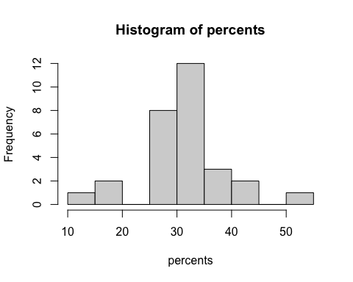

hist(percents, main="Percent of Population whose mental health has declined", xlab="Percent of Population Group")

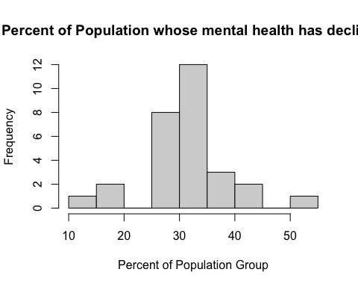

hist(percents, xlim = c(min(percents), max(percents)+10), ylim = c(0,14))

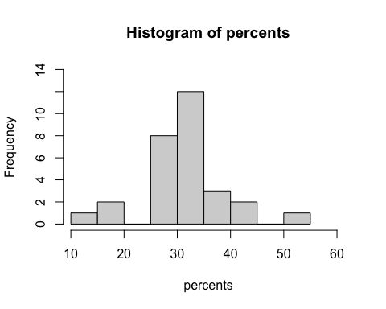

#The breaks argument controls the number of bars, cells or bins of the histogram  
hist(percents, breaks = 20)

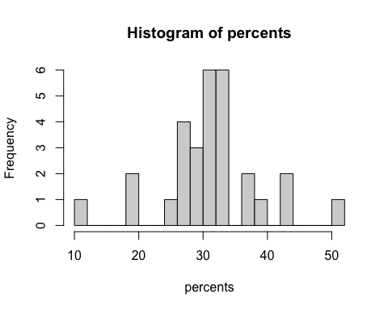

hist(percents, border = "red", col = "yellow")

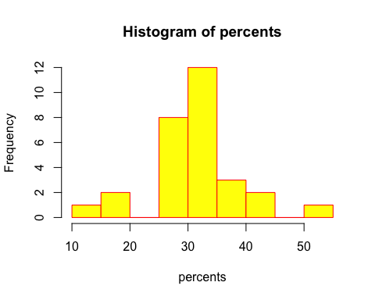

round(percents, 0)

## [1] 31 32 33 28 30 28 26 28 36 11 19 29 32 27 51 18 27 33 40 42 38 32 25 31 33  
## [26] 43 31 32 32

# We can create the stem plot by using the stem() function  
  
stem(round(percents, 0))

##   
## The decimal point is 1 digit(s) to the right of the |  
##   
## 1 | 1  
## 1 | 89  
## 2 |   
## 2 | 56778889  
## 3 | 011122222333  
## 3 | 68  
## 4 | 023  
## 4 |   
## 5 | 1

#scale argument: the scale we want to use for our plot/ width argument: the desired width for our plot   
stem(round(percents, 0), scale = 0.5)

##   
## The decimal point is 1 digit(s) to the right of the |  
##   
## 1 | 189  
## 2 | 56778889  
## 3 | 01112222233368  
## 4 | 023  
## 5 | 1

#=====================================================  
data()  
dataset<- ChickWeight  
head(dataset)

## weight Time Chick Diet  
## 1 42 0 1 1  
## 2 51 2 1 1  
## 3 59 4 1 1  
## 4 64 6 1 1  
## 5 76 8 1 1  
## 6 93 10 1 1

dataset$weight

## [1] 42 51 59 64 76 93 106 125 149 171 199 205 40 49 58 72 84 103  
## [19] 122 138 162 187 209 215 43 39 55 67 84 99 115 138 163 187 198 202  
## [37] 42 49 56 67 74 87 102 108 136 154 160 157 41 42 48 60 79 106  
## [55] 141 164 197 199 220 223 41 49 59 74 97 124 141 148 155 160 160 157  
## [73] 41 49 57 71 89 112 146 174 218 250 288 305 42 50 61 71 84 93  
## [91] 110 116 126 134 125 42 51 59 68 85 96 90 92 93 100 100 98 41  
## [109] 44 52 63 74 81 89 96 101 112 120 124 43 51 63 84 112 139 168  
## [127] 177 182 184 181 175 41 49 56 62 72 88 119 135 162 185 195 205 41  
## [145] 48 53 60 65 67 71 70 71 81 91 96 41 49 62 79 101 128 164  
## [163] 192 227 248 259 266 41 49 56 64 68 68 67 68 41 45 49 51 57  
## [181] 51 54 42 51 61 72 83 89 98 103 113 123 133 142 39 35 43 48  
## [199] 55 62 65 71 82 88 106 120 144 157 41 47 54 58 65 73 77 89  
## [217] 98 107 115 117 40 50 62 86 125 163 217 240 275 307 318 331 41 55  
## [235] 64 77 90 95 108 111 131 148 164 167 43 52 61 73 90 103 127 135  
## [253] 145 163 170 175 42 52 58 74 66 68 70 71 72 72 76 74 40 49  
## [271] 62 78 102 124 146 164 197 231 259 265 42 48 57 74 93 114 136 147  
## [289] 169 205 236 251 39 46 58 73 87 100 115 123 144 163 185 192 39 46  
## [307] 58 73 92 114 145 156 184 207 212 233 39 48 59 74 87 106 134 150  
## [325] 187 230 279 309 42 48 59 72 85 98 115 122 143 151 157 150 42 53  
## [343] 62 73 85 102 123 138 170 204 235 256 41 49 65 82 107 129 159 179  
## [361] 221 263 291 305 39 50 63 77 96 111 137 144 151 146 156 147 41 49  
## [379] 63 85 107 134 164 186 235 294 327 341 41 53 64 87 123 158 201 238  
## [397] 287 332 361 373 39 48 61 76 98 116 145 166 198 227 225 220 41 48  
## [415] 56 68 80 83 103 112 135 157 169 178 41 49 61 74 98 109 128 154  
## [433] 192 232 280 290 42 50 61 78 89 109 130 146 170 214 250 272 41 55  
## [451] 66 79 101 120 154 182 215 262 295 321 42 51 66 85 103 124 155 153  
## [469] 175 184 199 204 42 49 63 84 103 126 160 174 204 234 269 281 42 55  
## [487] 69 96 131 157 184 188 197 198 199 200 42 51 65 86 103 118 127 138  
## [505] 145 146 41 50 61 78 98 117 135 141 147 174 197 196 40 52 62 82  
## [523] 101 120 144 156 173 210 231 238 41 53 66 79 100 123 148 157 168 185  
## [541] 210 205 39 50 62 80 104 125 154 170 222 261 303 322 40 53 64 85  
## [559] 108 128 152 166 184 203 233 237 41 54 67 84 105 122 155 175 205 234  
## [577] 264 264

class(dataset$weight)

## [1] "numeric"

stem(dataset$weight)

##   
## The decimal point is 1 digit(s) to the right of the |  
##   
## 2 | 599999999  
## 4 | 00000111111111111111111112222222222222223333456678888888899999999999+38  
## 6 | 00111111122222222333334444455555666677777888888900111111222222333334+8  
## 8 | 00112223344444455555566777788999990001223333566666788888889  
## 10 | 0000111122233333334566667778889901122223445555667789  
## 12 | 00002223333344445555667788890113444555566788889  
## 14 | 11123444455556666677788890011234444555666777777789  
## 16 | 00002233334444466788990000134445555789  
## 18 | 12244444555677782225677778889999  
## 20 | 0123444555557900245578  
## 22 | 0012357701123344556788  
## 24 | 08001699  
## 26 | 12344569259  
## 28 | 01780145  
## 30 | 355798  
## 32 | 12712  
## 34 | 1  
## 36 | 13