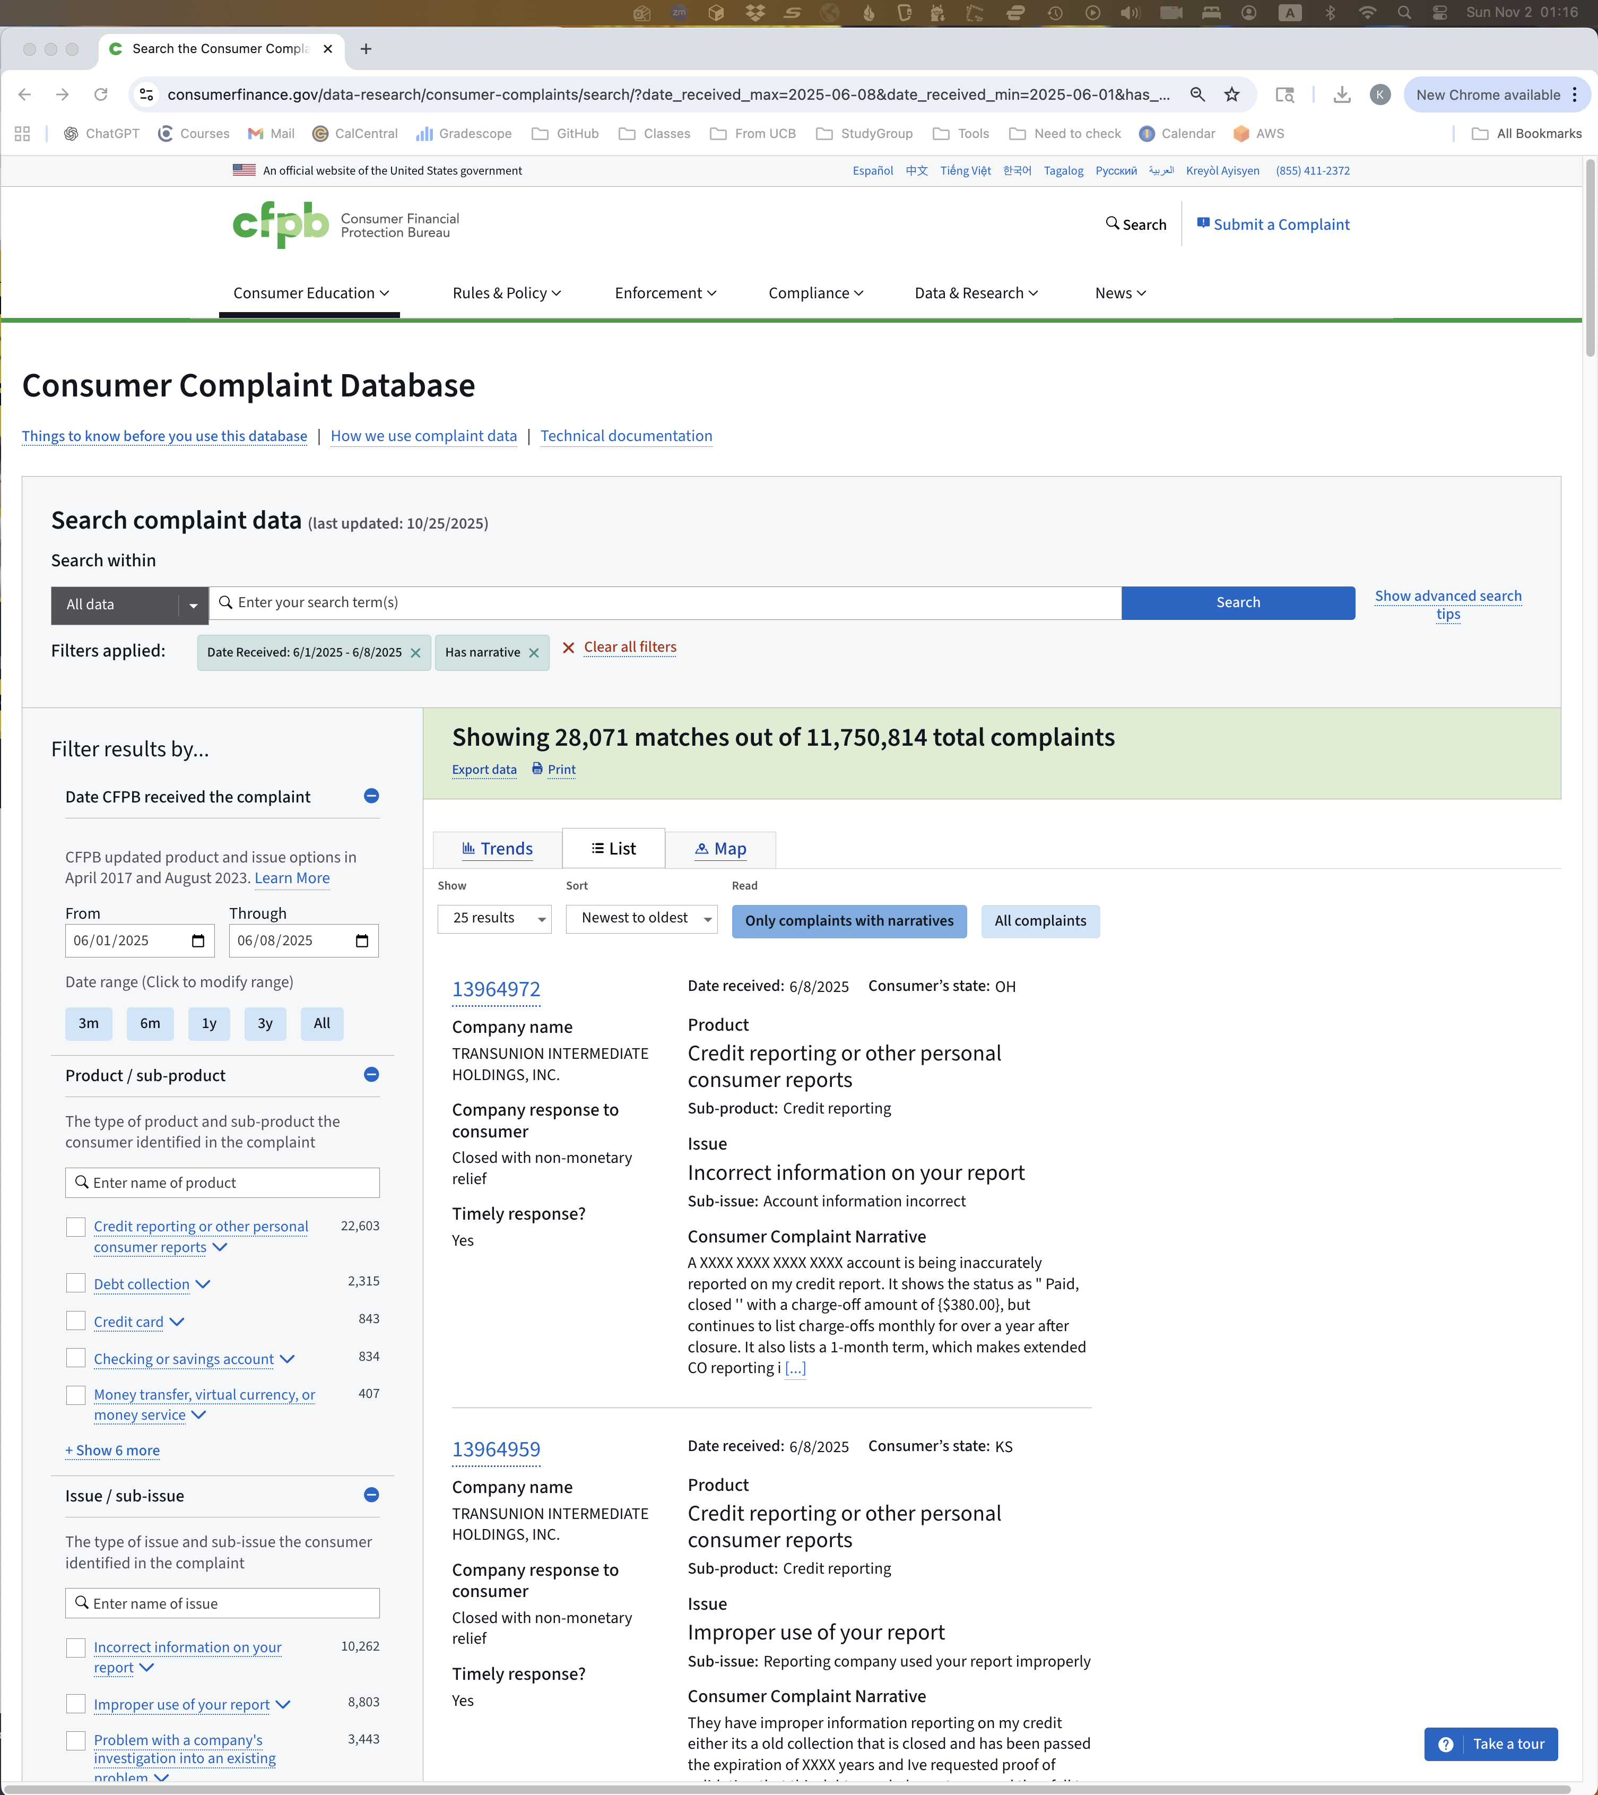
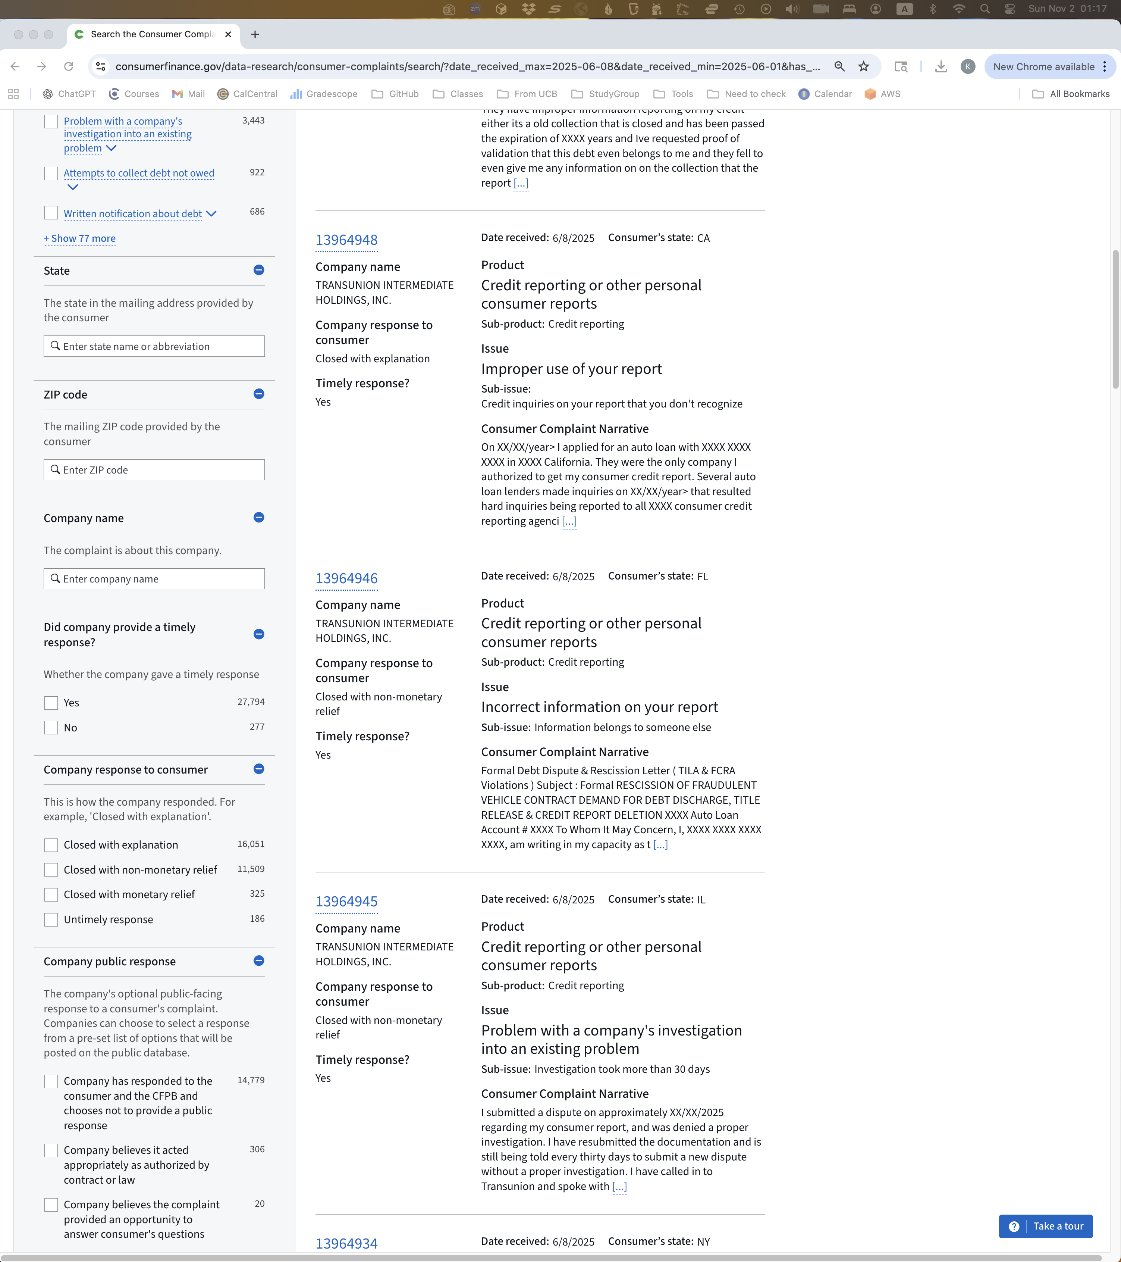
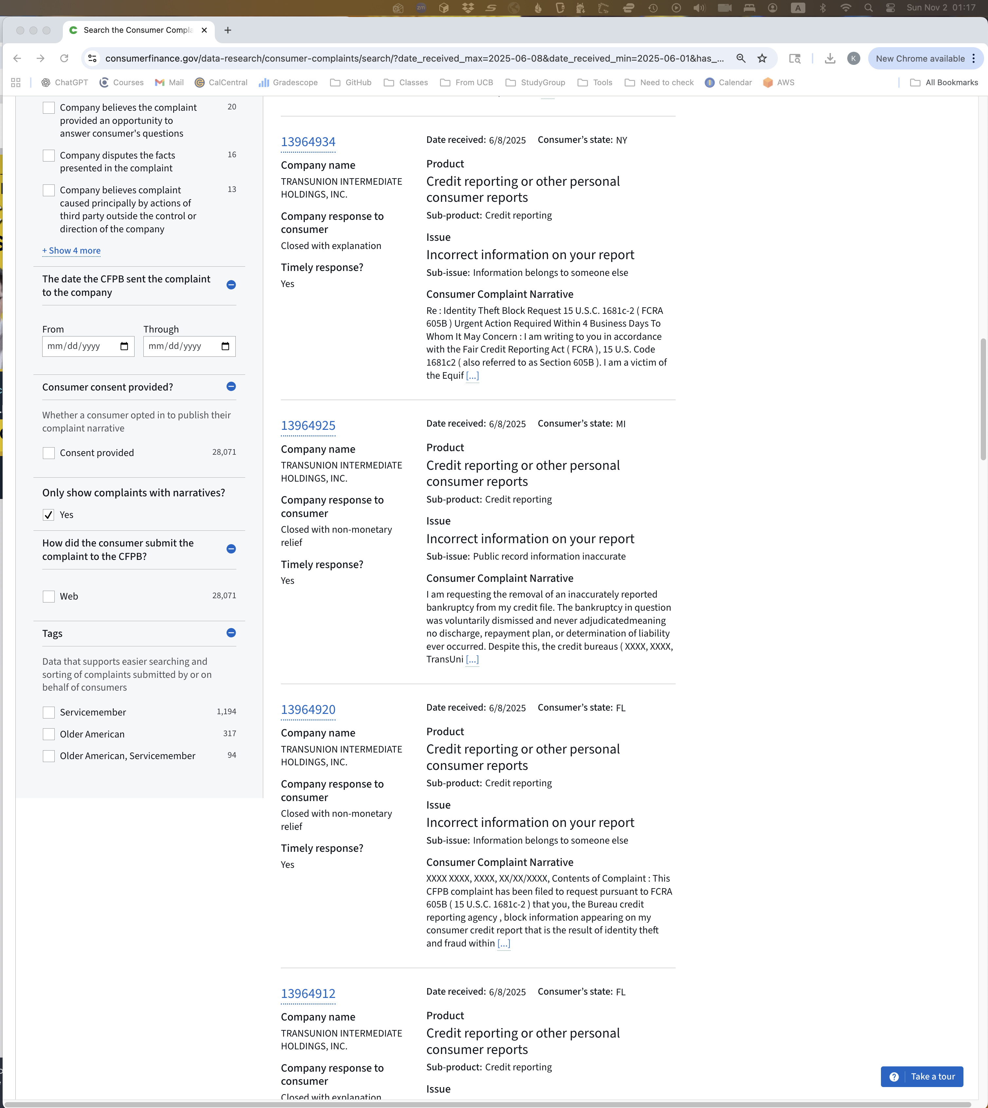
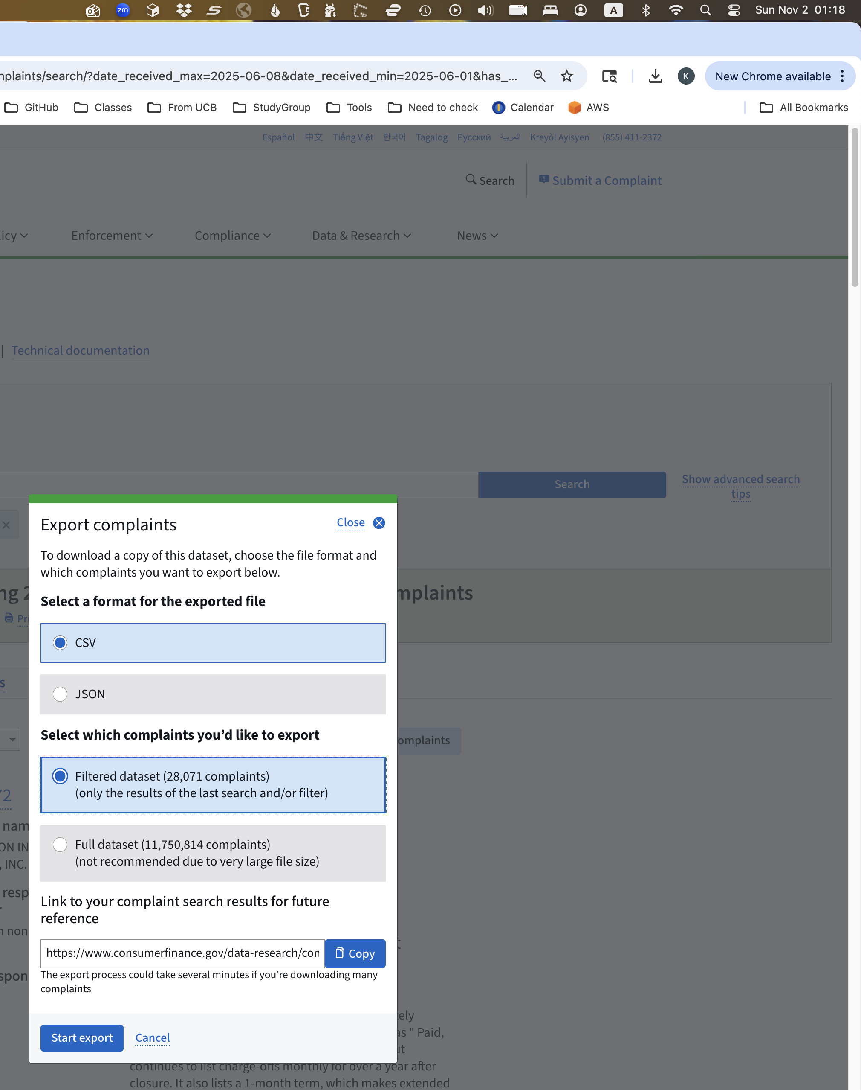
https://www.consumerfinance.gov/data-research/consumer-complaints/search/api/v1/?date_received_max=2025-06-08&date_received_min=2025-06-01&field=all&format=csv&has_narrative=true&no_aggs=true&size=28071

