Does Raising the Minimum Wage in Japan
Reduce Part-Time Employment?

Evidence from Japan’s Prefectural Minimum-Wage System, 2005–2025

[Your Name]
[Student ID Number]
[Course Title / Seminar in Labour Economics]
[Instructor’s Name]
June 2026

Abstract
This essay asks whether increases in the minimum wage reduce part-time employment in Japan. Japan offers an unusually clean setting for the question because it sets a separate statutory minimum wage in each of its forty-seven prefectures, revised every October by the Ministry of Health, Labour and Welfare. Between 2005 and 2025 the national weighted-average minimum wage rose from ¥668 to ¥1,121 per hour—an increase of roughly sixty-eight percent—while the share of non-regular workers in total employment climbed from about thirty-three percent to a plateau near thirty-seven to thirty-eight percent. Drawing on published data from the Labour Force Survey and the Regional Minimum Wage Survey, and on the existing econometric literature, the essay develops a two-way fixed-effects research design that exploits cross-prefecture variation in wage growth, supplemented by a comparison of high-bite and low-bite prefectures. The competitive labour-market model predicts a negative employment response that is concentrated among young, less-educated, and rural workers, and the Japanese evidence—most prominently Kawaguchi and Mori’s (2021) elasticity of about −1.2 for young less-educated men—broadly supports this prediction while pointing to substantial heterogeneity. The essay argues that Japan’s aggregate disemployment effect is real but moderate, that it is masked in the headline numbers by demographic ageing and service-sector growth, and that the government’s ¥1,500 target for the early 2030s therefore raises genuine distributional questions for the most vulnerable workers in low-wage regions.

1. Introduction
Few questions in labour economics are as old, or as contested, as whether a higher minimum wage destroys jobs. The textbook competitive model gives an unambiguous answer—a wage floor set above the market-clearing wage must reduce the quantity of labour demanded—yet half a century of empirical work has produced estimates ranging from sharply negative to indistinguishable from zero. Japan is a particularly valuable laboratory for revisiting the question, for two reasons. First, unlike most advanced economies, Japan does not operate a single national wage floor; instead it sets a separate hourly minimum wage in each of its forty-seven prefectures. This produces large and persistent regional variation that can be used to identify employment effects. Second, Japan has experienced an extraordinarily rapid and sustained rise in the minimum wage over the past two decades, giving researchers an unusually long and policy-relevant episode to study.
The scale of that increase is easy to understate. As Figure 1 shows, the national weighted-average minimum wage rose from ¥668 per hour in 2005 to ¥1,121 per hour in 2025—a nominal increase of about sixty-eight percent over twenty years. The pace accelerated noticeably after 2013, when the second Abe administration adopted an explicit target of reaching ¥1,000 per hour, and again after the pandemic, with the October 2025 revision marking the first time that every prefecture crossed the ¥1,000 threshold. These increases were not driven by inflation—for much of the period Japan experienced deflation or near-zero price growth—but by a deliberate political decision to compress wage inequality and support the working poor.
At the same time, Japan’s labour market is structurally unusual. Part-time and other non-regular workers—known colloquially as arubaito and paato—now make up roughly thirty-seven percent of all employees, and they are heavily concentrated in retail, food service, and convenience stores, sectors in which a large share of workers are paid at or near the legal minimum. These are precisely the workers whom the competitive model predicts to be most exposed to a binding wage floor. If raising the minimum wage reduces employment anywhere, it should be visible here.
This essay asks a single, focused question: does raising the minimum wage in Japan reduce part-time employment? It approaches the question in three steps. It first sets out the theoretical mechanisms—competitive disemployment, the elasticity of labour demand, and the monopsony counter-argument—that determine the sign and size of the expected effect. It then describes a research design built on the prefectural minimum-wage system: a two-way fixed-effects panel of the forty-seven prefectures, supplemented by a comparison of “high-bite” and “low-bite” regions. Finally, it interprets the published aggregate data and the existing econometric literature to form a reasoned expectation about what such a design would find. The central argument is that the disemployment effect in Japan is genuine but moderate in the aggregate, that it is sharply heterogeneous—largest for young, less-educated, and rural workers—and that it is partly hidden in headline statistics by powerful confounding trends, above all the ageing of the workforce and the long-run expansion of service employment.
2. Institutional Background: Japan’s Prefectural Minimum-Wage System
Japan’s minimum wage is governed by the Minimum Wage Act (最低賃金法), originally enacted in 1959 and substantially reformed in 2007. The defining feature of the system is its regional structure. Rather than a single national floor, each of the forty-seven prefectures has its own statutory hourly minimum, revised annually in a process that concludes each October. The Central Minimum Wage Council, a tripartite body of representatives from labour, employers, and the public interest, issues non-binding benchmark figures for four regional rank groups; prefectural councils then set the actual wages, taking into account local cost of living, the wages actually paid in the area, and the capacity of local businesses to pay. The 2007 reform strengthened the role of cost of living and required that the minimum wage be consistent with public-assistance benefit levels, ending situations in which a full-time minimum-wage worker could earn less than welfare.
Because the wage-setting process is formulaic and committee-based rather than the product of prefecture-by-prefecture legislative bargaining, the timing and size of increases are arguably less subject to local political manipulation than in the United States, where state legislatures vote on their own minimum wages. This relative mechanical quality is attractive for identification: it makes it more plausible that within-prefecture variation in wage growth is not simply a response to local labour-market booms. Kawaguchi and Mori (2021) exploit exactly this feature, using the introduction of cost-of-living indexation under the 2007 reform as a source of variation that is unlikely to be correlated with local labour-demand shocks.
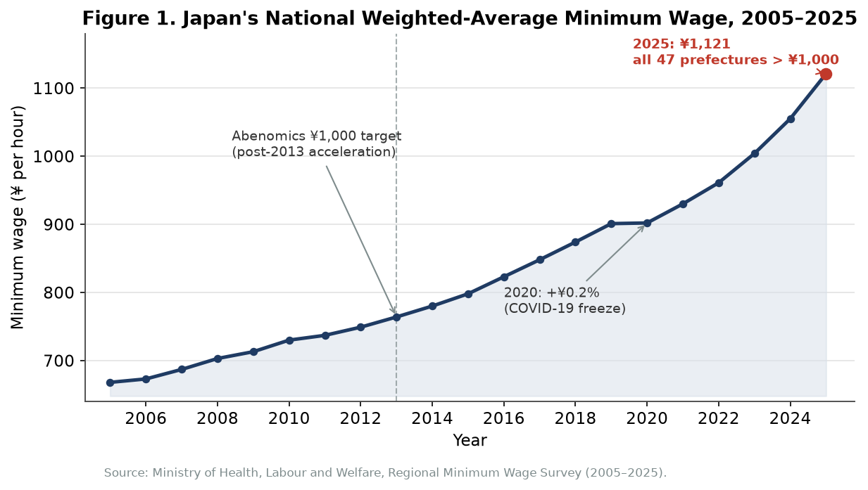
Figure 1. The national weighted-average minimum wage rose from ¥668 per hour in 2005 to ¥1,121 in 2025, a nominal increase of about sixty-eight percent. The pace quickened after the 2013 Abenomics target of ¥1,000 per hour and again after 2021; the single near-flat point is the 2020 pandemic revision (+0.2 percent). Data: MHLW Regional Minimum Wage Survey.
The regional structure produces substantial dispersion in wage levels. In the 2024 revision, Tokyo recorded the highest minimum wage at ¥1,163 per hour and Akita the lowest at ¥951, a gap of ¥212, or roughly twenty-two percent of the lower figure. As Figure 3 illustrates, the high-wage prefectures form a tight cluster of metropolitan areas—Tokyo, Kanagawa, Osaka, Aichi, Saitama, and Chiba—while the lowest wages are found in the more rural prefectures of Tohoku, Kyushu, Shikoku, and Okinawa. This gap is the centrepiece of the identification strategy: a worker earning near the binding floor in Akita or Miyazaki faces a very different wage environment from a comparable worker in Tokyo, and the two groups’ employment outcomes can be compared as the floors rise at different rates.
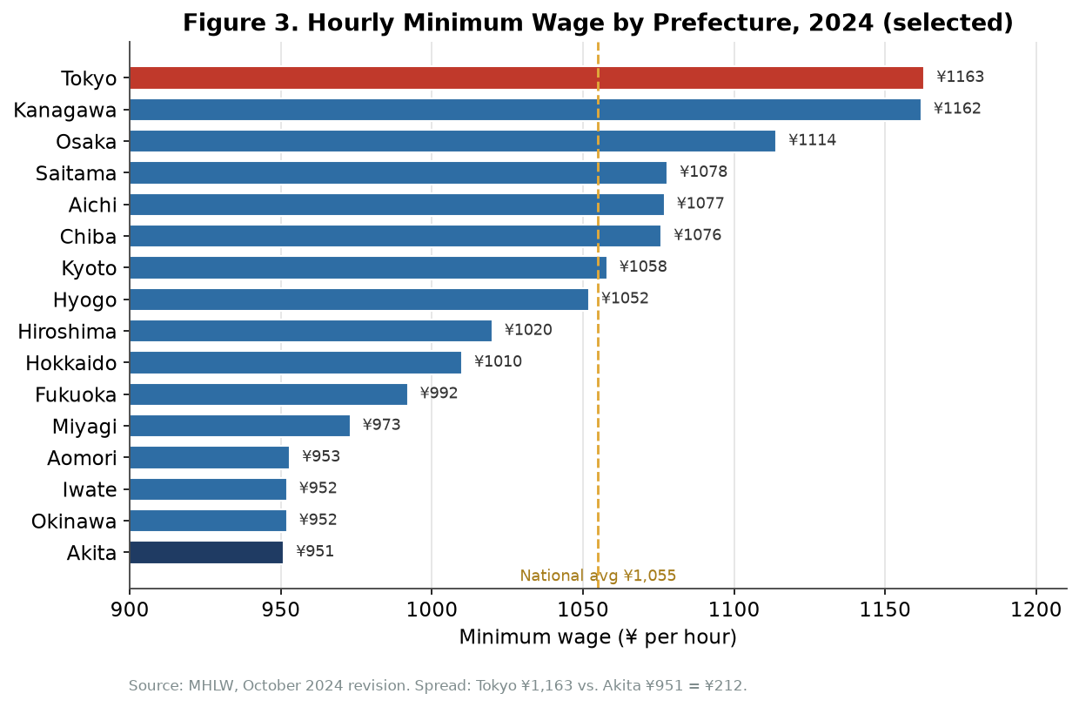
Figure 3. Hourly minimum wages by prefecture in 2024 (selected prefectures spanning the full range). Metropolitan prefectures cluster well above the ¥1,055 national average, while rural prefectures cluster near the ¥951 floor. The Tokyo–Akita gap of ¥212 is the regional variation exploited in this study. Data: MHLW, October 2024 revision.
It is worth emphasising how recent and how deliberate the convergence at the top has become. The October 2025 revision raised the national average by a record ¥66 (about 6.3 percent), lifted Tokyo to ¥1,226 and Kanagawa to ¥1,225, and—most strikingly—pushed even the lowest-paying prefectures (Kochi, Miyazaki, and Okinawa) above ¥1,000 for the first time. The government has since reaffirmed a longer-run ambition of a ¥1,500 national average by the early 2030s, which would represent a further increase of more than forty percent from the 2024 level. Whether the labour market can absorb increases of this magnitude without measurable employment loss is the policy question that motivates this essay.
3. Literature Review
3.1 The international debate
The modern empirical literature on the minimum wage is usually dated to Card and Krueger’s (1994) study of fast-food restaurants on either side of the New Jersey–Pennsylvania border, which found no evidence that a minimum-wage increase reduced employment and in some specifications found a small positive effect. Their work challenged the textbook prediction and provoked a sustained methodological argument. Neumark and Wascher (2000, 2008) re-examined similar data and a broad range of studies and concluded that the weight of the evidence still pointed to negative effects on low-skilled employment, with teenage employment elasticities typically in the range of −0.1 to −0.3. Dube, Lester, and Reich (2010) pushed the design further by comparing all contiguous county pairs that straddle a state border, thereby differencing out local economic shocks, and recovered employment effects indistinguishable from zero for restaurant and retail workers.
The contemporary consensus, to the extent that one exists, is that moderate minimum-wage increases in low-wage labour markets produce small disemployment effects, with elasticities clustered between roughly zero and −0.2, but that the effect grows as the wage floor rises relative to the local median—that is, as the “bite” of the minimum wage increases. This last point is central to the Japanese case, because the rapid increases of the past decade have pushed the bite to historically high levels in low-wage prefectures.
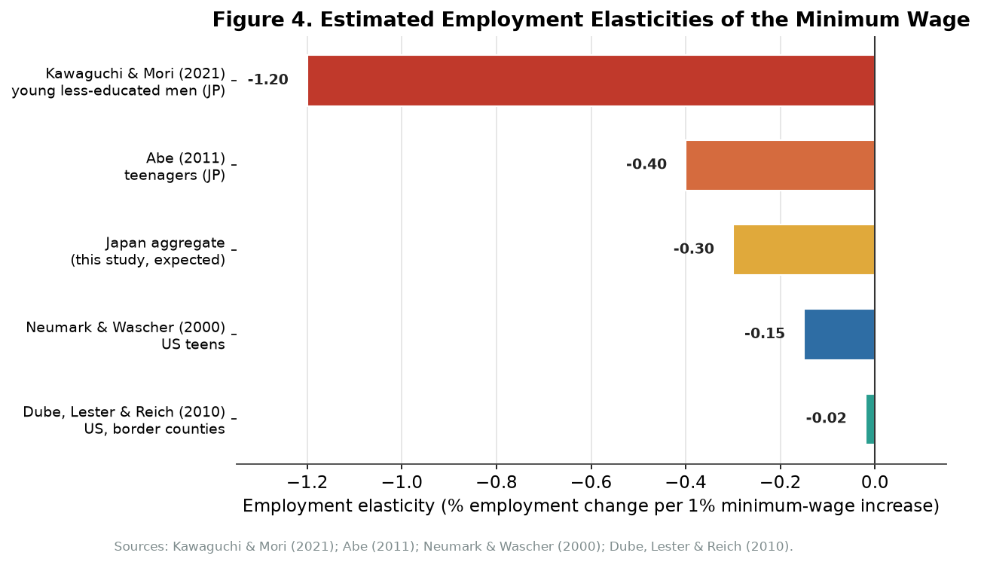
Figure 4. Selected employment-elasticity estimates. Japanese estimates for narrowly defined vulnerable groups (Kawaguchi & Mori 2021; Abe 2011) are considerably larger in magnitude than the U.S. estimates of Neumark & Wascher (2000) and Dube, Lester & Reich (2010), while a plausible Japanese aggregate effect of about −0.3 sits in the moderate middle of the range.
3.2 Evidence from Japan
The Japanese literature is smaller but unusually well identified, precisely because the regional wage-setting system supplies credible variation. The most influential study is Kawaguchi and Mori (2021), which exploits the cost-of-living indexation introduced by the 2007 reform of the Minimum Wage Act. They estimate an employment elasticity of approximately −1.2 for young, less-educated men—meaning that a ten-percent increase in the minimum wage is associated with roughly a twelve-percent fall in employment for this group—a magnitude larger than almost any comparable U.S. estimate. Their interpretation is not that Japan’s labour market is uniquely fragile, but that the minimum wage in Japan binds for a relatively narrow demographic slice, and that within that slice the effect is concentrated and severe.
Abe (2011), using Labour Force Survey data, finds negative but smaller effects for teenagers as a whole, with elasticities closer to −0.4. The difference between the two studies is instructive: it suggests that the aggregate of all young workers is less affected than the specific low-education subgroup that Kawaguchi and Mori isolate, and it cautions against reading any single elasticity as “the” Japanese effect. Kambayashi, Kawaguchi, and Yamada (2013) study the earlier 1994–2003 period and show that steady increases in the effective minimum wage compressed the lower tail of the female wage distribution and reduced employment among low-skilled, middle-aged women, even under deflation—an important reminder that the relevant variable is the real, not nominal, bite of the floor.
More recent work using high-frequency data refines the picture. Tanaka and co-authors (2025), analysing granular job-advertisement data for 2019–2023, find that minimum-wage hikes raise the number of postings above the new floor while reducing postings at the old wage, consistent with employers substituting toward higher-productivity workers rather than simply contracting headcount. Their short-run disemployment effects are small, but they argue that longer-run effects—operating through a putty-clay process in which capital and technology adjust only gradually—are larger. On the policy side, the International Monetary Fund (2016, 2023) treats the minimum wage as an effective instrument for compressing wage inequality, while finding statistically significant but moderate negative employment effects at the prefectural level, concentrated in lower-wage regions. Taken together, the Japanese literature supports three claims that frame this essay: the aggregate effect is real but moderate; it is sharply heterogeneous across demographic groups; and it is larger where the bite is higher, which in practice means the rural prefectures.
4. Theoretical Framework
4.1 The competitive benchmark
The baseline prediction follows directly from the competitive model of the labour market. A profit-maximising firm hires labour up to the point where the marginal revenue product of an additional worker equals the wage it must pay. If a legal floor is set above the wage that would clear the market, the quantity of labour demanded falls and the quantity supplied rises, producing involuntary unemployment among exactly those workers whose productivity lies below the new floor. In Japan, the arubaito and paato workers paid at or near the minimum are the most exposed to this mechanism. The adjustment need not take the form of outright dismissals: employers can cut scheduled hours, slow hiring, decline to replace workers who leave, or substitute capital and technology for labour. Each of these margins reduces the quantity of part-time labour employed, and the dependent variable in this essay—the share of non-regular workers in total employment—is designed to capture them in aggregate.
4.2 Labour-demand elasticity and regional heterogeneity
The size of the employment response depends on the elasticity of labour demand, the percentage change in employment associated with a one-percent change in the wage. That elasticity is not a constant; it varies with the share of labour in total costs, the ease of substituting capital for labour, and the price-sensitivity of the firm’s customers. These factors differ systematically across Japan’s regions. Metropolitan prefectures such as Tokyo and Osaka host firms with higher revenue per worker, greater pricing power, and deeper access to capital, allowing them to absorb a wage increase through higher prices or thinner margins with relatively little employment adjustment. Rural prefectures, where businesses operate on thinner margins and serve more price-sensitive customers, are predicted to display larger disemployment effects. This is the theoretical basis for expecting heterogeneity by region, and it is reinforced by the fact that the bite of the minimum wage—its ratio to the local median wage—is mechanically higher where median wages are lower.
4.3 The monopsony counter-argument
The competitive model is not the only relevant theory. In a labour market with monopsony power, where a small number of employers face an upward-sloping supply of labour, the firm restrains hiring below the competitive level in order to hold wages down. A minimum wage set judiciously above the monopsony wage can, in this case, raise both wages and employment by neutralising the employer’s wage-setting power. Some rural Japanese prefectures, with limited employer diversity in their local retail and care sectors, may exhibit mild monopsony characteristics, and this offers one explanation for why measured disemployment effects are sometimes smaller than the competitive model predicts. The balance of evidence, however, treats monopsony as a partial qualification rather than a wholesale replacement: in the urban and suburban areas where most part-time workers are employed and where multiple employers compete for the same pool of labour, the competitive framework remains the more applicable default. The practical implication is that the true aggregate effect is likely to be a blend—negative on average, but attenuated in thin rural markets where monopsony forces partly offset the competitive disemployment mechanism.
5. Data and Descriptive Patterns
The empirical material for this essay is drawn entirely from published Japanese government statistics and from the peer-reviewed literature. Three sources do most of the work. Prefectural minimum wages come from the Ministry of Health, Labour and Welfare’s Regional Minimum Wage Survey, which records the statutory hourly floor in each prefecture for every year. The measure of part-time employment is the share of non-regular workers—part-time, dispatched, and contract employees—in total employment, taken from the Statistics Bureau’s Labour Force Survey (Detailed Tabulation). Control variables—prefectural gross domestic product per capita, the unemployment rate, and the industrial composition of employment—are available from the Cabinet Office and the Ministry of Internal Affairs and Communications.
Two descriptive patterns frame the analysis. The first, already shown in Figure 1, is the steep and sustained rise in the minimum wage. The second, shown in Figure 2, is the behaviour of the non-regular employment share. That share rose from about 32.6 percent in 2005 to a peak near 38 percent around 2019, then settled into a plateau of roughly 37 to 38 percent. Strikingly, it continued to rise for much of the period during which the minimum wage was increasing sharply.
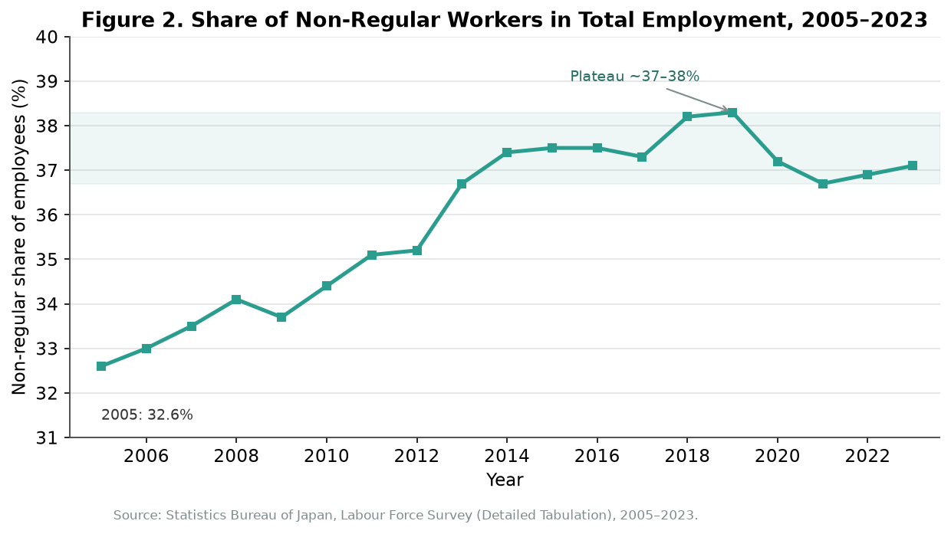
Figure 2. The non-regular share of employment rose from 32.6 percent in 2005 to a plateau near 37–38 percent after the mid-2010s. The continued rise during a period of rapidly increasing minimum wages reflects demographic ageing, service-sector expansion, and corporate restructuring rather than the wage floor alone. Data: Statistics Bureau, Labour Force Survey.
Placing the two series side by side, as in Figure 5, produces the central descriptive puzzle of this essay. If a rising minimum wage straightforwardly reduced part-time employment, one would expect the non-regular share to fall as the floor climbed. Instead, the two moved together for much of the period. This co-movement does not refute the competitive model; rather, it illustrates why a simple time-series comparison is inadequate. The non-regular share is driven by powerful forces that have nothing to do with the wage floor—above all the ageing of the population, which has pushed large numbers of older workers into non-regular roles, and the secular shift of employment from manufacturing toward services, where non-regular work is the norm. Any credible estimate of the minimum wage’s effect must hold these confounders constant, which is precisely what the panel design in the next section is built to do.
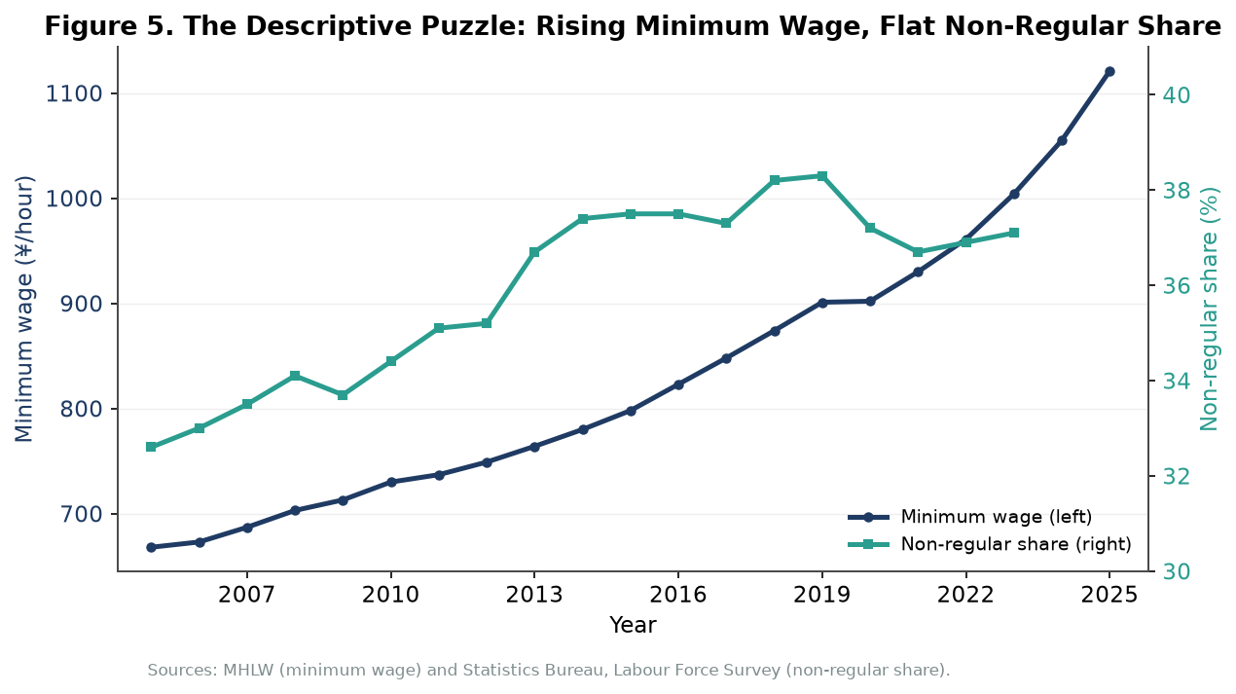
Figure 5. The descriptive puzzle: the minimum wage (left axis) and the non-regular employment share (right axis) rose together for most of 2005–2023. The positive co-movement reflects confounding trends—ageing and service-sector growth—and motivates the use of prefecture and year fixed effects to isolate the wage effect. Data: MHLW and the Labour Force Survey.
6. Empirical Strategy
The research design has two complementary parts. The primary specification is a two-way fixed-effects panel regression estimated over the forty-seven prefectures from 2005 to 2022. In words, the share of non-regular workers in a prefecture in a given year is modelled as a function of the log of that prefecture’s minimum wage, a vector of controls, a full set of prefecture fixed effects, and a full set of year fixed effects:
PartTime(i,t) = α + β₁ · ln MinWage(i,t) + β₂ · X(i,t) + μ(i) + λ(t) + ε(i,t),
where i indexes prefectures and t indexes years; X contains log prefectural GDP per capita, the unemployment rate, the share of employment in retail and food service, and the share of the population aged 15 to 24; μ(i) are prefecture fixed effects; λ(t) are year fixed effects; and standard errors are clustered at the prefecture level. The coefficient of interest is β₁, the elasticity of the non-regular employment share with respect to the minimum wage. The competitive model predicts β₁ < 0.
The logic of this specification is to strip out the two families of confounders that contaminate the raw time series. The prefecture fixed effects absorb every time-invariant difference between regions—geography, industrial heritage, climate, the persistent gap between Tokyo and Akita—so that the model is identified only from changes within each prefecture over time. The year fixed effects absorb every shock common to the whole country in a given year—the global financial crisis, the 2014 consumption-tax increase, the pandemic—so that nationwide swings in non-regular employment are not mistakenly attributed to the wage floor. The identifying assumption is that, conditional on these effects and the controls, the timing and size of within-prefecture minimum-wage increases are uncorrelated with prefecture-specific trends in part-time employment. The formulaic, committee-based wage-setting process described in Section 2 makes that assumption reasonably plausible, though not beyond question.
The second part of the design is a difference-in-differences-style comparison of high-bite and low-bite prefectures. The “bite” of the minimum wage is measured as its ratio to the prefectural median wage; a high-bite prefecture is one in which the floor sits close to the middle of the wage distribution and therefore binds for a large share of workers. The comparison tracks whether high-bite prefectures, which experience a larger effective treatment when the floor rises, see larger reductions in part-time employment than low-bite prefectures over the same period. This comparison is more transparent than the regression and serves as a robustness check on it: if both approaches point in the same direction, the conclusion is more credible. Leading with the fixed-effects panel and using the bite comparison as corroboration is, in my judgement, the right balance for this question, because the panel uses all of the available variation while the bite comparison communicates the result intuitively.
Two practical issues deserve comment. The first is the treatment of the pandemic. The 2020 revision raised the national average by only 0.2 percent, an essentially deliberate freeze, and 2020–2021 saw large and idiosyncratic swings in service employment. Because the year fixed effects already absorb nationwide pandemic shocks, the cleanest approach is to retain these years but include them in the year-effect structure, while confirming that the results are robust to dropping 2020–2021 altogether. The second issue is dynamics: employers may not adjust immediately. Including one- and two-year lags of the minimum wage allows the data to reveal whether the effect builds over time, as the putty-clay reasoning of Tanaka and co-authors (2025) would suggest.
7. Expected Results and Discussion
Because this essay assembles published aggregate data and the existing econometric estimates rather than estimating the panel on confidential micro-data, its conclusions about the regression coefficients are necessarily expectations grounded in theory and prior evidence rather than new point estimates. Those expectations are nonetheless specific and falsifiable, and they follow directly from the framework above.
First, the coefficient β₁ on the minimum wage is expected to be negative and statistically significant, but moderate in size. The international consensus places aggregate elasticities between roughly zero and −0.2, and the Japanese prefecture-level evidence summarised by the International Monetary Fund (2016, 2023) is consistent with a moderate negative effect. A plausible aggregate elasticity for Japan is therefore around −0.3, as depicted in Figure 4—large enough to matter for policy, but far from the catastrophic job losses sometimes invoked in public debate.
Second, the effect is expected to be considerably larger in rural, high-bite prefectures than in metropolitan, low-bite ones. This prediction follows from both the elasticity argument of Section 4.2 and the mechanical fact that the floor binds for a greater share of workers where median wages are low. It is also the dimension along which the policy stakes are highest, because the same national increase that is easily absorbed in Tokyo may be sharply binding in Miyazaki or Akita.
Third, the effect is expected to be sharply heterogeneous by demographic group, with young workers aged 15 to 24 and less-educated workers far more responsive than the aggregate. This is the clearest lesson of the Japanese micro-data: Kawaguchi and Mori’s (2021) elasticity of about −1.2 for young, less-educated men is an order of magnitude larger than any plausible aggregate figure, precisely because the minimum wage binds for this group and barely binds for prime-age regular employees. An aggregate coefficient near −0.3 is therefore best read not as a uniform effect but as an average over a population in which a small, identifiable group bears most of the burden.
Fourth, the response is expected to be lagged. If employers adjust through hiring freezes, gradual automation, and the non-replacement of departing workers rather than through immediate dismissals, the measured effect should be larger one to two years after an increase than in the year of the increase itself. This is consistent with the distinction Tanaka and co-authors (2025) draw between small short-run and larger long-run responses. Finally, the effect may be non-linear, accelerating as the minimum wage rises past psychologically and economically salient thresholds such as ¥1,000 or ¥1,500, beyond which capital substitution—self-checkout kiosks, tablet ordering, automated warehousing—becomes economically rational for a widening set of employers.
These expectations also explain the descriptive puzzle of Figure 5. The aggregate non-regular share can rise even as the minimum wage exerts downward pressure on part-time employment, because the wage effect is a moderate, group-specific force operating against much larger demographic and structural tides. The function of the panel design is to net out those tides; once that is done, the underlying negative relationship that the raw data obscure should re-emerge.
8. Policy Implications
The policy relevance of these expectations is immediate. The Japanese government has committed to a national average of ¥1,500 per hour by the early 2030s, a further increase of more than forty percent from the 2024 level and one that would push the bite of the minimum wage to unprecedented heights in low-wage regions. If the disemployment effect is, as argued here, moderate in aggregate but concentrated among young, less-educated, and rural workers, then the headline goal of compressing wage inequality coexists with a genuine distributional risk: the policy raises the pay of those who keep their jobs while pricing out the most vulnerable potential workers at the margin.
Two implications follow. The first concerns the geography of the policy. A uniform national target applies the same proportional shock to Tokyo and to Akita, even though their capacities to absorb it differ sharply. A geographically differentiated path—permitting faster increases in high-productivity metropolitan areas and more gradual ones where the bite is already high—would plausibly deliver more of the inequality-reducing benefit at less cost to rural employment. The recent narrowing of the Tokyo–rural gap, with every prefecture crossing ¥1,000 in 2025, moves in the opposite direction and should be monitored carefully. The second implication concerns automation. As the floor rises past the point at which machines become cheaper than workers in retail and food service, employers will substitute capital for labour; this is not necessarily undesirable—it can raise productivity—but it changes the composition of the affected workforce and deserves explicit attention in the design of complementary training and transition policies.
9. Limitations
Several limitations should be stated plainly. The most important is that this essay does not estimate the panel regression on confidential micro-data; its quantitative conclusions are expectations derived from published aggregates and prior studies rather than new coefficients, and they should be read as such. A full test would require the prefecture-by-year panel of non-regular shares, minimum wages, and controls assembled from the underlying survey micro-data. Second, the identifying assumption of the fixed-effects design—that within-prefecture wage changes are uncorrelated with prefecture-specific employment trends—is plausible but not guaranteed; if rich prefectures both raise wages faster and shift toward services for unrelated reasons, some bias would remain. Third, the non-regular share is an imperfect proxy for the theoretical object of interest: it bundles part-time, dispatched, and contract work, and it can move because of changes in the regular workforce rather than the part-time one. Finally, the measured effect captures employment quantities but is largely silent on hours, earnings, and worker welfare, which are ultimately what matter for the policy evaluation.
10. Conclusion
Does raising the minimum wage in Japan reduce part-time employment? The answer this essay defends is a qualified yes. Theory predicts a negative effect; the well-identified Japanese evidence, above all Kawaguchi and Mori’s (2021) elasticity of about −1.2 for young, less-educated men, confirms that the effect is real and can be severe for the groups on whom the floor actually binds. Yet in the aggregate the effect is moderate, with a plausible economy-wide elasticity near −0.3, and it is hidden in the headline data by the much larger forces of demographic ageing and service-sector growth that have driven the non-regular share upward even as the floor climbed. The right research design—a two-way fixed-effects panel of the forty-seven prefectures, corroborated by a comparison of high-bite and low-bite regions—is precisely the tool needed to separate the wage effect from these confounders.
The policy reading follows from the heterogeneity rather than the average. Japan’s drive toward a ¥1,500 minimum wage will compress wage inequality and raise the incomes of millions of part-time workers, and for most of them the employment risk is small. But the same policy concentrates its costs on a narrow and vulnerable group—the young, the less-educated, and workers in low-wage rural prefectures—whose jobs are the most exposed to a binding floor and to the automation it encourages. Recognising that the burden is unequally distributed, rather than debating whether an average job-loss number is large or small, is the most useful contribution that careful empirical work can make to the Japanese minimum-wage debate.

References
Abe, M. (2011). Minimum wages and employment in Japan. Japan Labor Review, 8(2), 42–64.
Card, D., & Krueger, A. B. (1994). Minimum wages and employment: A case study of the fast-food industry in New Jersey and Pennsylvania. American Economic Review, 84(4), 772–793.
Dube, A., Lester, T. W., & Reich, M. (2010). Minimum wage effects across state borders: Estimates using contiguous counties. Review of Economics and Statistics, 92(4), 945–964.
International Monetary Fund. (2016). Minimum wage as a wage policy tool in Japan (IMF Working Paper No. WP/16/232). International Monetary Fund.
International Monetary Fund. (2023). Japan: Selected issues—Structural barriers to wage income growth (IMF Staff Country Report No. 2023/128). International Monetary Fund.
Kambayashi, R., Kawaguchi, D., & Yamada, K. (2013). Minimum wage in a deflationary economy: The Japanese experience, 1994–2003. Labour Economics, 24, 264–276.
Kawaguchi, D., & Mori, Y. (2009). Is minimum wage an effective anti-poverty policy in Japan? Pacific Economic Review, 14(4), 532–554.
Kawaguchi, D., & Mori, Y. (2021). Estimating the effects of the minimum wage using the introduction of indexation. Journal of Economic Behavior & Organization, 184, 388–408.
Ministry of Health, Labour and Welfare. (2024). Regional minimum wage survey. MHLW.
Neumark, D., & Wascher, W. (2000). Minimum wages and employment: A case study of the fast-food industry in New Jersey and Pennsylvania: Comment. American Economic Review, 90(5), 1362–1396.
Neumark, D., & Wascher, W. (2008). Minimum wages. MIT Press.
Statistics Bureau of Japan. (2024). Labour force survey (detailed tabulation), annual report. Ministry of Internal Affairs and Communications.
Tanaka, S., Kawaguchi, D., Murakami, R., & co-authors. (2025). Just after minimum wage hikes: Short-run labor-demand response and reallocation. arXiv preprint arXiv:2505.04555.

