**INSIGHTSTREAMING: NAVIGATING YOUR NEWS LANDSCAPE**

**TEAM MEMBERS:**

**TEAM LEADER: KOKILA. J**

**TEAM MEMBER: ESTHER YASMINE D**

**TEAM MEMBER: HEMALATHA S**

**TEAM MEMBER: HEMALATHA N**

**TEAM MEMBER: NISHA R**

**INSIGHTSTREAMING (React)**

**1. Introduction**

Overview

This project is designed to create an intuitive, user-friendly news platform that addresses common challenges faced by users when consuming news online. The platform will provide a clean, distraction-free interface, enabling users to access news quickly and efficiently. It will offer personalized news feeds based on user preferences, provide verified and reliable content, and ensure a smooth, fast-loading experience across all devices, especially mobile. The goal is to enhance the user experience by eliminating irrelevant content, ensuring the credibility of the news, and delivering real-time updates. Using React for the frontend development, the platform will consist of various reusable components for a dynamic and responsive interface.

Project Purpose

This project aims to create a news platform that addresses the common pain points of users in the modern digital landscape. This platform will offer a clean, distraction-free, and user-friendly experience, tailored to different types of users, including busy professionals, casual readers, mobile users, and those concerned with the credibility of news sources. By streamlining news access and focusing on personalized, reliable content, this platform aims to improve user engagement and satisfaction, ensuring that users can stay informed efficiently without feeling overwhelmed or frustrated.

**2. Technologies Used**

Front-End Technologies

1. HTML – Structure of the web pages.

2. CSS – Styling for the web pages. CSS Flexbox and Grid are used for layout.

3. JavaScript – For dynamic content updates, fetching data from APIs, and updating the UI.

4. React.js – A popular JavaScript library for creating interactive apps.

5. Font Awesome – For the icons in the sidebar.

**3. Project Structure**

File Structure

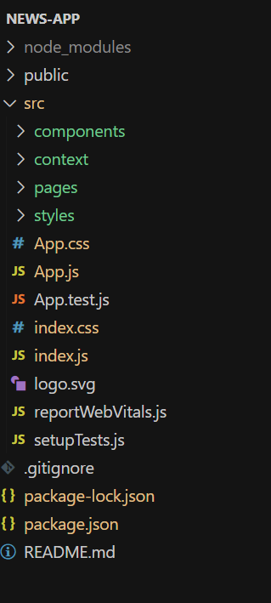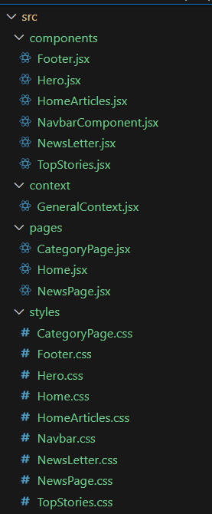

Key Files Overview

• index.html: Contains the structure of the main dashboard interface.

• styles.css: Defines the visual design of the application, including layout, colors, fonts, and responsiveness.

• script.js: Handles data fetching, UI population, and user interaction logic.

• logo.png: The logo used in the sidebar for the branding of Crypto Verse.

**4. Features**

Dashboard Overview

• Sidebar Navigation: Contains links to various pages or sections (e.g., Dashboard, Market Trends, etc.).

• Real-Time Updates: Displays live news.

• Search Functionality: Allows users to search for a specific news by name or category.

• Top 10 News: Displays a grid layout of the top 10 news by importance

**5. User Interface Design**

Sidebar Navigation

The sidebar is designed to be fixed on the left side of the screen. It includes:

• Branding with the application’s name.

• Navigation links to different sections of the dashboard.

• A logout button to navigate the user out of the system.

Main Content

The main content area is dynamically populated with:

* Top News: A panel with the top most news highlighted.
* Top News Panel: A grid displaying the top 10 news articles with their title.

**6. Project Flow**

Milestone 1: Project setup and configuration.

● Installation of required tools:

To build InsightStream, we'll need a developer's toolkit. We'll use React.js for the interactive interface, React Router Dom for seamless navigation, and Axios to fetch news data. For visual design, we'll choose either Bootstrap or Tailwind CSS for pre-built styles and icons.

Open the project folder to install necessary tools. In this project, we use:

o React Js

o React Router Dom

o React Icons

o Bootstrap/tailwind css

o Axios

Milestone 2: Project Development

❖ Setup the Routing paths

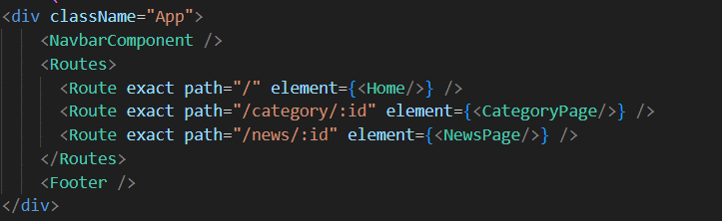

❖ Develop the Navbar and Hero components

❖ Code the popular categories components and fetch the categories from newsapi. ❖ Also, add the trending news in the home page.

❖ Additionally, we can add the component to subscribe for the newsletter and the footer.

❖ Now, develop the category page to display various news articles under the different categories.

**7. Project Execution:**

After completing the code, run the react application by using the command “npm start” or “npm run dev” if you are using vite.js

Here are some of the screenshots of the application.

* **Hero components**

In the hero component, the trending news articles are displayed. It is to highlight them. Apart from that, the search bar is also available to search for various articles and categories.

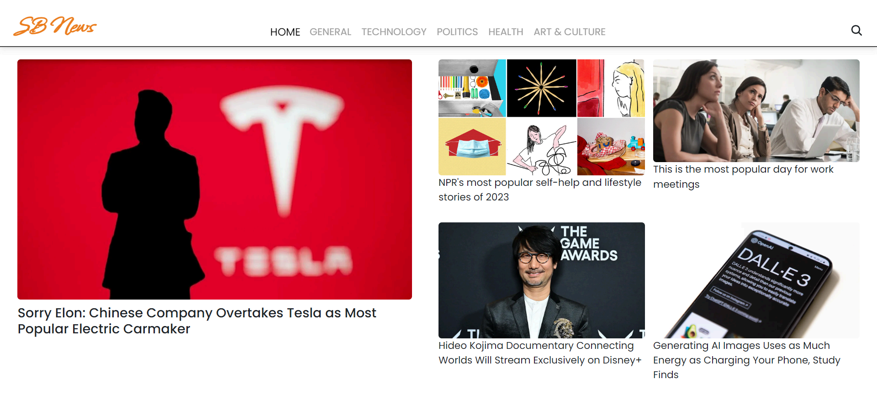

* **Popular categories**

In the hero component, the trending news articles are displayed. It is to highlight them. Apart from that, the search bar is also available to search for various articles and categories.

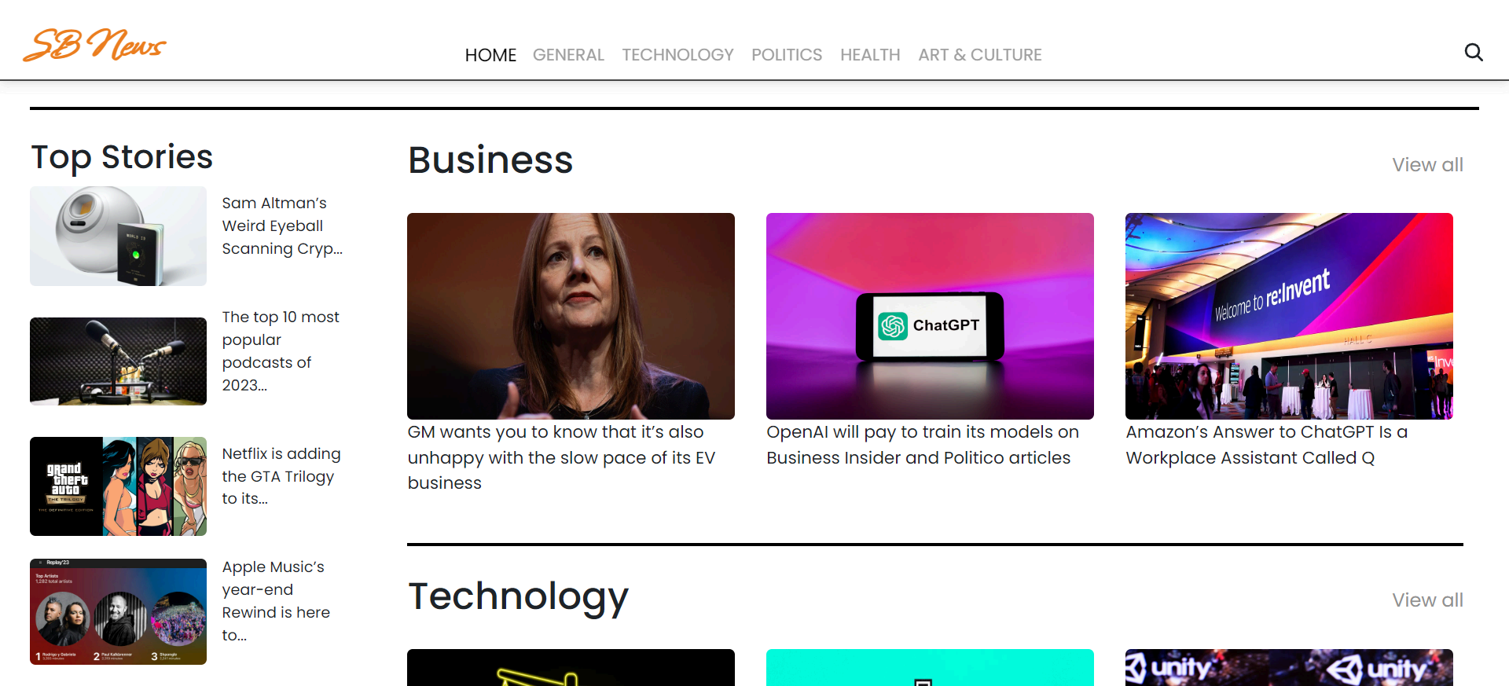

* **Newsletter**

Staying informed is key! This section would act as a magnet for users who want to stay up-to-date on the latest news. A brief signup form with an email field would be presented, along with a clear call to action button like "Subscribe Now" or "Get Daily News Updates." With a simple click, users can join the InsightStream community and receive curated news delivered straight to their inbox.

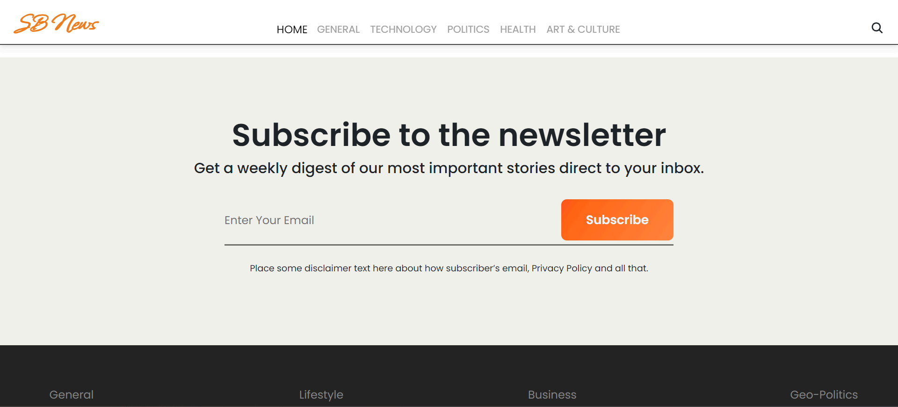

* **Category/Search result page**

Finding the news you crave is effortless with InsightStream. This page displays a neatly organized list of articles matching your chosen category or specific search query. Each entry would provide a clear headline, a concise summary, and if available, an image to give you a quick glimpse into the story. To further refine your exploration, filters or sorting options might be available. Imagine narrowing down results by date, source, keyword, or other relevant criteria to pinpoint exactly what you're looking for.

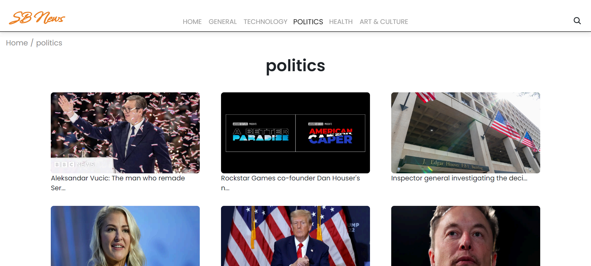

* **Redirected Article page**

This is where you dive deep! The article page proudly displays the complete news story, retrieved directly from the source. To keep you engaged and exploring related topics, the page might also suggest additional articles based on the current story. These suggestions can open doors to a world of interconnected information, allowing you to become a well-rounded news connoisseur.



**8. Testing**

Testing is conducted using:

• Manual Testing: Testing all features to ensure they work as expected.

• Functional Testing: Ensuring the functionality of each feature, including fetching and displaying data, chart rendering, and filtering.

**9. Conclusion**

In conclusion, this news platform aims to provide a clean, personalized, and reliable news experience. By addressing common issues like cluttered interfaces, slow load times, and misinformation, the platform ensures users stay informed efficiently. Built with React, it offers a fast, mobile-friendly design with real-time updates and trusted content. This project enhances user experience by delivering relevant news while promoting credibility, making it a valuable tool for users seeking timely and accurate information.