**NOISE POLLUTION MONITORING**

**Name:** K R Kokil

**Definition:**

Noise pollution is a growing problem in many urban areas, with negative impacts on human health, well-being, and quality of life. Real-time noise pollution monitoring and data sharing can help to raise awareness about the problem, enable informed decision-making, and support noise reduction efforts.

**Design Thinking:**

**Project Objectives**

* **Real-time noise pollution monitoring:**The IoT sensor system will continuously measure noise levels in public areas and transmit the data to the noise pollution information platform in real time.
* **Public awareness:** The noise pollution information platform will make real-time noise level data accessible to the public through a web-based platform and mobile app. This will help to raise awareness about noise pollution and its impacts on people's health and well-being.
* **Noise regulation compliance:** Local governments can use the real-time noise level data to monitor compliance with noise regulations.
* **Improved quality of life:** By making real-time noise level data accessible to the public, people can make informed decisions about where to live, work, and spend time. This can help to improve the overall quality of life in the community.

**IoT Sensor Design:**

The IoT sensor system will consist of a network of noise sensors deployed in various public areas. Each sensor will be equipped with a sound level meter and a wireless communication module. The sensors will be programmed to collect noise level data at regular intervals and transmit it to the noise pollution information platform.

The noise sensors can be deployed in a variety of ways, such as on lampposts, street signs, and building facades. The sensors should be placed in locations where they can provide representative measurements of noise levels in the surrounding area.

**Noise Pollution Information Platform**:

The noise pollution information platform will be a web-based platform and mobile app that displays real-time noise level data from the IoT sensor network. The platform will also provide information about noise pollution, its impacts on human health, and noise reduction strategies.

The noise pollution information platform should be designed to be user-friendly and accessible to the public. The platform should provide clear and concise information about noise levels in different areas of the community. The platform should also allow users to track noise levels over time and compare noise levels across different areas.

**Integration Approach:**

The IoT sensors will send data to the noise pollution information platform using a wireless communication protocol such as LoRaWAN or Sigfox. The sensors will be programmed to transmit data at regular intervals, such as every 15 minutes or every hour.

The noise pollution information platform will be hosted on a cloud server. The server will receive data from the IoT sensors and store it in a database. The server will then process the data and generate real-time noise level maps and reports.

**Implementation Plan:**

The following steps can be used to implement the IoT-based noise pollution monitoring system.

1. **Define the project scope and objectives:** This includes identifying the target areas for monitoring, the desired frequency of data collection, and the desired features of the noise pollution information platform.
2. **Design the IoT sensor network:** This includes selecting the appropriate sensor hardware, developing a sensor deployment plan, and programming the sensors to collect and transmit data.
3. **Develop the noise pollution information platform:** This includes designing the web-based platform and mobile app, developing data processing algorithms, and generating real-time noise level maps and reports.
4. **Deploy the IoT sensor network and noise pollution information platform:** This includes installing the sensors in the target areas and configuring the noise pollution information platform.
5. **Test and evaluate the system:** This includes collecting data from the sensors, generating noise level maps and reports, and assessing the accuracy and reliability of the system.

**Block Diagram:**

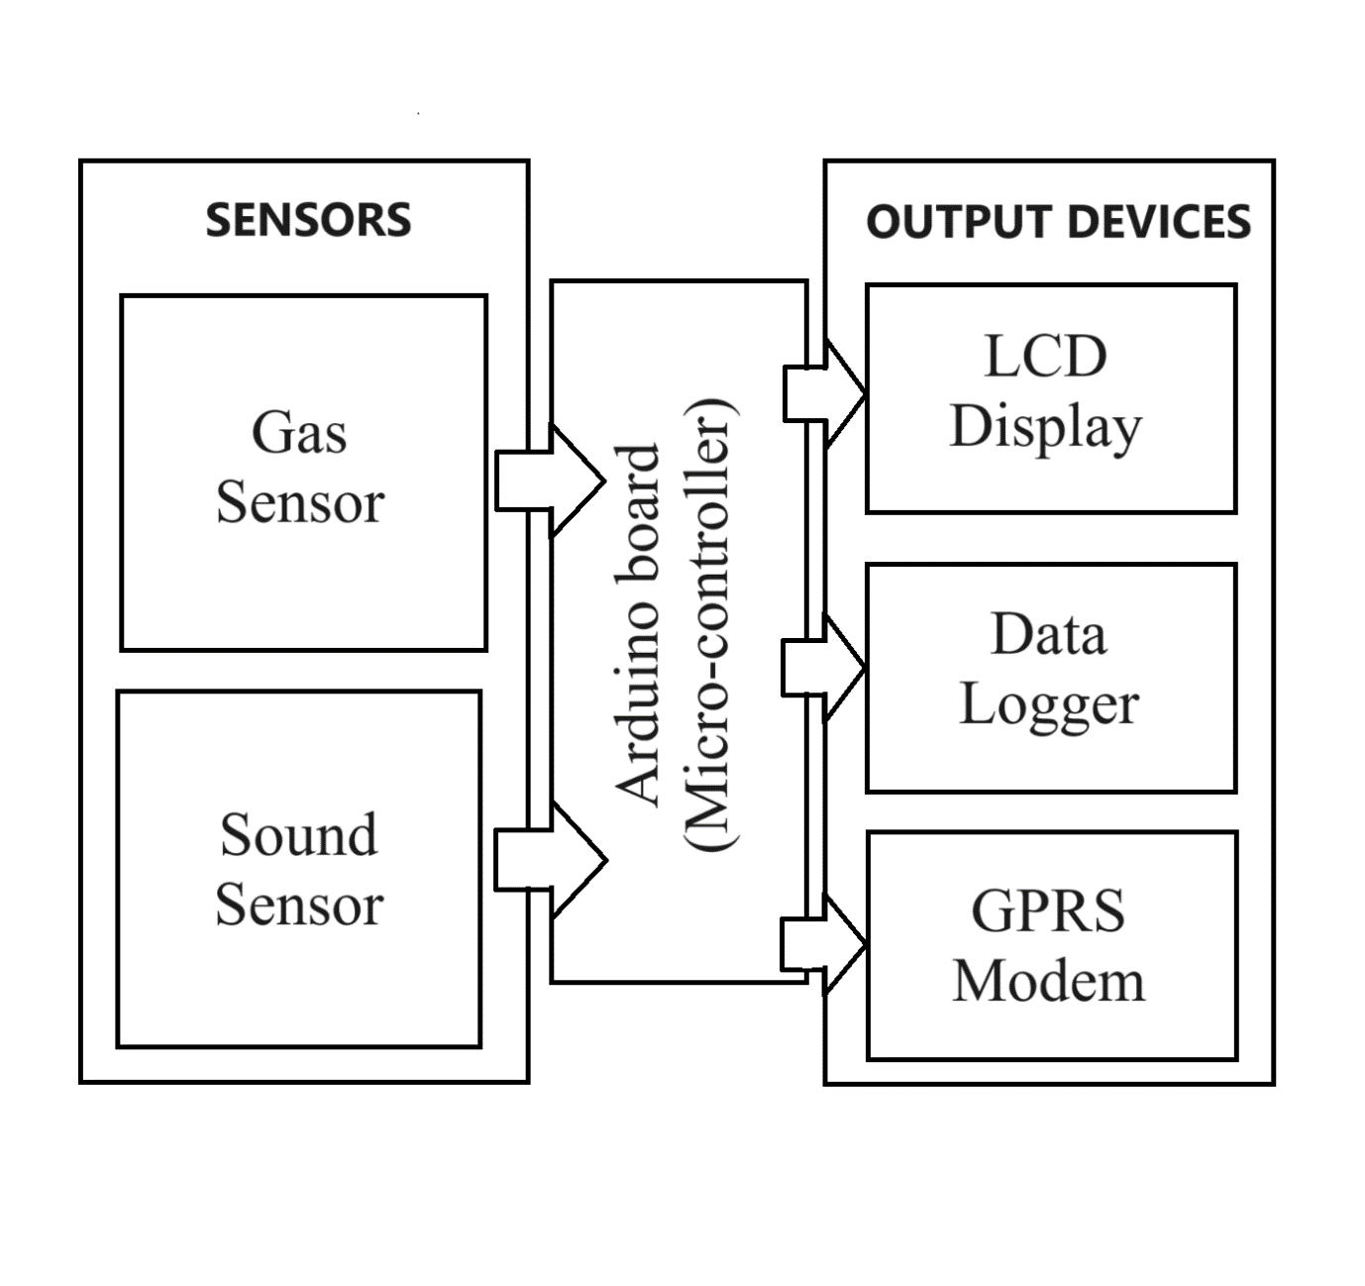

**Components:**

**Display:**

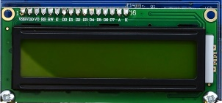

Liquid Crystal Display (LCD) and the Internet of Things (IoT) are related in that LCDs are often used as display devices for IoT devices and systems. For example, LCD screens can be used to display real-time data from IoT sensors or to provide a user interface for controlling IoT devices.

**Sound sensor:**

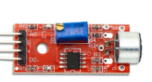

A sound sensor is an electronic device that detects sound waves, converting them into electrical signals, often used for applications like voice recognition, security systems, and noise monitoring.

**ESP32:**

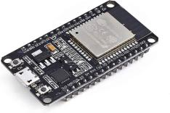

ESP32 is a series of low-cost, low-power system on a chip microcontroller with integrated Wi-Fi and dual-mode Bluetooth.

**Working:**

1. Noise sensors are deployed at strategic locations in the area to be monitored. These sensors can be either standalone devices or integrated into IoT networks.
2. The sensors use microphones to detect sound waves and convert them into electrical signals.
3. The electrical signals are then processed by the sensors to determine the sound pressure level (SPL) in decibels (dB).
4. The SPL data is transmitted to a central data collection server via wired or wireless communication.
5. The data collection server stores and analyses the SPL data to identify trends and patterns.
6. The data collection server can also generate reports and alerts for stakeholders, such as government agencies, environmental groups, and businesses.

Some noise pollution monitoring systems also use sound dosimeters to measure the amount of noise exposure that people receive. Sound dosimeters are typically worn by individuals to track their noise exposure over time.

Here is a more detailed explanation of each step in the noise pollution monitoring process:

**Noise sensors**

Noise sensors can be either analog or digital. Analog sensors output a continuous electrical signal that is proportional to the SPL. Digital sensors output a series of discrete values that represent the SPL.

Noise sensors can be classified by their frequency response. Some sensors are designed to measure a wide range of frequencies, while others are designed to measure specific frequencies. For example, some sensors are designed to measure low-frequency noise, such as traffic noise, while others are designed to measure high-frequency noise, such as aircraft noise.

**Noise sensor data processing**

Once the noise sensor has converted the sound waves into an electrical signal, the signal must be processed to determine the SPL. This processing typically involves filtering out noise from the signal and then measuring the peak amplitude of the signal.

The peak amplitude of the signal is converted to an SPL value using a logarithmic scale. This logarithmic scale is used because the human ear perceives loudness logarithmically.

**SPL data transmission**

The SPL data from the noise sensors can be transmitted to the central data collection server via wired or wireless communication. Wired communication is typically used for fixed installations, while wireless communication is used for mobile installations.

**SPL data collection and analysis**

The central data collection server stores the SPL data from the noise sensors and analyses it to identify trends and patterns. This analysis can be used to identify areas where noise pollution is a problem and to track the effectiveness of noise mitigation measures.

**SPL data reporting and alerts**

The central data collection server can generate reports and alerts for stakeholders, such as government agencies, environmental groups, and businesses. These reports and alerts can be used to inform decision-makers about noise pollution levels and to take action to reduce noise pollution.

**Noise pollution monitoring systems can be used to:**

* Identify areas where noise pollution is a problem
* Track the effectiveness of noise mitigation measures
* Develop noise pollution policies and regulations
* Educate the public about noise pollution and its effects

Noise pollution monitoring systems are an important tool for reducing noise pollution and protecting public health.

**Conclusion:**

By implementing an IoT-based noise pollution monitoring system, communities can gain real-time insights into noise levels and their impacts on people's health and well-being. This information can be used to raise awareness about noise pollution, enable informed decision-making, and support noise reduction efforts.