DATA MINING

Χαροκόπειο Πανεπιστήμιο Αθηνών
Κόκκαλης Κωνσταντίνος – it22047
Καθηγητής: Βαρλάμης Ηρακλής

Contents
DATA PRE-PROCCESSING 3
STEPS 3
Data frame Initialization 4
Remove redundant columns 5
Missing values 7
Data formatting 11
One-Hot encoding 12
Extra functions 16
Result 16
HOW TO RUN THE CODE 17

DATA PRE-PROCCESSING

STEPS
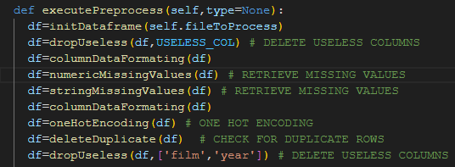
- Data frame Initialization.
- Remove redundant columns.
- Handle missing values.
- Data formatting.
- One Hot Encoding.
- Delete duplicates.

Note:
At the beginning we save in some arrays the numeric columns, the redundant columns, the target strings, the no target strings as long as the script types. The reason we do that is to handle easier decision changes in the future, such as which columns we are not going to use in our training model.
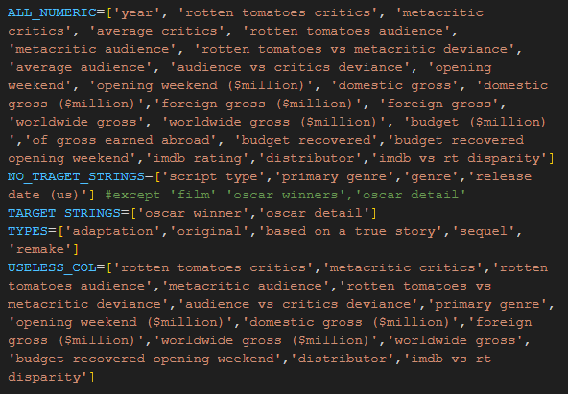
ALL_NUMERICS = all the columns that they contain numeric values.
TARGET_STRINGS=all the string columns that have Oscar details.
NO_TARGET_STRINGS=all the string columns that they are not target.
USELESS_COLUMNS=all the columns that we do not need for the training model.

Data frame Initialization
- We say the to the data frame to replace ‘-’ and ‘0’ with Not a Number values so we can handle them later.
- We remove redundant spaces from column names and we transform them to lower case so we can handle them easier. We also do the same for the whole dataset.
- We update the dataset.
- We update the ALL_NUMERIC and the NO_TRAGET_STRINGS table according to the USELESS COLUMNS
- Return the updated dataset
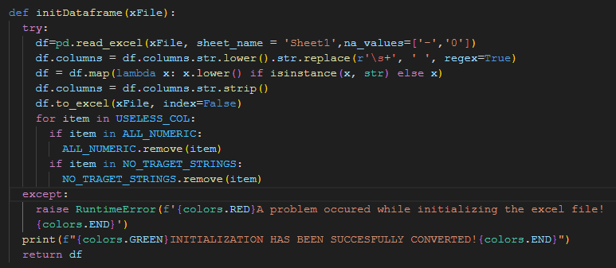

Remove redundant columns
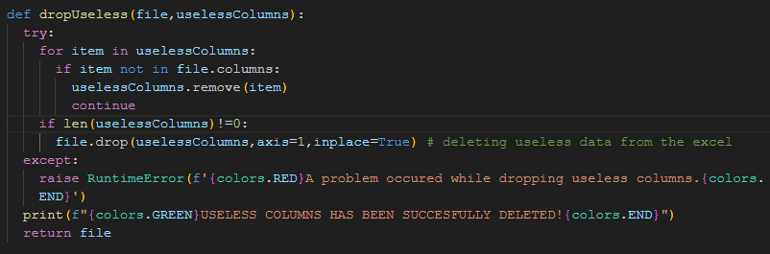
USELESS_COL=['rotten tomatoes critics','metacritic critics','rotten tomatoes audience','metacritic audience','rotten tomatoes vs metacritic deviance','audience vs critics deviance','primary genre','opening weekend ($million)','domestic gross ($million)','foreign gross ($million)','worldwide gross ($million)','worldwide gross','budget recovered opening weekend','distributor','imdb vs rt disparity']

Why each of them has been deleted?
distributor, imdb vs rt disparity, primary genre: We dropped these columns because we had no, or a few data comparing to the size of the tuples, which means they would not give any information and they would not help the training model.
opening weekend ($million), domestic gross ($million), foreign gross ($million), worldwide gross ($million): We dropped these columns because we have already the information of each on other columns with a bigger precision.
rotten tomatoes vs metacritic deviance, audience vs critics deviance: We dropped these columns because they do not provide any useful information.
worldwide gross: We dropped this column because worldwide gross is a result of domestic and foreign gross columns that we already kept, so there is no point to keep those two features and also the sum of those two features.
rotten tomatoes critics, metacrtic critics, rotten tomatoes audience, metacritic audience: Here we checked the corelation of these attributes and the averages columns to decide if we are going to keep the averages or each one individually. The result was to keep the averages and drop the individuals. The decision was made according to these results:
We can notice here that all the corelations are very close to 1 and they also very similar between them. That means that we can keep only one of them. In that case we will keep average critics because its’ corelations are closer to one and we will drop the rest.
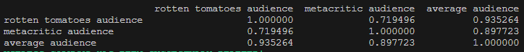
We can notice here that all the corelations are very close to 1 and they also very similar between them. That means that we can keep only one of them. In that case we will keep average audience because its’ corelations are closer to one and we will drop the rest.
budget recovered opening weekend: Here we checked again the corelation of this attribute, budget recovered and budget ($million). The decision was made according to these results:
We can notice here that all the corelations are very close to 0 (so there is no corelation) and they also very similar between them. We can only notice that budget recovered and budget recovered opening weekend they have corelation close to 1 so one of them could be deleted. I chose to keep budget recovered.
Code for getting corelation:
subset = df[['budget ($million)', 'budget recovered', 'budget recovered opening weekend']]
# subset = df[['rotten tomatoes critics', 'metacritic critics','average critics']]
# subset = df[['rotten tomatoes audience','metacritic audience','average audience']]
getCorrelation(subset)
def getCorrelation(items):
correlation_matrix = items.corr()
print(correlation_matrix)

Note:
film, year, script type, genre, Oscar detail: that is because some of them we will one-hot encode them and some of them we have to use them for completing missing values, so all of those features will get dropped later.

Missing values
df=numericMissingValues(df) # RETRIEVE MISSING VALUES
df=stringMissingValues(df) # RETRIEVE MISSING VALUES

def numericMissingValues(file): # replacing ',' and missing values with the mean of the year it belongs to
try:
for item in ALL_NUMERIC:
if item not in file.columns:
ALL_NUMERIC.remove(item)
continue
if len(ALL_NUMERIC)==0:
print(f'{colors.GREEN}NO NUMERIC COLUMNS TO BE PROCESSED.SUCCESFULLY COMPLETED{colors.END}')
return file
# file=externalIMDb(file) # IMDb
for element in ALL_NUMERIC:
for index, row in file.iterrows():
year = row['year']
mean = file[file['year'] == year][element].mean()
file[element] = pd.to_numeric(file[element], errors='coerce')
if pd.isna(row[element]):
if pd.isna(mean):
file[element]=file[element].ffill()
continue
file.loc[index, element] = mean
file[element].bfill(inplace=True)
except:
print(element,index,row,mean)
raise ValueError(f'{colors.RED}A problem occured while processing numeric missing values{colors.END}')
print(f"{colors.GREEN}NUMERIC MISSING VALUES HAS BEEN SUCCESFULLY RESTORED!{colors.END}")
return file

For numeric missing values we get external knowledge only for imdb rating feature. For all the others we take the mean value of each numeric feature according to year the film released.
(e.g Missing value at foreign gross. Year=2007, we complete the missing value with the foreign gross mean of the films released in 2007).
In case we cannot take the mean for a missing value we are doing a ffil() and if this is also not possible we do bfill().
def stringMissingValues(file):
try:
for item in NO_TRAGET_STRINGS:
if item not in file.columns:
NO_TRAGET_STRINGS.remove(item)
print(f"{item} column removed from the array because it doesn't exist in the dataset")
continue
if len(ALL_NUMERIC)==0:
print(f'{colors.GREEN}NO STRING COLUMNS TO BE PROCESSED.SUCCESFULLY COMPLETED{colors.END}')
return file
file=externalGenre(file)
for index, row in file.iterrows():
if 'oscar winners' in file.columns:
if (pd.isna(row['oscar winners'])):
file.loc[index, 'oscar winners'] = 0
else:
file.loc[index, 'oscar winners'] = 1
for j in NO_TRAGET_STRINGS:
if file[j].isnull().any():
file[j]=file[j].ffill()
else:
file[j]=file[j].bfill()
except:
raise RuntimeError(f'{colors.RED}A problem occured while processing string missing values{colors.END}')
print(f"{colors.GREEN}OTHER MISSING VALUES HAS BEEN SUCCESFULLY RESTORED!{colors.END}")
return file

In string missing values we get external knowledge only for genre.
If any other value is missing we are doing a ffill() and if this is also not possible we do bfill().

External knowledge
For the external knowledge we just use a python library of IMDb and we get the genre.If we cannot get the genre then we complete the value as NaN
def externalGenre(file):
ia=IMDb()
try:
for index,row in file.iterrows():
if pd.isna(row['genre']):
movies = ia.search_movie(row['film'])
if movies:
movie = ia.get_movie(movies[0].movieID)
genre=",".join(movie['genres']).lower()
else:
print("Movie not found.")
genre=np.nan
file.at[index, 'genre'] = genre
except:
raise RuntimeError(f'{colors.RED}A problem occured while receiving external knowledge in string missing values{colors.END}')
return file

For the external knowledge we just use a python library of IMDb and we get the imdb rating.If we cannot get the rating then we complete the value as NaN
def externalIMDb(file):
ia = IMDb()
i=2
for movieTitle in file['film']:
movies = ia.search_movie(f"{movieTitle}")
try:
if movies:
movie = ia.get_movie(movies[0].movieID)
print(f"Title: {movie['title']}")
year=movie['year']
rating=movie['rating']
else:
print("Movie not found.")
continue
print(i," ",rating)
if not rating:
file.at[i-2, 'imdb rating'] = np.nan
continue
else:
file.at[i-2, 'imdb rating'] = rating
file.at[i-2,'year']=year
except:
file.at[i-2, 'imdb rating'] = np.nan
continue
i=i+1
print(f'{colors.GREEN}EXTERNAL KNOWLEDGE \'IMDb\' HAS BEEN SUCCESFULLY ADDED{colors.END}')
# file.to_excel("clone.xlsx")
return file

this process has already been executed and we copied the data to another file, because the process to fetch data for almost 1400 rows needs a lot of time.

Data formatting
df=columnDataFormating(df)

After receiving all the new values and we have already dropped the most of the columns we do not need we have to format all the data to be the same so the model can work correctly.
def columnDataFormating(file):
try:
# Convert each value of the df that is ending with the '%' to decimal (divide by 100)
file = file.map(lambda val: float(val.rstrip('%')) / 100 if isinstance(val, str) and val.endswith('%') else val)
except:
raise RuntimeError(f'{colors.RED}A problem occured while converting precentages to decimal.{colors.END}')
try:
file[ALL_NUMERIC] = file[ALL_NUMERIC].replace(',', '', regex=True).apply(pd.to_numeric, errors='coerce')
file['budget ($million)'] = file['budget ($million)'] * 1000000
# file[NO_TRAGET_STRINGS] = file[NO_TRAGET_STRINGS].replace(',', '', regex=True)
file['genre'] = file['genre'].str.replace(',', ' ').str.replace('.', ' ').str.replace('\s+', ' ', regex=True).str.strip()
# file['oscar detail'] = file['oscar detail'].str.extract(r'([^\(]+)')
file['oscar detail'] = file['oscar detail'].str.split('(', n=1).str[0].str.strip()
except:
raise RuntimeError(f'{colors.RED}A problem occured while replacing charachters.{colors.END}')
print(f"{colors.GREEN}ALL COLUMNS HAS BEEN SUCCESFULLY FORMATED!{colors.END}")
return file

One-Hot encoding
df=oneHotEncoding(df) # ONE HOT ENCODING
We do have nominal features that we need to represent them with a way to help the model to work better. Those are script type, oscar detail, release date (us), genre
# SCRIPT TYPE
if 'script type' in file.columns:
try:
one_hot_encoded = pd.get_dummies(file['script type'].apply(lambda x: next((t for t in TYPES if str(x).startswith(t)), None))).astype(int)
file = pd.concat([file, one_hot_encoded], axis=1)
file=dropUseless(file,['script type'])
except:
raise RuntimeError(f'{colors.RED}A problem occured while one-hot encoding script-type{colors.END}')

# OSCAR DETAILS
if 'oscar detail' in file.columns:
try:
one_hot_encoded = file['oscar detail'].str.get_dummies(', ').astype(int)
file = pd.concat([file, one_hot_encoded], axis=1)
file=dropUseless(file,['oscar detail'])
except:
raise RuntimeError(f'{colors.RED}A problem occured while one-hot encoding oscar details{colors.END}')

In the previous ones we did directly normal one-hot encoding but genre and release date (us) needed a special treatment.
As far as the genre is concerned there were a lot genres with wrong spelling or the same genre with another word , for example ‘thriller’ and ‘thrill’. All of those had to be handled before one-hot encoding.
# GENRE
if 'genre' in file.columns:
try:
file['genre']=file['genre'].str.lower()
genres=set()
correctGenre=[]
for item in file['genre']:
for word in item.split():
# correctedWords=[]
correctedWord=str(Word(word).correct().lower())
# print(correctedWord)
correctGenre.append(correctedWord)
genres.update(correctGenre)
# print("c:",genres)
words_to_remove = set()
for word1 in genres:
for word2 in genres:
if word1 != word2 and len(word1) >3 and len(word2) > 3:
common_substrings = set([word1[i:i+5] for i in range(len(word1)-4) if word1[i:i+5] in word2])
if common_substrings:
shorter_word = word1 if len(word1) < len(word2) else word2
words_to_remove.add(shorter_word)
genres.difference_update(words_to_remove)
# print(genres)
file['genre'] = file['genre'].apply(lambda cell: ' '.join(
[next((word_set_word for word_set_word in genres if word_set_word[:3] == word[:3]), word) for word in cell.split()]
))
print('Set:::',genres)
for genre in genres:
file[genre] = file['genre'].apply(lambda x: 1 if genre in x.split() else 0)
file=dropUseless(file,['genre'])
except:
raise RuntimeError(f'{colors.RED}A problem occured while one-hot encoding genres{colors.END}')
As far as the date is concerned before one hot encoding we played with the format and we kept only the released month instead of the whole day , month and year , because we believed all of thise information will not give us any advantage.
# DATE
if 'release date (us)' in file.columns:
try:
file['release date (us)'] = pd.to_datetime(file['release date (us)'],format='mixed')
# Extract month and day
file['release date (us)'] = file['release date (us)'].dt.strftime('%m').astype(int)
monthMapping = {
1: 'january',
2: 'february',
3: 'march',
4: 'april',
5: 'may',
6: 'june',
7: 'july',
8: 'august',
9: 'september',
10: 'october',
11: 'november',
12: 'december'
}

# Nominalize the 'release date (us)' column
file['release date (us)'] = file['release date (us)'].map(monthMapping)
one_hot_encoded = pd.get_dummies(file['release date (us)'], prefix='').astype(int)
file = pd.concat([file, one_hot_encoded], axis=1)
file=dropUseless(file,['release date (us)'])
except:
raise RuntimeError(f'{colors.RED}A problem occured while one-hot encoding dates{colors.END}')

Note:
Of course after one-hot encoding we drop each feature that got one-hot encoded.

Delete duplicates
df=deleteDuplicate(df) # CHECK FOR DUPLICATE ROWS

after all the process we have to check if we have duplicate data.
def deleteDuplicate(file):
try:
if (file.duplicated().sum() != 0) or (not file[file.duplicated(subset=['film'])].empty):
print(f'The dataset contains {(file.duplicated(subset=["film"])).sum()} duplicate films that need to be removed.')
print(f'The dataset contains {file.duplicated().sum()} duplicate rows that need to be removed.')
file.drop_duplicates(inplace=True)
file = file.drop_duplicates(subset=['film'],keep='first')
except:
raise RuntimeError(f'{colors.RED}A problem occured while deleting duplicates{colors.END}')
print(f"{colors.GREEN}DUPLICATE ROWS HAVE BEEN SUCCESFULLY DELETED!{colors.END}")
return file

we check the whole subset for duplicates , but also we check the subset film for duplicate film names. If a flm has a duplicate name then we keep the data of the film we first found in our dataset.

Extra functions
We also created some functions for the preprocessing such as scaling and normalization because we do not know yet what classification model we are going to use and what are its prerequires for it to work.

Result
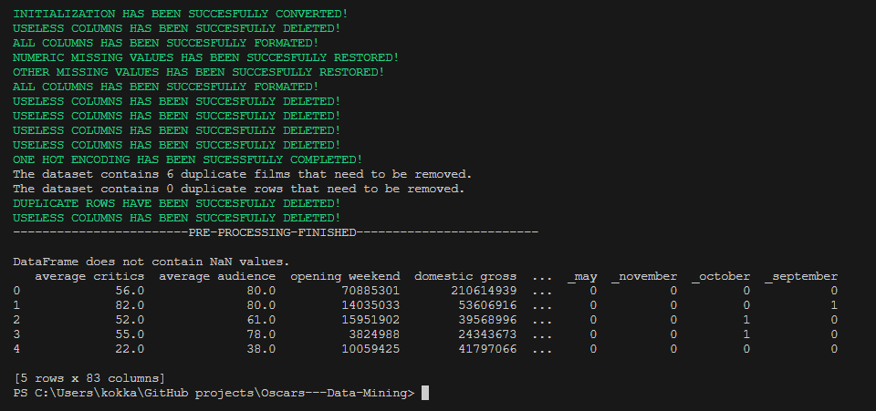

Important Note:
The features that have been selected to be used they are not the final as long as the classification model might not give us the best results. So modifications to USELESS_COL might happen.

HOW TO RUN THE CODE

