AEROCHART INSPECTOR
Aeronautical Chart Quality-Control & Comparison System
User Manual & Operational Guide

Application is Designed and Developed by: Sergo Kokolia
Contents
Chapter 1 System Overview 3
Chapter 2 Interface Reference & Button Guide 4
2.1 Import Tab (Batch Import & Chart Mapping) 4
2.2 Chart Comparison Tab 5
2.3 Errors Tab (Discrepancy Logging) 6
2.4 Report Tab (Summary & PDF Generation) 7
Chapter 3 End-to-End Quality Control Process (Step-by-Step Guide) 9
Chapter 4 Control and functions 11

Chapter 1 System Overview
This document establishes the operational framework for AeroChart Inspector, serving as the definitive technical reference for aeronautical cartographers and aviation data quality controllers. In the high-consequence domain of aeronautical chart production, maintaining absolute data integrity across publication cycles is directly linked to flight safety and navigational efficiency. AeroChart Inspector provides a specialized desktop quality-control (QC) environment engineered specifically to make visual verification, spatial alignment, defect logging, and reporting seamless, rigorous, and repeatable.
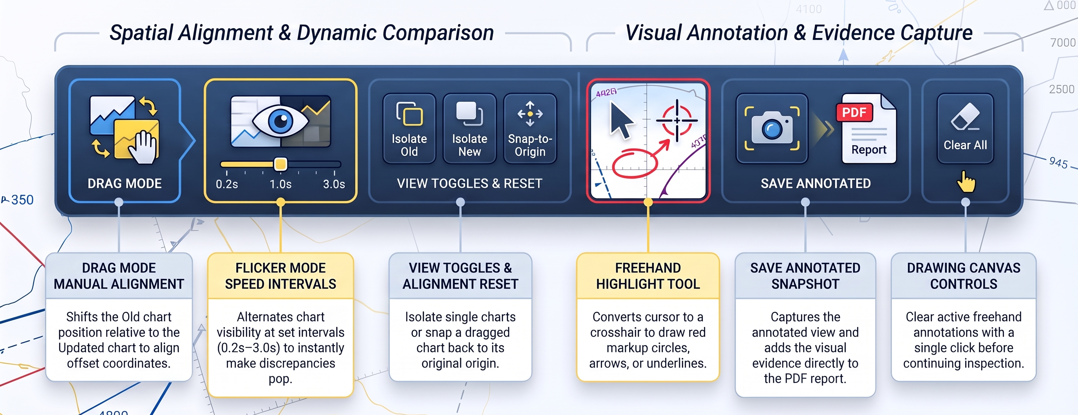
Designed and developed by Sergo Kokolia, the application's core operational mandate is to streamline the visual verification of updated aeronautical charts against legacy baseline charts. Rather than relying on manual, side-by-side paper inspections or general-purpose graphic viewers, the software enables quality controllers to overlay high-resolution digital chart revisions, perform precision spatial registration, highlight visual discrepancies, log categorized safety errors, and generate standardized PDF validation reports.
The baseline comparison methodology rests on evaluating a newly revised chart (the Updated chart) against its preceding published revision (the Old baseline chart). By directly superimposing and comparing these two versions, the application mitigates the risks associated with unverified cartographic updates—such as unnoticed obstacle shifts, omitted airspace boundaries, misprinted frequencies, or altered procedure altitudes—before new charts are released into operational aviation channels.
To execute this quality assurance workflow efficiently, the application implements a modular, four-stage workspace architecture structured around dedicated operational tabs.

Chapter 2 Interface Reference & Button Guide

2.1 Import Tab (Batch Import & Chart Mapping)
The Import tab manages bulk uploading of PDF charts and pairs each Updated chart with its corresponding Old baseline chart.
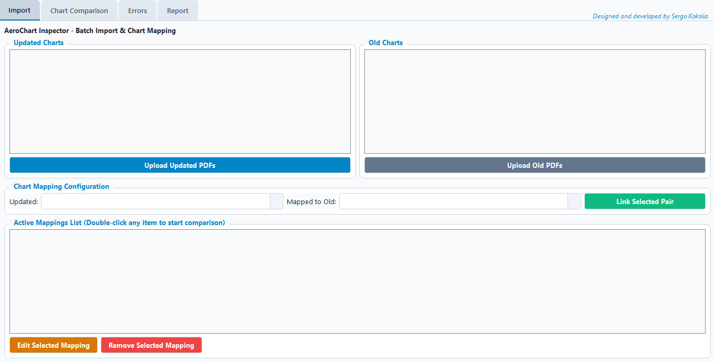
Button & Control Functions:
- Upload Updated PDFs: Opens a file browser to select one or more revised PDF charts. Each file is validated and added to the Updated Charts list.
- Upload Old PDFs: Opens a file browser to select one or more baseline/legacy PDF charts and adds them to the Old Charts list.
- Updated / Old Dropdown Menus: Allow manual selection of a specific updated chart and its corresponding old chart for pairing.
- Link Selected Pair: Pairs the currently selected Updated and Old charts from the dropdown menus and adds the connection to the Active Mappings List.
- Active Mappings List (Interactive Box): Displays all linked chart pairs. Double-clicking any row automatically loads both charts into the Chart Comparison tab.
- Remove Selected Mapping: Deletes the highlighted chart pair from the Active Mappings List without deleting the uploaded files.

2.2 Chart Comparison Tab
The Chart Comparison tab is the primary visual inspection workspace for overlaying, aligning, flickering, zooming, and annotating charts.
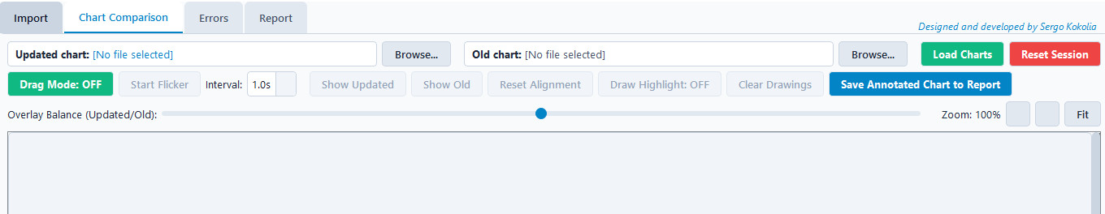
File & Session Bar Buttons:
- Browse... (Updated chart): Selects a single Updated PDF chart directly from disk. If the selected file was already paired in the Import tab, the corresponding Old chart is automatically mapped and loaded.
- Browse... (Old chart): Selects a single Old PDF chart from disk.
- Load Charts: Activates once both an Updated and Old chart are selected. Renders high-resolution views of both charts onto the canvas and unlocks the comparison toolbar.
- Reset Session: Clears the currently loaded charts, drawings, and saved annotations from the comparison view while keeping previously logged entries in the Errors tab intact.

Interactive Inspection Toolbar Buttons:
- Drag Mode: OFF / ON: Toggles manual chart alignment mode.
  - When ON (red button), clicking and dragging on the canvas shifts the position of the Old chart relative to the Updated chart so you can align shifted borders or projection references.
  - Relative alignment stays locked even when zooming in or out or running flicker mode.
- Start Flicker / Pause Flicker: Starts an automated timer that alternates visibility between the Updated chart and the Old chart. Any changes (moved obstacles, revised altitudes, text shifts, or missing symbols) immediately "pop" visually. Starting flicker automatically turns off Drag Mode.
- Interval Dropdown (0.2s, 0.5s, 1.0s, 2.0s, 3.0s): Controls how fast the view switches between the Updated and Old charts during Flicker mode.
- Show Updated: Pauses flicker and displays 100% of the Updated chart only.
- Show Old: Pauses flicker and displays 100% of the Old chart only.
- Reset Alignment: Snaps a manually dragged Old chart back to its original centered origin (0, 0).
- Draw Highlight: OFF / ON: Toggles freehand annotation mode. When ON, the cursor changes to a crosshair, allowing you to draw red highlight circles, arrows, or underlines directly over chart discrepancies.
- Clear Drawings: Removes all red freehand annotations currently drawn on the canvas.
- Save Annotated Chart to Report: Remains disabled until at least one drawing stroke is added to the chart. Clicking it captures a snapshot of the current chart view (with your red annotations) and appends it to the visual evidence queue for the PDF report. Multiple snapshots can be saved per session.

Sub-Toolbar & Navigation Controls:
- Overlay Balance (Updated/Old) Slider: Adjusts the transparency (alpha opacity) of the Old chart from 0% to 100% when viewing both charts simultaneously.
- - (Zoom Out) & + (Zoom In) Buttons: Decreases or increases the chart magnification by 20% per click (25% to 500% range). You can also scroll the mouse wheel directly over the canvas to zoom.
- Fit Button: Resets the zoom level back to 100%.
- Vertical & Horizontal Scroll Bars: Automatically scale with the zoomed chart dimensions so you can pan to the extreme top, bottom, left, and right edges of high-zoom charts.

2.3 Errors Tab (Discrepancy Logging)
The Errors tab records and categorizes every discrepancy discovered during chart inspection.
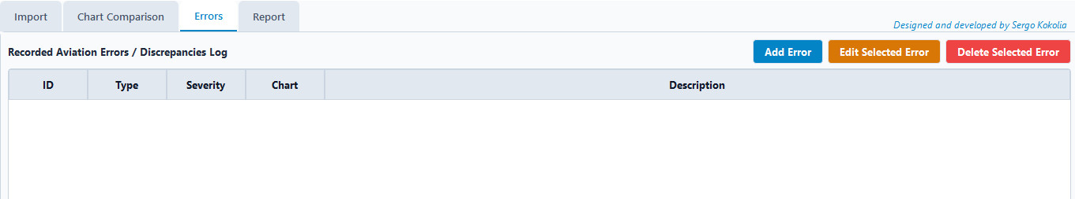
Main Tab Buttons:
- Add Error: Opens the Record New Error pop-up dialog to log a discrepancy.
- Edit Selected Error: Opens the pop-up dialog pre-filled with the highlighted row's details so you can update its severity, description, or comments.
- Delete Selected Error: Permanently deletes the highlighted error row from the log after confirmation.
Error Pop-Up Dialog Controls:
- Error ID: Auto-generated sequential identifier (e.g., ERR-001, ERR-002).
- Error Type Dropdown: Categorizes the finding (Typographical, Symbolization, Obstacle, Airspace / Boundary, Procedure / Altitude, Coordinate / Grid, Omission, Other).
- Severity Dropdown: Assigns safety impact (Critical, Major, Minor, Observation).
- Affected Chart Field: Pre-populated with the currently loaded Updated chart name, or editable to specify any chart name.
- Description Box: Required field describing the exact nature of the cartographic error.
- Comments Box: Optional field for corrective instructions, source document references (e.g., AIP Amendment number), or reviewer notes. Appears directly underneath the error description in the final PDF report.

2.4 Report Tab (Summary & PDF Generation)
The Report tab compiles metadata, checked chart lists, error statistics, and visual evidence into an official QC document.
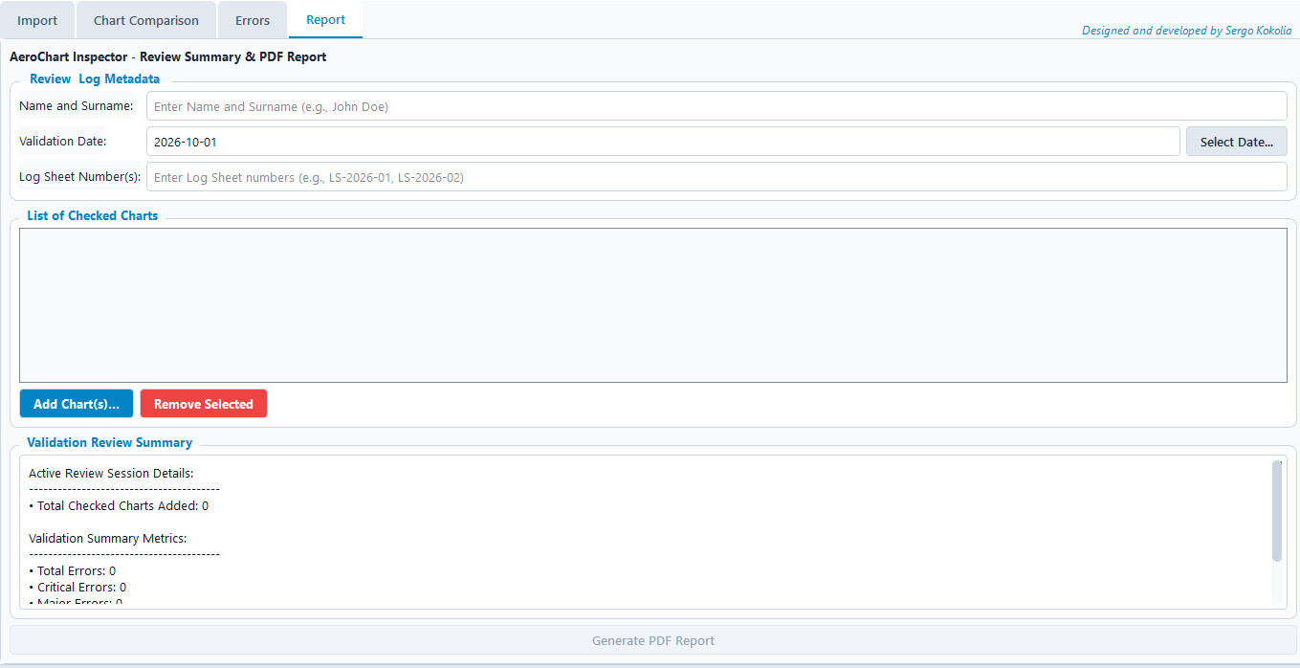Controls & Buttons:
- Name and Surname Field: Mandatory text input for the Quality Controller's full name.
- Validation Date Field & Select Date... Button: Displays the validation date. Clicking Select Date... opens an interactive pop-up calendar.
- Log Sheet Number(s) Field: Text input for recording internal QC tracking or log sheet numbers.
- Add Chart(s)... Button (List of Checked Charts): Opens a multi-file browser allowing you to select all PDF charts verified during the session. All charts in this list are printed in a dedicated box in the generated PDF report.
- Remove Selected Button: Removes the highlighted chart(s) from the List of Checked Charts.
- Validation Review Summary Box: Automatically updates whenever you open the Report tab or modify checked charts, displaying total checked charts, error counts broken down by severity (Critical, Major, Minor, Observations), and the count of saved annotated chart snapshots.
- Generate PDF Report Button: Compiles all session data and prompts you to save the formatted PDF report. The generated PDF is structured in five sequential sections:
  - Main Metadata Box: Quality Controller, Review Date, and Log Sheet Number(s).
  - Checked Charts Box: Bullet list of all charts added to the List of Checked Charts.
  - Review Summary Table: Color-coded table of Total, Critical, Major, Minor, and Observation counts.
  - Recorded Error(s) Log Table: Full discrepancy log including ID, Type, Severity, Chart, Description, and Comments.
  - Annotated Chart Visual Evidence: High-resolution snapshots of every annotated chart saved during comparison.

Chapter 3 End-to-End Quality Control Process (Step-by-Step Guide)
Follow this standard operating procedure (SOP) to perform a complete aeronautical chart validation session in AeroChart Inspector:
Step 1: Batch Ingestion & Pairing
- Launch AeroChart Inspector and start in the Import tab.
- Click Upload Updated PDFs and select all new chart editions scheduled for quality control.
- Click Upload Old PDFs and select the corresponding previous baseline editions.
- In the Chart Mapping Configuration box, select an updated chart and its matching old chart from the dropdowns, then click Link Selected Pair. Repeat for all pairs in your batch.
- Double-click the first linked pair in the Active Mappings List to load it into the Chart Comparison tab.
Step 2: Spatial Alignment & Visual Verification
- In the Chart Comparison tab, inspect the initial overlay using the Overlay Balance slider.
- If the chart nearliness or coordinate grids are slightly offset between editions, click Drag Mode: OFF (turning it ON), then click and drag on the canvas until the Old chart aligns with the Updated chart. Click the button again to lock the alignment.
- Select an interval (e.g., 0.5s or 1.0s) and click Start Flicker.
- Use the + - buttons or mouse wheel and the vertical/horizontal scroll bars to systematically scan the chart from top to bottom (Header, Plan View, Profile View, Minimums Box, and Notes).
- When a discrepancy is spotted, click Pause Flicker and use Show Updated / Show Old to verify the exact change.
Step 3: Visual Evidence Annotation
- Zoom in on the discrepancy so the surrounding context is clear.
- Click Draw Highlight: OFF (turning it ON) and draw a red highlight circle or arrow pointing to the error on the chart canvas.
- Click Save Annotated Chart to Report. A confirmation pop-up will verify that the snapshot has been added to the report's visual evidence queue.
- Click Clear Drawings and turn Draw Highlight off before continuing your scan of the rest of the chart.
Step 4: Discrepancy Logging
- Switch to the Errors tab and click Add Error.
- Select the appropriate Error Type and Severity (Critical for safety-of-flight hazards like wrong altitudes/obstacles; Major for missing operational data; Minor for cosmetic/typographical issues; Observation for non-mandatory notes).
- Enter a clear Description and add any source references or corrective instructions in the Comments box, then save.
Step 5: Report Compilation & Sign-Off
- Once all charts are inspected, open the Report tab.
- Enter your full name in Name and Surname, choose the Validation Date via Select Date..., and enter the Log Sheet Number(s).
- In the List of Checked Charts section, click Add Chart(s)... and select all PDF charts that were reviewed during the session.
- Verify the counts in the Validation Review Summary box.
- Click Generate PDF Report, choose a destination filename, and save the official PDF Quality-Control Review Report.

Chapter 4 Control and functions
Tab Name | Control / Button Name | Control Type | Primary Function | Usage Instructions
Import Tab | Upload Updated PDFs | Button | Opens a file browser to select one or more revised PDF charts. | Click to select and upload revised PDF charts to the Updated Charts list.
Import Tab | Upload Old PDFs | Button | Opens a file browser to select one or more baseline/legacy PDF charts. | Click to select and upload baseline/legacy PDF charts to the Old Charts list.
Import Tab | Updated / Old Dropdown Menus | Dropdown | Allow manual selection of a specific updated chart and its corresponding old chart for pairing. | Select an updated chart and a corresponding old chart from the respective dropdown menus.
Import Tab | Link Selected Pair | Button | Pairs the currently selected Updated and Old charts from the dropdown menus. | Click after selecting a pair from the dropdowns to add the connection to the Active Mappings List.
Import Tab | Active Mappings List | Interactive Box | Displays all linked chart pairs. | Double-clicking any row automatically loads both charts into the Chart Comparison tab.
Import Tab | Remove Selected Mapping | Button | Deletes the highlighted chart pair from the Active Mappings List. | Highlight a chart pair in the Active Mappings List and click to delete the mapping without deleting the uploaded files.
Chart Comparison Tab | Browse... (Updated chart) | Button | Selects a single Updated PDF chart directly from file. | Click to select an Updated PDF chart. If previously paired, the corresponding Old chart is automatically mapped and loaded.
Chart Comparison Tab | Browse... (Old chart) | Button | Selects a single Old PDF chart from file. | Click to select an Old PDF chart directly from disk.
Chart Comparison Tab | Load Charts | Button | Renders high-resolution views of both charts onto the canvas and unlocks the comparison toolbar. | Click after both an Updated and Old chart are selected.
Chart Comparison Tab | Reset Session | Button | Clears currently loaded charts, drawings, and saved annotations from the comparison view. | Click to clear the current comparison session while keeping previously logged entries in the Errors tab intact.
Chart Comparison Tab | Drag Mode: OFF / ON | Button | Toggles manual chart alignment mode. | When ON (red button), click and drag on the canvas to shift the Old chart relative to the Updated chart.
Chart Comparison Tab | Start Flicker / Pause Flicker | Button | Starts or pauses an automated timer that alternates visibility between the Updated chart and the Old chart. | Click to start automated flickering (automatically turns off Drag Mode); click again to pause.
Chart Comparison Tab | Interval | Dropdown | Controls how fast the view switches between the Updated and Old charts during Flicker mode. | Select a time interval (0.2s, 0.5s, 1.0s, 2.0s, or 3.0s) from the dropdown list.
Chart Comparison Tab | Show Updated | Button | Pauses flicker and displays 100% of the Updated chart only. | Click to pause flicker and view only the Updated chart.
Chart Comparison Tab | Show Old | Button | Pauses flicker and displays 100% of the Old chart only. | Click to pause flicker and view only the Old chart.
Chart Comparison Tab | Reset Alignment | Button | Snaps a manually dragged Old chart back to its original centered origin (0, 0). | Click to reset any manual positioning changes made during Drag Mode.
Chart Comparison Tab | Draw Highlight: OFF / ON | Button | Toggles freehand annotation mode. | When ON, drag the crosshair cursor to draw red highlight circles, arrows, or underlines on the canvas.
Chart Comparison Tab | Clear Drawings | Button | Removes all red freehand annotations currently drawn on the canvas. | Click to erase all current freehand annotations from the canvas.
Chart Comparison Tab | Save Annotated Chart to Report | Button | Captures a snapshot of the current chart view with red annotations and appends it to the visual evidence queue for the PDF report. | Click to save a snapshot after adding at least one drawing stroke (button remains disabled until a stroke is added).
Chart Comparison Tab | Overlay Balance (Updated/Old) | Slider | Adjusts the transparency (alpha opacity) of the Old chart from 0% to 100% when viewing both charts simultaneously. | Slide to adjust the relative opacity between the Updated and Old charts.
Chart Comparison Tab | - (Zoom Out) & + (Zoom In) | Button | Decreases or increases the chart magnification by 20% per click (25% to 500% range). | Click - to zoom out or + to zoom in, or scroll the mouse wheel directly over the canvas.
Chart Comparison Tab | Fit | Button | Resets the zoom level back to 100%. | Click to reset magnification back to 100%.
Chart Comparison Tab | Vertical & Horizontal Scroll Bars | Scroll Bar | Scales with zoomed chart dimensions to enable panning across high-zoom charts. | Drag the scroll bars to pan to the extreme top, bottom, left, or right edges of the chart.
Errors Tab | Add Error | Button | Opens the Record New Error pop-up dialog to log a discrepancy. | Click to launch the Record New Error pop-up dialog.
Errors Tab | Edit Selected Error | Button | Opens the pop-up dialog pre-filled with the highlighted row's details to update severity, description, or comments. | Highlight an error row and click to open the edit pop-up dialog.
Errors Tab | Delete Selected Error | Button | Permanently deletes the highlighted error row from the log after confirmation. | Highlight an error row and click to delete it permanently.
Errors Tab (Pop-Up Dialog) | Error ID | Text Field | Displays an auto-generated sequential identifier (e.g., ERR-001, ERR-002). | Automatically populated by the system.
Errors Tab (Pop-Up Dialog) | Error Type | Dropdown | Categorizes the finding into specific cartographic types. | Select a category from the dropdown menu (Typographical, Symbolization, Obstacle, Airspace / Boundary, Procedure / Altitude, Coordinate / Grid, Omission, or Other).
Errors Tab (Pop-Up Dialog) | Severity | Dropdown | Assigns safety impact level to the error. | Select a severity level from the dropdown menu (Critical, Major, Minor, or Observation).
Errors Tab (Pop-Up Dialog) | Affected Chart | Text Field | Specifies the chart name affected by the discrepancy. | Pre-populated with the currently loaded Updated chart name, or edit manually to specify any chart name.
Errors Tab (Pop-Up Dialog) | Description | Text Box | Required field describing the exact nature of the cartographic error. | Type the detailed error description into the text box.
Errors Tab (Pop-Up Dialog) | Comments | Text Box | Optional field for corrective instructions, source document references, or reviewer notes. | Type optional notes or references into the text box (appears under the description in the PDF report).
Report Tab | Name and Surname | Text Field | Mandatory text input for the Quality Controller's full name. | Enter the full name of the Quality Controller into the text field.
Report Tab | Validation Date Field & Select Date... | Text Field / Button | Displays the validation date and opens an interactive calendar. | Click Select Date... to open a pop-up calendar restricted between January 1, 2025 and December 31, 2035 to pick a date.
Report Tab | Log Sheet Number(s) | Text Field | Text input for recording internal QC tracking or log sheet numbers. | Enter the internal QC tracking or log sheet numbers into the text field.
Report Tab | Add Chart(s)... | Button | Opens a multi-file browser allowing selection of all PDF charts verified during the session. | Click to open a file browser and select all verified PDF charts to add them to the List of Checked Charts.
Report Tab | Remove Selected | Button | Removes the highlighted chart(s) from the List of Checked Charts. | Highlight chart(s) in the list and click to remove them.
Report Tab | Validation Review Summary | Interactive Box | Displays total checked charts, error counts broken down by severity, and count of saved annotated chart snapshots. | Automatically updates whenever you open the Report tab or modify checked charts.
Report Tab | Generate PDF Report | Button | Compiles all session data and prompts user to save the formatted PDF report. | Click to compile session data, select a destination filename, and save the generated PDF report.

