
FPT UNIVERSITY

Final Project Document
Bio Pest Control System

<Group 4>
Group Members | <Huỳnh Lê Công Biên><1>< CE180220>  <Nguyễn Minh Tâm><2>< CE181522 >  <Nguyễn Quốc Bảo><3>< CE180121>  <Thái Hoàng Gia Phú><4><CE182003>  <Lê Trần Tấn><5>< CE190370 >  <Nguyễn Thị Kim Soàn><6><CE180197>
-Cần Thơ, 22/07/2026

I. Record of Changes 3
II. Project Introduction 4
1. Overview 4
1.1 Project Information 4
1.2 Project Team 4
2. Product Background 4
3. Business Opportunity 6
4. Software Product Vision 6
5. Project Scope & Limitations 7
5.1 Major Features 7
5.2 Limitations & Exclusions 8
III. Software Requirement Specification 8
1. Mô tả hệ thống 8
2. List of functions 9
3. Context Diagram 15
Link: Context Diagram.jpg 15
4. Actor 17
5. UC Diagram 18
6. Architecture Diagram 25
7. Database Design 28
8. Backlog 46
9. User Guide 46
9.1 Introduction 46
9.2 Guest Guide 47
9.2.1 User Register 47
9.2.2 Login 48
9.2.3 Browse Products 49
9.2.4 Browse Categories 50
9.2.5 View Articles 51
9.2.6 Contact 52
9.3 Customer Guide 53
9.3.1 Profile Management 53
9.3.2 Shopping Cart 54
9.3.3 Checkout and Payment 55
9.3.4 Order Management 56
9.3.5 Feedback Management 58
9.3.6 Agricultural Support 58
9.3.7 Logout 59
9.3.8 Forgot Password 60
9.4 Staff Guide 61
9.4.1 Profile Management 61
9.4.2 Customer Management 62
9.4.3 Order Management 62
9.4.4 Warehouse Management 63
9.4.5 Feedback Management 63
9.4.6 News & Article Management 64
9.5 Administrator Guide 64
9.5.1 Staff Management 64
9.5.2 Category Management 65
9.5.3 Product Management 66
9.5.4 Discount Management 67
9.5.5 Chemical Safety Management 68
9.5.6 Warehouse Import 69
9.5.7 Revenue Dashboard 70

I. Record of Changes

Date | A* M, D | In charge | Change Description
08/01/2026 | A | Công Biên | Initial version of Project Introduction
10/01/2026 | A | Công Biên | Use case diagram, Backlog
10/01/2026 | A | Gia Phú, Trần Tấn | System feature list, System description
10/01/2026 | A | Kim Soàn, Minh Tâm | Architecture/Package Diagram
10/01/2026 | A | Minh Tâm, Gia Phú, Quốc Bảo | Context Diagram, Actor
10/01/2026 | A | Kim Soàn | Database
10/01/2026 | A | Quốc Bảo | User guide
05/02/2026 | M | Công Biên, Minh Tâm, Quốc Bảo, Gia Phú,  Trần Tấn, Kim Soàn | Modify the document template
*A - Added M - Modified D - Deleted

II. Project Introduction

1. Overview

1.1 Project Information
• Project name: Pio Pest Control System
• Project code: https://github.com/KokoroRay/PRN232_BioPestControl.git
• Group name: Group 4
• Software type: Web

1.2 Project Team

Full Name | Role | Email | Mobile
Huỳnh Lê Công Biên | Leader | BienHLCCE181207@fpt.edu.vn | 0942004995
Nguyễn Minh Tâm | Member | TamNMCE181522@fpt.edu.vn | 0933561709
Nguyễn Quốc Bảo | Member | BaoNQ180121@fpt.edu.vn | 0335773398
Thái Hoàng Gia Phú | Member | PhuTHGCE182003@fpt.edu.vn | 0962791142
Lê Trần Tấn | Member | TanLT.CE190370@gmail.com | 0845788616
Nguyễn Thị Kim Soàn | Member | SoanNTKCE180197@fpt.edu.vn | 0367538287

2. Product Background
With the rapid development of high-tech agriculture and the growing demand for sustainable farming practices, traditional methods of purchasing agricultural supplies—such as pesticides, fertilizers, and plant protection products—are gradually revealing limitations in terms of accessibility, information transparency, and technical support.
Traditional agricultural stores that primarily rely on physical locations often struggle to provide farmers with immediate access to a wide range of biological control products or detailed guidance on how to use them effectively and safely.
Today's farmers and agricultural businesses need a shopping experience that allows them to:
-View biological pest control products and organic fertilizers anytime, anywhere.
-Access detailed technical specifications, ingredients, and usage instructions for each product to ensure crop safety.
-Order and pay online conveniently through various methods (COD or Online).
-Easily track order status from processing to delivery.
-Discover modern, eco-friendly solutions to replace harmful chemical pesticides.
On the other hand, business owners and managers in the agricultural sector face challenges in:
-Effectively managing a diverse and specialized product catalog (pesticides, fertilizers, bio-agents).
-Accurately updating inventory levels and fluctuating prices of seasonal products.
-Processing and tracking complex customer orders across different regions.
-Managing customer information and purchase history to provide better agricultural consulting.
-Generating comprehensive monthly and yearly statistical reports on revenue and top-selling products.
Currently, many agricultural supply businesses still rely on fragmented systems such as manual logbooks or simple spreadsheets, which do not adequately support centralized inventory control, multi-role management (Admin, Staff), or real-time sales analysis. Furthermore, there is a lack of integrated platforms that can eventually support advanced features like AI-based crop disease identification.
BioPestControl is proposed to address these issues by providing a centralized e-commerce platform specializing in the sale of biological plant protection products. The system is built on a modern tech stack—utilizing ASP.NET Core, SQL Server, and Kafka—to ensure high performance and scalability.
The platform allows administrators and staff to efficiently manage products and orders through dedicated Blazor and Razor interfaces, while customers can explore and purchase sustainable agricultural solutions through a user-friendly MVC web interface, promoting a greener and safer future for agriculture.

3. Business Opportunity
The Vietnamese agricultural sector is undergoing a powerful digital transformation, with a strong shift towards organic and sustainable farming. However, many biological pesticide and fertilizer providers still lack a specialized, high-performance digital sales and management system to reach modern farmers.
BioPestControl creates a significant business opportunity by offering:
-A specialized e-commerce platform dedicated to biological pest control and plant protection products, filling the gap in the niche "Green Agriculture" market.
-Integrated multi-role management, allowing seamless coordination between Admins, Staff, and Customers through optimized interfaces (Blazor, Razor, and MVC).
-Advanced technical scalability by utilizing a distributed messaging system (Kafka) and containerization (Docker) to handle high traffic and large-scale data processing.
-Real-time business intelligence through comprehensive dashboards for revenue tracking, inventory monitoring, and sales analysis.
-Future AI integration potential, specifically for crop disease identification via images, which creates a unique value proposition that standard e-marketplaces cannot provide.
With the rise of high-tech farming and the increasing preference for eco-friendly agricultural inputs, building a dedicated online platform allows BioPestControl to:
-Increase market reach to farmers and agricultural enterprises across various provinces beyond physical store boundaries.
-Improve operational efficiency by automating order workflows, payment processing (COD/Online), and inventory updates.
-Build long-term brand authority as a professional and reliable source for biological agricultural solutions.
-Enhance customer loyalty through historical data tracking, feedback systems, and personalized product recommendations based on specific crop needs.

4. Software Product Vision
For agricultural supply store owners and biological pesticide providers who want a professional and centralized digital distribution system, BioPestControl is a high-performance web-based e-commerce platform that simplifies specialized product management, order processing, and large-scale business analytics.
Unlike selling through fragmented social media channels, manual record-keeping, or general-purpose marketplaces that lack technical agricultural depth, BioPestControl provides:
-Full Data Ownership & Scalability: Powered by a modern architecture (BLL/DAL) with SQL Server and MongoDB, ensuring data integrity and system stability.
-Role-Based Access Control (RBAC): Optimized workflows for four distinct roles: Admin (System Control), Staff (Operations), Customer (Shopping), and Guest (Browsing), each with dedicated interfaces (Blazor, Razor, and MVC).
-Integrated Advanced Infrastructure: Utilizing Kafka for distributed messaging and Docker/AWS for reliable deployment, ensuring the system can handle high transaction volumes during peak farming seasons.
-Specialized Business Monitoring: Real-time tracking of inventory, revenue, and top-selling bio-products to help managers make data-driven decisions.
-Future AI-Driven Support: A roadmap to include AI Crop Disease Identification, transforming a simple store into a smart agricultural consultant.
Our vision is to digitalize the biological plant protection industry in Vietnam, making eco-friendly farming solutions more accessible, professional, and technologically advanced in the modern agricultural ecosystem.

5. Project Scope & Limitations

5.1 Major Features
FE-01: User Authentication & Role-Based Access Control (RBAC): Provides a secure system for registration, login, and password recovery. Implements strict authorization for four user groups (Admin, Staff, Customer, and Guest) through specialized interfaces: Blazor for Admin, Razor Pages for Staff, and MVC for Customers.
FE-02: Advanced Product & Inventory Management: Facilitates the management of plant protection product categories (pesticides, fertilizers). Admins and Staff can perform CRUD operations, filter products by inventory levels or business status, and manage stock movements (Import/Export).
FE-03: Order & Multi-channel Payment: Customers can place orders via a shopping cart or direct purchase. The system integrates popular payment methods such as COD and Online Payment, while supporting order tracking and delivery confirmation.
FE-04: Interaction & Feedback Management: Manages two-way communication between customers and the store. Customers can leave comments and product ratings; Admins/Staff have the authority to moderate, respond to, or edit these interactions to improve service quality.
FE-05: Real-time Business Analytics & Dashboard: Provides visual statistical charts on revenue, order volume, and best-selling products. This feature enables Admins to quickly grasp the business situation to make informed decisions regarding stock replenishment or promotions.
FE-06: Distributed Messaging & Data Storage: Utilizes Kafka for distributed message processing and a hybrid storage approach combining SQL Server (relational data) and MongoDB (unstructured data) to ensure high performance and system scalability.

5.2 Limitations & Exclusions
LI-01: Native Mobile Application: The current system focuses on a Responsive Web platform. It does not yet support Native Apps for iOS or Android and does not function in Offline Mode.
LI-02: Automated AI Diagnosis: In the initial phase, AI-based crop disease recognition is considered a future development goal and is not directly integrated into the current version.
LI-03: Multi-language & Global Logistics: The system exclusively supports the Vietnamese language and local currency. International shipping services and customs processing are outside the scope of this project.
LI-04: Complex Warehouse Automation: While the system supports basic inventory management (In/Out), it does not integrate smart warehouse automation solutions or robotic operations.

III. Software Requirement Specification

1. Mô tả hệ thống
BioPestControl is an e-commerce platform specifically designed for stores trading in plant protection products (pesticides, fertilizers, etc.) in Vietnam. The system focuses on providing safe and effective biological pest control solutions, aiming to digitalize traditional business models to strictly manage specialized product categories and complex operational processes.
The platform provides a centralized, professional solution that helps:
- Guest is a user who has not registered or has not logged in to the BioPestControl system. Guests are allowed to access public information about plant protection products, search and filter items, and view community feedback, but are restricted from performing purchasing and transaction-related activities.
- Customer is a user who has successfully registered and logged in to the BioPestControl system. Customers are authorized to perform full shopping functions, including cart management, payment , maintaining a wishlist, tracking order history, and providing feedback on product quality.
- Staff supports direct operational management. Staff members are responsible for managing the product list, processing orders (creating, updating status, or canceling), managing customer information, and engaging with users by responding to, editing, or deleting comments and feedback.
- Admin has the highest level of administrative authority. In addition to staff-level permissions, the Admin monitors detailed business statistics via a comprehensive Dashboard (total revenue, top-selling products, etc.), manages inventory (Import/Export), manages staff accounts, and oversees the entire system's data integrity.

2. List of functions

ID | Use Case Name | Description | Actor
UC-01 | Register Account | Allows a Guest to create a new account, serving as the base action for specific registration methods. | Guest
UC-1.1 | Register with Email | Allows sign-up providing an email and password with validation. | Guest
UC-1.2 | Register with Google | Allows sign-up using a Google account via OAuth. | Guest
UC-02 | Manage Products | The main entry point for interacting with the product catalog without logging in. | Guest/Customer
UC-2.1 | View products list | Allows browsing the full catalog with basic info like name and price. | Guest/Customer
UC-2.2 | View product detail | Displays comprehensive information about a specific product. | Guest/Customer
UC-2.3 | Search product | Enables finding specific items by entering keywords. | Guest/Customer
UC-2.4 | Filter product | Narrows down results based on category, price range, or brand. | Guest/Customer
UC-2.5 | View comments/reviews | Allows reading feedback and ratings left by other customers. | Guest/Customer
UC-12 | Login | Allows authentication to access personal accounts; a mandatory prerequisite. | Customer
UC-04 | Forget password | Enables resetting account passwords through a verification process. | Customer
UC-05 | Logout | Securely terminates the current session. | Customer
UC-03 | Manage profile | Central hub for handling identity, including profile viewing and password changes. | Customer
UC-03.1 | View Profile | Allows viewing current account information and membership status. | Customer
UC-03.2 | Change password | Secure interface to replace an old password with a new one. | Customer
UC-03.3 | Update profile | Allows editing personal details like name, phone, and address. | Customer
UC-06 | Manage cart | Covers all CRUD operations for items in the shopping cart. | Customer
UC-07 | Manage order | Dashboard to monitor purchase history and current order status. | Customer
UC-07.1 | View orders list | Browse through a history of all past and processing orders. | Customer
UC-13 | Manage order payment | Orchestrates the checkout process and payment method selection. | Customer
UC-13.1 | COD payment | Option to pay in cash upon physical receipt of goods. | Customer
UC-13.2 | PayOS payment | Integrates with PayOS for secure electronic payments. | Customer
UC-08 | Manage feedback | Allows CRUD actions on own product reviews and ratings. | Customer
UC-08.1 | View feedbacks list | Displays all feedback submitted by the customer. | Customer
UC-08.2 | Filter feedbacks | Enables sorting/filtering product reviews based on scores or dates. | Customer
UC-09 | Agri Calculations | Toolset for technical calculations required for pest management. | Customer
UC-09.1 | Calculating dosages | Determines exact amount of drug needed for specific land areas. | Customer
UC-09.2 | Check mixability | Guidance on whether different chemicals can be safely combined. | Customer
UC-10 | Agri Support | Resources like weather updates to ensure farming success. | Customer
UC-10.1 | View weather | Provides real-time weather data to help plan applications. | Customer
UC-11 | Manage news/article | Hub for accessing educational content, pest alerts, and news. | Guest/Customer
UC-11.1 | View news/article | Allows reading full details of selected posts or guides. | Guest/Customer
UC-11.2 | Filter news/article | Narrows down content by categories like 'Pest Alerts'. | Guest/Customer
UC-11.3 | Search news/article | Quick retrieval of information via keywords in the database. | Guest/Customer
UC-14 | Manage customer | Base function for handling user accounts and customer data. | Admin/Staff
UC-14.1 | View customer list | Allows managers to browse all registered customers. | Admin/Staff
UC-14.2 | View detail | Displays in-depth profile and history for a specific customer. | Admin/Staff
UC-14.3 | Search customer | Enables retrieval of records using keywords. | Admin/Staff
UC-14.4 | Lock customer | Allows suspending accounts for policy violations. | Admin
UC-15 | Manage order | Central hub for processing and monitoring transactions. | Admin/Staff
UC-15.1 | View order list | Overview of all orders placed within the system. | Admin/Staff
UC-15.2 | View order detail | Viewing specific items, payment status, and customer notes. | Admin/Staff
UC-15.3 | Update delivery | Enables tracking and updating shipping progress. | Admin/Staff
UC-15.4 | Filter order list | Organizes orders by status, date, or payment method. | Admin/Staff
UC-16 | Manage news/article | Provides full CRUD capabilities for educational content. | Admin/Staff
UC-17 | Manage product | Primary interface for controlling catalog and inventory. | Admin/Staff
UC-17.4 | Update product | Allows modifying pricing, descriptions, or stock levels. | Admin/Staff
UC-17.5 | Reply feedback | Enables direct responses to customer reviews. | Admin/Staff
UC-18 | Manage Category | Allows organization of products into logical groups. | Admin
UC-19 | Manage Warehouse | Tools to monitor stock levels and storage locations. | Staff
UC-19.2 | Filter warehouse | Filtering items by type, expiration, or quantity. | Staff
UC-20 | Manage safety | Centralizes safety guidelines and technical data sheets. | Admin/Staff
UC-20.2 | Search safety | Quickly finds specific safety protocols. | Admin/Staff
UC-21 | Manage Staff | Provides full CRUD control over staff accounts. | Admin
UC-21.1 | View Staff | Displays a comprehensive list of all current staff. | Admin
UC-21.2 | Search Staff | Finds specific staff records using names or IDs. | Admin
UC-21.3 | Filter Staff | Filters staff lists based on roles or department. | Admin
UC-22 | Manage Warehouse | Controls inventory flow, imports, and exports. | Staff
UC-22.1 | View imported list | Reviews historical logs of all products imported. | Staff
UC-22.2 | Search Warehouse | Searches warehouse movements by product name. | Staff
UC-22.3 | Import product | Records new stock entries into the system. | Staff
UC-23 | Manage revenue | Accesses financial data and business metrics. | Admin
UC-23.1 | View revenue | Displays summary statistics of income over time. | Admin
UC-23.2 | View orders sold | Shows statistics on sales volume to analyze demand. | Admin
UC-23.3 | Filter stats | Drills down into data by dates or categories. | Admin
UC-24 | Manage Category | Full CRUD authority over product category structure. | Admin
UC-25 | Manage Product | High-level management of the entire product catalog. | Admin/Staff
UC-25.1 | Add Product | Introduces new items with full technical details. | Admin/Staff
UC-25.2 | Update Product | Modifies existing product info, pricing, and specs. | Admin/Staff
UC-25.3 | Delete Product | Permanently removes products from the catalog. | Admin
UC-26 | Manage discount | Full control over promotional campaigns (CRUD). | Admin
UC-26.1 | Search discount | Quickly retrieves specific rules or active coupons. | Admin
UC-27 | Manage safety | Oversees CRUD operations for chemical handling protocols. | Admin

3. Context Diagram

Link: Context Diagram.jpg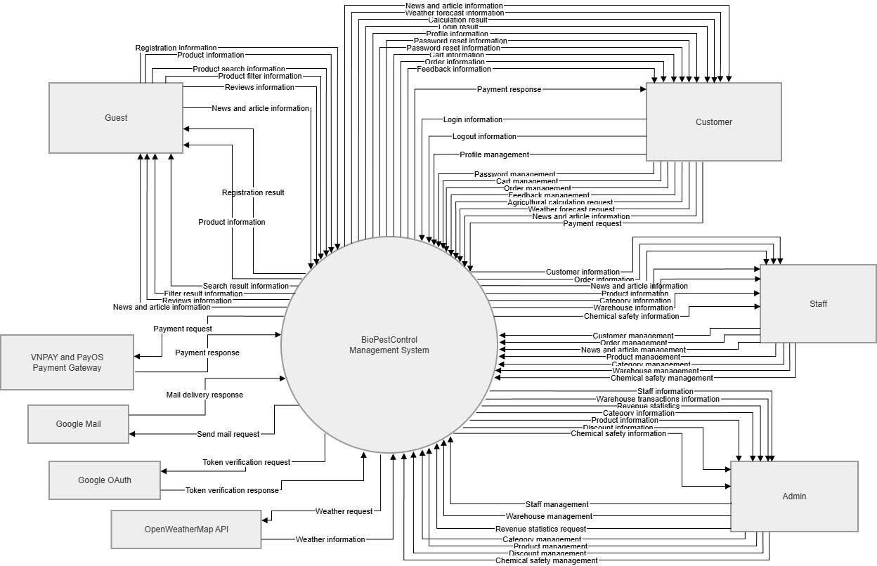
Non-Screen requirements
# | Feature | System Function | Description
1 | Password Encryption | string HashPassword(string password) | Utilizes the BCrypt hashing algorithm to encrypt user passwords before database storage, ensuring no credentials are saved in plain text.
2 | JWT Token Security | Token GenerateJwt(User user) | Generates JWT tokens using the HMAC SHA-256 algorithm to manage secure user sessions and handle role-based access control (Claims).
3 | OTP Expiry Logic | bool IsOtpValid(string email, string code) | Generates a 6-digit OTP for password resets with a 15-minute Time-To-Live (TTL) mechanism for automatic invalidation.
4 | Payment Signature | bool VerifySignature(string data, string sign) | Validates data integrity from PayOS/VNPay gateways using HMAC SHA-512 to prevent transaction tampering before updating order status.
5 | Order State Machine | Task UpdateStatus(int orderId, Status newStatus) | Enforces business logic for order transitions (e.g., preventing a "Cancelled" order from being updated to "Shipped").
6 | Dosage Engine | double GetChemicalAmount(int cropId, float area) | Calculates the precise amount of chemical required based on land area, specific crop types, and target pest data.
7 | Mixability Validator | bool CanMix(List<int> productIds) | Validates chemical compatibility between different products to warn users against hazardous or ineffective tank-mixing combinations.
8 | Inventory Audit | void LogStockTransaction(StockAction action) | Automatically records a comprehensive audit trail for every stock movement (import, export, or return) including precise timestamps.
9 | Weather Caching | Task<Weather> GetCachedWeather(string city) | Integrates external Weather APIs and implements a 24-hour cache to minimize API costs and improve system response times.
10 | Kafka Async Tracking | Task ProduceProductView(long productId) | Dispatches "Product View" events to Kafka topics for asynchronous processing, ensuring zero impact on UI performance during analytics gathering.
11 | Recommendation Logic | List<Product> SuggestProducts(string userId) | Analyzes user browsing history stored in MongoDB to generate relevant product suggestions based on categories and behavioral patterns.
12 | Discount Validation | bool IsDiscountActive(int promoId) | Verifies promotion eligibility by checking active date ranges and remaining inventory quotas before applying discounts to the cart.

4. Actor
# | Actor | Description
1 | Guest | A visitor who has not logged into the system. The guest can browse product lists, search for products, filter by category/price, and view product details. Guests can also read community feedback and comments but are restricted from purchasing.
2 | Customer | A registered user who can log into the system to manage their profile, add products to the cart, and create orders. Customers can make online or COD payments, track order history, manage their favorite wishlist, and provide feedback/comments on products.
3 | Staff | A system user authorized to manage operational data such as product lists, customer information, and orders. Staff can create orders for customers, update order statuses, and interact with users by responding to, editing, or deleting comments and feedback.
4 | Admin | The highest-level administrator who manages employees and monitors detailed business statistics via a dashboard. Admin handles inventory management, approves orders, and has full access to all administrative and reporting features of the system.

5. UC Diagram
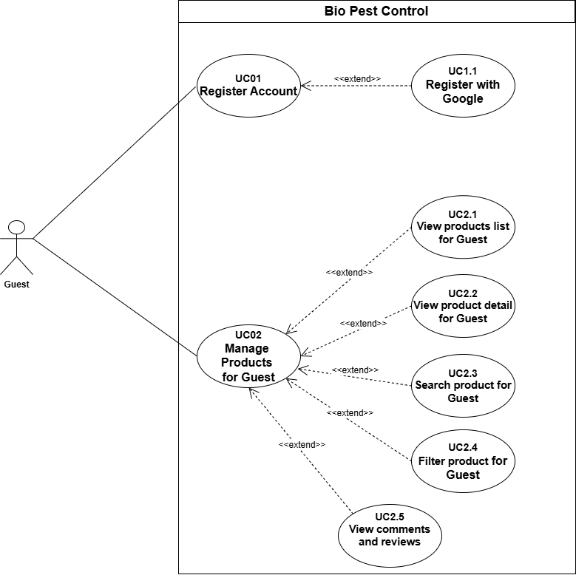
1. Use case Guest
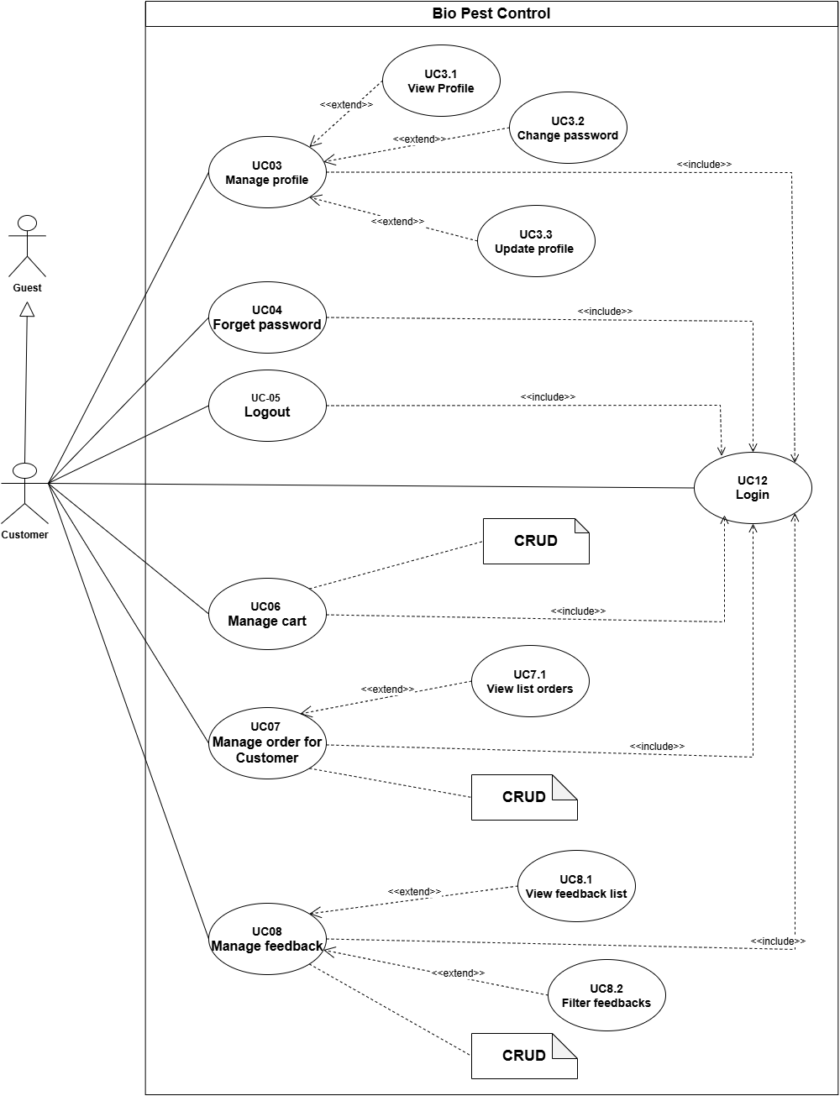
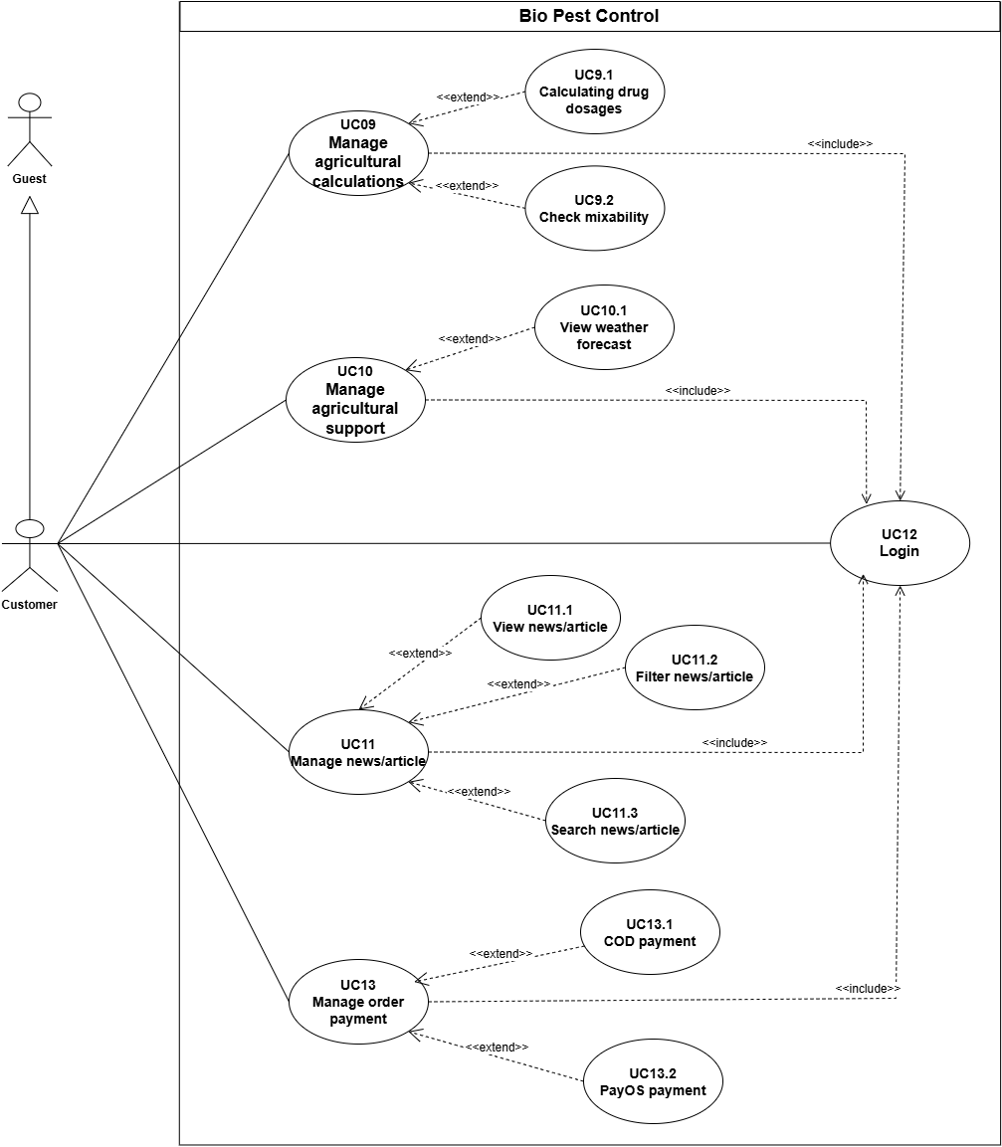
2. Use case Customer
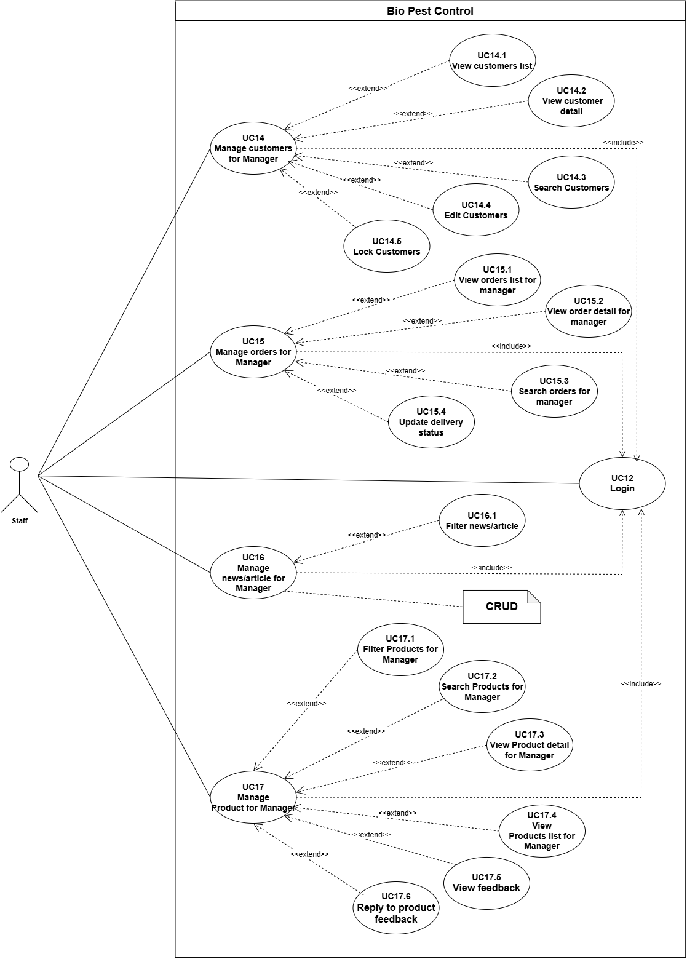
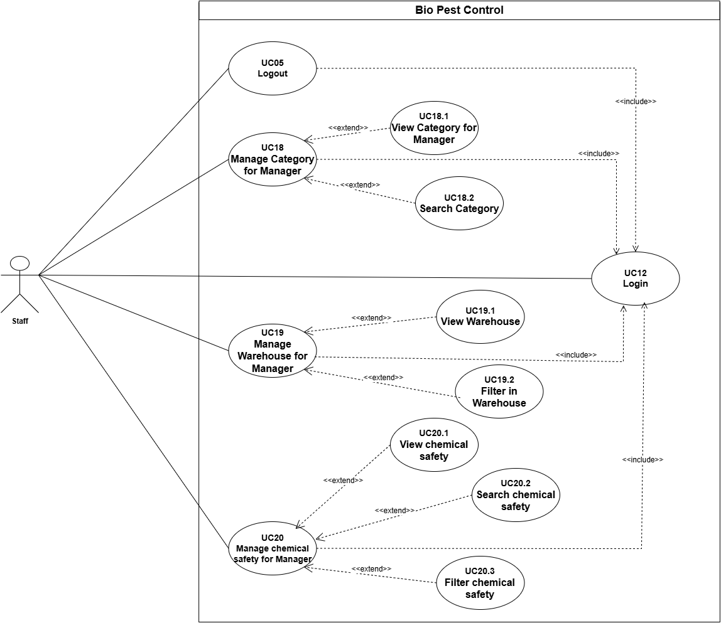
3. Use case Staff
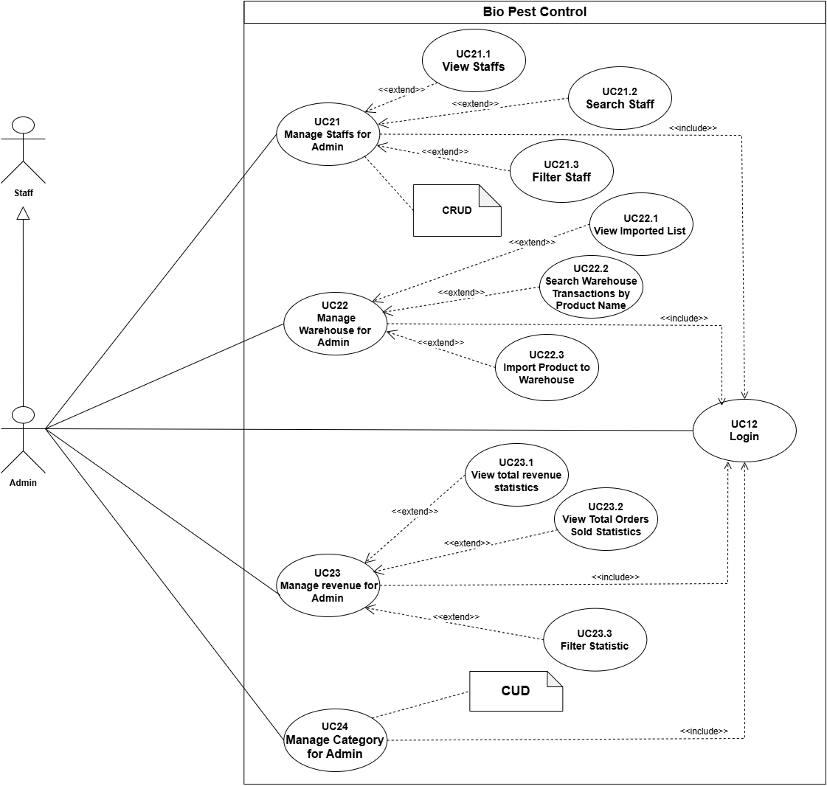
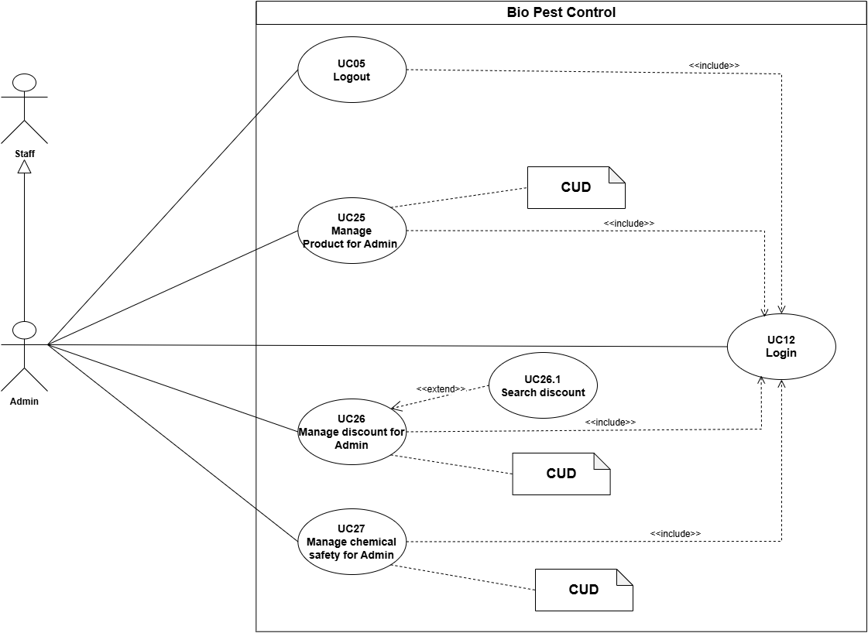
4. Use case Admin
Link Use case: https://drive.google.com/file/d/1C-XT4lqoUtSiF4DTqITJ9xfGNehItkXN/view?usp=sharing

6. Architecture Diagram
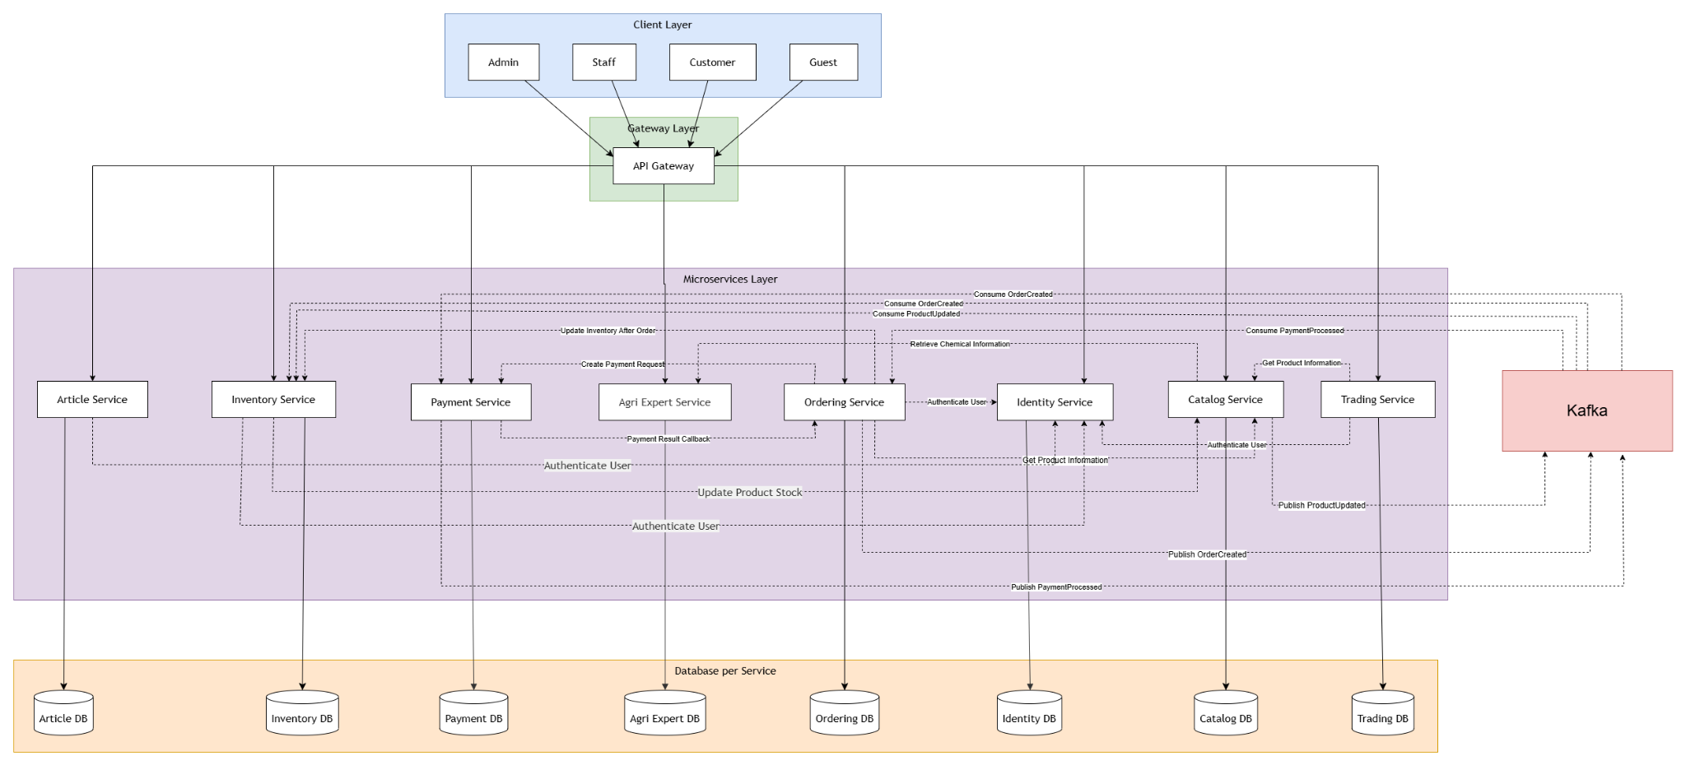
Package Descriptions
No | Package | Description
01 | Identity Service | Responsible for user management, authorization, and system security. Handles tasks such as user login, registration, token issuance/validation, and profile management for different roles (Admin, Staff, Customer, Guest).
02 | Catalog Service | Manages the product catalog and master data. Stores core product information including names, descriptions, images, prices, and categories. Provides product data to other services (like Ordering and Trading) for display purposes.
03 | Inventory Service | Manages warehouse operations and stock levels. Tracks incoming and outgoing goods, and automatically reserves or deducts product quantities when a new order is successfully created to prevent overselling.
04 | Ordering Service | Manages the entire lifecycle of an order (from creation, awaiting payment, to successful delivery). Acts as the central coordinator, interacting with Inventory (for stock updates), Payment (for transactions), and storing purchase history.
05 | Payment Service | Handles all financial and transaction-related operations. Integrates with third-party payment gateways (credit cards, digital wallets, etc.), manages payment statuses (success/failure/pending), and processes refunds.
06 | Agri Expert Service | The agricultural expert domain service. Manages specialized agricultural data such as fertilizer/pesticide compositions, farming technical instructions, and safety warnings for agricultural chemical usage.
07 | Trading Service | Manages specialized trading transactions (e.g., agricultural commodity exchanges, auctions, or B2B partner trading). Handles complex business logic like pricing negotiations, sales contracts, and goods exchange.
08 | Article Service | A Content Management System (CMS) service. Manages news, blog posts, agricultural handbooks, technical guidelines, and expert experience-sharing posts intended for farmers and customers.

7. Database Design

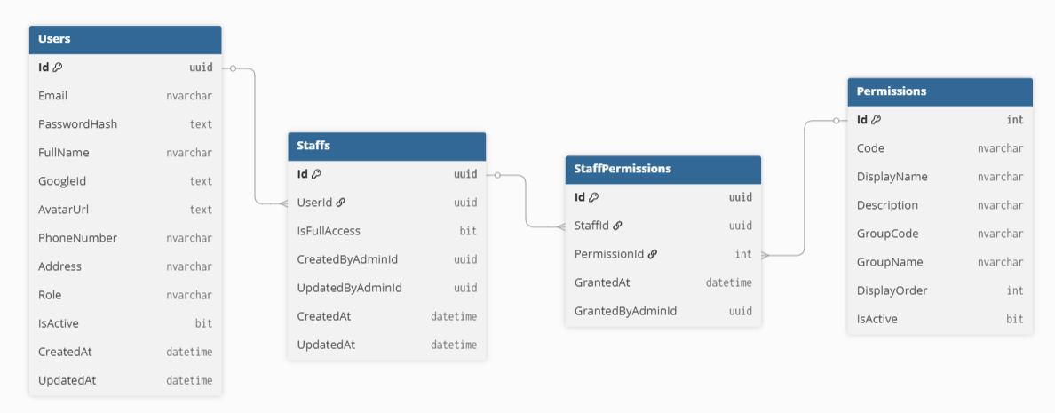
Figure 7.2.1 Identity Service
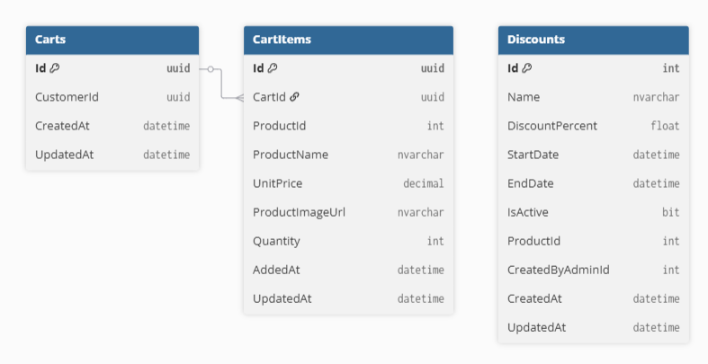
Figure 7.2.2 Trading Service ERD

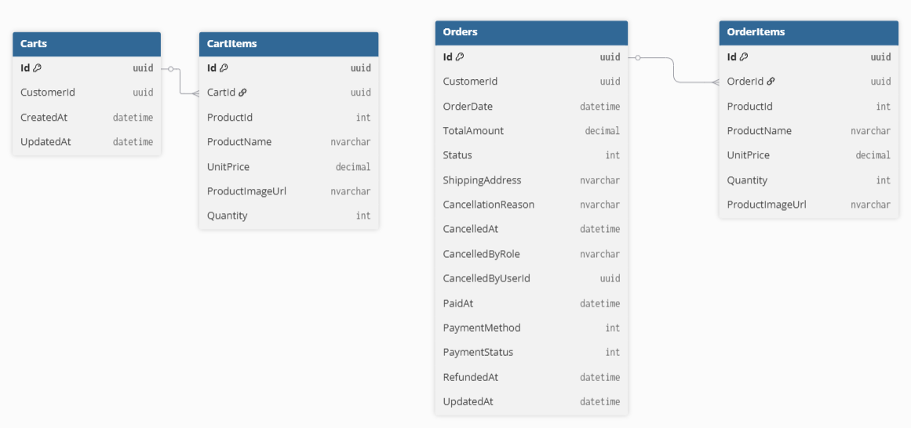
Figure 7.2.3 Ordering Service ERD

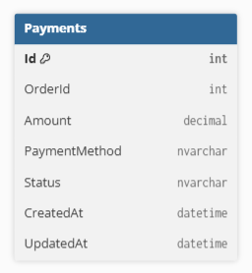

Figure 7.2.4 Payment Service ERD

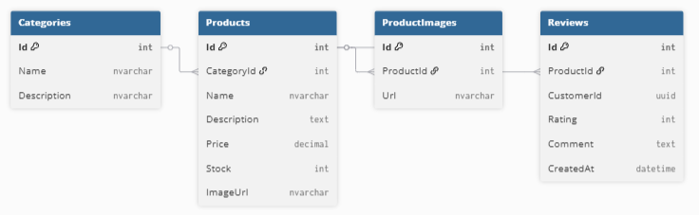

Figure 7.2.5 Catalog Service ERD
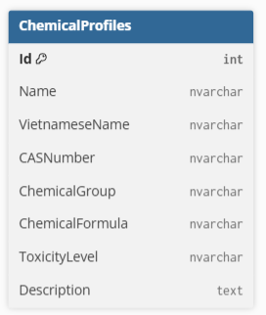
Figure 7.2.6 Agri Expert Service ERD

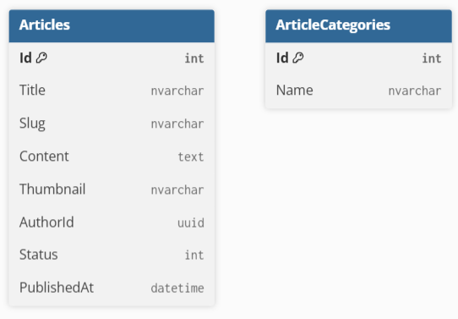
Figure 7.2.7 Article Service ERD

Table Descriptions
No | Table | Description
01 | Users | Description: The Users table stores all registered user accounts, including customers, staff members, and administrators. It maintains authentication credentials, profile information, account status, and personal details.  Primary keys (PK):  Id (INT, IDENTITY(1,1))  Columns (all fields in the table):  - Id (INT, IDENTITY)  Unique identifier for each admin.  - Email (NVARCHAR(200), UNIQUE, NOT NULL)  Email address used for login.  - PasswordHash (NVARCHAR(MAX), NOT NULL)  Encrypted password.  - FullName (NVARCHAR(100))  Full name of the user.  - GoogleId (NVARCHAR(MAX), NULL)  Google account identifier.  - PhoneNumber(NVARCHAR(20), NULL)  Contact phone number.  - Role (NVARCHAR(50))  User role (Customer, Staff, Admin).  - Address (NVARCHAR(500), NULL)  Residential address.  - AvatarUrl (NVARCHAR(MAX), NULL)  Profile image URL.  - IsActive (BIT, NOT NULL )  Indicates whether the account is active.  - CreatedAt (DATETIME2, NOT NULL )  Account creation timestamp.  - UpdatedAt (DATETIME2, NULL)  Last update timestamp.
02 | Staffs | Description:  Stores staff accounts and links each staff member to a user account.  Primary Key (PK):  Id (INT, IDENTITY(1,1))  Foreign Keys (FK):  UserId (INT) → references ADMINS(Id)  Columns (all fields in the table):  - Id (INT, IDENTITY(1,1))  Auto-incremented identifier for each staff.  - IsFullAccess (BIT, NOT NULL)  Indicates full system access.  - CreatedAt (DATETIME2, NOT NULL)  Account creation timestamp.  - UpdatedAt (DATETIME2, NULL)  Account update timestamp.  - CreatedByAdminId (INT, NULL)  Admin who created the staff account.  - UpdatedByAdminId (INT, NULL)  Administrator who last updated the staff.
03 | Permissions | Description:  Defines all permissions available in the Role-Based Access Control (RBAC) system.  Primary Key (PK):  Id (INT, IDENTITY(1,1)) – Permission identifier.  Columns (all fields in the table):  - Id (INT, IDENTITY(1,1))  Permission identifier.  - Code (NVARCHAR(100), UNIQUE)  Unique permission code.  - DisplayName (NVARCHAR(200), NOT NULL)  Permission display name.  - Description (NVARCHAR(500), NULL)  Permission description.  - GroupCode (NVARCHAR(100), NOT NULL)  Functional group code.  - GroupName (NVARCHAR(200), NOT NULL)  Functional group name.  - DisplayOrder (INT, NOT NULL)  Display order.  - IsActive (BIT, NOT NULL)  Indicates whether permission is enabled.
04 | StaffPermissions | Description:  Stores permission assignments granted to staff members.  Primary Key (PK):  Id (INT, IDENTITY(1,1)) – Assignment identifier.  Foreign Keys (FK):  StaffId (INT) → Staff member receiving permission.  PermissionId (INT) → Assigned permission.  Columns (all fields in the table):  - Id (INT, IDENTITY(1,1))  Assignment identifier.  - StaffId (INT)  Staff member receiving permission.  - PermissionId (INT)  Assigned permission.  - GrantedAt (NVARCHAR(500), NULL)  Assignment date.  - GrantedByAdminId (NVARCHAR(100), NOT NULL)  Administrator granting permission.
05 | Categories | Description:  Stores product categories used to classify products.  Primary Key (PK):  Id (INT, IDENTITY(1,1))  Columns (all fields in the table):  - Id (INT, IDENTITY(1,1))  Auto-incremented category identifier.  - Name (NVARCHAR(200), NOT NULL)  Category name.  - Description (NVARCHAR(1000), NULL)  Category description.
06 | Products | Description:  Stores detailed information about agricultural products available on the platform.  Primary Key (PK):  Id (INT, IDENTITY(1,1)) – Unique identifier for each product.  Foreign Keys (FK):  CategoryId (INT) → references CATEGORIES(Id)  Columns (all fields in the table):  - Id (INT, IDENTITY(1,1))  Auto-incremented identifier for each product.  - CategoryId (INT)  Product category.  - Name (NVARCHAR(200), NOT NULL)  Name of the product.  - Description (NVARCHAR(MAX), NULL)  Detailed description of the product.  - Price (DECIMAL(18,2), NOT NULL)  Selling price of the product.  - Stock (INT, NOT NULL)  Available inventory.  - ImageUrl (NVARCHAR(500), NULL)  Main product image.
07 | ProductImages | Description: Stores additional images associated with products.  Primary Key (PK):  Id (INT, IDENTITY(1,1)) – Unique identifier for each product image.  Foreign Keys (FK):  ProductId (INT) → references PRODUCTS(Id)  Columns (all fields in the table):  - Id (INT, IDENTITY(1,1))  Auto-incremented identifier for each image.  - ProductId (INT)  Related product.  - Url (NVARCHAR(500), NOT NULL)  URL or path to the image file.
08 | Reviews | Description: Stores customer reviews and ratings for products.  Primary Key (PK):  Id (INT, IDENTITY(1,1)) – Review identifier.  Foreign Keys (FK):  ProductId (INT) → Reviewed product.  CustomerId (INT) → Customer identifier.  Columns (all fields in the table):  - Id (INT, IDENTITY(1,1))  Review identifier.  - ProductId (INT)  Reviewed product.  - CustomerId (INT)  Customer identifier.  - Rating (INT, NOT NULL)  Product rating.  - Comment (NVARCHAR(MAX), NULL)  Customer feedback.  - CreatedAt (DATETIME2, NOT NULL)  Review date.
09 | Carts | Description: Stores shopping carts belonging to customers.  Primary Key (PK):  Id (INT, IDENTITY(1,1)) – Unique identifier for each cart.  Foreign Keys (FK):  CustomerId (INT) → references CUSTOMERS(Id)  Columns (all fields in the table):  - Id (INT, IDENTITY(1,1))  Auto-incremented identifier for each cart.  - CustomerId (INT, NOT NULL)  Customer who owns the cart.  - CreatedAt (DATETIME2, NOT NULL)  Creation timestamp.  - UpdatedAt (DATETIME2, NOT NULL)  Last updated time of the cart.
10 | CartItems | Description:  Stores products added to shopping carts.  Primary Key (PK):  Id (INT, IDENTITY(1,1)) – Unique identifier for each cart item.  Foreign Keys (FK):  CartId (INT) → references Carts(Id)  ProductId (INT) → references Products(Id)  Columns (all fields in the table):  - Id (INT, IDENTITY(1,1))  Auto-incremented identifier for each cart item.  - CartId (INT, NOT NULL)  Related cart.  - ProductId (INT, NOT NULL)  Product identifier.  - ProductName (NVARCHAR(200), NOT NULL)  Product name snapshot.  - UnitPrice (DECIMAL(18,2), NOT NULL)  Product price when added.  - ProductImageUrl (NVARCHAR(500), NULL)  Product image.  - Quantity (INT, NOT NULL)  Quantity added.  - AddedAt (DATETIME2, NOT NULL)  Added timestamp.  - UpdatedAt (DATETIME2, NULL)  Updated timestamp.
11 | Orders | Description:  Stores customer purchase orders and tracks the complete order lifecycle.  Primary Key (PK):  Id (INT, IDENTITY(1,1)) – Unique identifier for each order.  Foreign Keys (FK):  CustomerId (INT) → Customer placing the order.  Columns (all fields in the table):  - Id (INT, IDENTITY(1,1))  Auto-incremented identifier for each order.  - OrderDate (DATETIME2, NOT NULL)  Date when the order was placed.  - TotalAmount (DECIMAL(18,2), NOT NULL)  Total amount before fees.  - ShippingFee (DECIMAL(18,2), NOT NULL)  Shipping cost.  - FinalAmount (DECIMAL(18,2), NOT NULL)  Final amount to be paid.  - CancellationReason (NVARCHAR(MAX), NOT NULL)  Cancellation reason.  - CancelledAt (DATETIME2 , NOT NULL)  Cancellation time.  - CancelledByRole (NVARCHAR(20), NULL)  User role performing cancellation.  - ShippingAddress (NVARCHAR(500), NOT NULL)  Delivery address.  - CancelledByUserId (INT, NULL)  User performing cancellation.  - PaidAt (DATETIME2, NOT NULL)  Payment completion time.  - Status (INT, NOT NULL)  Current order status.  - PaymentMethod (INT, DEFAULT 0)  Payment method used.  - CustomerId (INT, NOT NULL)  Customer who placed the order.  - PaymentStatus (INT, DEFAULT 0)  Payment status.  - RefundedAt (DATETIME2, NOT NULL)  Refund timestamp.  - UpdatedAt (DATETIME2, NULL)  Last update timestamp.
12 | OrderItems | Description: Stores products included in each order.  Primary Key (PK):  Id (INT) → Order item identifier.  Foreign Keys (FK):  OrderId (INT) → references Orders(Id)  ProductId (INT) → references Products(Id)  Columns (all fields in the table):  - Id (INT, IDENTITY(1,1))  Order item identifier.  - OrderId (INT, NOT NULL)  Order reference.  - ProductId (INT, NOT NULL)  Product included in the order.  - UnitPrice (DECIMAL(18,2), NOT NULL)  Product selling price.  - Quantity (INT)  Ordered quantity.  - ProductImageUrl (NVARCHAR(500), NULL)  Product image.
13 | Payments | Description: Stores payment transaction records associated with customer orders.  Primary Key (PK):  Id (INT, IDENTITY(1,1)) – Unique identifier for each payment.  Foreign Keys (FK):  OrderId (INT) → references Orders(Id)  Columns (all fields in the table):  - Id (INT, IDENTITY(1,1))  Auto-incremented identifier for the payment.  - OrderId (INT, NOT NULL)  Related order identifier.  - Amount (DECIMAL(18,2), NOT NULL)  Payment amount.  - PaymentMethod (INT, NOT NULL)  Payment method used.  - Status (NVARCHAR(50), NOT NULL)  Current payment status.  - Description (NVARCHAR(500), NULL)  Optional description of the payment.  - CreatedAt (DATETIME2, NOT NULL)  Time when the payment was created.  - UpdateAt(DATETIME2, NULL)  Last update time.
14 | Discounts | Description: Stores promotional discounts applied to products.  Primary Key (PK):  Id (INT, IDENTITY(1,1)) – Unique identifier for each discount.  Foreign Keys (FK):  ProductId (INT) → references PRODUCTS(Id)  CreatedByAdminId (INT) → references ADMINS(Id)  Columns (all fields in the table):  - Id (INT, IDENTITY(1,1))  Auto-incremented identifier for each discount.  - Name (NVARCHAR(200), NOT NULL)  Name of the discount program.  - DiscountPercent (FLOAT, NOT NULL)  Discount percentage applied to the product.  - StartDate (DATETIME2, NOT NULL)  Discount start date.  - EndDate (DATETIME2, NOT NULL)  Discount end date.  - IsActive (BIT, NOT NULL)  Indicates whether the discount is currently active.  - ProductId (INT, NOT NULL)  Product to which the discount applies.  - CreatedByAdminId (INT, NULL)  Admin who created the discount.  - CreatedAt (DATETIME2, NOT NULL)  Creation timestamp.  - UpdateAt(DATETIME2, NULL)  Last modification timestamp.
15 | ChemicalProfiles | Description: Stores detailed information about agricultural chemicals, including safety, toxicity, and chemical composition, to support chemical lookup, dosage calculation, and compatibility checking.  Primary Key (PK):  Id (INT, IDENTITY(1,1)) – Unique identifier for each chemical profile.  Columns (all fields in the table):  - Id (INT, IDENTITY(1,1))  Auto-incremented identifier for each chemical profile.  - Name (NVARCHAR(200), NOT NULL)  Name of the chemical substance.  - VietnameseName (NVARCHAR(200), NOT NULL)  Vietnamese chemical name.  - CASNumber (NVARCHAR(100), UNIQUE)  CAS Registry Number.  - ChemicalGroup (NVARCHAR(200), NOT NULL)  Chemical classification group.  - ChemicalFormula (NVARCHAR(100), NULL)  Molecular formula.  - ToxicityLevel (NVARCHAR(100), NOT NULL)  Toxicity classification.  - Description (NVARCHAR(MAX), NULL)  Chemical description and safety information.
16 | Articles | Description: Stores agricultural news, announcements, and educational articles published on the platform.  Primary Key (PK):  Id (INT, IDENTITY(1,1)) – Unique identifier for each article.  Columns (all fields in the table):  - Id (INT, IDENTITY(1,1))  Auto-incremented identifier for each article.  - Title (NVARCHAR(500), NOT NULL)  Title of the article.  - Slug (NVARCHAR(1000), NULL)  SEO-friendly URL.  - Content (NVARCHAR(MAX), NOT NULL)  Full content of the article.  - Thumbnail (NVARCHAR(500), NULL)  Thumbnail image.  - AuthorId (INT, NOT NULL)  Author identifier.  - Status (INT, NOT NULL)  Publication status.  - PublishedAt (DATETIME2, NULL)  Publication date.
17 | ArticleCategories | Description: Stores categories used to classify articles.  Primary Key (PK):  Id (INT, IDENTITY(1,1)) – Unique identifier for each article image.  Columns (all fields in the table):  - Id (INT, IDENTITY(1,1))  Category identifier.  - Name (NVARCHAR(200), NOT NULL)  Category name.

8. Backlog
Backlog_PRN232.xlsx

9. User Guide

9.1 Introduction
This chapter provides instructions for using the BioPest Control System. The system supports four user roles: Guest, Customer, Staff, and Administrator. Each role is granted different permissions according to its responsibilities. The following sections describe the main functions available to each role and provide step-by-step instructions for performing common tasks.

9.2 Guest Guide

9.2.1 User Register
Purpose
This function allows a guest to create a new customer account using either an email address or a Google account.
Preconditions
- The user has not logged into the system.
- A valid email address or Google account is available.
Steps
Register with Email
- Open the BioPest Control website.
- Click Login -> Select Create an Account.
- Enter Full Name, Email, Phone, Address, Password, and Confirm Password.
- Click Sign Up ->.
- Wait until the registration process is completed.
Register with Google
- Click Register with Google.
- Select a Google account.
- Grant the required permissions.
- Wait for the system to complete authentication.
Expected Result
A new customer account is successfully created, and the user can access the system.
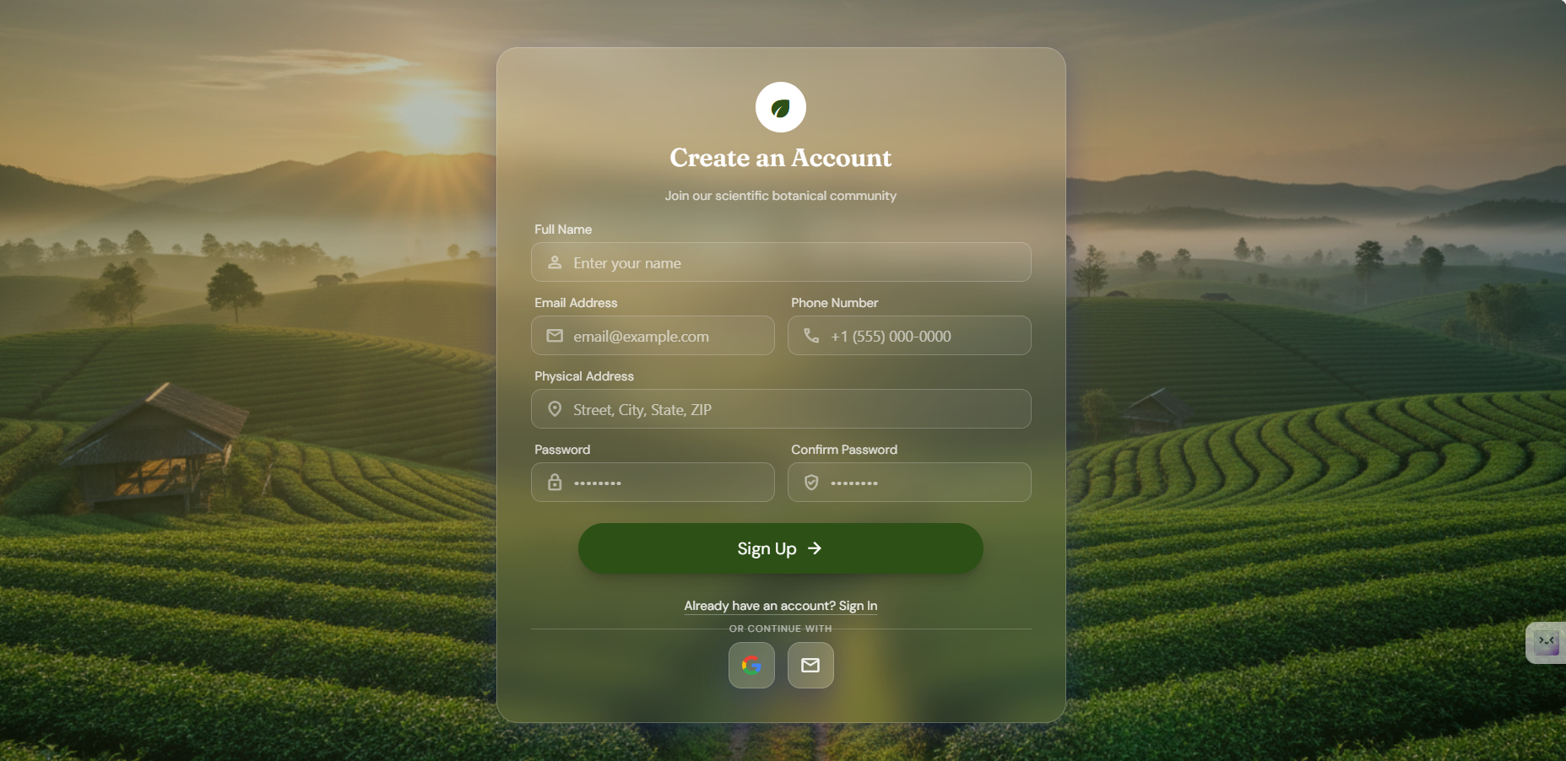
Figure 9.2.1 User Registration

9.2.2 Login
Purpose
Allows users to access the BioPest Control System.
Preconditions
The user has a registered account.
Steps
- Open the Login page.
- Enter Email and Password.
- Click Login.
Or
- Click Login with Google.
- Select a Google account.
Expected Result
The user is redirected to the homepage after successful authentication.
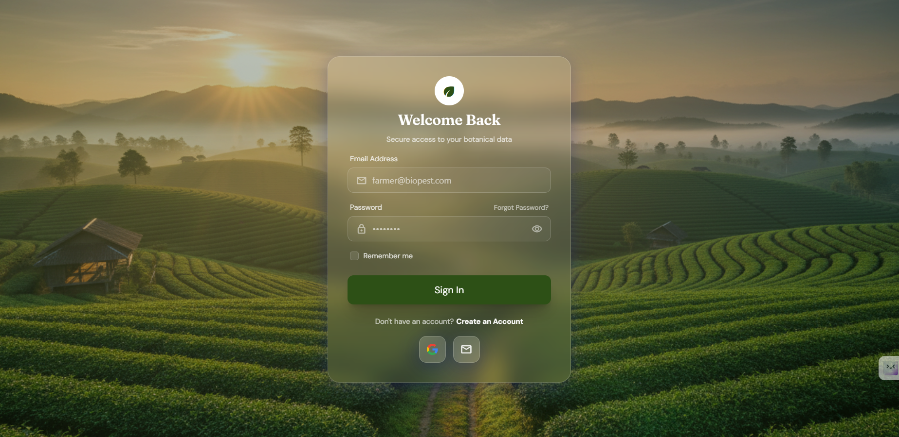
Figure 9.2.2 Login

9.2.3 Browse Products
Purpose
Allows users to browse, search, filter, and view product information.
Steps
- Open the Products page.
- Browse the product list.
- Search by product name, target pest, or SKU code... .
- Apply filters if necessary.
- Click a product to view detailed information.
Expected Result
The system displays the selected product together with its detailed information.
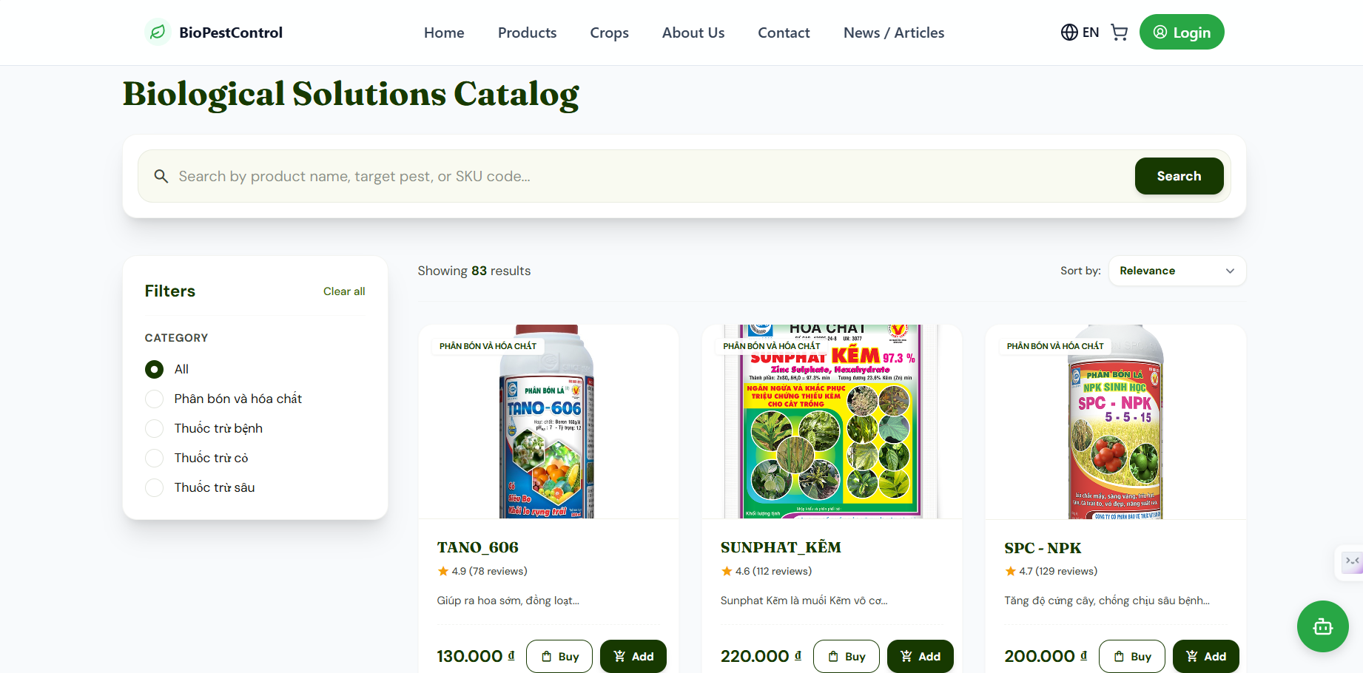
Figure 9.2.3 Product Management

9.2.4 Browse Categories
Purpose
Allows users to browse and search product categories.
Steps
- Open the Categories page.
- Browse all available categories.
- Enter a keyword to search categories.
Expected Result
Matching categories are displayed.
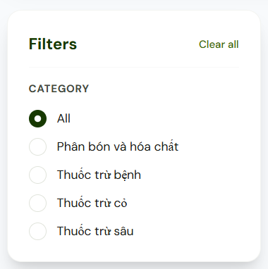
Figure 9.2.4 Category List

9.2.5 View Articles
Purpose
Allows users to browse agricultural news and articles.
Steps
- Open the News & Articles page.
- Browse available articles.
- Search or filter articles.
- Click an article to view its content.
Expected Result
The selected article is displayed.
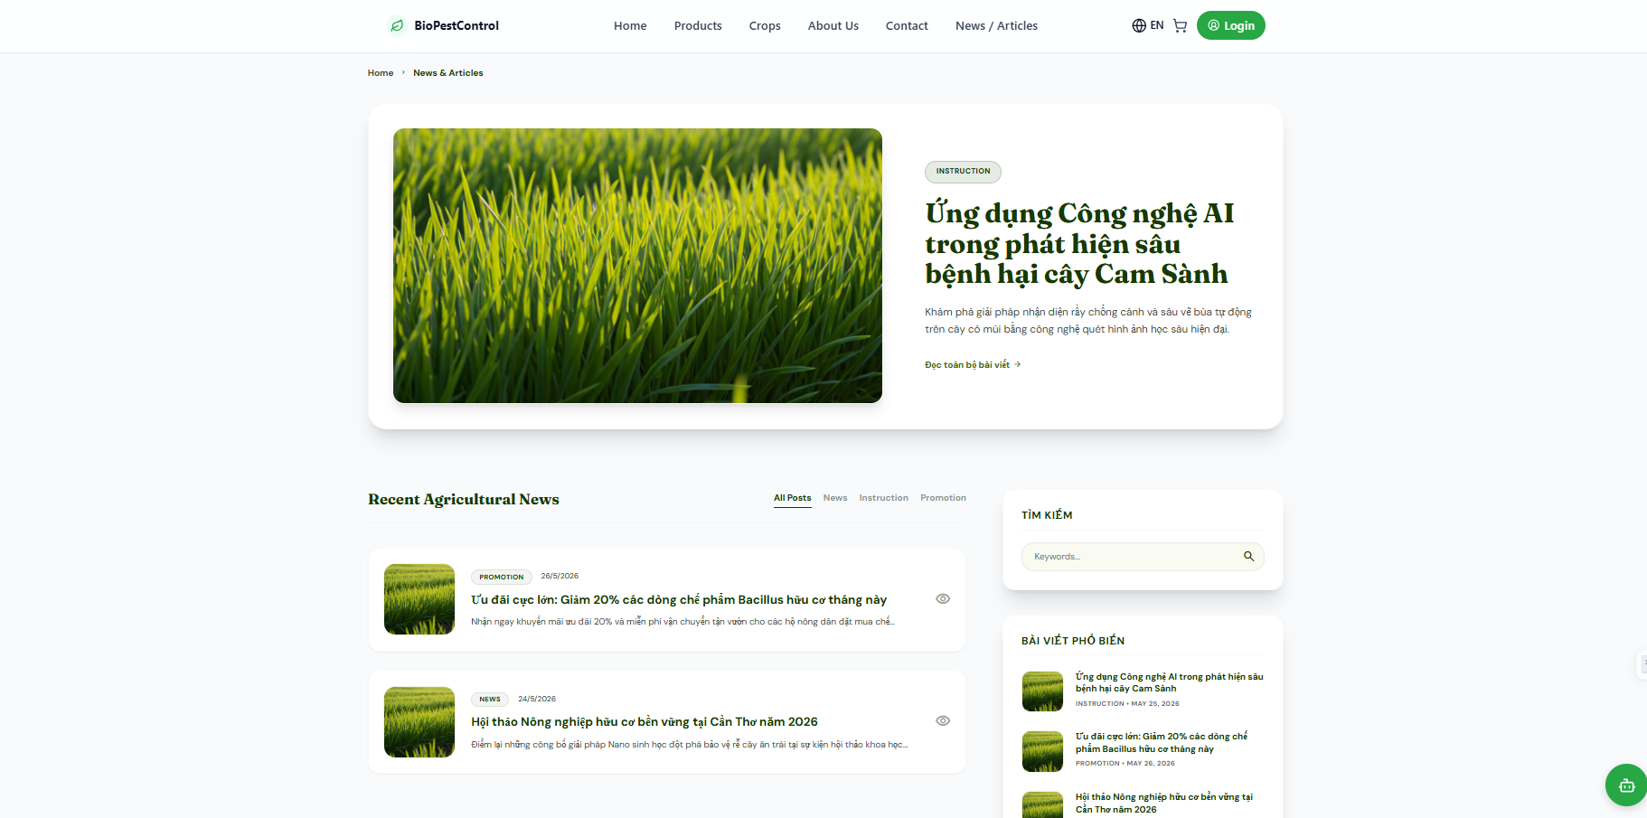
Figure 9.2.5 News & Articles

9.2.6 Contact
Purpose
Allows users to contact the BioPest Control support team.
Steps
- Open the Contact page.
- Fill in the required information.
- Submit the contact form.
Expected Result
The contact request is submitted successfully.
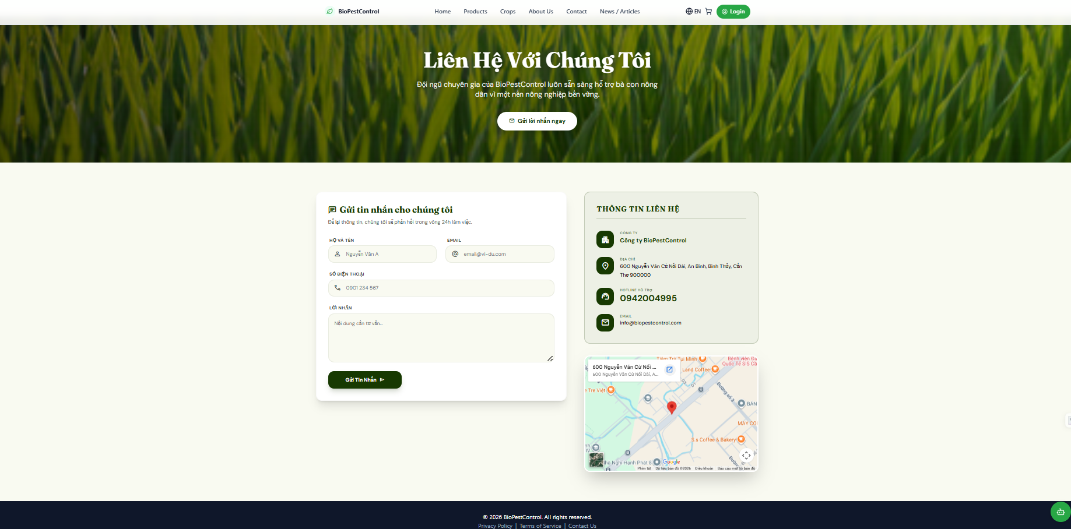
Figure 9.2.6 Contact Page

9.3 Customer Guide

9.3.1 Profile Management
Purpose
Allows customers to view and update their personal information and change their account password.
Preconditions
- The customer has logged into the system.
Steps
View Profile
- Click the user avatar.
- Select My Profile.
Edit Profile
- Select Avatar -> Profile.
- Update the required information.
- Click Save Profile.
Change Password
- Select Avatar -> Profile.
- Select Change Password.
- Enter the current password.
- Enter the new password and confirm it.
- Click Update Password.
Expected Result
The customer's profile information or password is updated successfully.
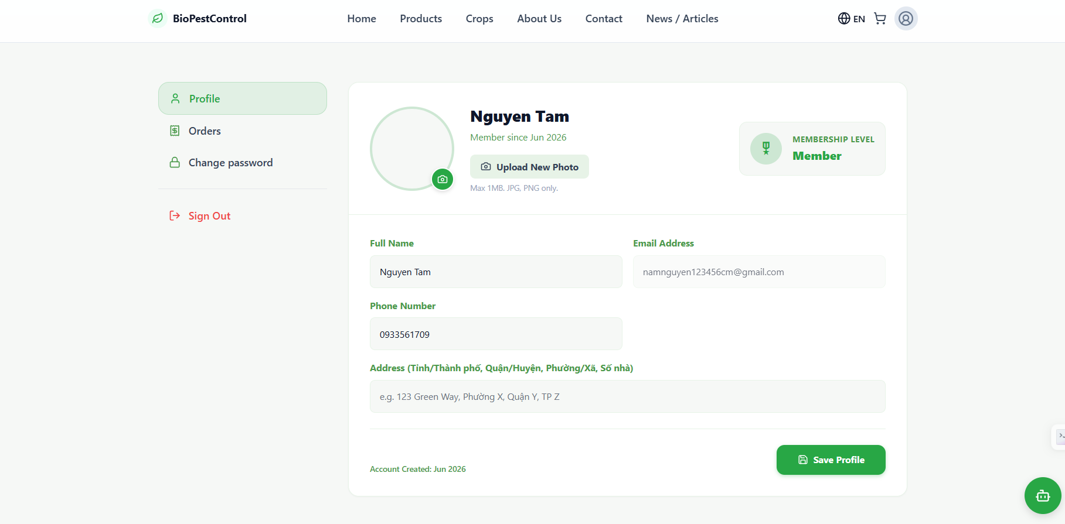
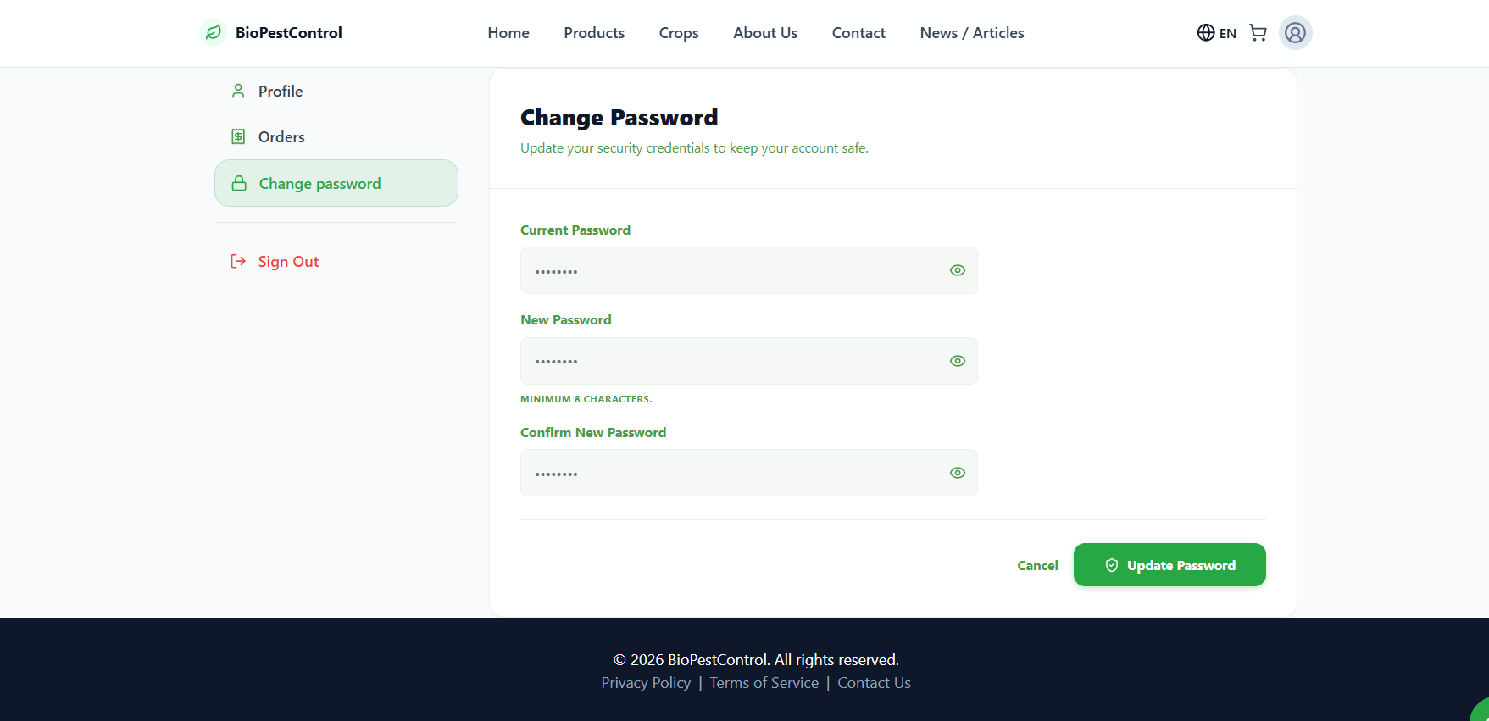
Figure 9.3.1 Profile Management

9.3.2 Shopping Cart
Purpose
Allows customers to manage products before placing an order.
Preconditions
- The customer has logged into the system.
Steps
- Browse products.
- Select a product.
- Click Add to Cart.
- Open the shopping cart.
- Update the quantity or remove products if necessary.
- Review the total amount.
Expected Result
The shopping cart is updated with the selected products.
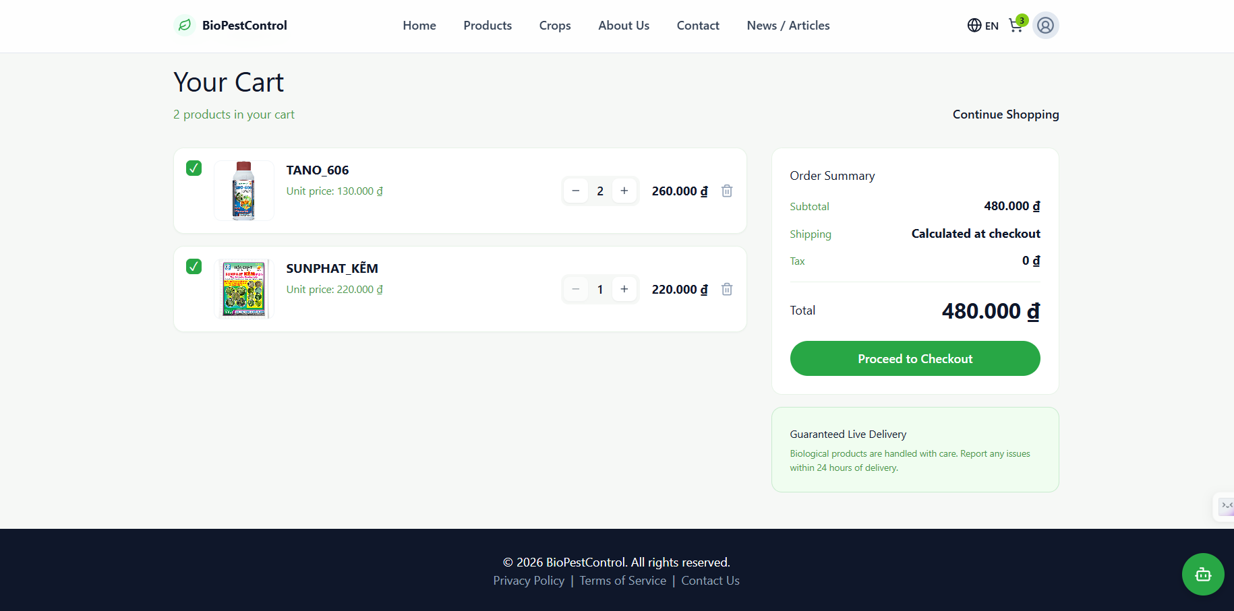
Figure 9.3.2 Shopping Cart

9.3.3 Checkout and Payment
Purpose
Allows customers to place orders and complete payments.
Preconditions
- The shopping cart contains at least one product.
Steps
- Open the shopping cart.
- Click Proceed to Checkout.
- Enter the shipping information.
- Select the payment method:
  - Cash on Delivery (COD)
  - PayOS (Online)
- Review the order information.
- Click Place Order.
Expected Result
The order is successfully created and the payment request is processed.
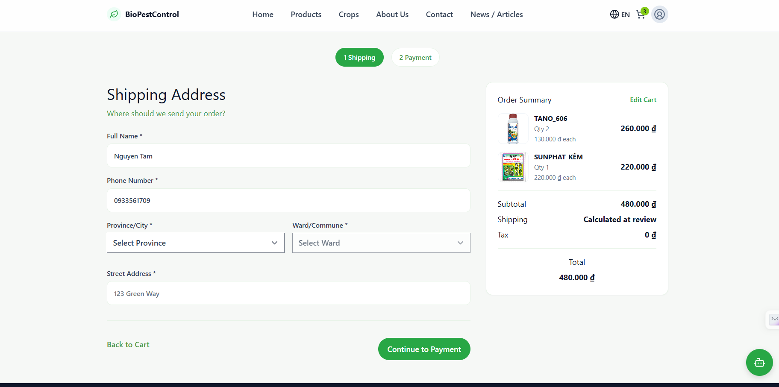
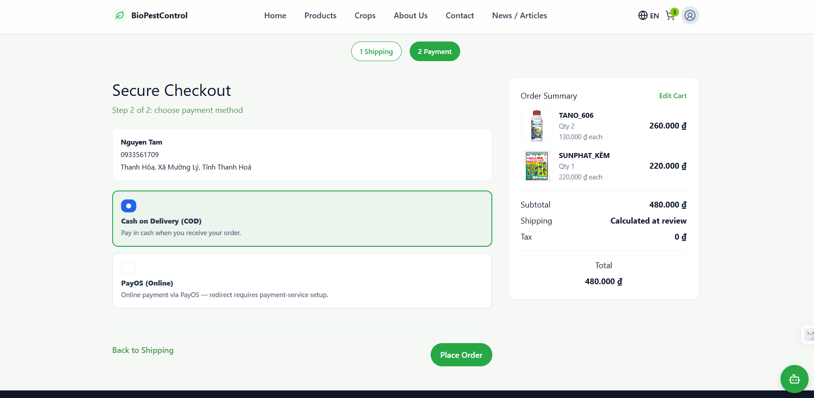
Figure 9.3.3 Checkout and Payment

9.3.4 Order Management
Purpose
Allows customers to track and manage their orders.
Preconditions
- The customer has placed at least one order.
Steps
- Select Avatar -> Orders.
- Browse the order list.
- Search for a specific order if necessary.
- Click an order to view detailed information.
- Cancel the order if its status allows cancellation.
Expected Result
Order information and status are displayed correctly, and eligible orders can be canceled.
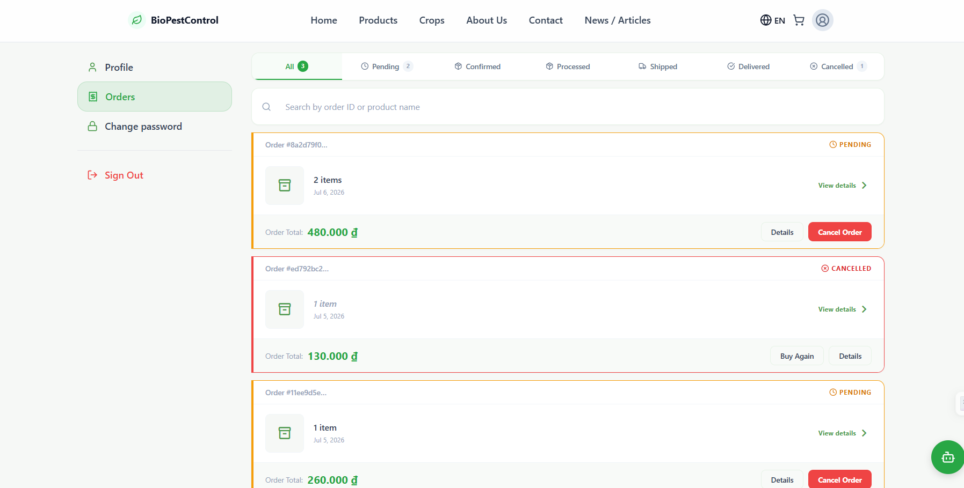
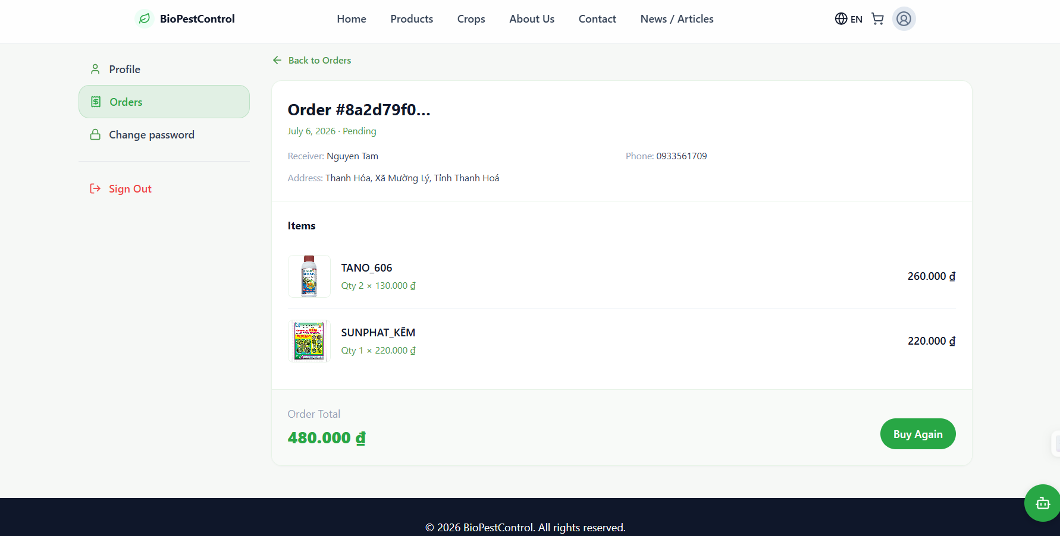
Figure 9.3.4 Order Management

9.3.5 Feedback Management
Purpose
Allows customers to submit and manage product feedback.
Preconditions
- The customer has logged into the system.
Steps
- Open the product detail page.
- Navigate to the Feedback section.
- Click Write Feedback.
- Enter the feedback content.
- Submit the feedback.
- Edit or delete previously submitted feedback if necessary.
Expected Result
The feedback is successfully created, updated, or deleted.
Screenshot
Figure 9.3.5 Feedback Management

9.3.6 Agricultural Support
Purpose
Provides agricultural tools to help customers use products safely and effectively.
Preconditions
- The customer has logged into the system.
Steps
Drug Dosage Calculator
- Open Agricultural Calculator.
- Enter the required values.
- Click Calculate Dosage.
Chemical Mixability Checker
- Open Checker Mixability.
- Select two or more chemicals.
- Click Check Mixability.
Expected Result
The system displays dosage calculations, chemical compatibility results, or weather information.
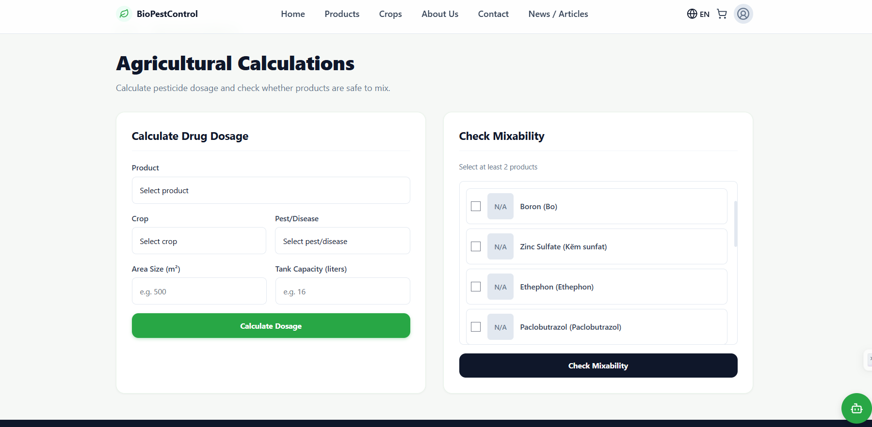
Figure 9.3.6 Agricultural Support

9.3.7 Logout
Purpose
Allows customers to securely exit the system.
Preconditions
- The customer has logged into the system.
Steps
- Click the user avatar.
- Select Logout.
Expected Result
The customer session is terminated and the system redirects to the homepage.
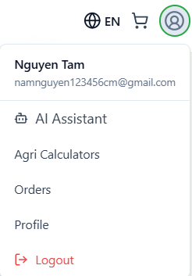
Figure 9.3.7 Logout

9.3.8 Forgot Password
Purpose
Allows customers to reset their password when they forget their login credentials.
Preconditions
- The customer has a registered account.
- The customer can access the registered email address.
Steps
- Click Forgot Password on the Login page.
- Enter the registered email address.
- Click Send OTP.
- Check the email inbox and enter the OTP.
- Enter a new password.
- Confirm the new password.
- Click Reset Password.
Expected Result
The password is updated successfully, and the customer can log in using the new password.
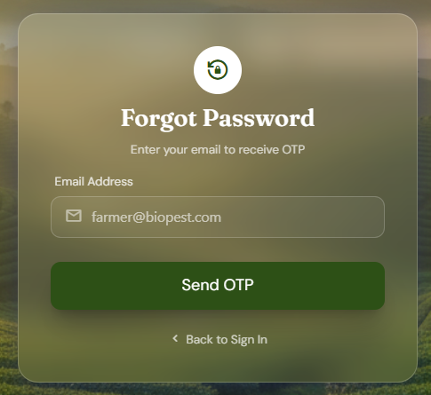
Figure 9.3.8 Forgot Password

9.4 Staff Guide

9.4.1 Profile Management
Purpose
Allows staff members to manage their personal information and account security.
Preconditions
- The staff member has logged into the system.
Steps
- Click the user avatar.
- Select My Profile.
- View or edit personal information.
- Select Change Password if necessary.
- Save the changes.
Expected Result
The profile information or password is updated successfully.
Screenshot
Figure 8.17 Staff Profile Management

9.4.2 Customer Management
Purpose
Allows staff members to manage customer information.
Preconditions
- The staff member has permission to access Customer Management.
Steps
- Navigate to Customer Management.
- Browse the customer list.
- Search or filter customers using keywords.
- Select a customer to view detailed information.
- Edit customer information or lock the account if necessary.
Expected Result
Customer information is displayed and updated successfully.
Screenshot
Figure 8.18 Customer Management

9.4.3 Order Management
Purpose
Allows staff members to monitor and process customer orders.
Preconditions
- The staff member has permission to access Order Management.
Steps
- Open Order Management.
- Browse or search the order list.
- Select an order to view its details.
- Update the delivery status.
- Save the changes.
Expected Result
The order status is updated successfully.
Screenshot
Figure 8.19 Order Management

9.4.4 Warehouse Management
Purpose
Allows staff members to monitor warehouse inventory.
Preconditions
- The staff member has warehouse access permission.
Steps
- Open Warehouse Management.
- Browse warehouse information.
- Search products by keyword.
- Apply filters if necessary.
Expected Result
Warehouse information is displayed correctly.
Screenshot
Figure 8.20 Warehouse Management

9.4.5 Feedback Management
Purpose
Allows staff members to respond to customer feedback.
Preconditions
- Customer feedback exists in the system.
Steps
- Open Feedback Management.
- Browse or filter customer feedback.
- Select a feedback entry.
- Click Reply.
- Enter the response.
- Save the reply.
- Edit the reply if necessary.
Expected Result
The reply is successfully published and visible to customers.
Screenshot
Figure 8.21 Feedback Management

9.4.6 News & Article Management
Purpose
Allows staff members to publish and maintain news articles.
Preconditions
- The staff member has article management permission.
Steps
- Open News & Article Management.
- Browse existing articles.
- Create a new article or edit an existing one.
- Delete articles if required.
- Save the changes.
Expected Result
The article is created, updated, or deleted successfully.
Screenshot
Figure 8.22 News & Article Management

9.5 Administrator Guide

9.5.1 Staff Management
Purpose
Allows administrators to manage staff accounts and permissions.
Preconditions
- The administrator has logged into the system.
Steps
- Navigate to Staff Management.
- View the staff list.
- Search for a staff member if necessary.
- Add a new staff account by entering the required information.
- Edit staff information when needed.
- Delete a staff account if it is no longer required.
- Save the changes.
Expected Result
Staff accounts are successfully created, updated, or removed.
Screenshot
Figure 8.23 Staff Management

9.5.2 Category Management
Purpose
Allows administrators to manage product categories.
Preconditions
- The administrator has logged into the system.
Steps
- Open Categories.
- Browse or search existing categories.
- Add a new category.
- Edit category information.
- Delete unnecessary categories.
Expected Result
Product categories are successfully maintained.
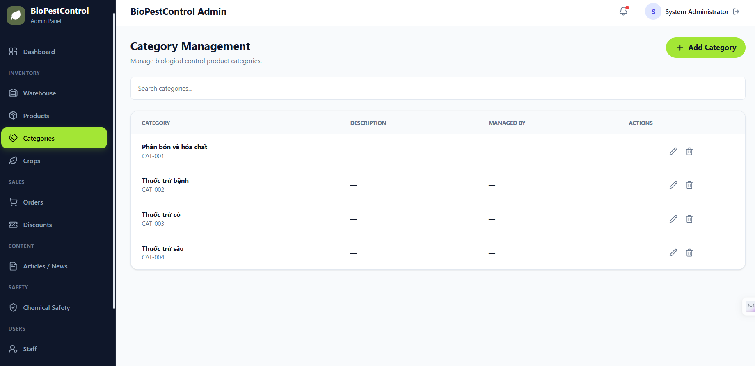
Figure 9.5.2 Category Management

9.5.3 Product Management
Purpose
Allows administrators to manage product information.
Preconditions
- The administrator has logged into the system.
Steps
- Navigate to Products.
- Browse, search, or filter products.
- Create a new product.
- Edit product information.
- Delete products when necessary.
Expected Result
Product information is updated successfully.
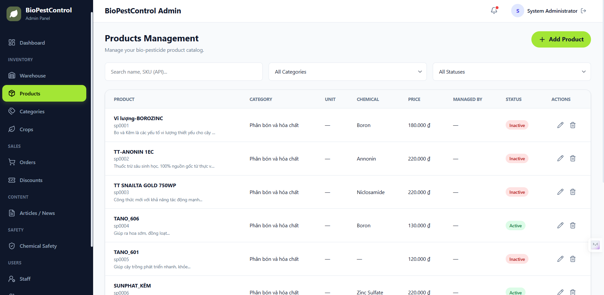
Figure 9.5.3 Product Management

9.5.4 Discount Management
Purpose
Allows administrators to manage promotional discounts.
Preconditions
- The administrator has logged into the system.
Steps
- Open Discounts.
- Browse available discounts.
- Search or filter discounts.
- Create a new discount.
- Edit discount information.
- Delete expired or unnecessary discounts.
Expected Result
Discount information is successfully managed.
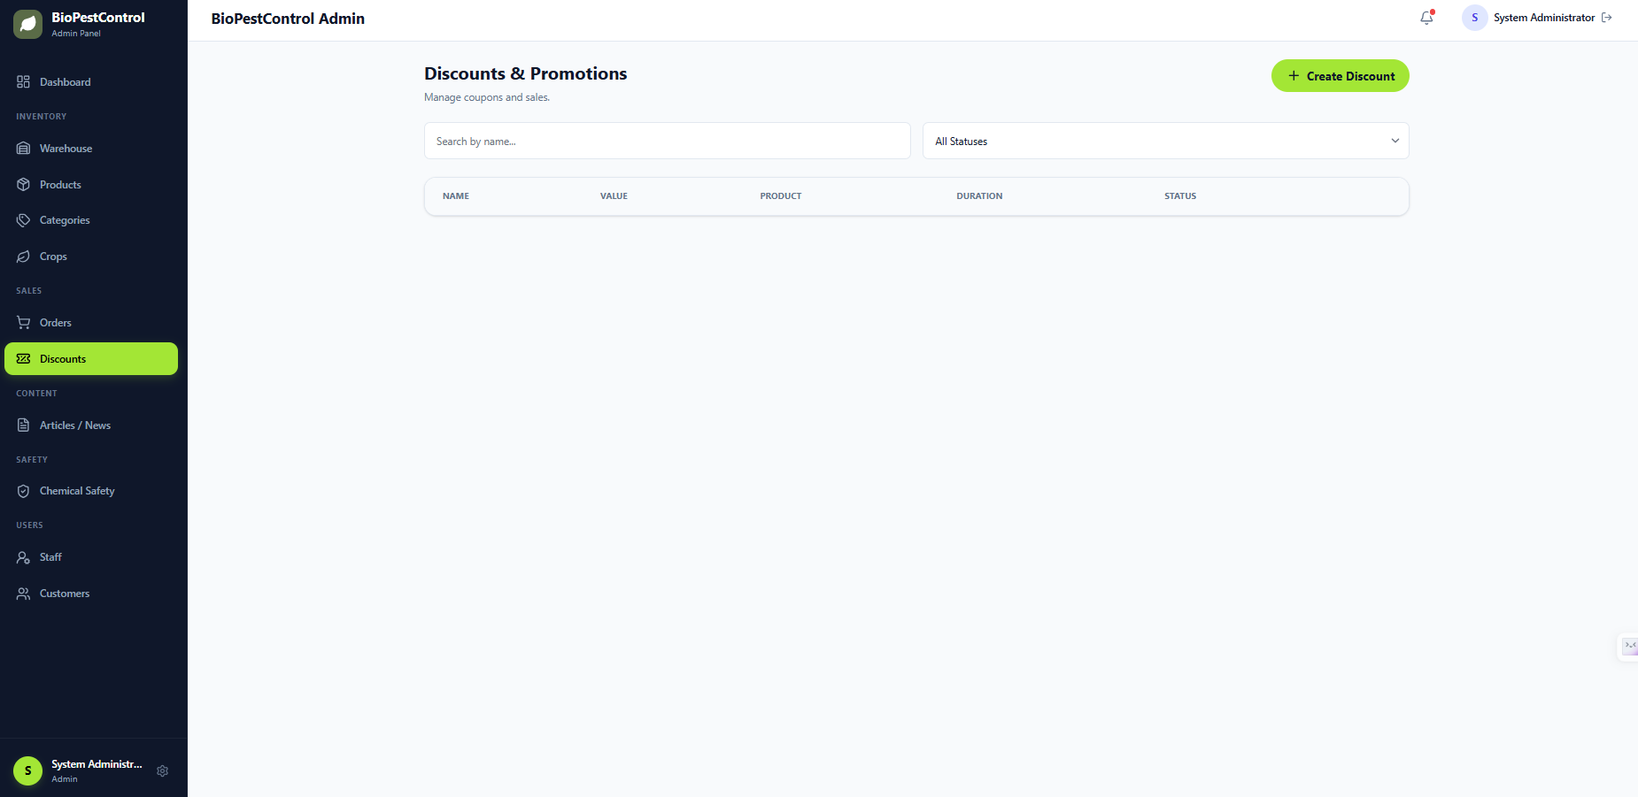
Figure 9.5.4 Discount Management

9.5.5 Chemical Safety Management
Purpose
Allows administrators to maintain chemical safety information.
Preconditions
- The administrator has logged into the system.
Steps
- Navigate to Chemical Safety.
- Browse, search, or filter chemical records.
- Create a new chemical record.
- Update existing information.
- Delete outdated records.
Expected Result
Chemical safety information is maintained successfully.
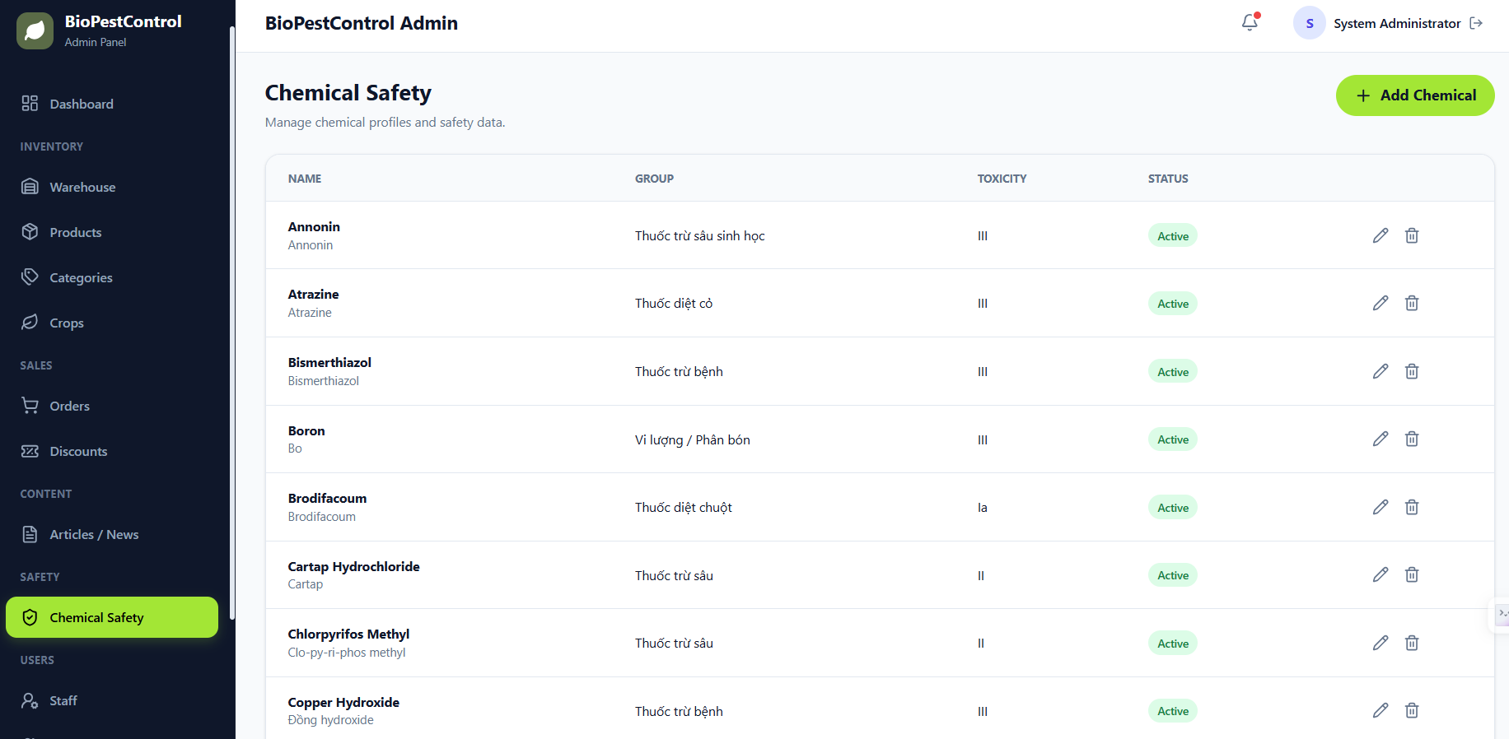
Figure 9.5.5 Chemical Safety Management

9.5.6 Warehouse Import
Purpose
Allows administrators to import products into the warehouse.
Preconditions
- The administrator has warehouse management permission.
Steps
- Open Warehouse.
- Select Import.
- Enter the product quantity and related information.
- Confirm the import.
Expected Result
The warehouse inventory is updated successfully.
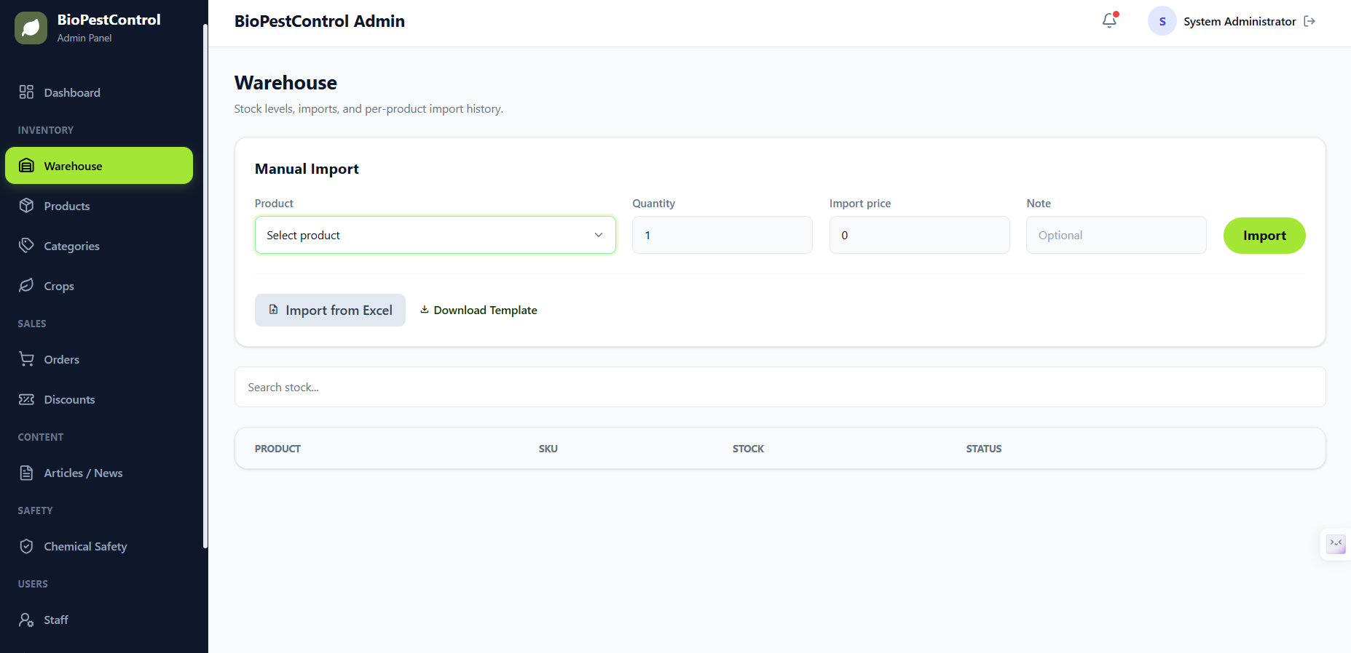
Figure 9.5.6 Warehouse Import

9.5.7 Revenue Dashboard
Purpose
Allows administrators to monitor business performance through statistical reports.
Preconditions
- The administrator has logged into the system.
Steps
- Open the Revenue Dashboard.
- View the total revenue.
- View total products sold.
- View linked product statistics.
- Apply filters by date or reporting period.
Expected Result
The dashboard displays accurate business statistics and reports.
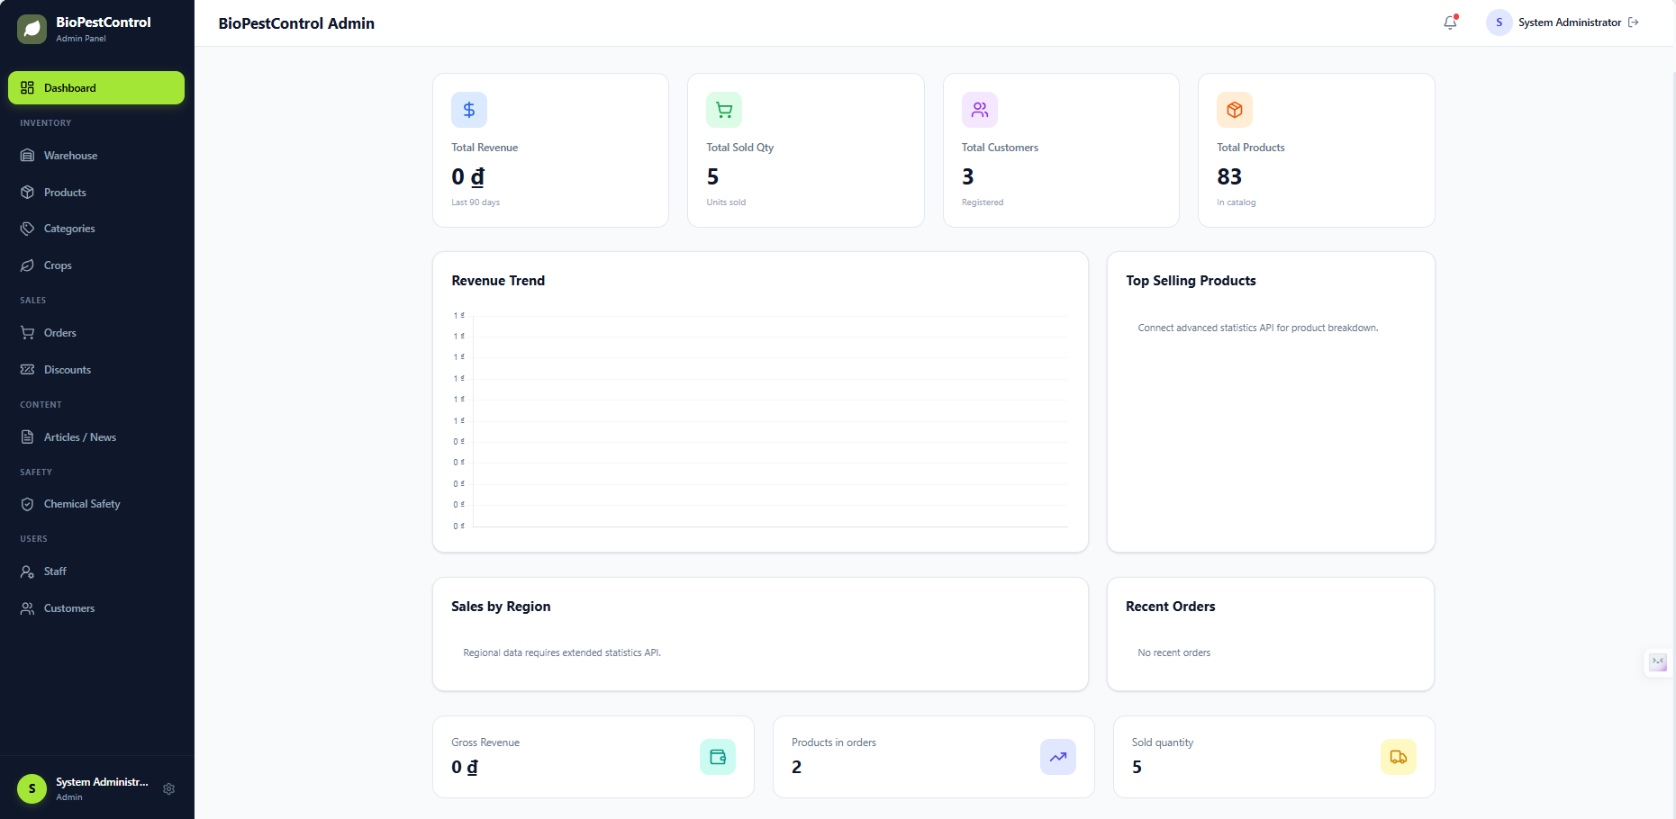
Figure 9.5.7 Revenue Dashboard

