|  |  |
| --- | --- |
| **Group** 8 | **Death Star Image Exfiltration** |
| **Major:** | **Team members:** |
| EE | Nicholas Michael |
| CEG | Mason McDaniel |
| IT/Cyber | Chase Ennis |
| IT/Cyber  CS | Cade Wrinkle  Michael Mowad |

**System Architecture**

Hardware Architecture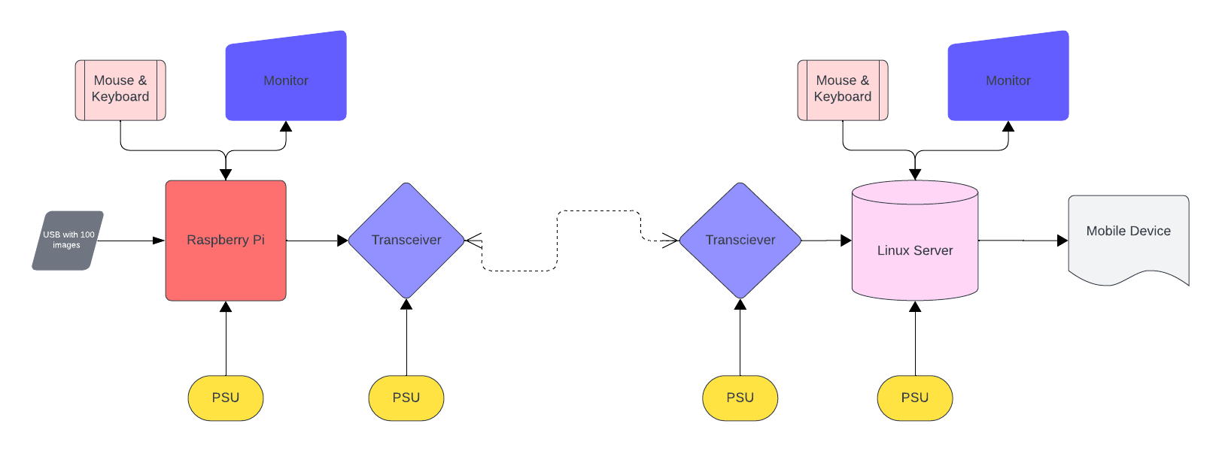

Hardware functional block definitions

1. USB with 100 images – Contains 100 1024x1024 pixel PNG images. 10 images depict the Death Star out of the 100 images on the USB Thumb drive.
2. Raspberry Pi - Software running on the Raspberry Pi must identify which 10 images depict the Death Star out of the 100 images on the USB Thumb drive.
3. PSU - Power supply unit. Supplies power to the individual components
4. Transceiver - A device that can both transmit and receive communications, in particular a combined radio transmitter and receiver. Will be used to transmit images to the Linux server.
5. Monitor – Displays visual information to the user.
6. Mouse & Keyboard – Allows for user input to the connected system
7. Linux Server – Isolates the weaknesses of the 10 images of the death star and uploads them to a web server to be displayed on the mobile application.
8. Mobile Device – Displays the weaknesses uploaded to the website from the linux server

Software Architecture

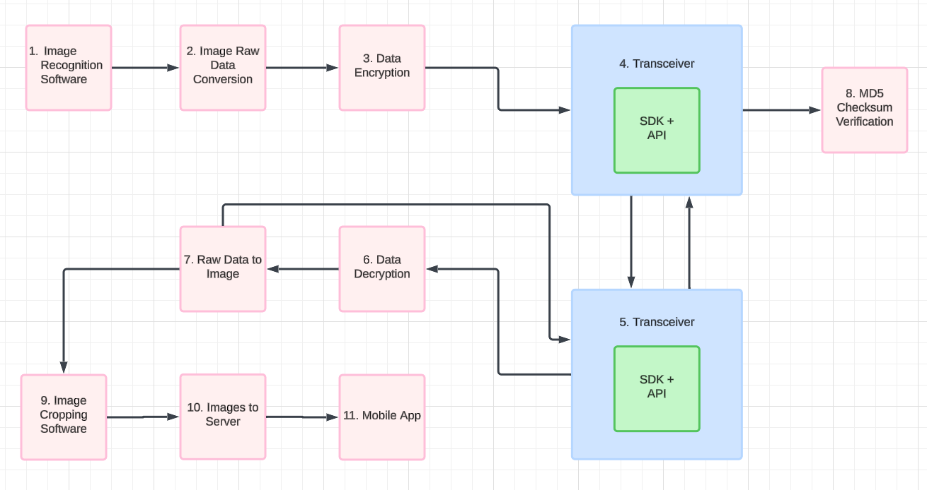

Software functional block definitions

1. Image Recognition Software – Software will analyze and filter the 10 death star images out of the 100 provided
2. Image Raw Data Conversion – The 10 death star images then have their raw data extracted to be sent
3. Data Encryption – The data of those 10 images is then encrypted to ensure secure transfer
4. Transceiver – Software communicates with a radio module utilizing an API to an SDK
   1. 4 → 5 – Encrypted image data is sent from the Raspberry Pi to the Linux Server
5. Transceiver – Software communicates with a radio module utilizing an API to an SDK
   1. 5 → 4 – MD5 Checksum of received images is sent from Linux Server to Raspberry Pi
6. Data Decryption – The received data is decrypted by the Linux server
7. Raw Data to Image – The raw data is converted back to 10 png images
   1. 7 – 5 – MD5 Checksum of received images is calculated and sent back to the transceiver
8. MD5 Checksum Validation – The 10 received images have their MD5 checksums checked against the original 10 images
9. Image Cropping Software – The 10 images are analyzed and cropped down to the circled weaknesses.
10. Images to Server – The 10 cropped weakness images are uploaded to a server for access from the mobile application
11. Mobile App – A mobile application for iOS/Android downloads the 10 images from the web server and displays them