
MASTER BRAND PACKAGE
The Definitive Brand System — Tagline, Voice, Visual Identity & Applications
Version 2 — Consolidated & Reconciled
July 2026 · Confidential · Founder & Design Reference
Guard Leaf — the shield that watches over every reading, every refill, every family.

Contents

0. How This Document Was Built
This is the single source of truth. It reconciles two prior branding drafts into one system, keeping the strongest element from each and resolving every conflict with a clear, stated decision. Where the two drafts disagreed, the reasoning is shown so you can overrule any call.

0.1 What Each Draft Contributed
Element | Draft A (design-led) | Draft B (strategy-led)
Kept from A | Guard Leaf logo, hex palette + usage ratios, tagline extension system, logo anatomy & misuse rules, voice do/don't, naming architecture | —
Kept from B | — | Master tagline, Guardian/Guide archetype, product messaging matrix, 6 campaign concepts, words-to-use/avoid, social & app-store copy, dashboard card specs, icon system

0.2 The Conflicts — and How They Were Resolved
Conflict | Draft A | Draft B | Decision
Master tagline | "Well within reach." | "Care that stays with you." | B wins → master. A → campaign line.
Wordmark case | lowercase "tarragonhealth" | Capitalised "TarragonHealth" | B wins — cleaner, per your note.
Descriptor | "Trusted health monitoring…" | "Clinician-led health monitoring…" | B wins — "clinician-led" adds credibility.
Palette accent | Green + Gold only | Green + Navy + Ivory | Merge both — Navy for B2B, Gold for prompts.
Clinical colours | Green/amber/red, muted | + Blue (info), Grey (pending) | Merge — B's 5-state system, A's muted tones.

1. Brand Foundations

1.1 The Brand Truth
Tarragon Health is not selling healthcare. It is selling continuity — the thing Nigerian families have never reliably had. The brand idea in four words: the care between doctor visits. Every element exists to make one thing felt in five seconds: someone is watching over this, consistently, so you don't have to carry it alone.

1.2 Positioning Statement
For Nigerian families managing hypertension, diabetes, and the health of loved ones near or far, Tarragon Health is the digital-first care coordination platform that keeps watch continuously — through nurses, AI, and a trusted partner network — unlike hospitals, telemedicine apps, and labs that only show up when something has already gone wrong.

1.3 Positioning by Audience
Investor | Tarragon Health is building the chronic disease and preventive health operating system for Nigeria — starting with hypertension, diabetes, ParentCare, medication adherence, labs, pharmacy coordination, corporate health, and HMO population monitoring.
Patient | Track your blood pressure, blood sugar, medication, lab checks, and health reminders — with support when you need closer monitoring.
Family | Stay informed about your parent or loved one's health, even when you are not physically there every day.
Corporate / HMO | Visibility into chronic disease risk, care gaps, preventive screening, medication adherence, and population health outcomes.

1.4 Brand Promise
We help families monitor health, close care gaps, coordinate follow-up, and prevent avoidable crises — before problems become emergencies.

1.5 Brand Archetype
Primary — Guardian | Protective, watchful, safe. Tarragon guards against avoidable crises.
Secondary — Guide | Helps families and patients navigate a fragmented system with clarity.
Strategic — Infrastructure builder | Long term, Tarragon is the coordination layer others build on.
This means Tarragon should never sound like a trendy wellness brand. It should sound like a reliable health partner that families, clinicians, employers, HMOs, and investors can all trust.

2. Tagline System

2.1 Master Tagline — Final
"Care that stays with you."
Why this beats the alternative. Both candidate lines are strong, but continuity is Tarragon's entire strategic thesis — "the care between doctor visits." This line names the exact differentiator no competitor owns:
- Emotional — it directly reassures the anxious diaspora daughter, who is the highest-LTV buyer in the whole model.
- Strategic — it captures continuity, monitoring, prevention, follow-up, and long-term care in one phrase.
- Broad — it works across hypertension, diabetes, ParentCare, preventive screening, corporate, and HMO products without rewording.
- Durable & scalable — it sounds trustworthy rather than app-trendy, and travels to diaspora and future African markets intact.

The runner-up, reassigned
"Well within reach." is not discarded — it becomes the attainability / accessibility campaign line, used where the message is that quality care is affordable and close. It is deliberately punchier and works well on billboards and paid social, but it is more generic than the master line, so it does not carry the brand alone.

2.2 Secondary Taglines by Context
Use case | Tagline
Website hero | Trusted health monitoring for you, your parents, and your loved ones.
Family product | Peace of mind for the people you love.
Chronic disease | Better follow-up. Better control. Better health.
Preventive health | Find risks early. Act before crisis.
Corporate / HMO | Smarter monitoring for healthier populations.
Accessibility campaign | Well within reach.
Premium ParentCare | Dedicated care coordination for your loved ones.
Diaspora marketing | Look after home, even from far away.

2.3 Usage Rules
- Master tagline always appears in sentence case with a full stop: "Care that stays with you." — never a question, never all-caps in body text.
- The functional descriptor ("Clinician-led health monitoring for you, your parents, and your loved ones.") sits beneath the master line — it supports, never replaces it.
- Only one secondary tagline per page or asset — never stack two.

3. Brand Personality & Voice

3.1 Personality Pillars
Trustworthy | Clinically credible, safe, protocol-driven. We earn trust, we don't claim it.
Warm | Family-centred and human. We sound like a nurse who knows your name, not a hospital PA system.
Intelligent | Data-led, organised, preventive. We explain HbA1c in one clear sentence and never patronise.
Calm | Not alarmist, not fear-based. We notice things early and calmly.
Premium but accessible | High quality without feeling elitist. Well within reach.
Nigerian-relevant | Salt in jollof, garri, BP cuffs from the market — our examples are always local.

3.2 Voice: Do / Don't
Do | Don't
"Your BP has been a little high this week — your nurse will call today." | "WARNING: Abnormal reading detected."
"Dad's numbers looked good this week." | "Patient X-4471 vitals within normal parameters."
"12% of your team are pre-diabetic — here's what that could cost, and how we bring it down." | "Revolutionary AI-powered platform disrupting Nigerian healthcare!"

3.3 Vocabulary
Words to use often | Words to avoid
Monitor · Follow-up · Remind · Coordinate · Support · Prevent · Escalate · Review · Loved ones · Parent · Family · Care gaps · Health record · Peace of mind | Cure · Guaranteed · Emergency response · Instant doctor · Replace hospital · Diagnose yourself · Perfect control · No complications · Free healthcare

3.4 Voice in Practice

WhatsApp check-in
Good morning! Time for your BP reading. Reply with your numbers (e.g. 128/82) and I'll let you know how you're trending.

Website hero
Care that stays with you. Clinician-led health monitoring for you, your parents, and your loved ones.

HMO pitch line
We don't just manage chronic disease. We catch it earlier — and we can prove it.

4. Visual Identity

4.1 The Mark — "Guard Leaf"
The logo fuses two ideas that must never be separated in Tarragon's story: protection and growth. A shield gives the sense of active watching-over; a tarragon leaf gives the sense of natural, preventive wellbeing — tying the name to something living rather than institutional.


Anatomy of the mark
- Shield silhouette — the guard: continuous monitoring, safety, escalation-when-needed. Rounded shoulders keep it approachable, not militaristic.
- Sprout crown — two leaflets at the apex: prevention and growth, the promise that most problems are caught while still small.
- Checkmark vein — the leaf's midrib drawn as a checkmark: a completed reading, a closed care gap, a reviewed result. Reads as both "leaf vein" and "task done."

Wordmark
The wordmark is set as "TarragonHealth" — a single word, camel-cased, with "Tarragon" in Charcoal Ink and "Health" in Tarragon Green. This reads more cleanly and premium than an all-lowercase treatment and keeps the two brand ideas legible at a glance.


Logo variations & rules
- Primary lockup (mark + wordmark + tagline): website header, business cards, investor decks, letterheads, corporate proposals, app landing pages.
- Wordmark alone: where space is limited or the brand is already familiar.
- Mark alone (Guard Leaf): app icon, favicon, social avatar, dashboard sidebar, watermark.
- Clear space equals the height of the sprout crown on all sides. Minimum size: 120px wide (full lockup), 32px (mark alone) — the checkmark vein disappears first below this.
- Backgrounds: white, Warm Ivory, Soft Sage, or Deep Navy only. On clinical documents, use the navy or green mark. On premium materials, gold accent sparingly.
- Never stretch, skew, rotate, add shadows, place over busy images, or recolour the shield outside the palette (no blue, no red medical-cross styling).

4.2 Colour Palette
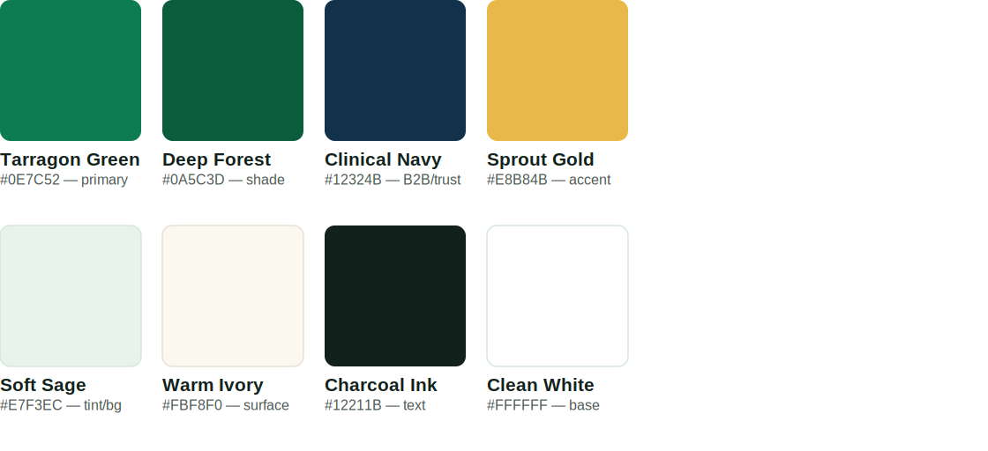
Tarragon Green is reserved for the mark, primary buttons, and positive states. Clinical Navy carries B2B, investor, and clinical-document contexts where a more institutional register is needed. Sprout Gold is used sparingly — screening reminders, upgrade prompts, premium moments — never for alarm. Soft Sage and Warm Ivory are the calm default backgrounds; Charcoal Ink (not pure black) is the standard text colour.

Usage ratio
- 60% Warm Ivory / Soft Sage / White (space to breathe)
- 25% Tarragon Green / Deep Forest / Navy (brand presence, primary actions)
- 10% Charcoal Ink (text)
- 5% Sprout Gold (accents, prompts — never more)

Clinical status colours — kept separate from the brand palette
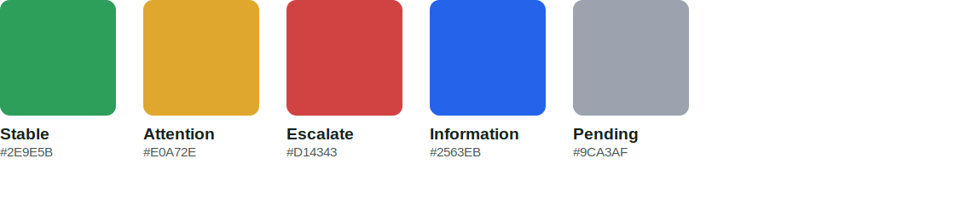
These five states power the patient, family, and nurse dashboards. They are a standardised clinical system and must never be confused with brand Tarragon Green. Red and amber are reserved strictly for true clinical alerts so they never lose meaning. Pair with icons, not colour alone, for colour-blind safety.

4.3 Typography
Use | Typeface | Notes
Headlines / marketing | Sora (Bold / SemiBold) | Geometric, warm, free for commercial use
Product UI & body | Inter | Excellent legibility on low-end Android screens
Documents / Office | Calibri | Universal fallback for Word, Excel, PowerPoint
WhatsApp / SMS | Plain text only | Voice and structure carry the brand, not styling

4.4 Icon System
A single rounded-stroke icon set, 2px weight, single-colour (Deep Forest or Tarragon Green). Never photo-realistic medical icons.
Feature | Icon idea | Feature / Icon
BP monitoring | Cuff or pulse line | Preventive — shield + check
Diabetes | Glucose droplet | Family — linked circles
Medication | Pill bottle | Escalation — care note
Labs | Test tube | Pharmacy — medicine bag
ParentCare | Parent + child figures | Corporate — building + pulse
Nurse follow-up | Headset | HMO — population grid

4.5 Photography & Illustration
Show | Avoid
Adult children with parents · Nigerian families in natural settings · older adults using BP monitors · nurses on calm follow-up calls · people reassured, not sick · clean homes · technology used simply | Emergency scenes · critically ill people · overly Western stock · hospital corridors only · doctors pointing at charts · fake call-centre smiles · generic wellness yoga imagery
Illustration: simple line style, rounded edges, green and navy palette, light medical symbols, family-care scenes, dashboard icons.

5. Messaging Architecture

5.1 Homepage Hero
Headline: Care that stays with you.
Subheadline: Clinician-led health monitoring for you, your parents, and your loved ones.
Body: Track blood pressure, blood sugar, medication, lab checks, and preventive health needs in one secure platform. Tarragon helps families stay informed and supports escalation when closer care is needed.
Primary CTA: Start monitoring · Secondary CTA: Join the 90-Day Health Reset · Corporate CTA: Request employer health plan · HMO CTA: Talk to Tarragon Health

5.2 Product Messages
Product | Message
Hypertension Care | Stay ahead of high blood pressure before it causes complications.
Diabetes Care | Track glucose, HbA1c, medication, labs, and complications in one place.
ParentCare | Know how your parent is doing, even when you are not there every day.
Preventive Health | Find care gaps early and know what checks may be due.
Medication Support | Reduce missed doses and avoid running out of medication.
Lab Coordination | Know what tests are due, book them, and track follow-up.
Corporate Health | Help your workforce detect and manage chronic disease risk.
HMO Support | Monitor member risk, close care gaps, and generate outcome evidence.

5.3 Campaign Concepts
Audience | Line | Use for
Families | Your parents looked after you. Now help look after them. | ParentCare, diaspora, family plans
Hypertension | High blood pressure needs follow-up, not guesswork. | HTN plan
Diabetes | Diabetes care is more than sugar checks. | Diabetes plan
Prevention | The best emergency is the one you prevent. | Preventive education
Corporate | Know your workforce health risks before they become costs. | Employer plans
HMO | Close care gaps. Monitor risk. Prove outcomes. | HMO sales

6. Product & Brand Applications

6.1 Dashboard Design
Patient dashboard | Family dashboard | Nurse dashboard
Today's status (green/amber/red) · Latest BP · Latest glucose · Medication · Labs due · Preventive checks · Health Passport · Next action | Is my loved one okay? · Medication status · Latest readings · Upcoming actions · Monthly report · Alerts | Patients due today · Abnormal readings · Missed medications · Labs overdue · Escalations · Family updates pending · Caseload metrics
Dashboard UI is card-based with green/amber/red status, simple trends, and one clear next action per card. Card-based, never dense clinical tables for patients and families.

6.2 Digital Presence

WhatsApp Business profile
- Profile photo: Guard Leaf mark on white. About line: "Care that stays with you. Your Tarragon Health care team."

App icon
- Guard Leaf mark on a Tarragon Green rounded square — checkmark vein must stay visible at 44px.

Social media bio
TarragonHealth
Care that stays with you.
Chronic disease, preventive health, and family care monitoring for Nigerians and their loved ones.

App store description
Tarragon Health helps you track your blood pressure, blood sugar, medications, lab checks, and preventive health reminders in one secure place. Families can monitor loved ones with consent, receive updates, and stay ahead of avoidable health crises.

LinkedIn company description
Tarragon Health is building Nigeria's digital-first chronic disease, preventive health, and family care coordination platform. We help patients and families monitor blood pressure, blood sugar, medication adherence, lab checks, and care gaps — with nurse-led follow-up and doctor escalation when required.

6.3 Print
- Business card — Front: mark + wordmark + "Care that stays with you." Back (Soft Sage): name, role, email, phone, website, and "Clinician-led health monitoring for families, employers, and HMOs."
- Letterhead — top-left logo, top-right tagline, footer with website, email, phone, address, privacy statement.
- Corporate / HMO report cover — Deep Navy full-bleed, mark in white, title in Sora Bold, client name beneath. Restrained, not promotional — this is a data document.

7. Brand Architecture & Naming
Tarragon Health is a single master brand — no independent sub-brands. Product names are descriptive, not invented, keeping every package legible to a first-time Nigerian user and concentrating all equity in the master mark.
Naming pattern | Example
[Tarragon] + [Condition/Audience] + [Care/Plan] | Hypertension Care, Diabetes Care, ParentCare, Family Plan, Chronic Care Plus
[Tarragon] + [Duration/Format] + [Programme] | Tarragon 90-Day Health Reset, Tarragon Free Health Tracker
[Premium] modifier — top diaspora tier only | Premium ParentCare — the only place "Premium" appears in the portfolio
Rule: never coin a standalone brand name (e.g. avoid "VitalTrack by Tarragon") for an internal product. A genuinely separate consumer brand — say, for a new country — returns to this document for a full architecture review before any naming begins.

8. One-Page Reference
Company | Tarragon Health
Master tagline | Care that stays with you.
Descriptor | Clinician-led health monitoring for you, your parents, and your loved ones.
Campaign line | Well within reach.
Logo concept | Guard Leaf — shield + sprout crown + checkmark vein
Wordmark | TarragonHealth (camel-case, Ink + Green)
Primary colour | Tarragon Green #0E7C52 · B2B: Clinical Navy #12324B
Fonts | Sora (headlines) · Inter (UI/body)
Archetype | Guardian (primary) · Guide (secondary)
Voice in one line | A nurse who knows your name, not a hospital PA system
Best product CTA | Start monitoring.
Never do | Fear-based urgency · red medical crosses · Western stock photography · invented sub-brand names
— End of Master Brand Package v2 · Tarragon Health · Confidential —

