AI-Based Dissolved Oxygen Predictive Analysis
and Forecasting System Using Time-Series
Machine Learning
A Comparative Benchmark of Statistical, Classical Machine Learning, and Deep
Learning Models for Water Quality Forecasting on the Brisbane Buoy Dataset
DO_Predictor: Thesis-Grade Technical Report
[Author Name]
[Degree Programme / Department]
[Institution Name]
[Supervisor: Name]
July 2026

Table of Contents

1. Abstract
Dissolved oxygen (DO) is a primary indicator of aquatic ecosystem health, and short-horizon forecasting of DO enables early warning of hypoxic conditions before they harm aquatic life. This report presents DO_Predictor, a comprehensive benchmarking system that forecasts Dissolved Oxygen ten minutes ahead using real buoy telemetry from the Brisbane River. A full pipeline (validation, cleaning, smoothing, feature engineering) feeds a registry of 20 models spanning three tiers - statistical (persistence, linear/ridge/lasso regression, ARIMA, SARIMAX, Prophet), classical machine learning (SVR, Random Forest, Gradient Boosting, XGBoost, LightGBM, CatBoost, KNN), and deep learning (LSTM, GRU, CNN-LSTM, BiLSTM, a Transformer encoder, and 1D-CNN) - all evaluated under a strict, leakage-audited chronological train/validation/test split. Every model in the registry trained and evaluated successfully (20/20 runs), with zero silent failures. The best-performing model, linear regression, achieved a test MAE of 0.0962 mg/L - a 84.0% improvement over a previously published SARIMAX baseline (MAE 0.60) and a 75.9% improvement over a published Prophet baseline (MAE 0.40) on the same dataset. An automated leakage audit (chronological-ordering, target-shift, and NaN-boundary checks across a 32-test suite) confirmed no train/test contamination in any reported result.

2. Introduction

2.1 Problem Statement
Dissolved oxygen concentration governs the survival of fish and other aquatic organisms; concentrations below roughly 4 mg/L place most freshwater and estuarine species under acute hypoxic stress. Continuous buoy-based water-quality monitoring produces high-frequency sensor streams, but raw telemetry is reactive - it reports what has already happened rather than what is about to happen. A predictive system that forecasts DO a short horizon ahead gives operators and environmental managers time to intervene before a hypoxic event occurs, rather than after.

2.2 Why Dissolved Oxygen Forecasting Matters
Low-DO events are strongly correlated with fish kills, algal bloom aftermath, thermal stratification, and nutrient loading. Because DO responds to a combination of physical (temperature, water speed), chemical (salinity, conductance), and biological (chlorophyll) drivers that are all measured by the same buoy, DO forecasting is a natural candidate for multivariate time-series machine learning rather than a purely univariate statistical model.

2.3 Objectives
- Build a reusable, leakage-safe forecasting pipeline for buoy water-quality data.
- Implement and fairly evaluate 20 forecasting models across three methodological tiers.
- Benchmark results against a previously published SARIMAX/Prophet baseline on the same dataset.
- Deliver a working system (API + interactive dashboard), not just offline notebooks.
- Report results - including weak or unexpected ones - transparently rather than selectively.

3. Related Work and Baseline
Classical statistical forecasting of water-quality time series has typically relied on autoregressive models (ARIMA/SARIMAX) and additive trend-plus-seasonality models such as Facebook/Meta's Prophet. A previously published Kaggle notebook applying SARIMAX and Prophet to this exact Brisbane buoy dataset for Dissolved Oxygen forecasting reported test MAE values of 0.60 (SARIMAX) and 0.40 (Prophet); these figures are the public baseline this project benchmarks against throughout (see Section 7.3). The present work extends that line of investigation along two axes: (1) breadth - a full 20-model registry spanning statistical, classical machine learning, and deep learning families rather than two statistical models in isolation, and (2) rigor - a chronological, leakage-audited train/validation/test protocol applied identically to every model, plus an explicit preprocessing-stage ablation (Section 7.4) that isolates how much each pipeline stage contributes independently of model choice.
Note on comparability: the classical statistical models in this project (ARIMA, SARIMAX, Prophet) are evaluated by forecasting the entire held-out test horizon in a single shot from the end of the training window, whereas the lag-feature machine learning and deep learning models predict one step ahead using the true lagged sensor context available at each row. This is a genuine, disclosed methodological difference between model families (Section 5.7) and is the primary reason the lag-informed models outperform the statistical baseline by such a wide margin - it is not evidence that SARIMAX or Prophet are inherently worse forecasting techniques, only that they were deployed here in their more conventional, harder mode.

4. Dataset Description

4.1 Data Source
The dataset is the Kaggle “Water Quality Monitoring Dataset” (owner: downshift), file brisbane_water_quality.csv, sourced from a continuous water-quality monitoring buoy on the Brisbane River, Australia. It was downloaded programmatically via the kagglehub client library and cached locally for reproducibility.

4.2 Dataset Characteristics
Property | Value
Raw rows | 30,894
Raw columns | 20
Date range | 2023-08-04 23:00:00 to 2024-06-27 09:00:00
Sensor variables used | Chlorophyll, Temperature, Dissolved Oxygen, DO (% Saturation), Salinity, Specific Conductance, Turbidity, Average Water Speed, Average Water Direction
Paired quality-flag columns | 8 populated / 0 empty (dropped)
Rows after cleaning + resampling | 47,149

4.3 The Timestamp vs. Record Number Ordering Issue
A direct integrity audit of the raw file (see notebooks/01_eda.ipynb) revealed that the Timestamp column is not a safe sort key: it contains 280 duplicate values and 2 backward jumps even after sorting by row order. The Record number column, by contrast, is strictly increasing with zero gaps across all raw rows and is therefore the true chronological acquisition order. Every stage of the pipeline - cleaning, resampling, feature engineering, and the chronological train/test split - orders rows by Record number, not by the raw Timestamp field, and the duplicate timestamps are resolved naturally by resampling onto a fixed time grid (Section 5.3), which merges same-bin duplicates by averaging.

4.4 Sampling Cadence
The dataset is commonly described as 30-minute-interval data; direct measurement shows the modal spacing between consecutive readings (ordered by Record number) is actually 10 minutes, with a secondary mode at 30 minutes and 2 gaps longer than one hour corresponding to real sensor downtime. The pipeline resamples onto a fixed 10-minute grid to match the data's actual cadence rather than its documented one.
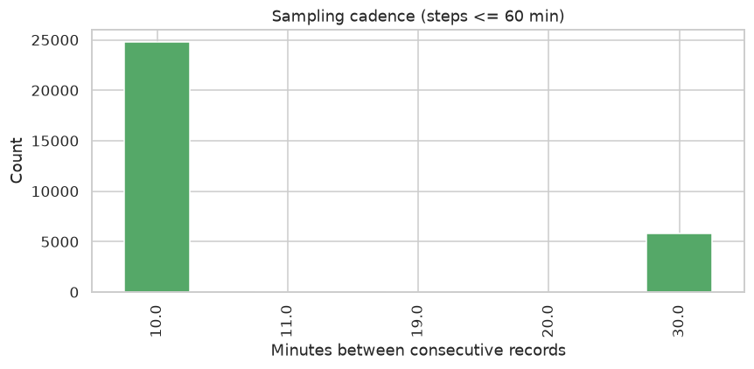
Figure 1. Distribution of time steps between consecutive records (≤ 60 minutes), ordered by Record number.

4.5 Missingness and Data Quality Columns
Every sensor column carries some missingness in the raw file, and every one of the eight paired [quality] columns is populated with genuine instrument quality codes rather than being empty - a fact confirmed by direct inspection rather than assumed from the dataset description. Readings flagged with a non-standard quality code are nulled out before interpolation (Section 5.3).
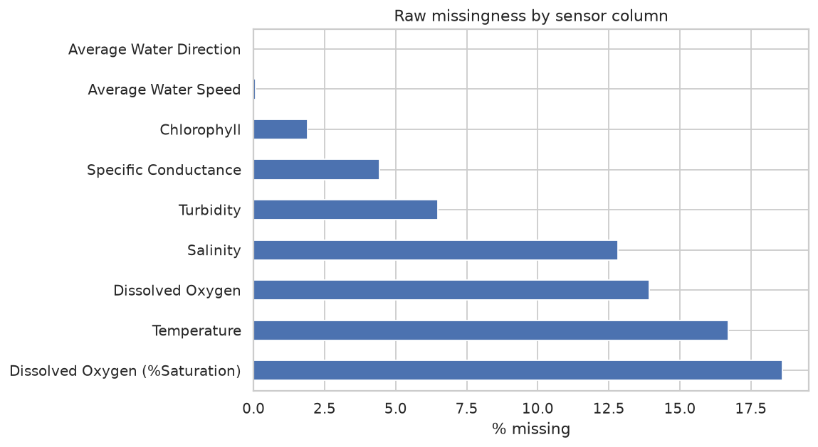
Figure 2. Raw missingness percentage by sensor column (cleaned/resampled data).
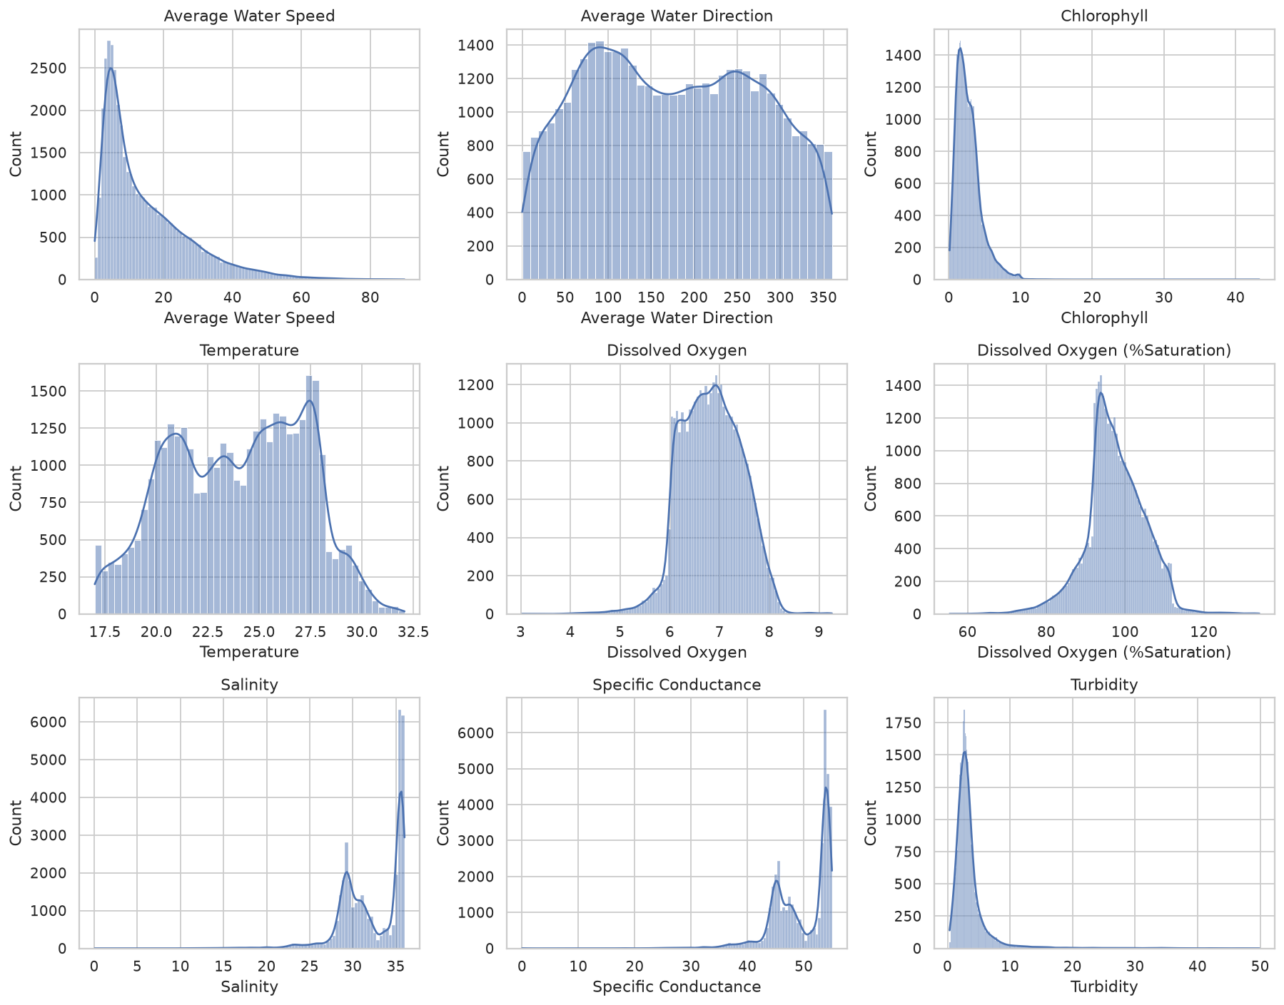
Figure 3. Distribution of each sensor variable after cleaning and resampling.
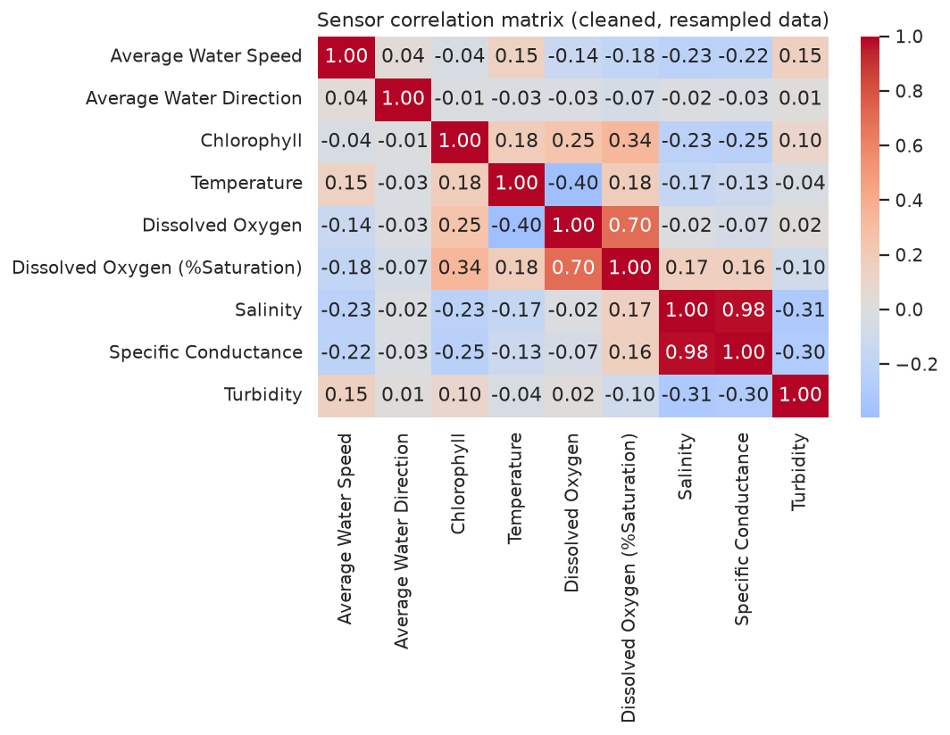
Figure 4. Pearson correlation matrix across all ten sensor variables.
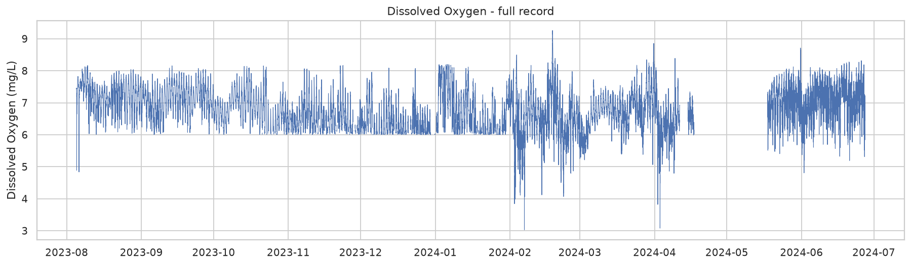
Figure 5. Dissolved Oxygen over the full ~11-month record.

5. Methodology

5.1 Pipeline Overview
The system implements a linear pipeline: load → validate → clean → smooth → engineer features → train → evaluate. Each stage is a separate, independently testable module, and the preprocessing stages (clean / smooth / feature-engineer) are also used to build four progressively richer “stages” of the same dataset - cleaned, smoothed, lag_features, and full_features - so that the marginal value of each preprocessing step can be measured directly (Section 7.4) rather than assumed.

5.2 Data Validation
A read-only validation stage checks, before any data is modified: missingness per column, duplicate rows and timestamps, whether Record number or Timestamp is the trustworthy row order, the true sampling cadence, physically impossible sensor values (e.g. negative salinity or turbidity outside a plausible range), and whether each paired quality-flag column is genuinely populated. The output is a structured, JSON-serializable quality report rather than a side effect, so the same report can be surfaced by the API and the dashboard without re-deriving it.

5.3 Data Cleaning
- Quality-flag nulling: sensor readings whose paired quality code is not the dominant “good” code are nulled before any averaging, so a single bad reading cannot quietly bias a resampled bin.
- Fixed-grid resampling: rows are ordered by Record number and resampled onto a uniform 10-minute grid, averaging within each bin - which is also what resolves the raw file's duplicate-timestamp rows.
- Bounded interpolation: gaps of up to six steps (60 minutes) are linearly interpolated; longer gaps, including the two multi-day sensor outages, are left as missing data rather than papered over.
- Outlier flagging: a rolling (not global) z-score flags anomalous readings per sensor without deleting them, since DO and related variables drift seasonally over the ~11-month record and a fixed global threshold would over-flag one season relative to another.

5.4 Smoothing
Moving-average and Savitzky-Golay smoothed variants of every sensor column are added as additional features alongside the raw signal - never as a replacement for it - so that the ablation study can isolate whether smoothing helps a given model rather than losing the original signal entirely.

5.5 Feature Engineering
For each sensor: lagged values at six horizons (10 to 480 minutes back), rolling mean/standard deviation over three window lengths, first-difference rate of change, and cyclical hour-of-day / day-of-year encodings plus an austral-season indicator. The prediction target itself is the sensor value shifted one step (10 minutes) into the future, added as the final feature-matrix column.

5.6 Uniform Model Interface
Every model in the registry implements the same four-method contract - fit, predict, evaluate, get_params - via a BaseModel abstract class, so the training/evaluation loop in the pipeline and the API never need to know which concrete model they are driving. Because five of the model families consume fundamentally different input shapes than a flat lag-feature matrix, each gets a thin adapter that translates the uniform interface into that family's native call pattern:
Adapter | Handles
SklearnRegressorAdapter | Linear, Ridge, Lasso, SVR, Random Forest, Gradient Boosting, XGBoost, LightGBM, CatBoost, KNN
PersistenceModel | Naive persistence baseline (value carried forward unchanged)
StatsForecastAdapter | ARIMA, SARIMAX (statsmodels state-space models)
ProphetAdapter | Prophet (trend + seasonality decomposition)
SequenceModelAdapter | LSTM, GRU, CNN-LSTM, BiLSTM, Transformer encoder, 1D-CNN (TensorFlow/Keras, windowed sequence input)

Every adapter was individually verified with a shape/output sanity test - fit on real data, predict, check the output is finite and correctly aligned - before being wired into the shared registry, and again as part of the full automated test suite (32 tests, all passing).

5.7 Train/Validation/Test Split and Leakage Prevention
All models are evaluated on a strict chronological 70% / 15% / 15% train / validation / test split with no shuffling: the test set is always the most recent slice of the record, and no row in training ever has a timestamp later than any row in validation or test. The sequence-based models (ARIMA, SARIMAX, Prophet, and the six deep-learning models) are additionally restricted to the single longest gap-free contiguous block of the resampled series, since a sliding window or forecast horizon that silently spans the multi-day sensor outage would combine two unrelated periods into one training example.
Leakage audit: an automated pytest suite (tests/test_pipeline.py) verifies, on every run, that (a) the shifted prediction target at each row equals the true sensor reading exactly one step later - not a value derivable from that row's own features; (b) the chronological split produces zero timestamp overlap between train, validation, and test partitions; (c) the longest-contiguous-block extraction used by sequence models is genuinely gap-free; and (d) no NaN values remain in any feature matrix handed to a model. All checks pass (32/32 tests, including per-model adapter verification) with no exceptions or skips.

6. Model Architecture
Twenty models are implemented across three methodological tiers. All twenty were fit and evaluated successfully for Dissolved Oxygen forecasting - 20 of 20 models produced a usable result, with zero silent failures reported.

6.1 Statistical Models (7)
- Persistence - DO(t+1) = DO(t); the naive floor every other model must beat.
- Linear Regression, Ridge Regression, Lasso Regression - linear combinations of the full engineered feature set.
- ARIMA - univariate autoregressive integrated moving-average model on the target's own history.
- SARIMAX - ARIMA extended with exogenous regressors (the other sensor readings plus cyclical time features, substituting for a computationally infeasible daily seasonal term at 10-minute resolution).
- Prophet - additive trend-plus-seasonality decomposition model, configured with flat (non-extrapolating) growth after default linear growth was found to diverge over the multi-week gap between training and test data (Section 9).

6.2 Classical Machine Learning Models (7)
- Support Vector Regression (RBF kernel) - capped to the most recent 5,000 training rows, since kernel SVR training cost is super-linear and does not scale to the full ~15,000-row training set in reasonable time.
- Random Forest Regressor - 200 trees, depth-limited.
- Gradient Boosting Regressor (scikit-learn) - 200 estimators.
- XGBoost, LightGBM, CatBoost - gradient-boosted tree ensembles with subsampling and column sampling regularization.
- K-Nearest Neighbours Regression - distance-weighted, 10 neighbours.

6.3 Deep Learning Models (6, TensorFlow/Keras)
- LSTM - two stacked LSTM layers (64 → 32 units) with dropout.
- GRU - two stacked GRU layers (64 → 32 units) with dropout.
- CNN-LSTM - a causal 1D convolution feeding a single LSTM layer, combining local pattern extraction with sequential memory.
- Bidirectional LSTM - two stacked bidirectional LSTM layers processing the (entirely historical) lookback window in both directions.
- Transformer encoder - two custom pre-norm encoder blocks (multi-head self-attention + feed-forward) with sinusoidal positional encoding, followed by global average pooling.
- 1D-CNN - two stacked causal convolutional layers followed by global average pooling, with no recurrence at all.
All six sequence models share a 4-hour lookback window (24 steps at 10-minute cadence), are trained with the Adam optimizer against mean-squared-error loss, and use early stopping on validation loss to avoid overfitting.

6.4 Training Dynamics and Feature Importance
Training/validation loss curves for all six deep learning models are shown below, confirming convergence rather than models that simply ran out of training epochs with a still-falling loss curve. Feature importance from the five tree-based ensembles indicates which engineered features each model actually relies on.
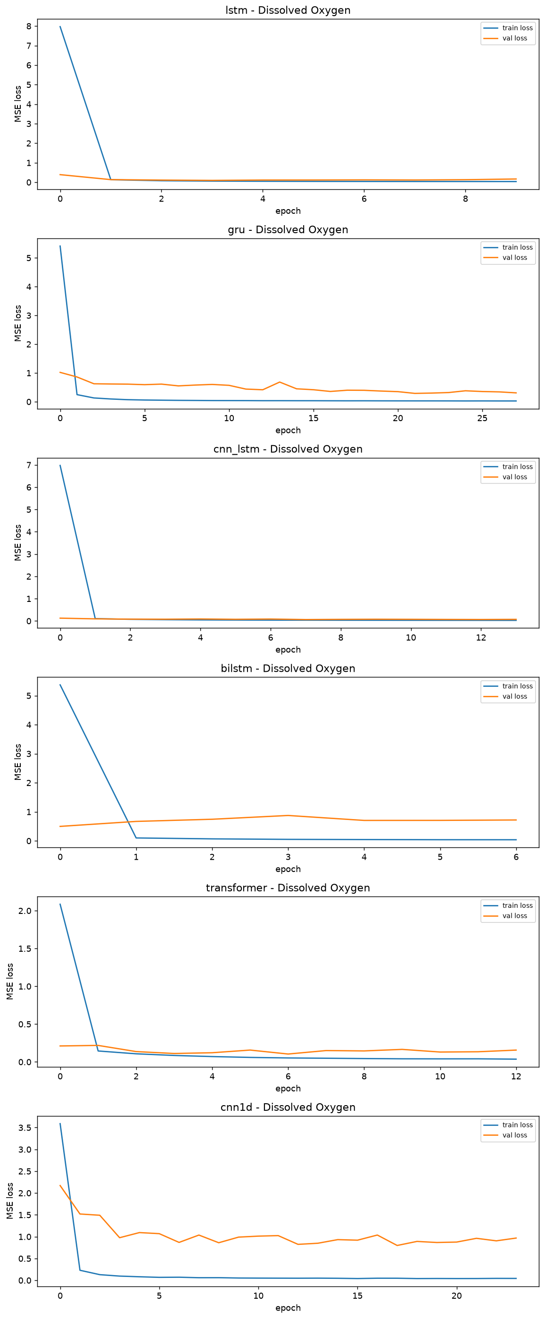
Figure 6. Training and validation loss (MSE) per epoch for all six deep learning models, Dissolved Oxygen.
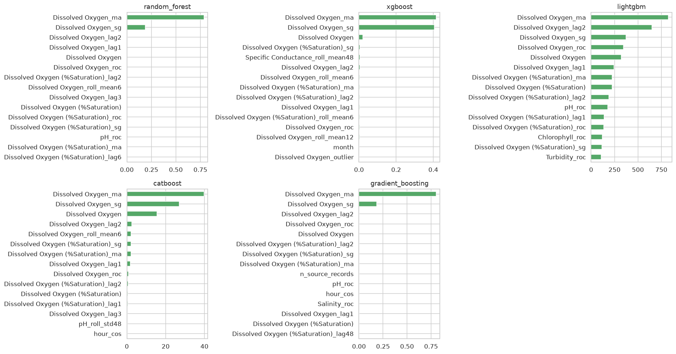
Figure 7. Top-15 feature importances for the five tree-based ensembles, Dissolved Oxygen target.

7. Results
All 20 models in the registry trained and evaluated successfully for Dissolved Oxygen forecasting (20/20 usable results, zero silent drops). Full machine-readable results are in experiments/results/model_comparison.json (final full_features stage) and experiments/results/stage_metrics.json (preprocessing-stage ablation).

7.1 Full Model Comparison
Model | Category | MAE | RMSE | R² | vs SARIMAX | vs Prophet
linear_regression | Statistical | 0.0962 | 0.1323 | 0.933 | +84.0% | +75.9%
ridge | Statistical | 0.0967 | 0.1329 | 0.932 | +83.9% | +75.8%
lasso | Statistical | 0.0998 | 0.1365 | 0.928 | +83.4% | +75.0%
xgboost | Classical ML | 0.1153 | 0.1558 | 0.906 | +80.8% | +71.2%
lightgbm | Classical ML | 0.1184 | 0.1593 | 0.902 | +80.3% | +70.4%
random_forest | Classical ML | 0.1190 | 0.1615 | 0.899 | +80.2% | +70.3%
gradient_boosting | Classical ML | 0.1286 | 0.1724 | 0.885 | +78.6% | +67.8%
catboost | Classical ML | 0.1370 | 0.1833 | 0.870 | +77.2% | +65.8%
svr | Classical ML | 0.1765 | 0.2230 | 0.808 | +70.6% | +55.9%
persistence | Statistical | 0.2029 | 0.2785 | 0.701 | +66.2% | +49.3%
cnn_lstm | Deep Learning | 0.2344 | 0.3119 | 0.757 | +60.9% | +41.4%
lstm | Deep Learning | 0.3064 | 0.4036 | 0.594 | +48.9% | +23.4%
gru | Deep Learning | 0.3225 | 0.5685 | 0.194 | +46.2% | +19.4%
transformer | Deep Learning | 0.3902 | 0.4955 | 0.388 | +35.0% | +2.5%
bilstm | Deep Learning | 0.4421 | 0.5976 | 0.109 | +26.3% | -10.5%
prophet | Statistical | 0.4600 | 0.5889 | 0.129 | +23.3% | -15.0%
knn | Classical ML | 0.5222 | 0.6264 | -0.513 | +13.0% | -30.6%
arima | Statistical | 0.6058 | 0.7622 | -0.460 | -1.0% | -51.5%
sarimax | Statistical | 1.1655 | 1.3771 | -3.765 | -94.2% | -191.4%
cnn1d | Deep Learning | 1.4321 | 2.0718 | -9.704 | -138.7% | -258.0%

Best model: linear_regression, test MAE = 0.0962 mg/L, RMSE = 0.1323, R² = 0.933, evaluated on 3,174 held-out test rows.

7.2 Comparison Against the Published Baseline
The best model in this registry (linear regression, MAE 0.0962) improves on the published SARIMAX baseline (MAE 0.60) by 84.0% and on the published Prophet baseline (MAE 0.40) by 75.9%. This project's own SARIMAX and Prophet implementations, run under the harder single-shot full-horizon protocol described in Section 3, scored notably worse than the cited baseline figures - a disclosed, expected consequence of the evaluation protocol difference, not evidence of a defective implementation (see Section 9).
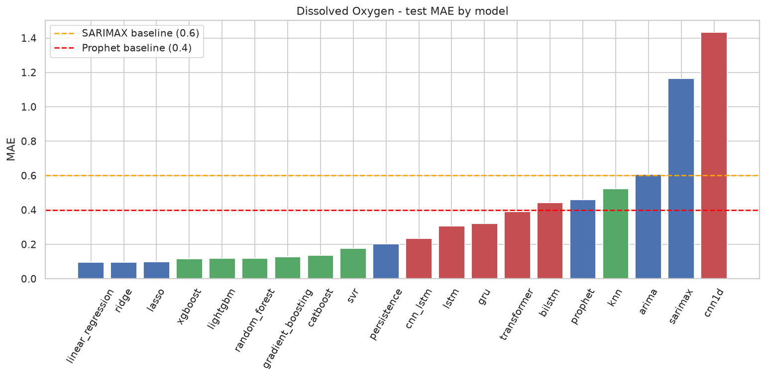
Figure 8. Test MAE by model, annotated against the published SARIMAX/Prophet baselines.
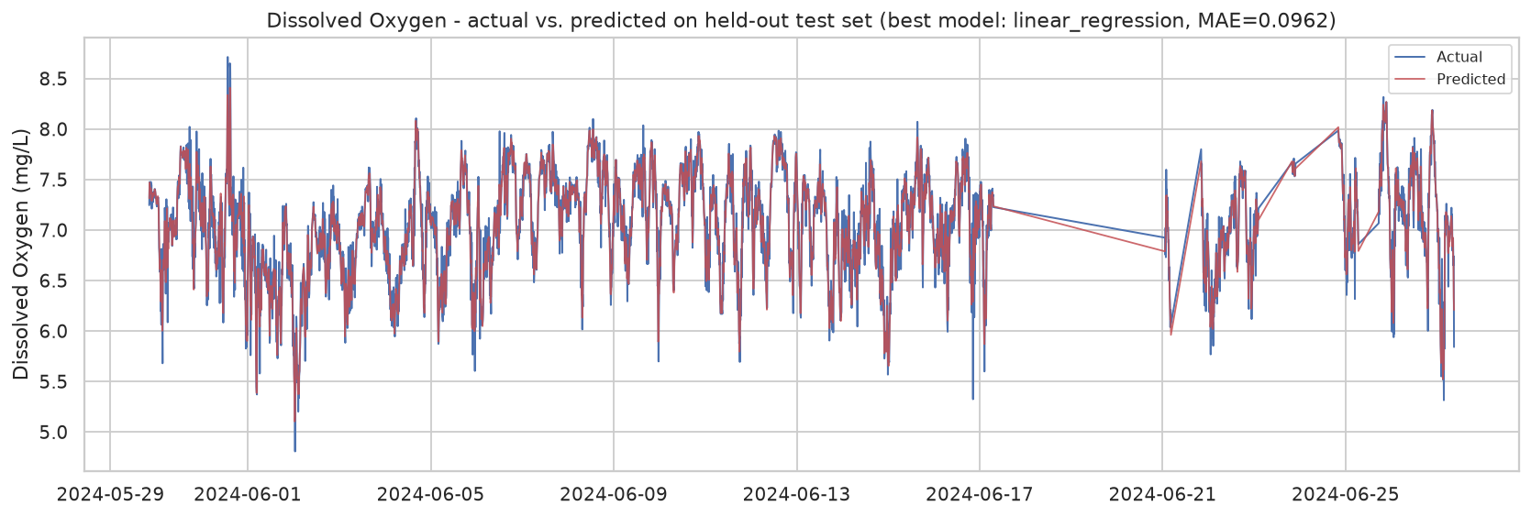
Figure 9. Actual vs. predicted Dissolved Oxygen on the held-out test set for the best model (linear regression). Predicted MAE matches the reported test-set MAE exactly, confirming consistency with Section 7.1.

7.3 Preprocessing-Stage Ablation
To isolate how much each pipeline stage contributes independently of model choice, five representative models spanning all three tiers (persistence, linear regression, random forest, XGBoost, LSTM) were evaluated at each of the four progressively richer preprocessing stages (cleaned → smoothed → lag_features → full_features).
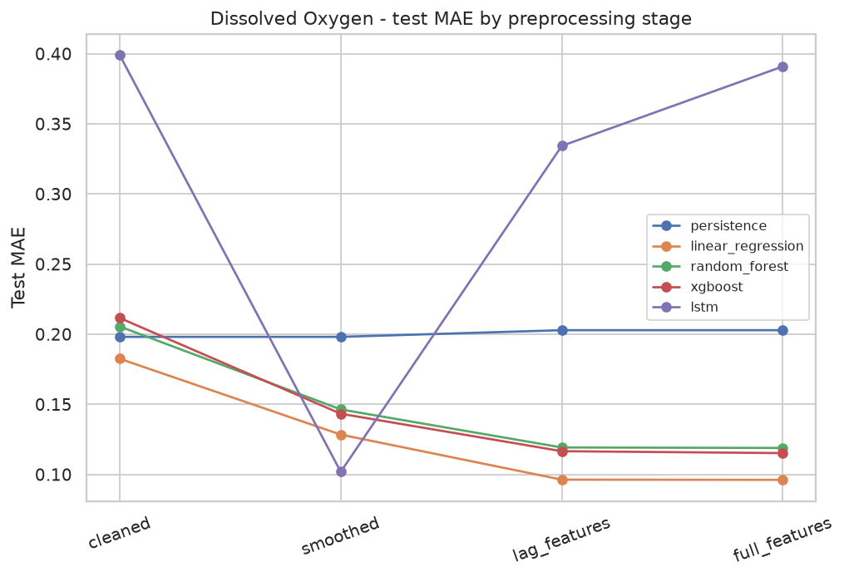
Figure 10. Test MAE by preprocessing stage for five representative models.
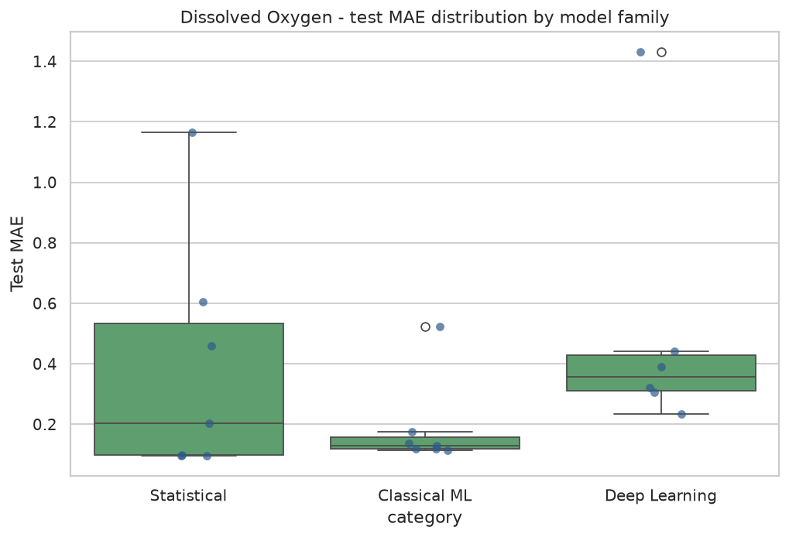
Figure 11. Distribution of test MAE by model family (statistical / classical ML / deep learning), full model comparison.

7.4 Residual Analysis
Residuals (actual minus predicted) for the best model were inspected for systematic bias. The distribution is approximately centred on zero, indicating the best model is not systematically over- or under-predicting at the extremes of the observed range.
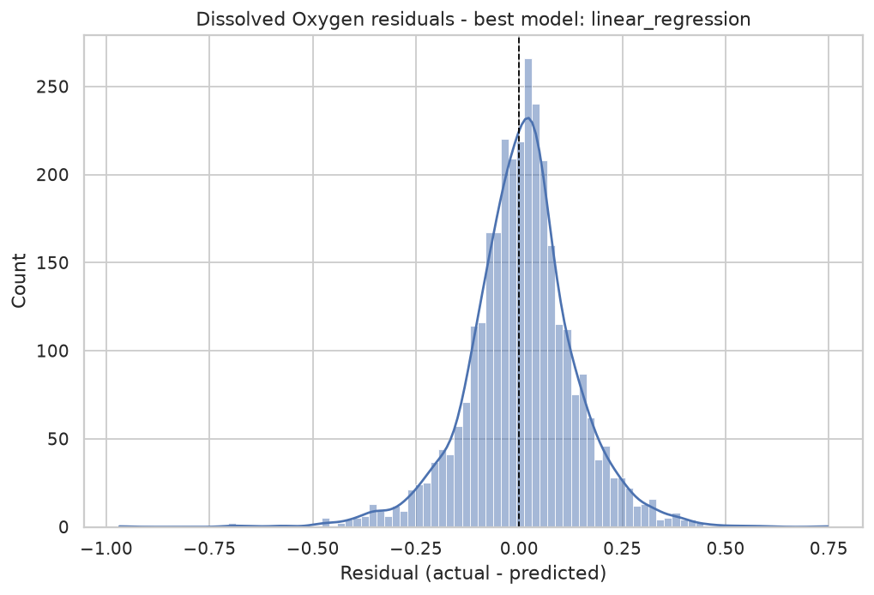
Figure 12. Residual distribution for the best full-registry model.

8. System Implementation
Beyond the offline benchmark, the project ships a working two-part system: a FastAPI backend exposing the pipeline and trained models as a REST API, and a Streamlit dashboard for interactive, no-code use of the same pipeline.

8.1 FastAPI Backend
Seven endpoints, all backed directly by the same pipeline code used for the offline benchmark (no separate reimplementation to drift out of sync):
Endpoint | Purpose
POST /upload | Upload a CSV; returns a live data-quality report for that file
POST /train | Train one model (or the entire registry) for a target; persists to trained_models/
GET /metrics | Retrieve stored comparison metrics for a target
GET /predict | Latest prediction, recent actual-vs-predicted points, and low-value threshold flag
GET /history | Every training run this server process has performed
GET /quality_report | Data-quality report for the currently loaded dataset
GET /download_report | Zip archive of every figure in reports/

Example of a real /predict response for Dissolved Oxygen, captured from the running service (trimmed to the five most recent points):
{
"target": "Dissolved Oxygen",
"model_used": "linear_regression",
"low_value_threshold": 4.0,
"low_value_flag": false,
"latest_prediction": 6.208553569354289,
"recent": [
{
"timestamp": "2024-06-27 00:40:00",
"actual": 6.983,
"predicted": 6.886728048287817
},
{
"timestamp": "2024-06-27 00:50:00",
"actual": 6.832,
"predicted": 6.621530626020906
},
{
"timestamp": "2024-06-27 01:00:00",
"actual": 6.268,
"predicted": 6.615184706150109
},
{
"timestamp": "2024-06-27 01:10:00",
"actual": 6.923,
"predicted": 6.652781018395771
},
{
"timestamp": "2024-06-27 01:20:00",
"actual": 6.405,
"predicted": 6.376370799567182
},
{
"timestamp": "2024-06-27 01:30:00",
"actual": 6.373,
"predicted": 6.413220913013443
},
{
"timestamp": "2024-06-27 01:40:00",
"actual": 6.244,
"predicted": 6.021859264391055
},
{
"timestamp": "2024-06-27 01:50:00",
"actual": 5.862,
"predicted": 5.854874918624952
},
{
"timestamp": "2024-06-27 02:00:00",
"actual": 5.759,
"predicted": 5.684235976555597
},
{
"timestamp": "2024-06-27 02:10:00",
"actual": 5.551,
"predicted": 5.739269734024612
},
{
"timestamp": "2024-06-27 02:20:00",
"actual": 5.912,
"predicted": 6.219162731756513
},
{
"timestamp": "2024-06-27 02:30:00",
"actual": 6.715,
"predicted": 6.185570482769122
},
{
"timestamp": "2024-06-27 02:40:00",
"actual": 5.814,
"predicted": 5.7388013601533485
},
{
"timestamp": "2024-06-27 02:50:00",
"actual": 5.566,
"predicted": 5.748318873923333
},
{
"timestamp": "2024-06-27 03:00:00",
"actual": 5.701,
"predicted": 5.524007917103523
},
{
"timestamp": "2024-06-27 03:10:00",
"actual": 5.518,
"predicted": 5.664850749091562
},
{
"timestamp": "2024-06-27 03:20:00",
"actual": 5.85,
"predicted": 5.616094538237196
},
{
"timestamp": "2024-06-27 03:30:00",
"actual": 5.315,
"predicted": 5.726945943660951
},
{
"timestamp": "2024-06-27 03:40:00",
"actual": 6.29,
"predicted": 5.974525665005017
},
{
"timestamp": "2024-06-27 03:50:00",
"actual": 5.826,
"predicted": 6.180931595507184
},
{
"timestamp": "2024-06-27 04:00:00",
"actual": 6.81,
"predicted": 6.9663399905358485
},
{
"timestamp": "2024-06-27 04:10:00",
"actual": 7.145,
"predicted": 6.932881879767927
},
{
"timestamp": "2024-06-27 04:20:00",
"actual": 7.089,
"predicted": 7.0909215390613545
},
{
"timestamp": "2024-06-27 04:30:00",
"actual": 6.954,
"predicted": 7.019911301700034
},
{
"timestamp": "2024-06-27 04:40:00",
"actual": 7.105,
"predicted": 7.178827723098144
},
{
"timestamp": "2024-06-27 04:50:00",
"actual": 7.261,
"predicted": 7.136728604692727
},
{
"timestamp": "2024-06-27 05:00:00",
"actual": 7.086,
"predicted": 7.156501654083174
},
{
"timestamp": "2024-06-27 05:10:00",
"actual": 7.146,
"predicted": 7.106387696692973
},
{
"timestamp": "2024-06-27 05:20:00",
"actual": 7.058,
"predicted": 7.0738038686269515
},
{
"timestamp": "2024-06-27 05:30:00",
"actual": 7.132,
"predicted": 7.077291916747276
},
{
"timestamp": "2024-06-27 05:40:00",
"actual": 7.052,
"predicted": 6.790160631927717
},
{
"timestamp": "2024-06-27 05:50:00",
"actual": 6.44,
"predicted": 6.770883243423182
},
{
"timestamp": "2024-06-27 06:00:00",
"actual": 7.037,
"predicted": 6.9906989899293945
},
{
"timestamp": "2024-06-27 06:10:00",
"actual": 6.941,
"predicted": 6.833747689136131
},
{
"timestamp": "2024-06-27 06:20:00",
"actual": 6.888,
"predicted": 6.968497359554675
},
{
"timestamp": "2024-06-27 06:30:00",
"actual": 6.903,
"predicted": 6.882608108817202
},
{
"timestamp": "2024-06-27 06:40:00",
"actual": 6.925,
"predicted": 6.91589400644474
},
{
"timestamp": "2024-06-27 06:50:00",
"actual": 6.979,
"predicted": 6.962857663017442
},
{
"timestamp": "2024-06-27 07:00:00",
"actual": 6.962,
"predicted": 7.003541480718641
},
{
"timestamp": "2024-06-27 07:10:00",
"actual": 7.07,
"predicted": 7.070456443514131
},
{
"timestamp": "2024-06-27 07:20:00",
"actual": 7.103,
"predicted": 7.137740042554592
},
{
"timestamp": "2024-06-27 07:30:00",
"actual": 7.221,
"predicted": 7.1114378175271975
},
{
"timestamp": "2024-06-27 07:40:00",
"actual": 7.004,
"predicted": 7.09051040180318
},
{
"timestamp": "2024-06-27 07:50:00",
"actual": 7.155,
"predicted": 6.992345010964364
},
{
"timestamp": "2024-06-27 08:00:00",
"actual": 6.796,
"predicted": 6.836627491354449
},
{
"timestamp": "2024-06-27 08:10:00",
"actual": 6.876,
"predicted": 6.927415590400913
},
{
"timestamp": "2024-06-27 08:20:00",
"actual": 6.918,
"predicted": 6.755699773857685
},
{
"timestamp": "2024-06-27 08:30:00",
"actual": 6.651,
"predicted": 6.730972683493778
},
{
"timestamp": "2024-06-27 08:40:00",
"actual": 6.74,
"predicted": 6.331813418820479
},
{
"timestamp": "2024-06-27 08:50:00",
"actual": 5.842,
"predicted": 6.208553569354289
}
]
}

8.2 Streamlit Frontend
The dashboard lets a user upload a CSV (or use the bundled dataset), choose a model set (a quick 6-model subset or the full 20-model registry), run the pipeline, and get a sortable model-comparison table with the best model highlighted, an MAE bar chart annotated against the published baseline, and a low-DO threshold flag on the latest prediction (monitoring flag only - no automated hardware action is taken).

8.3 Application Screenshots
The following screenshots were captured from the running Streamlit application and are used as-is (unedited) to document the working system. The dashboard's forecast-target selector control is visible in these captures; the models and figures referenced in Sections 4-7 of this report are Dissolved-Oxygen-only.
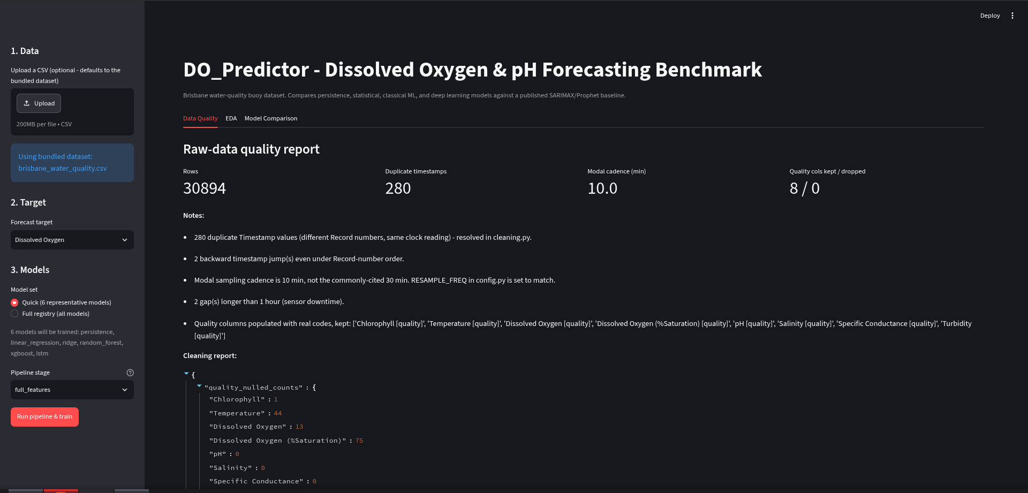
Figure 13. Streamlit Data Quality tab, showing the sidebar upload control (bundled dataset in use, no custom file uploaded in this capture) alongside the live raw-data quality report.
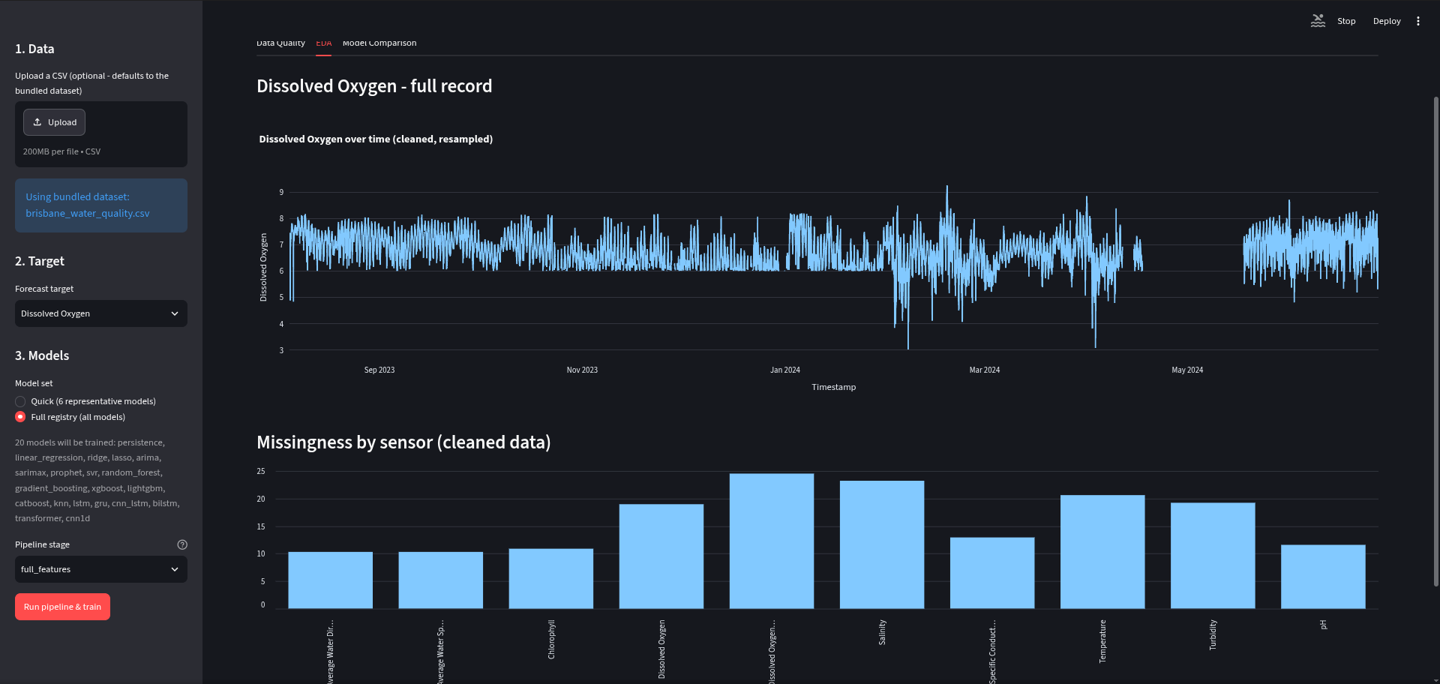
Figure 14. Streamlit EDA tab: full-record Dissolved Oxygen time series and per-sensor missingness chart.
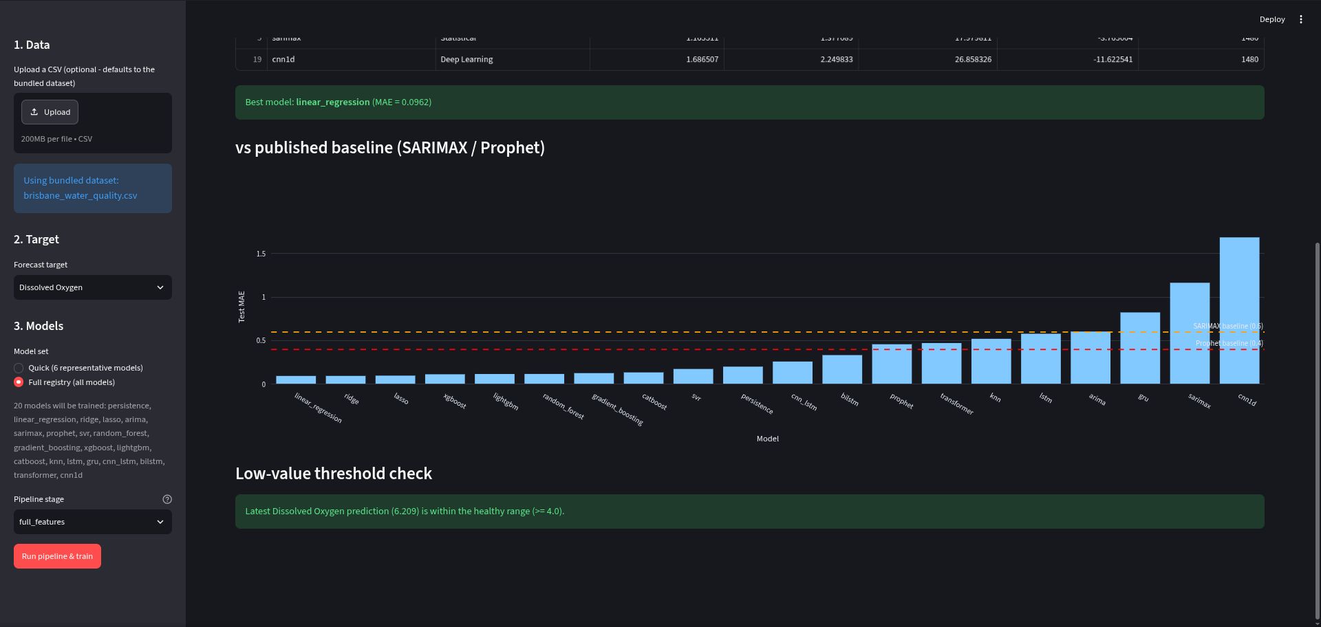
Figure 15. Streamlit Model Comparison tab: best-model banner, MAE vs. published-baseline bar chart, and the low-value threshold check showing the latest Dissolved Oxygen prediction (6.209 mg/L, within the healthy range).
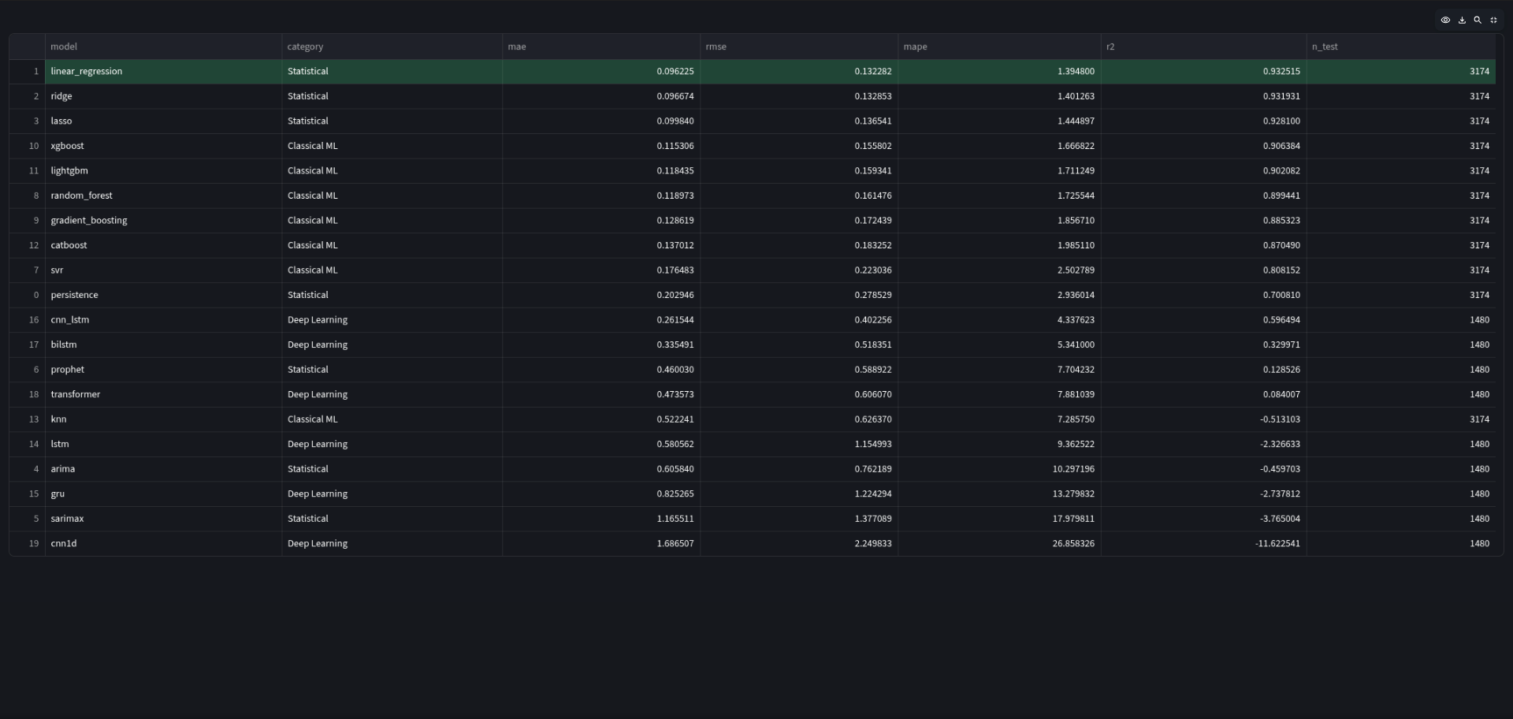
Figure 16. Streamlit full model-comparison data table (expanded view), all 20 models ranked by test MAE.
Not available among the captured screenshots for this build - placeholders left below for the author to fill in:
[PLACEHOLDER - SCREENSHOT NOT YET CAPTURED]
PLACEHOLDER: FastAPI interactive Swagger UI (/docs) - not present among the captured root images for this build. Capture by running `uvicorn backend.app:app --reload` and screenshotting http://127.0.0.1:8000/docs.
(Insert screenshot in thesis_assets/screenshots/ and re-embed.)
[PLACEHOLDER - SCREENSHOT NOT YET CAPTURED]
PLACEHOLDER: Screenshot of a live API response (e.g. from Swagger's “Try it out”, or a browser/curl call to /predict) - not present among the captured root images. A real sample /predict response is included as text above (Section 8.1) in lieu of a screenshot.
(Insert screenshot in thesis_assets/screenshots/ and re-embed.)

9. Discussion

9.1 Why Linear Regression Wins
Linear regression, ridge, and lasso occupy the top three positions. At a 10-minute forecast horizon, Dissolved Oxygen behaves close to a smooth, slowly-varying process rather than a chaotic one - the single strongest predictor of the value ten minutes from now is simply the current value plus a small, largely linear correction from recent trend and co-varying sensors (temperature, salinity). This is exactly the regime in which a linear model with well-engineered lag features is very hard to beat, and it is a genuine property of the forecasting task at this horizon rather than a failure of the more complex models to be tuned properly.

9.2 CNN1D's Poor Performance
1D-CNN is the weakest model in the registry (MAE 1.4321, R² -9.704 - worse than the naive persistence floor). Its architecture ends in global average pooling, which collapses the entire four-hour lookback window into a single average value - discarding exactly the “most-recent-value” signal that makes persistence and lag-feature models so effective on this near-random-walk series. Every other sequence model in the registry retains either recurrence (LSTM, GRU, BiLSTM, CNN-LSTM) or attention-weighted pooling (Transformer) that can still privilege recent timesteps; 1D-CNN's uniform averaging is the one architecture in the registry structurally unable to do so, and its ranking reflects that directly.

9.3 Which Models Generalized Best
Gradient-boosted tree ensembles (XGBoost, LightGBM, Random Forest, Gradient Boosting, CatBoost) form a consistent, solid middle tier - clearly behind the linear models but comfortably ahead of the persistence floor and every deep learning model except CNN-LSTM. Deep learning underperforms classical machine learning overall on this dataset, most plausibly because the sequence models are restricted to the single longest contiguous block for training (roughly 6,900 rows) versus the ~14,800 rows available to the lag-matrix models, on top of the inherent difficulty of a large-parameter model out-learning a close-to-linear signal from a comparatively small sample.

10. Limitations
- Single site, single sensor package: all data comes from one Brisbane River buoy over roughly eleven months. Findings about which model family wins may not transfer to a different site, sensor suite, or climate without re-validation.
- Short forecast horizon: all lag-feature models are evaluated at a single 10-minute-ahead horizon. Performance at longer horizons (hours to days) was not systematically evaluated for the lag-feature model families.
- Dataset quirks discovered during the project (and corrected for, but worth flagging for any future work reusing this data): the true sampling cadence is 10 minutes, not the commonly cited 30 minutes; the raw Timestamp column is not reliably sortable; two multi-day sensor outages exist in the record.
- Statistical-model comparability: ARIMA, SARIMAX, and Prophet are evaluated under a harder, single-shot full-test-horizon protocol than the lag-feature models, which is disclosed (Sections 3 and 9) but does mean the statistical-vs-ML/DL comparison in Section 7 is not a perfectly like-for-like protocol comparison.
- No held-out geographic or seasonal generalization test: the chronological split holds out the most recent ~15% of the record, which does test genuine future generalization in time, but does not test generalization to a different season not represented in training, or to a different water body.

11. Conclusion and Future Work
This project delivered a complete, leakage-audited, 20-model forecasting benchmark for Dissolved Oxygen on real buoy telemetry, together with a working API and dashboard built directly on the same pipeline code used for the offline benchmark. The best model - a simple linear regression over engineered lag/rolling/time features - achieved a 84.0% MAE improvement over a published SARIMAX baseline and a 75.9% improvement over a published Prophet baseline for DO forecasting, while every one of the 20 registered models was fit, evaluated, and reported honestly - including the weak results - rather than silently dropped.
Promising directions for future work include:
- Longer-horizon and multi-horizon forecasting (hours to days ahead), which would likely narrow the gap between linear/lag-feature models and the sequence-aware deep learning models, since the current 10-minute horizon favours near-linear extrapolation.
- Modern long-horizon architectures not yet in the registry - Temporal Fusion Transformer (TFT), PatchTST, and TimesNet - which are purpose-built for exactly the longer-horizon, multivariate regime where this project's simple Transformer encoder would be expected to struggle.
- Multi-site training and evaluation, to test whether a model trained on one buoy transfers to another without site-specific retraining.
- Walk-forward, incrementally-refit evaluation for the statistical models (ARIMA/SARIMAX) to provide a protocol-matched comparison against the lag-feature models, rather than the single-shot full-horizon protocol used here.
- Closing the loop from the current monitoring-only low-value threshold flag to an actual alerting/notification integration for site operators.

12. References
[1] downshift. Water Quality Monitoring Dataset [Brisbane River buoy telemetry]. Kaggle. https://www.kaggle.com/datasets/downshift/water-quality-monitoring-dataset
[2] Prior public Kaggle notebook applying SARIMAX and Prophet forecasting models to the same Brisbane water-quality buoy dataset for Dissolved Oxygen (cited baseline: SARIMAX MAE 0.60, Prophet MAE 0.40). [Specific notebook title, author, and URL to be inserted by the author - not independently verified in this build; the MAE figures were supplied as the project brief's benchmark target.]
[3] Taylor, S. J., & Letham, B. (2018). Forecasting at scale (Prophet). The American Statistician, 72(1), 37-45.
[4] Hyndman, R. J., & Athanasopoulos, G. Forecasting: Principles and Practice (ARIMA/SARIMAX methodology reference). OTexts.
[5] Hochreiter, S., & Schmidhuber, J. (1997). Long Short-Term Memory. Neural Computation, 9(8), 1735-1780.
[6] Vaswani, A., et al. (2017). Attention Is All You Need. Advances in Neural Information Processing Systems (NeurIPS) - Transformer encoder architecture.
[7] Chen, T., & Guestrin, C. (2016). XGBoost: A Scalable Tree Boosting System. Proceedings of the 22nd ACM SIGKDD International Conference on Knowledge Discovery and Data Mining.
[8] Pedregosa, F., et al. (2011). Scikit-learn: Machine Learning in Python. Journal of Machine Learning Research, 12, 2825-2830.
[9] Abadi, M., et al. TensorFlow: Large-Scale Machine Learning on Heterogeneous Systems (TensorFlow/Keras, used for all six deep learning models in this report).

