**Open AI**

**#1: black and white clip art sticker of a meat platter**

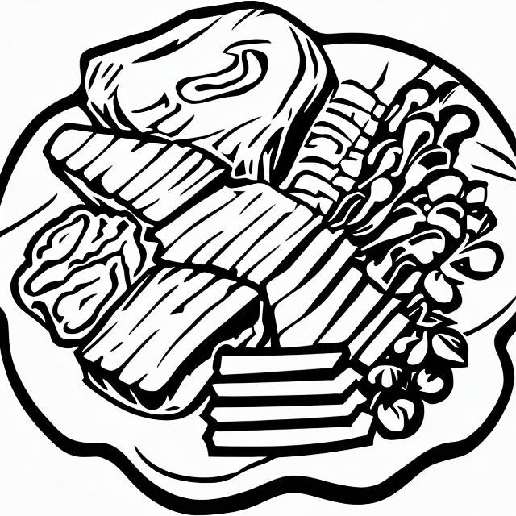 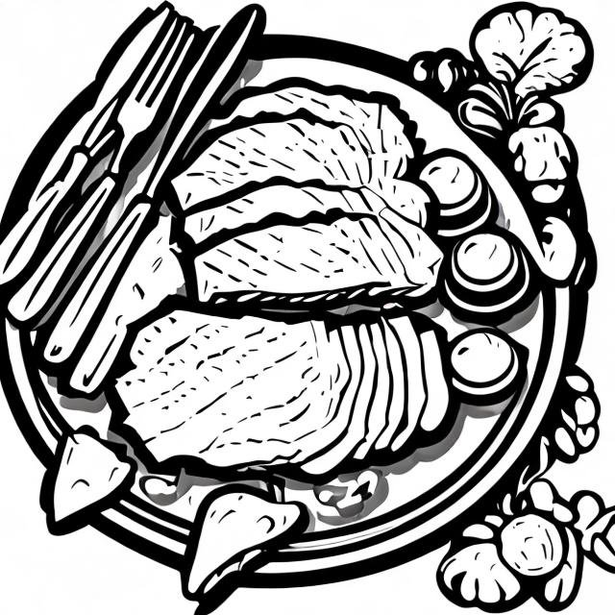

While both designs gave me what I asked for, I’m not sure a student would get the word ‘meat’ from either of these without more context. I actually tried this prompt several times, adding more and more detail. This was the best it got.

**Features :**

* Generates 2 designs for every prompt
* Both images used the same art style and color palate.
* Automatically saves all the images you create, including the prompts
* You can create folders to organize your images.
* Images are around 300 kb and can be downloaded with no watermark.
* Time to create images varied from around 15 seconds to over a minute.
* You can include negative prompts (i.e., words to exclude from the image)
* **Style**: Highly detailed, semi-realistic with artistic enhancements.
* **Strengths**:
  + Strong composition and well-defined elements.
  + Excellent lighting and depth.
  + Fine details with a polished, refined appearance.

**CRAIYON**

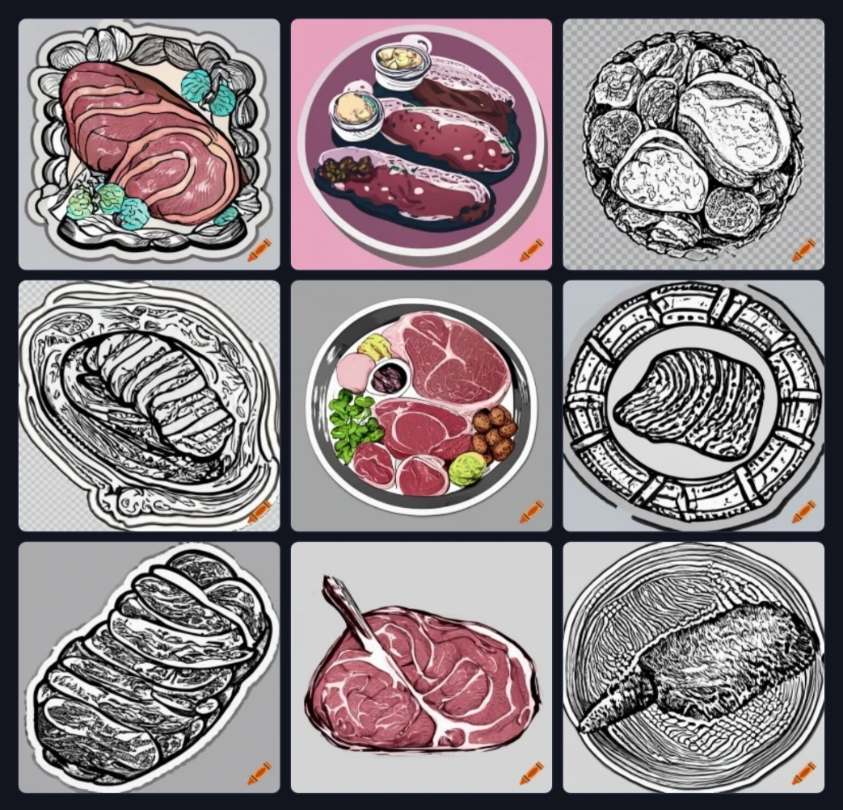

**black and white clip art sticker of a meat platter**

At first glance I liked some of these images. But, as I studied them individually I realized the black and white images are going to be difficult for students to identify as ‘meat’. The color images are better (and may contribute to the overall impression of ‘meat’) but I couldn’t use them on a photocopied handout, and I specifically asked for black and white.

**Features :**

* Choose which category you want to generate: art, drawing, photo, or none
* Generates 9 low-quality images for every prompt (about 1.5 MB for the panel of 9)
* Upscale” any image (i.e., increase its quality to around 150kb) for free - this takes 1-2 minutes per image.
* Images had some stylistic variety but were all in the same artistic genre.
* Free images all include a small logo / watermark
* Ability to include negative prompts (words not to include)
* Images are not saved automatically, but can be saved if you create an account.
* Suggests prompts to refine your images; the suggestions were helpful.
* **Style**: Rougher, sketch-like with limited color depth.
* **Strengths**:
  + Quick generation process.
  + Variety of different perspectives.
  + More artistic and abstract outputs.

**PICSART**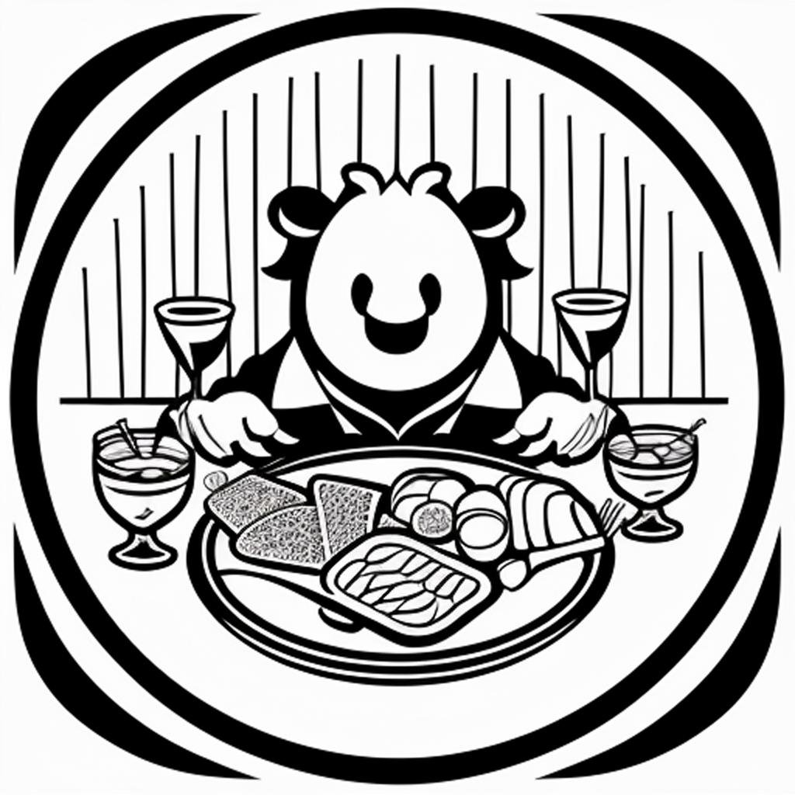

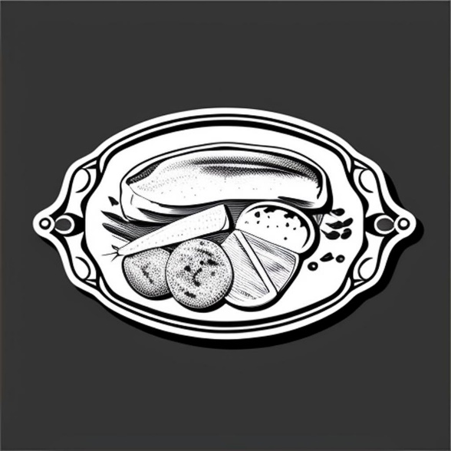

**black and white clip art sticker of a meat platter**

**Features :**

* Generates 4 designs for every prompt, with an option to generate more.
* Images had the most variety of any site.
* Your work is not saved automatically.
* Images are around 100 kb and can be downloaded with no watermark.
* Generated images the most quickly of any site, in under 20 seconds
* You can include negative prompts (i.e., words to exclude from the image)
* After entering your text, you are prompted to select from a large menu of art styles such as graphite pencil, watercolor, anime, or artists such as Rembrandt, Monet, or Andy Warhol. Each style includes a small thumbnail example.
* **Style**: More cartoonish and stylized, sometimes exaggerated.
* **Strengths**:
  + Bold and expressive.
  + Great for fun, creative projects.
  + Strong use of bold outlines and contrast.

**Comparison Table**

|  |  |  |  |
| --- | --- | --- | --- |
| **Feature** | **OpenAI (DALL·E)** | **Craiyon** | **PicsArt AI** |
| **Realism** | High | Low | Medium |
| **Detail** | Excellent | Moderate | Low |
| **Artistic Style** | Balanced | Sketch-like | Cartoonish |
| **Use Cases** | General creative, professional art | Quick ideas, concept sketches | Fun, stylized artwork |
| **Weaknesses** | Over-enhancing, occasional artifacts | Rough, low-detail | Exaggerated features |