Documentation of use of stylesheets in EHF Invoice and Creditnote

The stylesheet is dynamic, and will show all elements sent on an EHF Invoice or Credit note. If elements are not present in the xml-file they will not display on the stylesheet, neither will the associated heading/text.

# Files used

The stylesheet consists of the following 4 files:

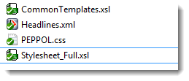

# CSS-file

The path for the PEPPOL.CSS file is referenced in a parameter named pStylesheetDir in Stylesheet_Full.xsl (1)

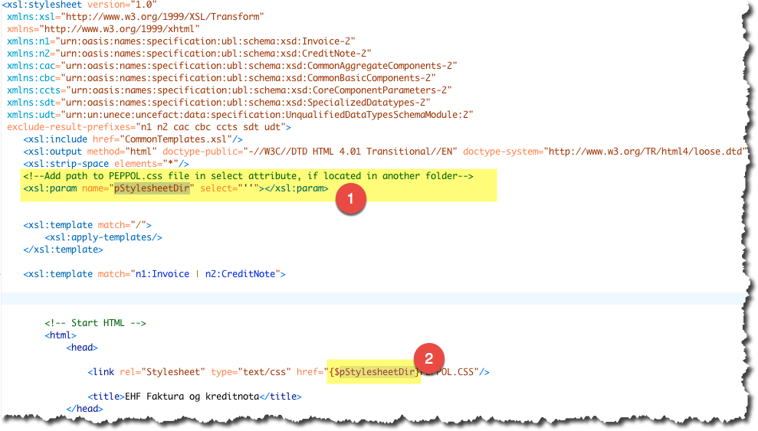

If the PEPPOL.CSS is placed in the same folder as Stylesheet_Full.xsl, the parameter pStylesheetDir can be left empty. If however, there is a need to place the CSS-file in another directory, add the path to the directory where the CSS file is placed (excluding the filename).

Example of path: /Users/Test/EHF-Stylesheet/Docs/

# Referencing the stylesheet

The xml-file must reference the Stylesheet_Full.xsl, like this:

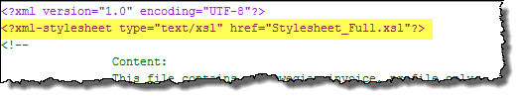

# Language

The stylesheet is set up to show Norwegian headings and text. To change this to English, open the file CommonTemplates.xsl and change the parameter pLang to read select =’en’ instead of ‘no’:

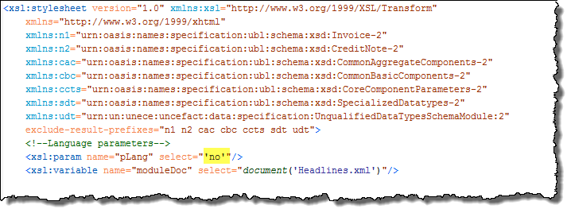

# UnitCodes as text

The stylesheet is set up to be able to show most common unit codes as text, instead of the unit code it self. To use this function, open the CommonTemplates.xsl and change the parameter pUoMText value to be ‘yes’. Default value is ‘not’, which means that the codes, as sent in the file, will be visible in the html.

