Documentation of use of stylesheets in EHF Invoice and Creditnote

The stylesheet is dynamic, and will show all elements sent on an EHF Invoice or Creditnote. If elements are not present in the xml-file they will not display on the stylesheet, neither will the associated heading/text.

The following files, must be placed in the same directory/folder as the EHF xml file:

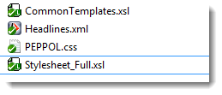

The xml-file must reference the Stylesheet_Full.xsl, like this:

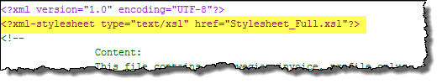

The stylesheet is now set up to show Norwegian headings and text. To change this to English, open the file CommonTemplates.xsl and change the parameter pLang to read select =’en’ instead of ‘no’:

