Project Design Phase
Problem – Solution Fit Template
Field | Details
Date | 04 November 2025
Team ID | NM2025TMID06302
Project Name | Medical Inventory Management System
Maximum Marks | 2 Marks

Problem Solution Fit:
The Problem-Solution Fit simply means that you have found a problem with your customer and that the solution you have realized for it actually solves the customer's problem. It helps entrepreneurs, marketers and corporate innovators identify behavioral patterns and recognize what would work and why.
Purpose:
- Solve complex problems in a way that fits the state of your customers.
- Succeed faster and increase your solution adoption by tapping into existing mediums and channels of behavior.
- Sharpen your communication and marketing strategy with the right triggers and messaging.
- Increase touch-points with your company by finding the right problem-behavior fit and building trust by solving frequent annoyances, or urgent or costly problems.
- Understand the existing situation in order to improve it for your target group.
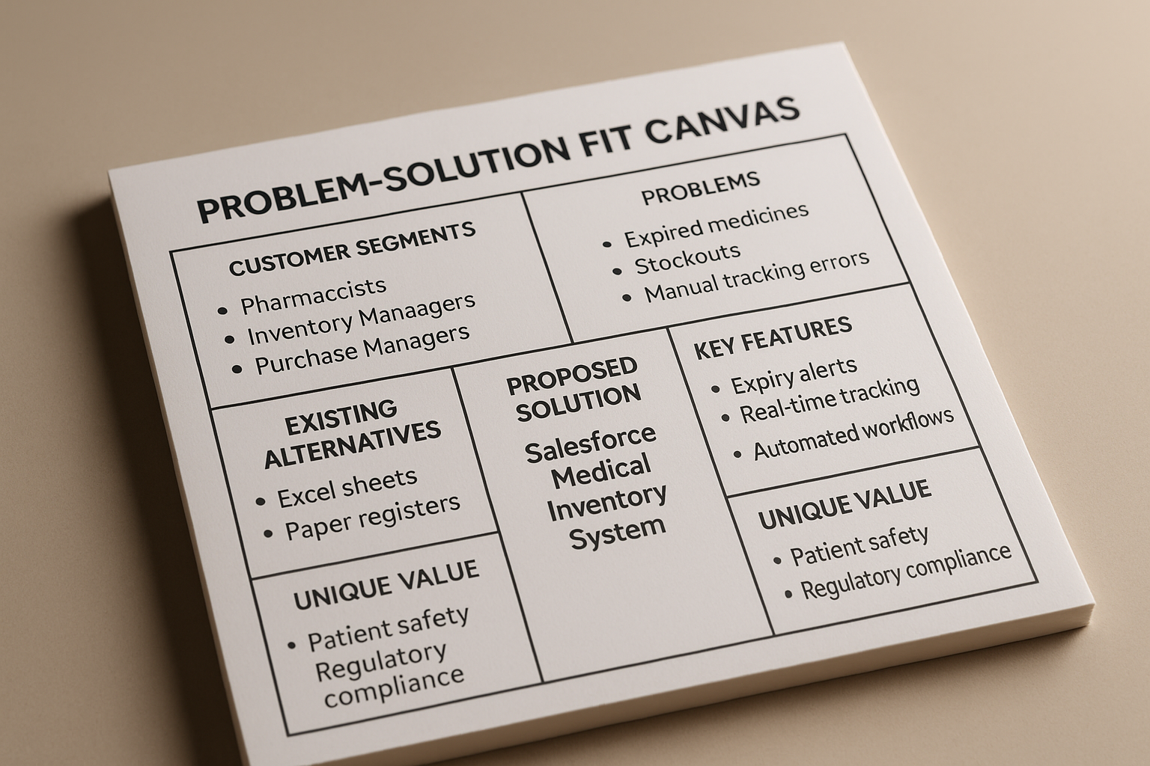

Conclusion:
The project "Medical Inventory Management System" addresses a crucial gap in healthcare operations and patient safety management within medical facilities. By ensuring that no expired medicines are dispensed to patients and critical medical supplies are always available when needed, we significantly improve patient safety, regulatory compliance, and operational efficiency.

This solution not only safeguards healthcare delivery workflows but also supports better resource management, cost optimization, and audit compliance. With the successful implementation of automated expiry monitoring, real-time stock tracking, intelligent purchase order workflows, and comprehensive supplier performance dashboards in Salesforce, this project sets a foundation for building smarter and safer inventory management systems in healthcare environments.
Problem-Solution Fit Analysis:
1. CUSTOMER SEGMENTS
Primary Users:
- Hospital Pharmacists - Manage medicine inventory, ensure patient safety
- Inventory Managers - Track stock levels, prevent shortages
- Purchase Managers - Handle supplier relationships, procurement
- Healthcare Administrators - Monitor costs, ensure compliance
- Warehouse Staff - Manage inventory transactions
2. CUSTOMER PROBLEMS
Problem Category | Problem Description | Pain Intensity | Frequency
Expired Product Risk | Medicines expire without alerts causing waste (₹50,000-₹2,00,000/month) and potential patient safety incidents | Critical | Daily
Stock Shortages | Critical medicines run out unexpectedly during emergencies affecting patient care and treatment delivery | Critical | Weekly
Manual Data Errors | Manual tracking causes 10-15% inventory discrepancies leading to audit failures and compliance issues | High | Daily
Supplier Delays | No visibility into supplier performance causes unpredictable delivery times and emergency purchases at 30-40% premium | High | Monthly
Regulatory Non-Compliance | Missing audit trails and documentation lead to regulatory penalties and license risks | Critical | Quarterly
Excessive Time Waste | Staff spend 60% time on manual paperwork instead of patient care | Medium | Daily

3. EXISTING ALTERNATIVES
Current Solutions Used:
Alternative | Limitations
Excel Spreadsheets | No real-time updates, prone to errors, no automation, difficult multi-user access
Paper Registers | Time-consuming, no search capability, data gets lost, no audit trail
Manual Phone Calls | Inefficient supplier communication, no documentation, delays
Physical Stock Checks | Labor-intensive, only point-in-time accuracy, cannot predict shortages
Email-based PO Tracking | Scattered information, difficult to track status, no centralized visibility

Why They Fail:
- No automated expiry monitoring
- Reactive instead of proactive
- Cannot handle volume/complexity
- Poor data integrity
- No integration between processed
4. PROPOSED SOLUTION
Salesforce-Based Medical Inventory Management System
Core Solution Components:
Component | Solution Feature | Solves Problem
Automated Expiry Monitoring | Flows send alerts at 30, 15, 7 days before expiry; Dashboard highlights expiring products | Prevents expired medicine dispensing; Reduces waste by 90%
Real-Time Stock Tracking | Current stock levels updated automatically; Minimum threshold alerts trigger reorder workflows | Eliminates stockouts; Ensures critical supplies always available
Automated Data Entry | Validation rules prevent errors; Triggers auto-calculate totals; Mobile barcode scanning | Achieves 100% data accuracy; Saves 50% time
Supplier Performance Dashboard | Track on-time delivery %, lead times, quality scores; Comparative analytics | Improves supplier accountability; Enables data-driven negotiations
Complete Audit Trail | Every transaction logged with user, timestamp, before/after values | Ensures regulatory compliance; Passes audits
Purchase Order Automation | Workflows manage approval, notifications, delivery tracking | Reduces PO processing time by 60%; Prevents delays

5. UNIQUE VALUE PROPOSITION
What Makes This Solution Different:
✅ Healthcare-Specific: Built specifically for medical inventory with expiry monitoring and patient safety focus
✅ Native Salesforce: No external plugins required; Cloud-based, mobile-accessible, scalable
✅ Complete Ecosystem: Integrates inventory, purchasing, suppliers, transactions, and reporting in one platform
✅ Automated Intelligence: Proactive alerts prevent problems before they occur
✅ Role-Based Security: HIPAA-ready with profiles, roles, permission sets for compliance
✅ Real-Time Visibility: Dashboards provide instant insights for faster decision-making

PROBLEM-SOLUTION FIT CANVAS:
