Project Design Phase
Proposed Solution
Field | Details
Date | 04 November 2025
Team ID | NM2025TMID06302
Project Name | Medical Inventory Management System
Maximum Marks | 2 Marks

Proposed Solution Template:
S.No. | Parameter | Description
1. | Problem Statement | Problem to be solved:Healthcare organizations struggle with manual medical inventory management, leading to expired product usage, inadequate stock levels, poor supplier tracking, and lack of real-time visibility into inventory transactions. This results in patient safety risks, financial losses, and operational inefficiencies.
2. | Idea | Solution description:A comprehensive Salesforce-based Medical Inventory Management System that automates supplier management, product cataloging, purchase order tracking, expiry monitoring, and transaction management. The system includes custom objects, automated workflows using Flows and Triggers, validation rules for data integrity, role-based access control, and real-time dashboards for inventory visibility and decision-making.
3. | Novelty | Uniqueness:This solution leverages Salesforce's native platform capabilities (Lightning Experience, custom objects, automation tools, security features) to create a healthcare-specific inventory system without requiring external plugins or third-party integrations. The expiry monitoring automation and real-time supplier performance analytics provide unique value for medical facilities.
4. | Social Impact | Customer Satisfaction:Ensures patient safety by preventing expired product usage, maintains optimal stock levels to avoid shortages during critical times, improves healthcare delivery efficiency, reduces wastage through better inventory control, and enhances supplier accountability leading to better service quality in medical facilities.
5. | Business Model | Revenue Model:While the solution is built as a project, it demonstrates cost-saving potential through reduced inventory waste (20-30%), prevention of stockouts, optimized purchasing decisions, and improved supplier negotiations. The system can reduce manual labor costs and minimize compliance risks associated with expired medical products.
6. | Scalability of the Solution | The solution can be extended to include: Multi-location inventory management, integration with hospital management systems, barcode/RFID scanning capabilities, predictive analytics for demand forecasting, automated reordering based on minimum stock levels, temperature-controlled inventory tracking for vaccines, and mobile app access for warehouse staff.
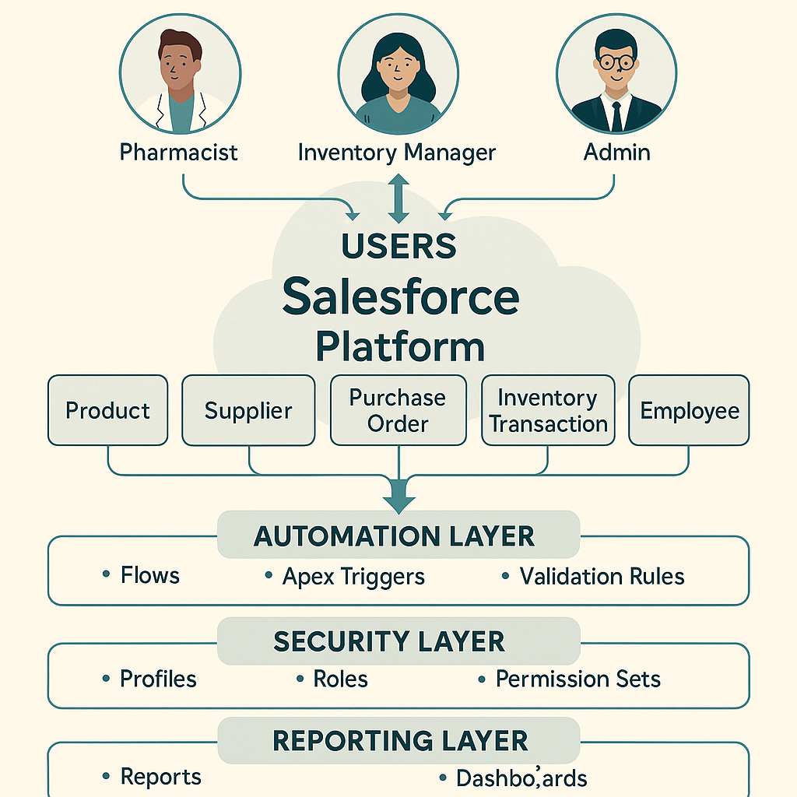

Solution Description:
To streamline medical inventory management in healthcare facilities, a custom Salesforce application is implemented with the following architecture:
Core Components:
- Custom Objects Structure:
  - Supplier Object: Stores supplier details, contact information, performance ratings, and contract terms
  - Product Object: Maintains product catalog with descriptions, stock levels, minimum thresholds, and category classifications
  - Purchase Order Object: Tracks procurement requests, approval workflows, and order fulfillment status
  - Transaction Object: Records all inventory movements (additions, withdrawals, returns, adjustments)
  - Expiry Tracking Object: Monitors product expiration dates with automated alerts
- Automation Layer:
  - Validation Rules: Ensure data integrity (e.g., expiry date must be future date, stock quantity cannot be negative)
  - Flows: Automate processes like low-stock alerts, expiry notifications (30/15/7 days before), automatic reorder point triggers
  - Triggers: Handle complex business logic such as automatic stock level updates after transactions, supplier performance scoring
- Security & Access Control:
  - Profiles: Define base-level access for Admin, Inventory Manager, Pharmacist, Procurement Officer roles
  - Roles: Establish organizational hierarchy for data visibility
  - Permission Sets: Grant specialized access for audit functions, reporting, and system configuration
- Analytics & Reporting:
  - Reports: Supplier performance, expiry summary, stock movement, transaction history, low-stock items
  - Dashboards: Real-time visualization of inventory levels, expiry alerts, purchase order status, supplier metrics
Key Features:
- Expiry Management: Automated email/SMS alerts prevent usage of expired products
- Stock Monitoring: Real-time tracking with automatic reorder suggestions when stock reaches minimum threshold
- Supplier Analytics: Performance scoring based on delivery time, product quality, and pricing
- Audit Trail: Complete transaction history for regulatory compliance
- Mobile Access: Lightning App enables inventory checks and updates from anywhere
Technology Stack:
- Platform: Salesforce Lightning Platform
- Automation: Flow Builder, Apex Triggers
- UI: Lightning App Builder, Custom Page Layouts
- Reporting: Salesforce Reports & Dashboards
- Security: Native Salesforce security model (Profiles, Roles, Permission Sets)
This approach leverages native Salesforce functionality, making it maintainable, scalable, and cost-effective without requiring external plugins or integrations.
Project Implementation Plan:
Milestone | Activity | Description
1.Developer Account Creation | Setup Salesforce Environment | Create Salesforce Developer Edition account and configure basic organizational settings
2.Object Creation | Design Data Model | Create custom objects: Supplier, Product, Purchase Order, Transaction, Expiry Tracking with proper relationships
3. Tab Setup | Configure Navigation | Create custom tabs for each object to enable easy navigation
4. Lightning App Setup | Build Application Container | Create "Medical Inventory" Lightning App with branding and navigation items
5.Field Definitions | Configure Object Fields | Define all custom fields with appropriate data types: - Supplier: Name, Contact, Email, Phone, Rating, Contract Terms - Product: Name, Description, Category, Stock Level, Min Threshold, Unit Price, Expiry Date - Purchase Order: PO Number, Supplier, Product, Quantity, Status, Order Date - Transaction: Type, Product, Quantity, Date, User, Notes - Expiry: Product, Expiry Date, Alert Status
6. Page Layout Updates | Design User Interface | Customize page layouts for optimal data entry and viewing, organize fields into logical sections
7.Compact Layouts | Configure Quick View | Set up compact layouts for mobile and quick view displays
8.Validation Rules | Implement Data Quality Controls | Create validation rules: - Expiry Date must be future date - Stock quantity cannot be negative - Required fields validation - Email format validation - Phone number format validation
9. Profile Setup | Configure Base Access | Set up profiles: System Administrator, Inventory Manager, Pharmacist, Procurement Officer
10. Role Setup | Define Organizational Hierarchy | Create role hierarchy: Executive → Manager → Staff levels
11. User Setup | Create Test Users | Set up users for each role with appropriate profile assignments
12.Permission Sets | Grant Specialized Access | Create permission sets for: Audit Access, Advanced Reporting, System Configuration, Bulk Operations
13. Flows | Build Process Automation | Develop flows for: - Low Stock Alert (triggers when quantity < minimum threshold) - Expiry Alert (30/15/7 days before expiry) - Auto Reorder Suggestion - Transaction Approval Workflow
14. Triggers | Implement Complex Logic | Create Apex triggers for: - Auto-update stock levels after transaction - Supplier performance calculation - Prevent deletion of products in active POs
15. Reports | Build Analytics | Create reports: - Supplier Performance Report - Expiry Summary Report - Stock Movement Report - Low Stock Items Report - Transaction History Report - Purchase Order Status Report
16. Dashboards | Visualize Key Metrics | Build dashboards with components: - Current Stock Levels (Gauge Chart) - Products Expiring Soon (Table) - Top Suppliers by Performance (Bar Chart) - Monthly Transaction Trends (Line Chart) - Purchase Order Status (Donut Chart) - Low Stock Alerts (Metric)
17. Testing & Deployment | Quality Assurance | Conduct UAT, test all workflows, validate data integrity, perform security testing
18. Conclusion | Project Summary | Document lessons learned, prepare user training materials, plan maintenance schedule

Conclusion
The "Medical Inventory Management System" addresses a crucial gap in healthcare operations and patient safety. By ensuring that no expired medicines are dispensed and critical supplies are always available, this solution significantly improves accountability, data integrity, and operational transparency.
This solution not only safeguards patient health and regulatory compliance but also supports better resource management and cost optimization. With the successful implementation of automated expiry monitoring, real-time stock tracking, intelligent purchase order workflows, and comprehensive supplier performance dashboards in Salesforce, this sets a foundation for building smarter and safer healthcare inventory management systems in hospital environments.
Reference: Infographic created using MidJourney.

