Hospital Management System Dashboard using Django
We can set this up step-by-step so it’s clean and ready to expand later.
I’ll make a basic dashboard with:
- Patients – register and view
- Pharmacy – manage drugs
- Laboratory – record test results
- Accounts – manage transactions

Step 1 — Install Django
In your terminal:
pip install Django
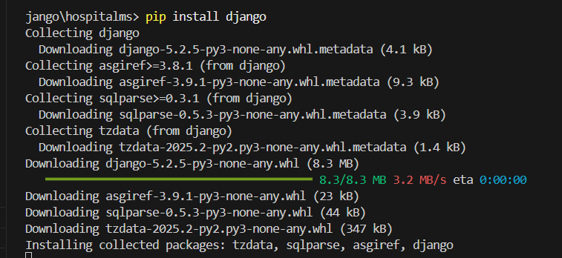

To update, run: python.exe -m pip install --upgrade pip
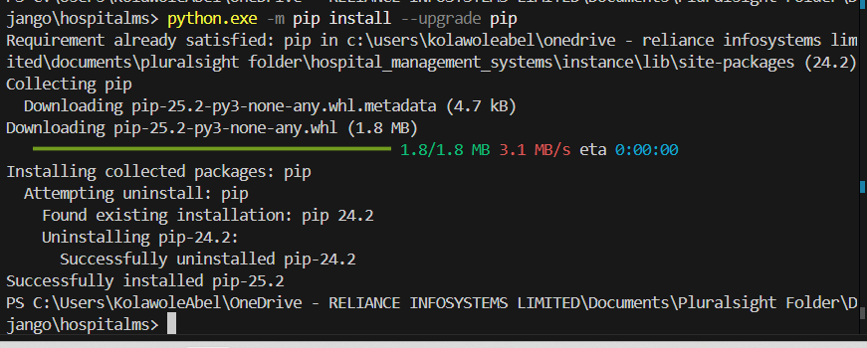
Create Django Project (your step)
bash
CopyEdit
django-admin startproject hospitalms
cd hospitalms(To run the above command)

Step 2 — Create Django Project
django-admin startproject hospitalms
cd hospitalms

Step 3 — Create an App
# From inside the hospitalms folder (where manage.py is)
python manage.py startapp dashboard
python manage.py startapp pharmacy
python manage.py startapp laboratory
python manage.py startapp doctor
python manage.py startapp accounntant

Step 4 — Add App to settings.py
Inside hospitalms/settings.py:
INSTALLED_APPS = [
...,
'dashboard',
]

Step 5 — Create Models for Hospital Entities
Inside dashboard/models.py:
from django.db import models

class Patient(models.Model):
name = models.CharField(max_length=100)
age = models.IntegerField()
gender = models.CharField(max_length=10)
condition = models.TextField()

def __str__(self):
return self.name

class Drug(models.Model):
drug_name = models.CharField(max_length=100)
quantity = models.IntegerField()
price = models.DecimalField(max_digits=10, decimal_places=2)

def __str__(self):
return self.drug_name

class LabResult(models.Model):
patient = models.ForeignKey(Patient, on_delete=models.CASCADE)
test_name = models.CharField(max_length=100)
result = models.TextField()

def __str__(self):
return f"{self.patient.name} - {self.test_name}"

class Transaction(models.Model):
description = models.CharField(max_length=200)
amount = models.DecimalField(max_digits=10, decimal_places=2)
type = models.CharField(max_length=20, choices=[('Income', 'Income'), ('Expense', 'Expense')])

def __str__(self):
return self.description

Step 6 — Create Admin Panel Access
Inside dashboard/admin.py:
from django.contrib import admin
from .models import Patient, Drug, LabResult, Transaction

admin.site.register(Patient)
admin.site.register(Drug)
admin.site.register(LabResult)
admin.site.register(Transaction)
Run migrations:
python manage.py makemigrations
python manage.py migrate
Create admin user:
python manage.py createsuperuser

Step 7 — Create Views
Inside dashboard/views.py:
from django.shortcuts import render
from .models import Patient, Drug, LabResult, Transaction

def home(request):
patients = Patient.objects.count()
drugs = Drug.objects.count()
lab_results = LabResult.objects.count()
transactions = Transaction.objects.all()

income = sum(t.amount for t in transactions if t.type == "Income")
expense = sum(t.amount for t in transactions if t.type == "Expense")

context = {
'patients_count': patients,
'drugs_count': drugs,
'lab_count': lab_results,
'income': income,
'expense': expense
}
return render(request, 'dashboard/home.html', context)

Step 8 — Create URL Routing
Inside dashboard/urls.py:
from django.urls import path
from . import views

urlpatterns = [
path('', views.home, name='home'),
]
Inside hospitalms/urls.py:
from django.contrib import admin
from django.urls import path, include

urlpatterns = [
path('admin/', admin.site.urls),
path('', include('dashboard.urls')),
]

Step 9 — Create Templates
Make folder:
dashboard/templates/dashboard/home.html
Paste:
<!DOCTYPE html>
<html>
<head>
<title>Hospital Dashboard</title>
<style>
body { font-family: Arial; background-color: #f8f9fa; }
.card { background: white; padding: 20px; margin: 10px; border-radius: 8px; display: inline-block; }
</style>
</head>
<body>
<h1>🏥 Hospital Management System Dashboard</h1>
<div class="card">Total Patients: {{ patients_count }}</div>
<div class="card">Drugs in Stock: {{ drugs_count }}</div>
<div class="card">Lab Records: {{ lab_count }}</div>
<div class="card">Total Income: ₦{{ income }}</div>
<div class="card">Total Expense: ₦{{ expense }}</div>
</body>
</html>

Step 10 — Run Server
python manage.py runserver
Open: http://127.0.0.1:8000
You’ll see your dashboard summary.
Go to http://127.0.0.1:8000/admin to manage Patients, Drugs, Lab Results, and Transactions.

If you want, I can now add Bootstrap charts, forms, and live data tables so your Django dashboard looks like a professional hospital system instead of just plain HTML.
Do you want me to add that UI upgrade next?

