**NAME: OGUNLADE KOLAWOLE VICTOR**

**MATRIC NUMBER : H/cs/23/1121**

**COM 316**

**COMPUTER SCIENCE HND1**

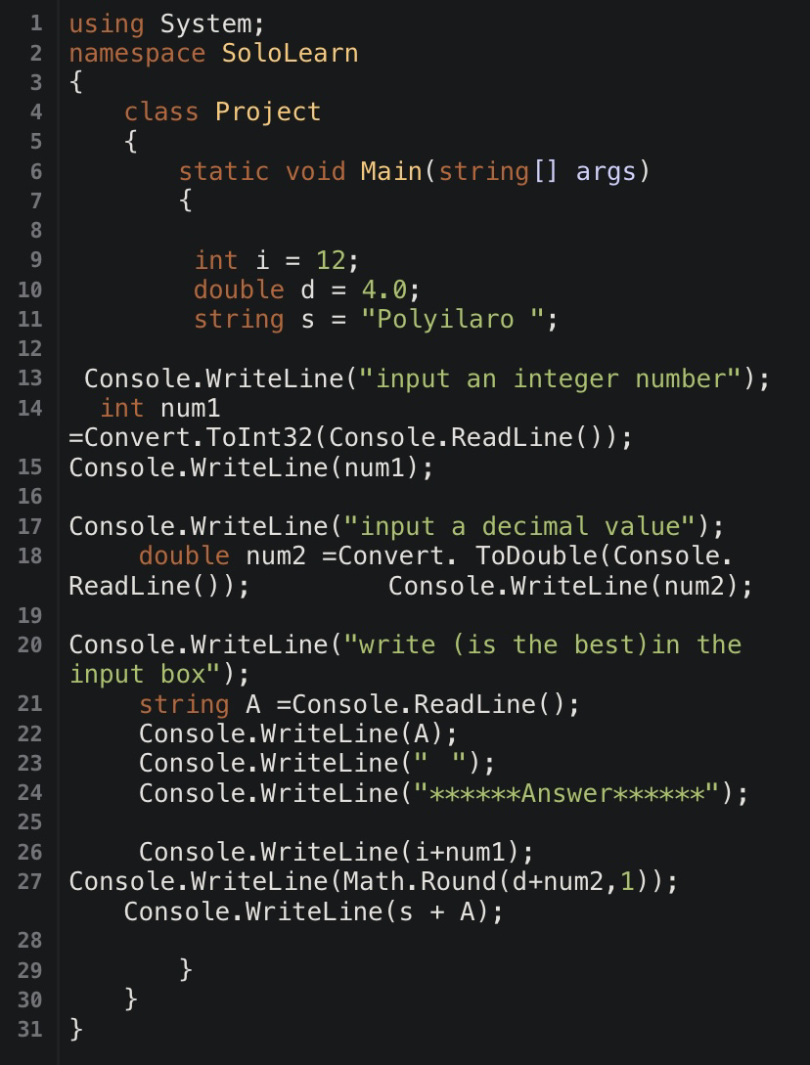

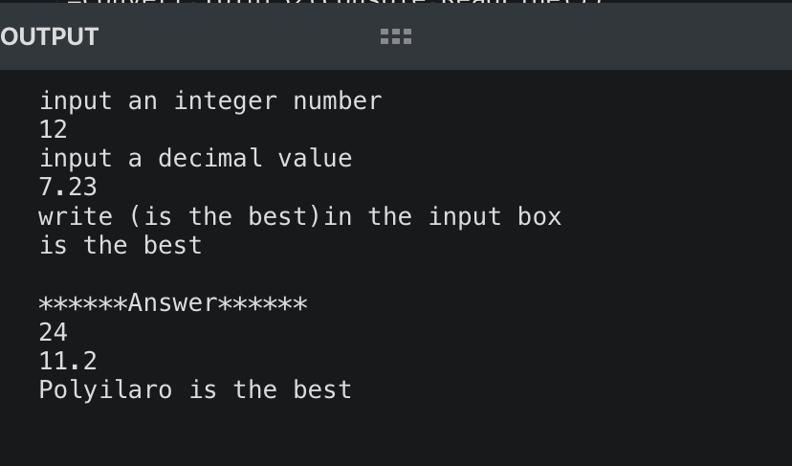

CODE:

using System;

namespace SoloLearn

{

class Project

{

static void Main(string[] args)

{

int i = 12;

double d = 4.0;

string s = "Polyilaro ";

Console.WriteLine("input an integer number");

int num1 =Convert.ToInt32(Console.ReadLine());

Console.WriteLine(num1);

Console.WriteLine("input a decimal value");

double num2 =Convert. ToDouble(Console. ReadLine()); Console.WriteLine(num2);

Console.WriteLine("write (is the best)in the input box");

string A =Console.ReadLine();

Console.WriteLine(A);

Console.WriteLine(" ");

Console.WriteLine("******Answer******");

Console.WriteLine(i+num1);

Console.WriteLine(Math.Round(d+num2,1)); Console.WriteLine(s + A);

}

}

}