**Log in:**

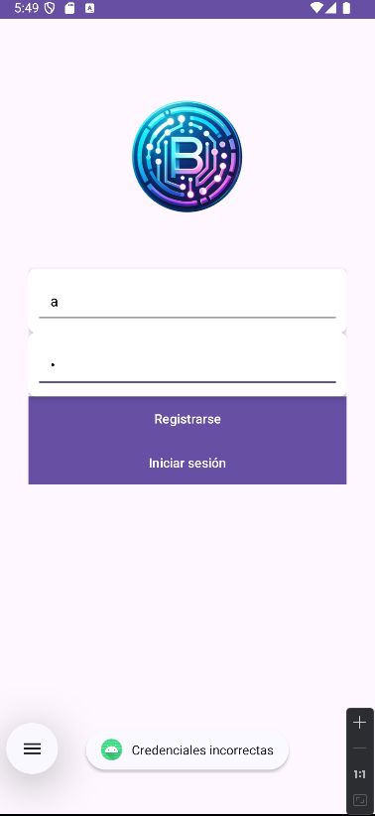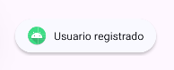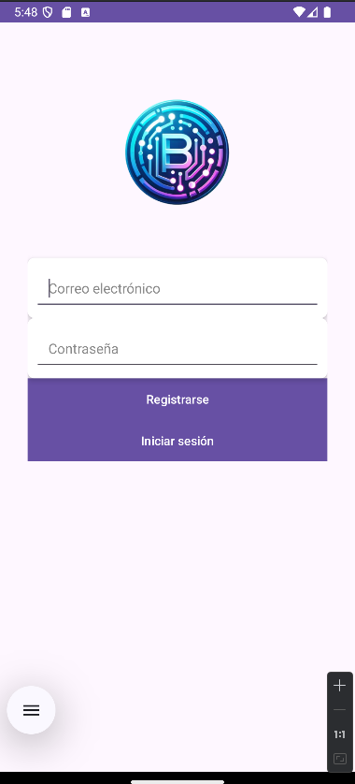

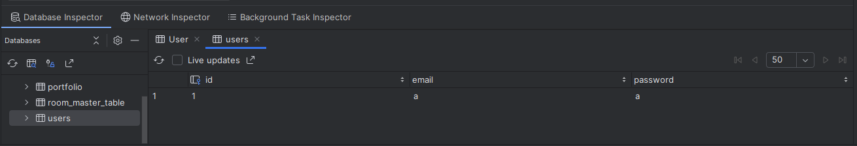

• **Register:**

* Allows users to create an account.
* Ensures all fields are filled and usernames are unique.

• **Login:**

* Authenticates users with their credentials.
* Redirects to the main application upon successful login.

• **Validation:**

* Validates input fields to prevent errors and incomplete entries.
* Displays appropriate error messages for invalid credentials or existing usernames.

• **Data Storage:**

* Stores user data securely in the local Room database.

**Home Activity:**

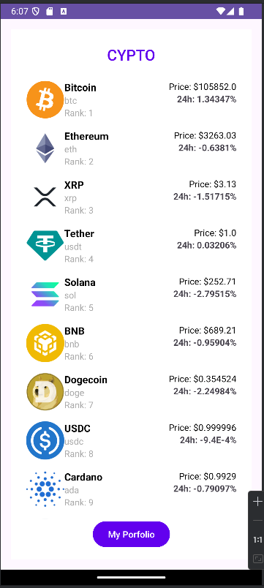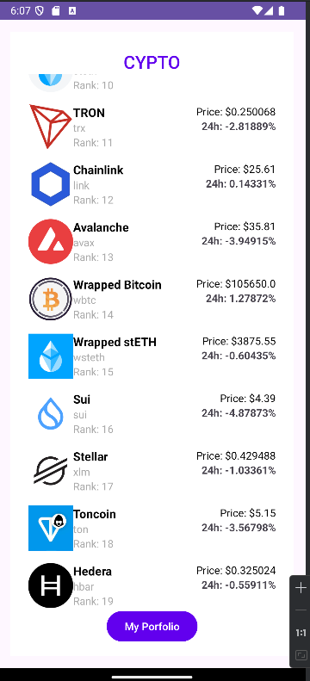

• **Cryptocurrency List:**

* Displays a list of the top cryptocurrencies fetched from a public API.
* Each item shows the following details:
  + Cryptocurrency name and symbol.
  + Market rank.
  + Current price.
  + 24-hour price change percentage.
* Dynamically updates the list by fetching real-time data.

• **Navigation to Portfolio:**

* Includes a "My Portfolio" button.
* Redirects users to the Portfolio Activity, where they can manage their cryptocurrency holdings.

• **Real-Time API Integration:**

* Fetches cryptocurrency data from the CoinGecko API.
* Specifically, it uses the endpoint:  
  **GET /coins/markets**  
  Example URL:  
  https://api.coingecko.com/api/v3/coins/markets?vs_currency=usd&order=market_cap_desc&per_page=100&page=1

• **Detailed View:**

* Tapping on a cryptocurrency redirects to the CryptoDetailActivity.
* Displays in-depth information and historical price data for the selected cryptocurrency.

**Detail Activity:**

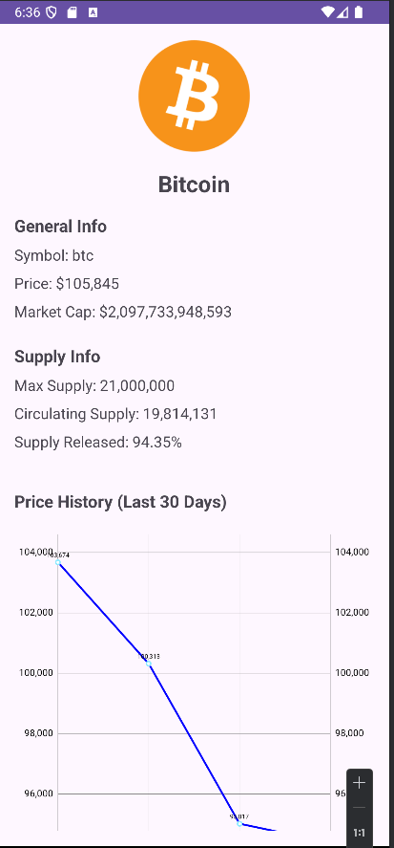

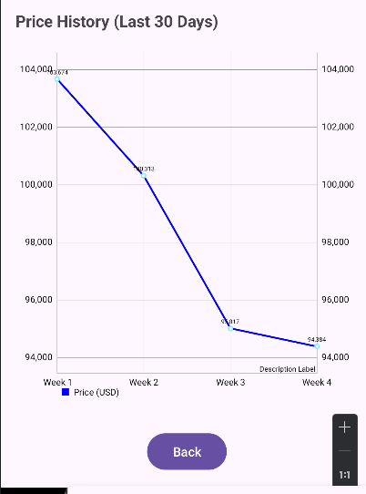

• **Detailed Information Display:**

* Shows critical details about the selected cryptocurrency:
  + **Name** and **symbol**.
  + **Current price** in USD.
  + **Market capitalization**.
  + **Max supply** and **circulating supply**.
  + **Supply released percentage.**

• **Historical Price Chart:**

* Visualizes the price trend for the cryptocurrency over the last 4 weeks.
* Fetches data dynamically from the CoinGecko API.
* Uses the endpoint:  
  **GET /coins/{id}/history**  
  Example URL:  
  https://api.coingecko.com/api/v3/coins/{id}/history?date=dd-MM-yyyy
* Displays a line chart with 4 data points, representing the weekly price trend.

• **User Navigation:**

* Includes a back button for seamless return to the previous activity.

**MyPorfolio**

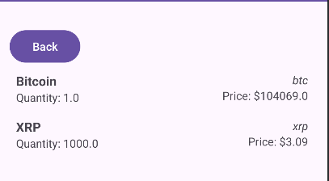

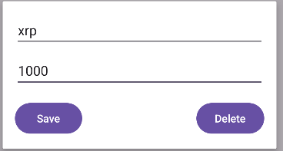



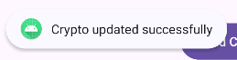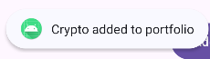

• **Portfolio Management:**

* Add a cryptocurrency to the portfolio by entering its symbol and quantity.
* Edit existing portfolio entries to update the quantity.
* Delete cryptocurrencies from the portfolio.

• **Automatic Data Fetching:**

* When adding a cryptocurrency, the app automatically retrieves its details (e.g., name, price, and market rank) from the CoinGecko API.
* API Endpoint:  
  **GET /coins/markets**  
  Example URL:  
  https://api.coingecko.com/api/v3/coins/markets?vs_currency=usd&order=market_cap_desc&per_page=100&page=1

• **Real-Time Updates:**

* Automatically fetches updated price data when adding or editing portfolio items.
* Reflects changes immediately in the RecyclerView list.

• **User-Friendly Interface:**

* A clear and intuitive interface with sections for adding, editing, and viewing portfolio items.
* Uses dialog boxes for adding and editing cryptocurrencies.