# Лабораторная работа № 7

# Шифратор, дешифратор, устройство постоянной памяти

**Russu Nicolai IS21Z**

**Цель работы:**

1. Изучение комбинационных элементов (шифратор, дешифратор) в статическом режиме.
2. Изучение комбинационных элементов (шифратор, дешифратор) в динамическом режиме.
3. Изучение и программирование устройства постоянной памяти.

# Эксперимент № 1. Дешифратор

Таблица 1. Таблица истинности дешифратора

|  |  |  |  |  |  |  |  |  |  |  |  |  |  |  |  |  |  |  |  |  |
| --- | --- | --- | --- | --- | --- | --- | --- | --- | --- | --- | --- | --- | --- | --- | --- | --- | --- | --- | --- | --- |
| Nr. d/o | Входы | | | | Выходы | | | | | | | | | | | | | | | |
| A | B | C | D | F15 | F14 | F13 | F12 | F11 | F10 | F9 | F8 | F7 | F6 | F5 | F4 | F3 | F2 | F1 | F0 |
| 0 | 0 | 0 | 0 | 0 | 0 | 0 | 0 | 0 | 0 | 0 | 0 | 0 | 0 | 0 | 0 | 0 | 0 | 0 | 0 | 1 |
| 1 | 0 | 0 | 0 | 1 | 0 | 0 | 0 | 0 | 0 | 0 | 0 | 0 | 0 | 0 | 0 | 0 | 0 | 0 | 1 | 0 |
| 2 | 0 | 0 | 1 | 0 | 0 | 0 | 0 | 0 | 0 | 0 | 0 | 0 | 0 | 0 | 0 | 0 | 0 | 1 | 0 | 0 |
| 3 | 0 | 0 | 1 | 1 | 0 | 0 | 0 | 0 | 0 | 0 | 0 | 0 | 0 | 0 | 0 | 0 | 1 | 0 | 0 | 0 |
| 4 | 0 | 1 | 0 | 0 | 0 | 0 | 0 | 0 | 0 | 0 | 0 | 0 | 0 | 0 | 0 | 1 | 0 | 0 | 0 | 0 |
| 5 | 0 | 1 | 0 | 1 | 0 | 0 | 0 | 0 | 0 | 0 | 0 | 0 | 0 | 0 | 1 | 0 | 0 | 0 | 0 | 0 |
| 6 | 0 | 1 | 1 | 0 | 0 | 0 | 0 | 0 | 0 | 0 | 0 | 0 | 0 | 1 | 0 | 0 | 0 | 0 | 0 | 0 |
| 7 | 0 | 1 | 1 | 1 | 0 | 0 | 0 | 0 | 0 | 0 | 0 | 0 | 1 | 0 | 0 | 0 | 0 | 0 | 0 | 0 |
| 8 | 1 | 0 | 0 | 0 | 0 | 0 | 0 | 0 | 0 | 0 | 0 | 1 | 0 | 0 | 0 | 0 | 0 | 0 | 0 | 0 |
| 9 | 1 | 0 | 0 | 1 | 0 | 0 | 0 | 0 | 0 | 0 | 1 | 0 | 0 | 0 | 0 | 0 | 0 | 0 | 0 | 0 |
| 10 | 1 | 0 | 1 | 0 | 0 | 0 | 0 | 0 | 0 | 1 | 0 | 0 | 0 | 0 | 0 | 0 | 0 | 0 | 0 | 0 |
| 11 | 1 | 0 | 1 | 1 | 0 | 0 | 0 | 0 | 1 | 0 | 0 | 0 | 0 | 0 | 0 | 0 | 0 | 0 | 0 | 0 |
| 12 | 1 | 1 | 0 | 0 | 0 | 0 | 0 | 1 | 0 | 0 | 0 | 0 | 0 | 0 | 0 | 0 | 0 | 0 | 0 | 0 |
| 13 | 1 | 1 | 0 | 1 | 0 | 0 | 1 | 0 | 0 | 0 | 0 | 0 | 0 | 0 | 0 | 0 | 0 | 0 | 0 | 0 |
| 14 | 1 | 1 | 1 | 0 | 0 | 1 | 0 | 0 | 0 | 0 | 0 | 0 | 0 | 0 | 0 | 0 | 0 | 0 | 0 | 0 |
| 15 | 1 | 1 | 1 | 1 | 1 | 0 | 0 | 0 | 0 | 0 | 0 | 0 | 0 | 0 | 0 | 0 | 0 | 0 | 0 | 0 |

Логические функции дешифратора.

|  |  |
| --- | --- |
| Nr | F |
| 0 | $\overline{a}$ $\overline{b}$ $\overline{c}$ $\overline{d}$*** |
| 1 | $\overline{a}$ $\overline{b}$ $\overline{c}$***d |
| 2 | $\overline{a}$ $\overline{b}$**c $\overline{d}$* |
| 3 | $\overline{a}$ $\overline{b}$**c*d |
| 4 | $\overline{a}$*b $\overline{c}$ $\overline{d}$** |
| 5 | $\overline{a}$*b $\overline{c}$**d |
| 6 | $\overline{a}$*b*c $\overline{d}$* |
| 7 | $\overline{a}$*b*c*d |
| 8 | a $\overline{b}$ $\overline{c}$ $\overline{d}$*** |
| 9 | a $\overline{b}$ $\overline{c}$***d |
| 10 | a $\overline{b}$**c $\overline{d}$* |
| 11 | a $\overline{b}$**c*d |
| 12 | a*b $\overline{c}$ $\overline{d}$** |
| 13 | a*b $\overline{c}$**d |
| 14 | a*b*c $\overline{d}$* |
| 15 | a*b*c*d |

**A.Статический режим.**

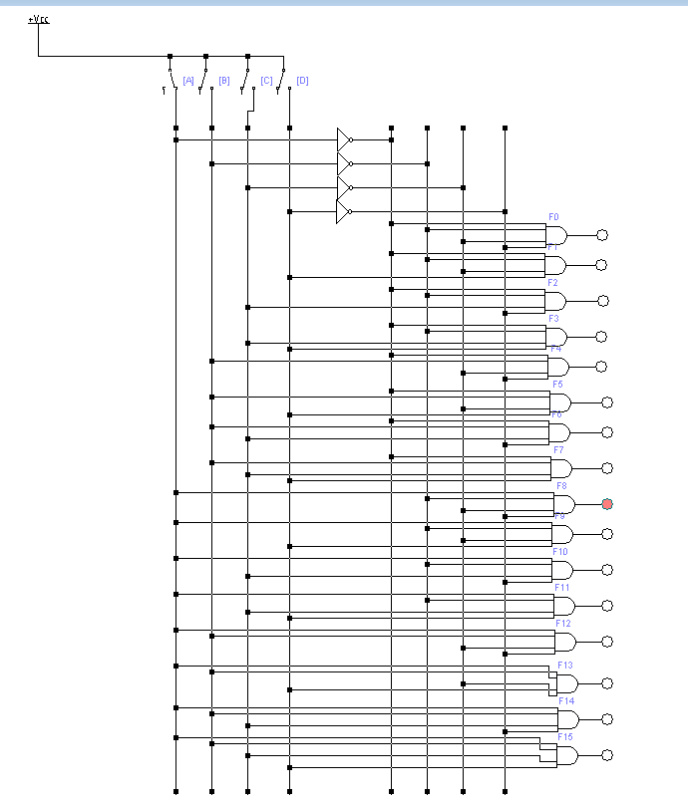

**Б.Динамический режим.**

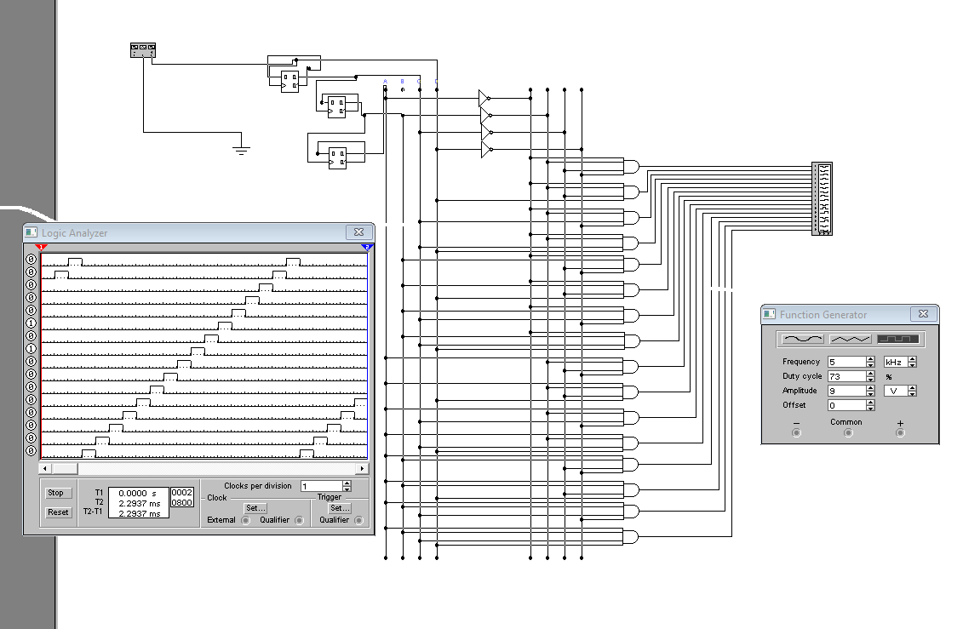

# Эксперимент № 2. Шифратор

Таблица 2. Состояния шифратора

|  |  |  |  |  |  |  |  |  |  |  |  |  |  |  |  |  |  |  |  |  |  |  |  |
| --- | --- | --- | --- | --- | --- | --- | --- | --- | --- | --- | --- | --- | --- | --- | --- | --- | --- | --- | --- | --- | --- | --- | --- |
| Nr | Входы | | | | | | | | | | | | | | | | | | Выходы | | | | |
| X16 | X15 | X14 | X13 | X12 | X11 | X10 | X9 | X8 | X7 | X6 | X5 | X4 | X3 | X2 | X1 | X0 | F4 | | F3 | F2 | F1 | F0 |
| 0 | 1 | 1 | 1 | 1 | 1 | 1 | 1 | 1 | 1 | 1 | 1 | 1 | 1 | 1 | 1 | 1 | 0 | 0 | | 0 | 0 | 0 | 0 |
| 1 | 1 | 1 | 1 | 1 | 1 | 1 | 1 | 1 | 1 | 1 | 1 | 1 | 1 | 1 | 1 | 0 | 1 | 0 | | 0 | 0 | 0 | 1 |
| 2 | 1 | 1 | 1 | 1 | 1 | 1 | 1 | 1 | 1 | 1 | 1 | 1 | 1 | 1 | 0 | 1 | 1 | 0 | | 0 | 0 | 1 | 0 |
| 3 | 1 | 1 | 1 | 1 | 1 | 1 | 1 | 1 | 1 | 1 | 1 | 1 | 1 | 0 | 1 | 1 | 1 | 0 | | 0 | 0 | 1 | 1 |
| 4 | 1 | 1 | 1 | 1 | 1 | 1 | 1 | 1 | 1 | 1 | 1 | 1 | 0 | 1 | 1 | 1 | 1 | 0 | | 0 | 1 | 0 | 0 |
| 5 | 1 | 1 | 1 | 1 | 1 | 1 | 1 | 1 | 1 | 1 | 1 | 0 | 1 | 1 | 1 | 1 | 1 | 0 | | 0 | 1 | 0 | 1 |
| 6 | 1 | 1 | 1 | 1 | 1 | 1 | 1 | 1 | 1 | 1 | 0 | 1 | 1 | 1 | 1 | 1 | 1 | 0 | | 0 | 1 | 1 | 0 |
| 7 | 1 | 1 | 1 | 1 | 1 | 1 | 1 | 1 | 1 | 0 | 1 | 1 | 1 | 1 | 1 | 1 | 1 | 0 | | 0 | 1 | 1 | 1 |
| 8 | 1 | 1 | 1 | 1 | 1 | 1 | 1 | 1 | 0 | 1 | 1 | 1 | 1 | 1 | 1 | 1 | 1 | 0 | | 1 | 0 | 0 | 0 |
| 9 | 1 | 1 | 1 | 1 | 1 | 1 | 1 | 0 | 1 | 1 | 1 | 1 | 1 | 1 | 1 | 1 | 1 | 0 | | 1 | 0 | 0 | 1 |
| 10 | 1 | 1 | 1 | 1 | 1 | 1 | 0 | 1 | 1 | 1 | 1 | 1 | 1 | 1 | 1 | 1 | 1 | 0 | | 1 | 0 | 1 | 0 |
| 11 | 1 | 1 | 1 | 1 | 1 | 0 | 1 | 1 | 1 | 1 | 1 | 1 | 1 | 1 | 1 | 1 | 1 | 0 | | 1 | 0 | 1 | 1 |
| 12 | 1 | 1 | 1 | 1 | 0 | 1 | 1 | 1 | 1 | 1 | 1 | 1 | 1 | 1 | 1 | 1 | 1 | 0 | | 1 | 1 | 0 | 0 |
| 13 | 1 | 1 | 1 | 0 | 1 | 1 | 1 | 1 | 1 | 1 | 1 | 1 | 1 | 1 | 1 | 1 | 1 | 0 | | 1 | 1 | 0 | 1 |
| 14 | 1 | 1 | 0 | 1 | 1 | 1 | 1 | 1 | 1 | 1 | 1 | 1 | 1 | 1 | 1 | 1 | 1 | 0 | | 1 | 1 | 1 | 0 |
| 15 | 1 | 0 | 1 | 1 | 1 | 1 | 1 | 1 | 1 | 1 | 1 | 1 | 1 | 1 | 1 | 1 | 1 | 0 | | 1 | 1 | 1 | 1 |
| 16 | 0 | 1 | 1 | 1 | 1 | 1 | 1 | 1 | 1 | 1 | 1 | 1 | 1 | 1 | 1 | 1 | 1 | 1 | | 0 | 0 | 0 | 0 |

Логические функции шифратора

F3 = $\overline{X15*X14*X13*X12*X11*X10*X9*X8}$

F2 = $\overline{X15*X14*X13*X12*X7*X6*X5*X4}$

F1 = $\overline{X15*X14*X11*X10*X7*X6*X3*X2}$

F0 = $\overline{X15*X13*X11*X9*X7*X5*X3*X1}$

**A.Статический режим.**

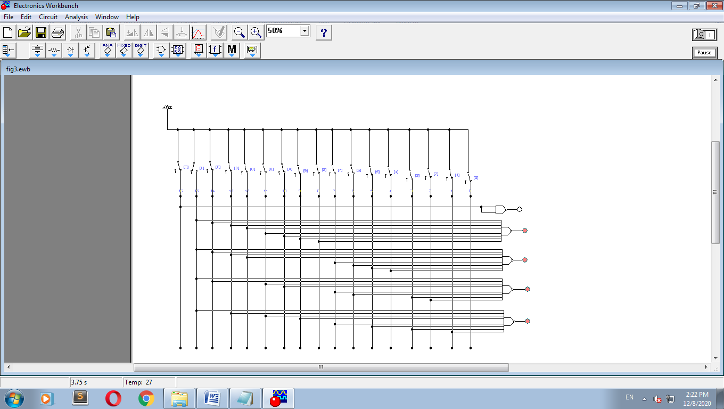

**Динамический режим**

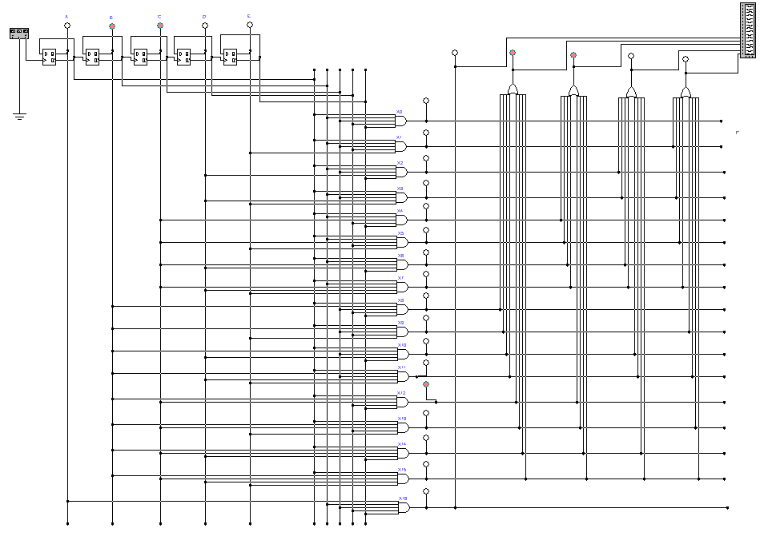

# Эксперимент № 3. Устройство постоянной памяти

|  |  |
| --- | --- |
| A3 A2 A1 A0 | D4 D3 D2 D1 D0 |
| 0000 | 10110 |
| 0001 | 11001 |
| 0010 | 11101 |
| 0011 | 01100 |
| 0100 | 00000 |
| 0101 | 10111 |
| 0110 | 11000 |
| 0111 | 11010 |
| 1000 | 01110 |
| 1001 | 10110 |
| 1010 | 10111 |
| 1011 | 01000 |
| 1100 | 00100 |
| 1101 | 10010 |
| 1110 | 10001 |
| 1111 | 11010 |

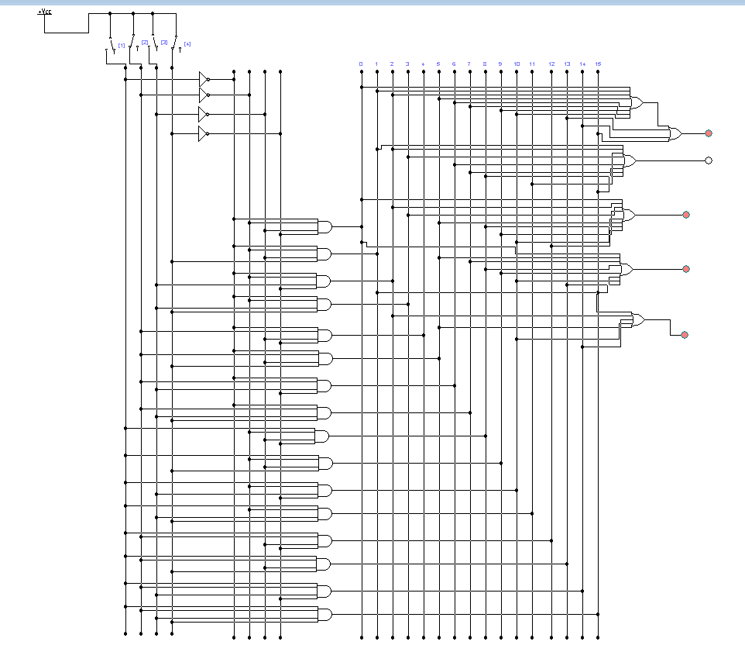

**Б.Динамический режим.**

