# Лабораторная работа № 6 Счётчики

**Цель работы:**

1. Исследование счетчика прямого счета в статическом и динамическом режимах.
2. Исследование счетчика обратного счета в статическом и динамическом режимах.

3. Исследование двоично-десятичного счетчика в статическом и динамическом режимах.

4. Исследование счетчика по модулю М в статическом и динамическом режимах.

# Эксперимент № 1. Двоичный счетчик прямого счета шестого порядка

**А. Статический режим.**

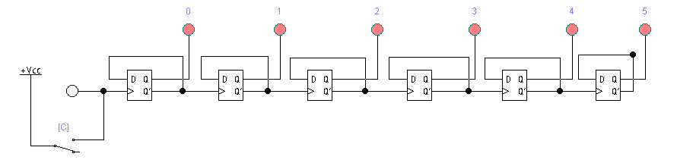

Рис. 1. Схема подключения двоичного счетчика шестого порядка прямого счета

(статический режим).

Таблица 1. Состояния двоичного счетчика шестого порядка прямого счета

|  |  |  |  |  |  |  |
| --- | --- | --- | --- | --- | --- | --- |
| Nr. d/o | Q0 | Q1 | Q2 | Q3 | Q4 | Q5 |
| 0 | 0 | 0 | 0 | 0 | 0 | 0 |
| 1 | 0 | 0 | 0 | 0 | 0 | 1 |
| 2 | 0 | 0 | 0 | 0 | 1 | 0 |
| 3 | 0 | 0 | 0 | 0 | 1 | 1 |
| 4 | 0 | 0 | 0 | 1 | 0 | 0 |
| 5 | 0 | 0 | 0 | 1 | 0 | 1 |
| 6 | 0 | 0 | 0 | 1 | 1 | 0 |
| 7 | 0 | 0 | 0 | 1 | 1 | 1 |
| 8 | 0 | 0 | 1 | 0 | 0 | 0 |
| 9 | 0 | 0 | 1 | 0 | 0 | 1 |
| 10 | 0 | 0 | 1 | 0 | 1 | 0 |
| 11 | 0 | 0 | 1 | 0 | 1 | 1 |
| 12 | 0 | 0 | 1 | 1 | 0 | 0 |
| 13 | 0 | 0 | 1 | 1 | 0 | 1 |
| 14 | 0 | 0 | 1 | 1 | 1 | 0 |
| 15 | 0 | 0 | 1 | 1 | 1 | 1 |
| 16 | 0 | 1 | 0 | 0 | 0 | 0 |
| 17 | 0 | 1 | 0 | 0 | 0 | 1 |
| 18 | 0 | 1 | 0 | 0 | 1 | 0 |
| 19 | 0 | 1 | 0 | 0 | 1 | 1 |
| 20 | 0 | 1 | 0 | 1 | 0 | 0 |
| 21 | 0 | 1 | 0 | 1 | 0 | 1 |
| 22 | 0 | 1 | 0 | 1 | 1 | 0 |
| 23 | 0 | 1 | 0 | 1 | 1 | 1 |
| 24 | 0 | 1 | 1 | 0 | 0 | 0 |
| 25 | 0 | 1 | 1 | 0 | 0 | 1 |
| 26 | 0 | 1 | 1 | 0 | 1 | 0 |
| 27 | 0 | 1 | 1 | 0 | 1 | 1 |
| 28 | 0 | 1 | 1 | 1 | 0 | 0 |
| 29 | 0 | 1 | 1 | 1 | 0 | 1 |
| 30 | 0 | 1 | 1 | 1 | 1 | 0 |
| 31 | 0 | 1 | 1 | 1 | 1 | 1 |
| 32 | 1 | 0 | 0 | 0 | 0 | 0 |
| 33 | 1 | 0 | 0 | 0 | 0 | 1 |
| 34 | 1 | 0 | 0 | 0 | 1 | 0 |
| 35 | 1 | 0 | 0 | 0 | 1 | 1 |
| 36 | 1 | 0 | 0 | 1 | 0 | 0 |
| 37 | 1 | 0 | 0 | 1 | 0 | 1 |
| 38 | 1 | 0 | 0 | 1 | 1 | 0 |
| 39 | 1 | 0 | 0 | 1 | 1 | 1 |
| 40 | 1 | 0 | 1 | 0 | 0 | 0 |
| 41 | 1 | 0 | 1 | 0 | 0 | 1 |
| 42 | 1 | 0 | 1 | 0 | 1 | 0 |
| 43 | 1 | 0 | 1 | 0 | 1 | 1 |
| 44 | 1 | 0 | 1 | 1 | 0 | 0 |
| 45 | 1 | 0 | 1 | 1 | 0 | 1 |
| 46 | 1 | 0 | 1 | 1 | 1 | 0 |
| 47 | 1 | 0 | 1 | 1 | 1 | 1 |
| 48 | 1 | 1 | 0 | 0 | 0 | 0 |
| 49 | 1 | 1 | 0 | 0 | 0 | 1 |
| 50 | 1 | 1 | 0 | 0 | 1 | 0 |
| 51 | 1 | 1 | 0 | 0 | 1 | 1 |
| 52 | 1 | 1 | 0 | 1 | 0 | 0 |
| 53 | 1 | 1 | 0 | 1 | 0 | 1 |
| 54 | 1 | 1 | 0 | 1 | 1 | 0 |
| 55 | 1 | 1 | 0 | 1 | 1 | 1 |
| 56 | 1 | 1 | 1 | 0 | 0 | 0 |
| 57 | 1 | 1 | 1 | 0 | 0 | 1 |
| 58 | 1 | 1 | 1 | 0 | 1 | 0 |
| 59 | 1 | 1 | 1 | 0 | 1 | 1 |
| 60 | 1 | 1 | 1 | 1 | 0 | 0 |
| 61 | 1 | 1 | 1 | 1 | 0 | 1 |
| 62 | 1 | 1 | 1 | 1 | 1 | 0 |
| 63 | 1 | 1 | 1 | 1 | 1 | 1 |

**B. Динамический режим.**

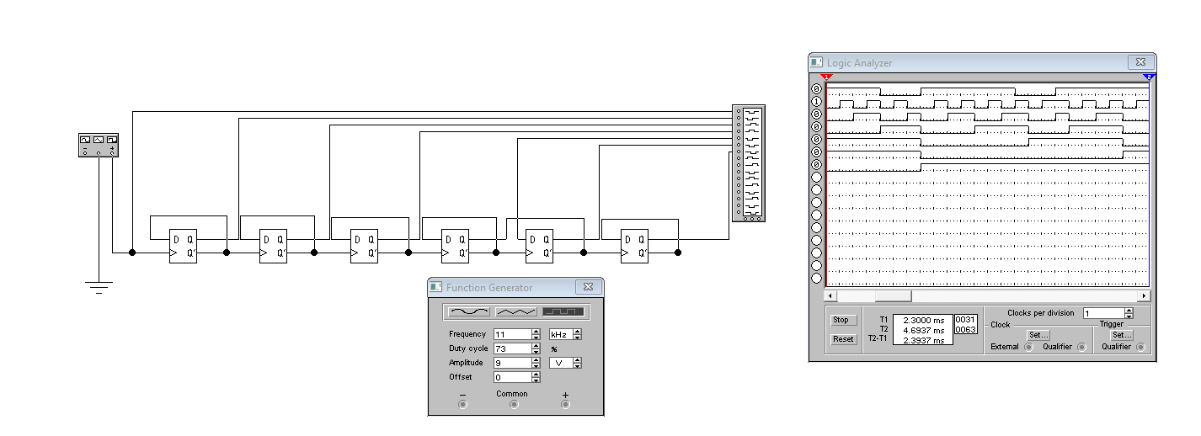

Рис. 2. Схема подключения двоичного счетчика шестого порядка прямого счета

(динамический режим).

# Эксперимент № 2. Двоичный счетчик обратного счета шестого порядка

**А. Статический режим.**

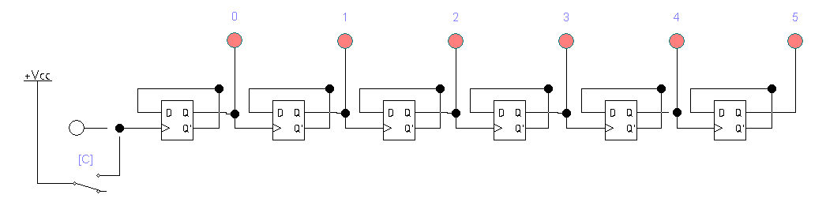

Рис. 3. Схема подключения двоичного счетчика шестого порядка обратного счета (статический режим).

Таблица 2. Состояния двоичного счетчика шестого порядка обратного счета

|  |  |  |  |  |  |  |
| --- | --- | --- | --- | --- | --- | --- |
| Nr. d/o | Q0 | Q1 | Q2 | Q3 | Q4 | Q5 |
| 0 | 1 | 1 | 1 | 1 | 1 | 1 |
| 1 | 1 | 1 | 1 | 1 | 1 | 0 |
| 2 | 1 | 1 | 1 | 1 | 0 | 1 |
| 3 | 1 | 1 | 1 | 1 | 0 | 0 |
| 4 | 1 | 1 | 1 | 0 | 1 | 1 |
| 5 | 1 | 1 | 1 | 0 | 1 | 0 |
| 6 | 1 | 1 | 1 | 0 | 0 | 1 |
| 7 | 1 | 1 | 1 | 0 | 0 | 0 |
| 8 | 1 | 1 | 0 | 1 | 1 | 1 |
| 9 | 1 | 1 | 0 | 1 | 1 | 0 |
| 10 | 1 | 1 | 0 | 1 | 0 | 1 |
| 11 | 1 | 1 | 0 | 1 | 0 | 0 |
| 12 | 1 | 1 | 0 | 0 | 1 | 1 |
| 13 | 1 | 1 | 0 | 0 | 1 | 0 |
| 14 | 1 | 1 | 0 | 0 | 0 | 1 |
| 15 | 1 | 1 | 0 | 0 | 0 | 0 |
| 16 | 1 | 0 | 1 | 1 | 1 | 1 |
| 17 | 1 | 0 | 1 | 1 | 1 | 0 |
| 18 | 1 | 0 | 1 | 1 | 0 | 1 |
| 19 | 1 | 0 | 1 | 1 | 0 | 0 |
| 20 | 1 | 0 | 1 | 0 | 1 | 1 |
| 21 | 1 | 0 | 1 | 0 | 1 | 0 |
| 22 | 1 | 0 | 1 | 0 | 0 | 1 |
| 23 | 1 | 0 | 1 | 0 | 0 | 0 |
| 24 | 1 | 0 | 0 | 1 | 1 | 1 |
| 25 | 1 | 0 | 0 | 1 | 1 | 0 |
| 26 | 1 | 0 | 0 | 1 | 0 | 1 |
| 27 | 1 | 0 | 0 | 1 | 0 | 0 |
| 28 | 1 | 0 | 0 | 0 | 1 | 1 |
| 29 | 1 | 0 | 0 | 0 | 1 | 0 |
| 30 | 1 | 0 | 0 | 0 | 0 | 1 |
| 31 | 1 | 0 | 0 | 0 | 0 | 0 |
| 32 | 0 | 1 | 1 | 1 | 1 | 1 |
| 33 | 0 | 1 | 1 | 1 | 1 | 0 |
| 34 | 0 | 1 | 1 | 1 | 0 | 1 |
| 35 | 0 | 1 | 1 | 1 | 0 | 0 |
| 36 | 0 | 1 | 1 | 0 | 1 | 1 |
| 37 | 0 | 1 | 1 | 0 | 1 | 0 |
| 38 | 0 | 1 | 1 | 0 | 0 | 1 |
| 39 | 0 | 1 | 1 | 0 | 0 | 0 |
| 40 | 0 | 1 | 0 | 1 | 1 | 1 |
| 41 | 0 | 1 | 0 | 1 | 1 | 0 |
| 42 | 0 | 1 | 0 | 1 | 0 | 1 |
| 43 | 0 | 1 | 0 | 1 | 0 | 0 |
| 44 | 0 | 1 | 0 | 0 | 1 | 1 |
| 45 | 0 | 1 | 0 | 0 | 1 | 0 |
| 46 | 0 | 1 | 0 | 0 | 0 | 1 |
| 47 | 0 | 1 | 0 | 0 | 0 | 0 |
| 48 | 0 | 0 | 1 | 1 | 1 | 1 |
| 49 | 0 | 0 | 1 | 1 | 1 | 0 |
| 50 | 0 | 0 | 1 | 1 | 0 | 1 |
| 51 | 0 | 0 | 1 | 1 | 0 | 0 |
| 52 | 0 | 0 | 1 | 0 | 1 | 1 |
| 53 | 0 | 0 | 1 | 0 | 1 | 0 |
| 54 | 0 | 0 | 1 | 0 | 0 | 1 |
| 55 | 0 | 0 | 1 | 0 | 0 | 0 |
| 56 | 0 | 0 | 0 | 1 | 1 | 1 |
| 57 | 0 | 0 | 0 | 1 | 1 | 0 |
| 58 | 0 | 0 | 0 | 1 | 0 | 1 |
| 59 | 0 | 0 | 0 | 1 | 0 | 0 |
| 60 | 0 | 0 | 0 | 0 | 1 | 1 |
| 61 | 0 | 0 | 0 | 0 | 1 | 0 |
| 62 | 0 | 0 | 0 | 0 | 0 | 1 |
| 63 | 0 | 0 | 0 | 0 | 0 | 0 |

**B. Динамический режим.**

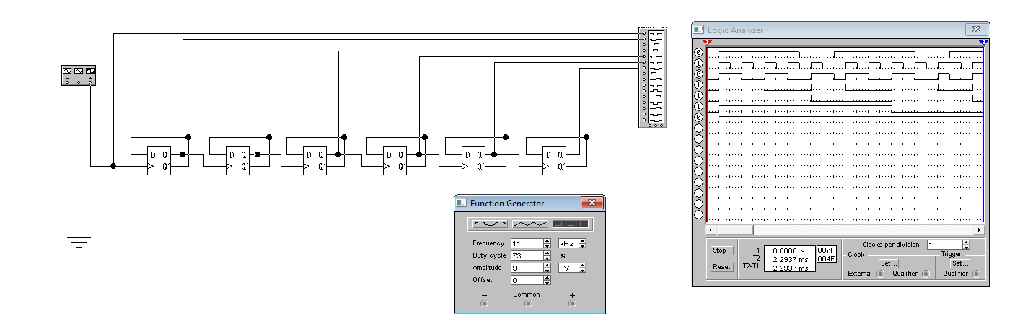

Рис. 4. Схема подключения двоичного счетчика шестого порядка обратного счета

(динамический режим).

**Эксперимент № 3. Двоично-десятичный счетчик**

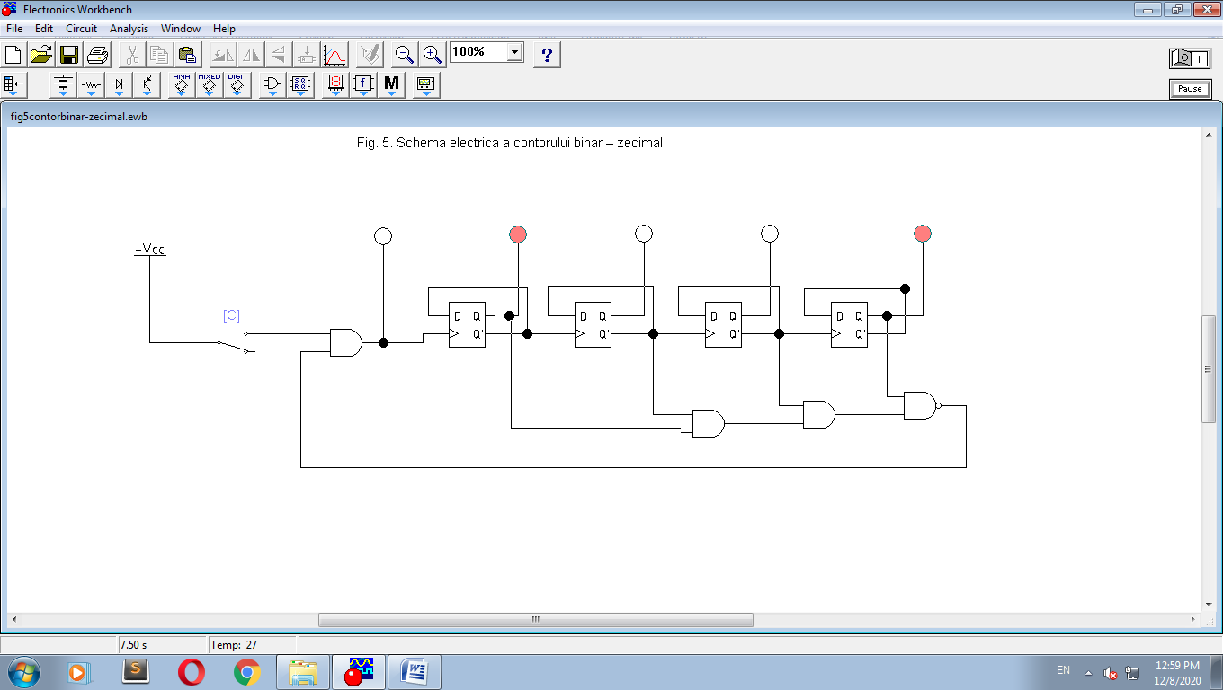

Рис. 5. Электрическая схема двоично-десятичного счетчика

Таблица 3. Состояния двоично-десятичного счетчика

|  |  |  |  |  |  |
| --- | --- | --- | --- | --- | --- |
| Nr. d/o | C | Q0 | Q1 | Q2 | Q3 |
| 0 | ↑ | 0 | 0 | 0 | 0 |
| 1 | ↑ | 0 | 0 | 0 | 1 |
| 2 | ↑ | 0 | 0 | 1 | 0 |
| 3 | ↑ | 0 | 0 | 1 | 1 |
| 4 | ↑ | 0 | 1 | 0 | 0 |
| 5 | ↑ | 0 | 1 | 0 | 1 |
| 6 | ↑ | 0 | 1 | 1 | 0 |
| 7 | ↑ | 0 | 1 | 1 | 1 |
| 8 | ↑ | 1 | 0 | 0 | 0 |
| 9 | ↑ | 1 | 0 | 0 | 1 |

# Эксперимент № 4. Двоичный счетчик по модулю M

|  |  |
| --- | --- |
| Nr. d/o | Modulul M |
| 16. | 110100 |

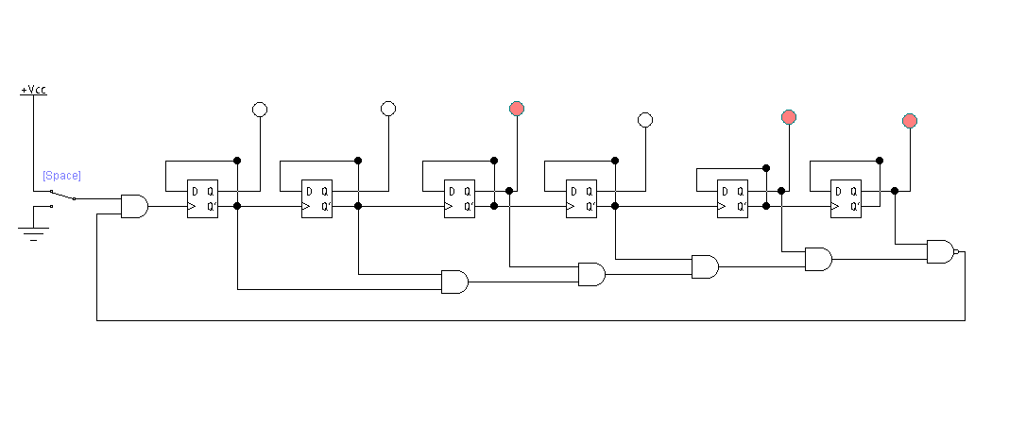

Таблица 5. Состояния счетчика по модулю M

|  |  |  |  |  |  |  |
| --- | --- | --- | --- | --- | --- | --- |
| Nr. d/o | Q0 | Q1 | Q2 | Q3 | Q4 | Q5 |
| 0. | 0 | 0 | 0 | 0 | 0 | 0 |
| 1. | 0 | 0 | 0 | 0 | 0 | 1 |
| 2. | 0 | 0 | 0 | 0 | 1 | 0 |
| 3. | 0 | 0 | 0 | 0 | 1 | 1 |
| 4. | 0 | 0 | 0 | 1 | 0 | 0 |
| 5. | 0 | 0 | 0 | 1 | 0 | 1 |
| 6. | 0 | 0 | 0 | 1 | 1 | 0 |
| 7. | 0 | 0 | 0 | 1 | 1 | 1 |
| 8. | 0 | 0 | 1 | 0 | 0 | 0 |
| 9. | 0 | 0 | 1 | 0 | 0 | 1 |
| 10. | 0 | 0 | 1 | 0 | 1 | 0 |
| 11. | 0 | 0 | 1 | 0 | 1 | 1 |
| 12. | 0 | 0 | 1 | 1 | 0 | 0 |
| 13. | 0 | 0 | 1 | 1 | 0 | 1 |
| 14. | 0 | 0 | 1 | 1 | 1 | 0 |
| 15. | 0 | 0 | 1 | 1 | 1 | 1 |
| 16. | 0 | 1 | 0 | 0 | 0 | 0 |
| 17. | 0 | 1 | 0 | 0 | 0 | 1 |
| 18. | 0 | 1 | 0 | 0 | 1 | 0 |
| 19. | 0 | 1 | 0 | 0 | 1 | 1 |
| 20. | 0 | 1 | 0 | 1 | 0 | 0 |
| 21. | 0 | 1 | 0 | 1 | 0 | 1 |
| 22. | 0 | 0 | 0 | 1 | 1 | 0 |
| 23. | 0 | 1 | 0 | 1 | 1 | 1 |
| 24. | 0 | 1 | 1 | 0 | 0 | 0 |
| 25. | 0 | 1 | 1 | 0 | 0 | 1 |
| 26. | 0 | 1 | 1 | 0 | 1 | 0 |
| 27. | 0 | 1 | 1 | 0 | 1 | 1 |
| 28. | 0 | 1 | 1 | 1 | 0 | 0 |
| 29. | 0 | 1 | 1 | 1 | 0 | 1 |
| 30. | 0 | 1 | 1 | 1 | 1 | 0 |
| 31. | 0 | 1 | 1 | 1 | 1 | 1 |
| 32. | 1 | 0 | 0 | 0 | 0 | 0 |
| 33. | 1 | 0 | 0 | 0 | 0 | 1 |
| 34. | 1 | 0 | 0 | 0 | 1 | 0 |
| 35. | 1 | 0 | 0 | 0 | 1 | 1 |
| 36. | 1 | 0 | 0 | 1 | 0 | 0 |
| 37. | 1 | 0 | 0 | 1 | 0 | 1 |
| 38. | 1 | 0 | 0 | 1 | 1 | 0 |
| 39. | 1 | 0 | 0 | 1 | 1 | 1 |
| 40. | 1 | 0 | 1 | 0 | 0 | 0 |
| 41. | 1 | 0 | 1 | 0 | 0 | 1 |
| 42. | 1 | 0 | 1 | 0 | 1 | 0 |
| 43. | 1 | 0 | 1 | 0 | 1 | 1 |
| 44. | 1 | 0 | 1 | 1 | 0 | 0 |
| 45. | 1 | 0 | 1 | 1 | 0 | 1 |
| 46. | 1 | 0 | 1 | 1 | 1 | 0 |
| 47. | 1 | 0 | 1 | 1 | 1 | 1 |
| 48. | 1 | 1 | 0 | 0 | 0 | 0 |
| 49. | 1 | 1 | 0 | 0 | 0 | 1 |
| 50 | 1 | 1 | 0 | 0 | 1 | 0 |
| 51 | 1 | 1 | 0 | 0 | 1 | 1 |
| 52 | 1 | 1 | 0 | 1 | 0 | 0 |

**Эксперимент № 5. Двоичный счетчик с повторением цикла счета**

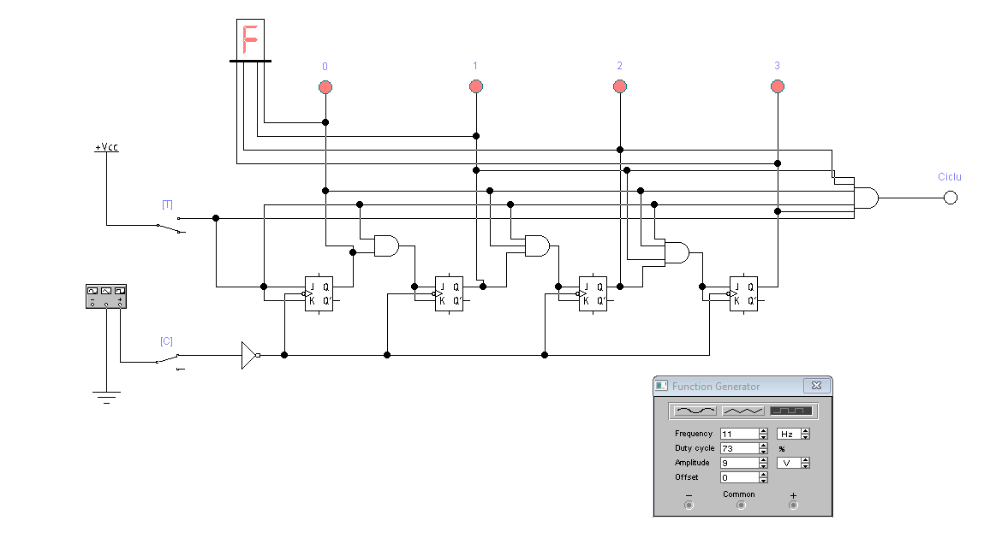

Таблица 6. Состояния двоичного счетчика с повторением цикла счета

|  |  |  |  |  |  |  |
| --- | --- | --- | --- | --- | --- | --- |
| Nr. d/o | C | Q0 | Q1 | Q2 | Q3 | Numar hexazecimal |
| 0 | ↑ | 0 | 0 | 0 | 0 | 0 |
| 1 | ↑ | 0 | 0 | 0 | 1 | 1 |
| 2 | ↑ | 0 | 0 | 1 | 0 | 2 |
| 3 | ↑ | 0 | 0 | 1 | 1 | 3 |
| 4 | ↑ | 0 | 1 | 0 | 0 | 4 |
| 5 | ↑ | 0 | 1 | 0 | 1 | 5 |
| 6 | ↑ | 0 | 1 | 1 | 0 | 6 |
| 7 | ↑ | 0 | 1 | 1 | 1 | 7 |
| 8 | ↑ | 1 | 0 | 0 | 0 | 8 |
| 9 | ↑ | 1 | 0 | 0 | 1 | 9 |
| 10 | ↑ | 1 | 0 | 1 | 0 | A |
| 11 | ↑ | 1 | 0 | 1 | 1 | B |
| 12 | ↑ | 1 | 1 | 0 | 0 | C |
| 13 | ↑ | 1 | 1 | 0 | 1 | D |
| 14 | ↑ | 1 | 1 | 1 | 0 | E |
| 15 | ↑ | 1 | 1 | 1 | 1 | F |