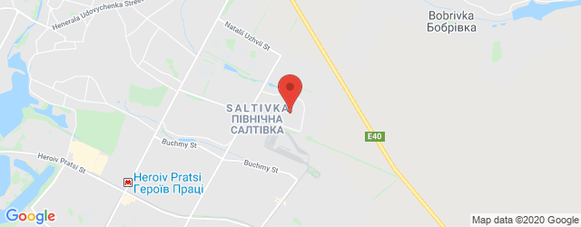
GPS Coordinates: 50.033766,36.366905
Head 1
dd

1

 | 31-01-2020 14:23
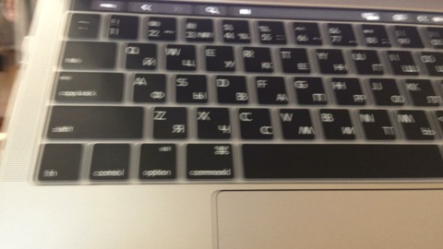 | 30-01-2020 15:53
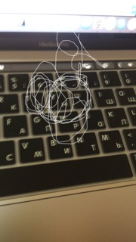 | 30-01-2020 15:57
 | 30-01-2020 15:57
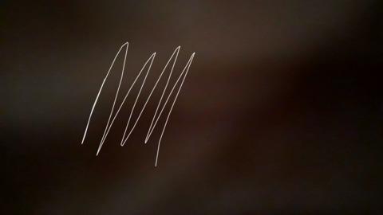 | 30-01-2020 16:09
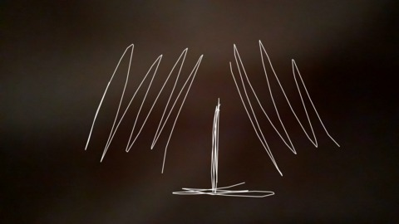 | 30-01-2020 16:09

