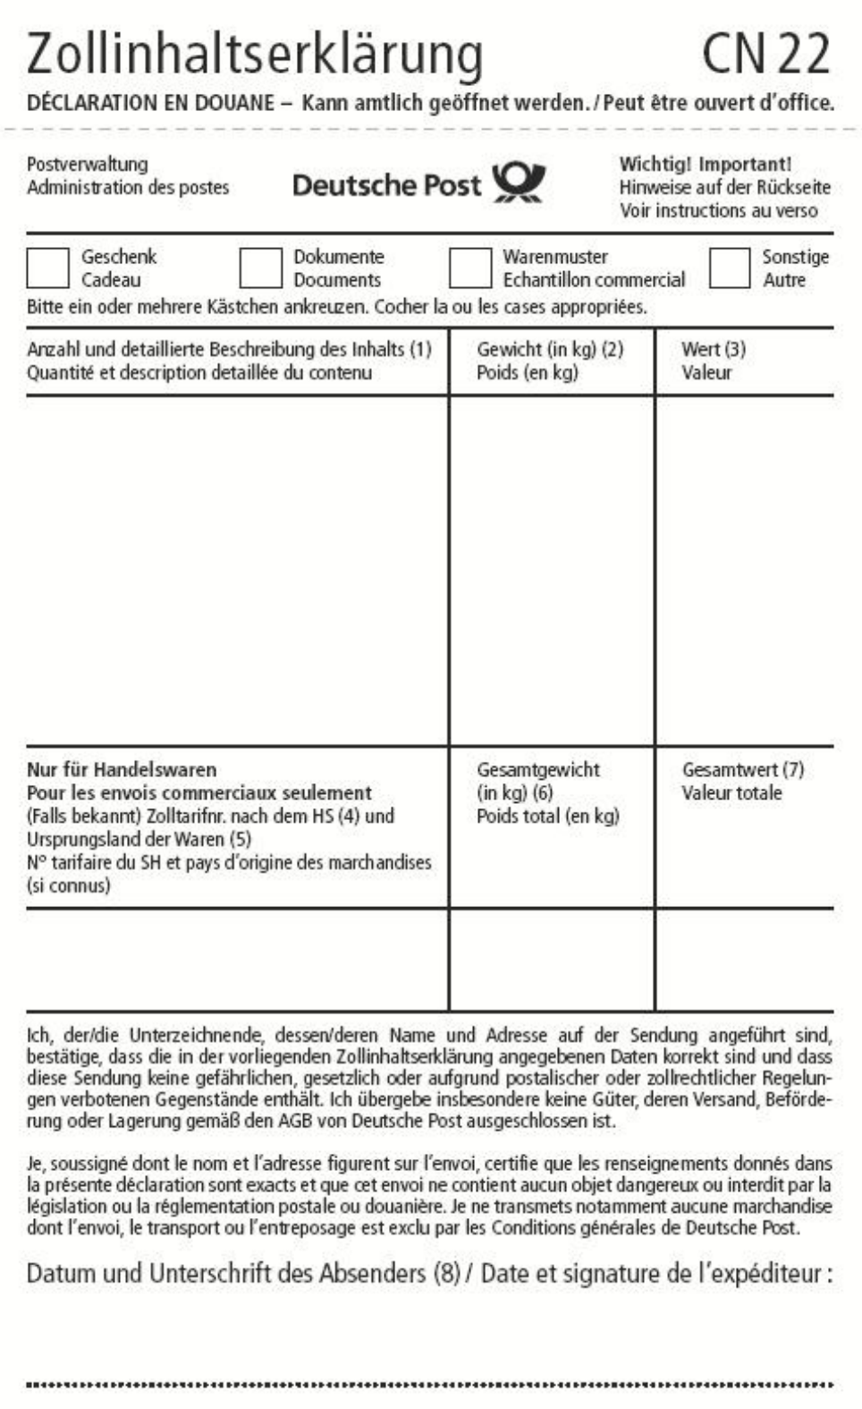 |  | X
Add-on PCB for micro SD cards for C.H.I.P. | 0.05 | $10
 | 0.05 | $10
2016-12-06

