Abstract. The Supplemental Nutrition Assistance Program (SNAP) is designed to improve food access among low-income households and support nutritional outcomes. Prior work evaluating the impact of SNAP expansion has predominantly focused on demand side responses, while impacts on the retail landscape that ultimately supplies consumers have remained largely unstudied. To that end, we exploit the Able-Bodied Adults Without Dependents (ABAWD) waivers as an intensive margin increase in SNAP provision. We show that ABAWD waiver conferral increases the number of dollar stores by approximately 10%, a feature not characteristic of other retail formats. Given previous work on how the arrival of dollar stores reduce fresh-produce consumption, these findings suggest that SNAP’s reshaping of retail may undercut the program’s objectives. We then outline a framework to study how consumers respond to SNAP-induced changes in the retail landscape.
Enacted in its modern form in 1964, the Supplemental Nutrition Assistance Program (SNAP) is the federal government’s largest nutritional assistance program, providing nutritional assistance to 41.7 million low-income households with a budget totaling over $99.8 billion in FY 2024 (USDA 2024). SNAP program design and funding levels remain an active area of policy debate, with disagreements over work requirements and the program’s nutritional impacts (HHS, Leung and Wolfson 2025). While prior work evaluating SNAP program design has focused predominantly on the impact of changes in the extensive margin of SNAP (via access and eligibility) on participation and consumption, there has been little work characterizing how intensive margin changes in program expenditure might interact with food retail market structure and how this interaction might shape consumer behavior. For example, Anders and Rafkin (2025) study how increasing the eligibility threshold as a function of the federal poverty line impacts program uptake. Byrne et al. (2025) similarly evaluate an extensive-margin change in SNAP by studying the sharp rise in retailer participation following the Great Recession and document how participating retailers adjust product variety. While some work focuses on the impact of program-wide changes at the intensive margin on food and non-food expenditures (Kim, 2016), no work to our knowledge has directly examined how intensive-margin increases in SNAP provision affect the market structure of the food retail industry. A central possibility is that the effects of intensive-margin SNAP expansions may operate in part through supply-side responses (entry, exit, and retailer incumbent composition) rather than solely through direct shifts in household demand. Households may treat SNAP dollars differently from cash, implying that changes in benefit exposure could shift purchasing behavior in ways that plausibly inform retailer incentives to enter and participate in SNAP (Hastings and Shapiro, 2016).
Recent findings from the empirical Industrial Organization literature suggest that entry dynamics, and entry by specific retail formats, play an important role in shaping consumption behavior. Caoui, Hollenbeck and Osborne (2025) find that dollar store entry significantly reduces fresh produce consumption, with effects concentrated among low-income households and those facing high travel costs. Chenarides et al. (2021) document the growth of dollar stores over time and show that, conditional on entry into underserved areas, dollar store expansion increases the likelihood that such areas remain without access to a supermarket. Building on prior work, Chenarides et al. (2024) construct a dynamic entry model and show that dollar store expansion displaces small independent retailers. Together, this literature suggests that demand-side subsidies may affect consumption insofar as these interventions alter the retail market structure. Understanding the relationship between SNAP program design and food retail market structure is therefore critical for evaluating changes in consumption behavior.
We focus on the SNAP Able-Bodied Adults Without Dependents (ABAWD) waivers as an intensive margin increase in SNAP provision. ABAWD waivers function as a targeted expansion in SNAP exposure by extending benefit duration for a subset of recipients, generating a localized increase in SNAP purchasing power. Until 2010, SNAP work waivers were in effect federally. Since then, states must apply to the USDA for either full state waivers, or waivers for contiguous areas that adhered to federally defined guidelines. Using a difference-in-differences framework, we exploit spatial and temporal variation in the implementation of ABAWD waivers to recover the impact of intensive-margin SNAP expansion on entry across retailer formats. Our project combines administrative data from the USDA’s SNAP retail database, digitalized information on waivers from the Food and Nutrition Service (FNS), and county-level information from the American Community Survey (ACS). We estimate the following Event Study specification for a given county i at time following Sun and Abraham (2021) to account for staggered rollout of ABAWD waivers:
$$Y_{it}=\sum_{k}{β_{k}{D_{it}}^{k}+{X_{it}}^{'}γ+α_{i}+λ_{t}+ε_{it}}$$
Where $Y_{it}$ is the inverse hyperbolic sine transformation of the count of a given retailer format in a county-year, and treatment $D_{it}$ is defined by event-time indicators relative to the first onset of a waiver adoption. Our controls $X_{it}$ include population, average wage, mean income, rent, and the unemployment rate, along with county and year fixed effects. Event time is defined relative to the year of waiver adoption. The parameters (Figure 1) show no evidence of differential pre-trends and a statistically significant increase in entry beginning one year after adoption.
We find that dollar store counts increase by approximately 10 percent at the county level on average following ABAWD waiver adoption, an effect that is unique to the dollar store format. We do not find evidence of comparable changes in the entry behavior of supermarkets, multi-category stores, or other retail formats. These findings motivate discussion about whether intensive-margin SNAP expansions can meaningfully reshape the retail environments faced by low-income consumers, and whether policy debates focused narrowly on demand-side restrictions may overlook supply-side mechanisms operating through retailer entry and participation. We therefore propose an empirical framework to study how entry by low-cost retailers interacts with the nutritional objectives of SNAP and how consumers respond to benefit restrictions that limit purchases to “healthy” alternatives.

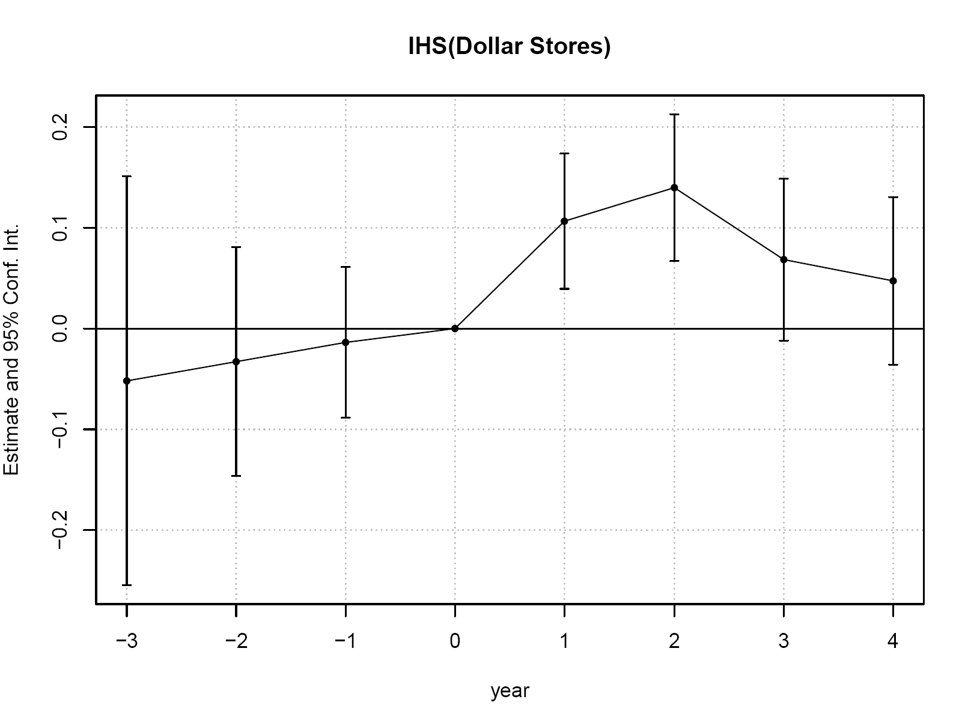
Figure 1: Event-Study Estimates of the Effect of ABAWD Waivers on Dollar Store Entry

