The Incredible Evolving Robot
60 seconds of gameplay

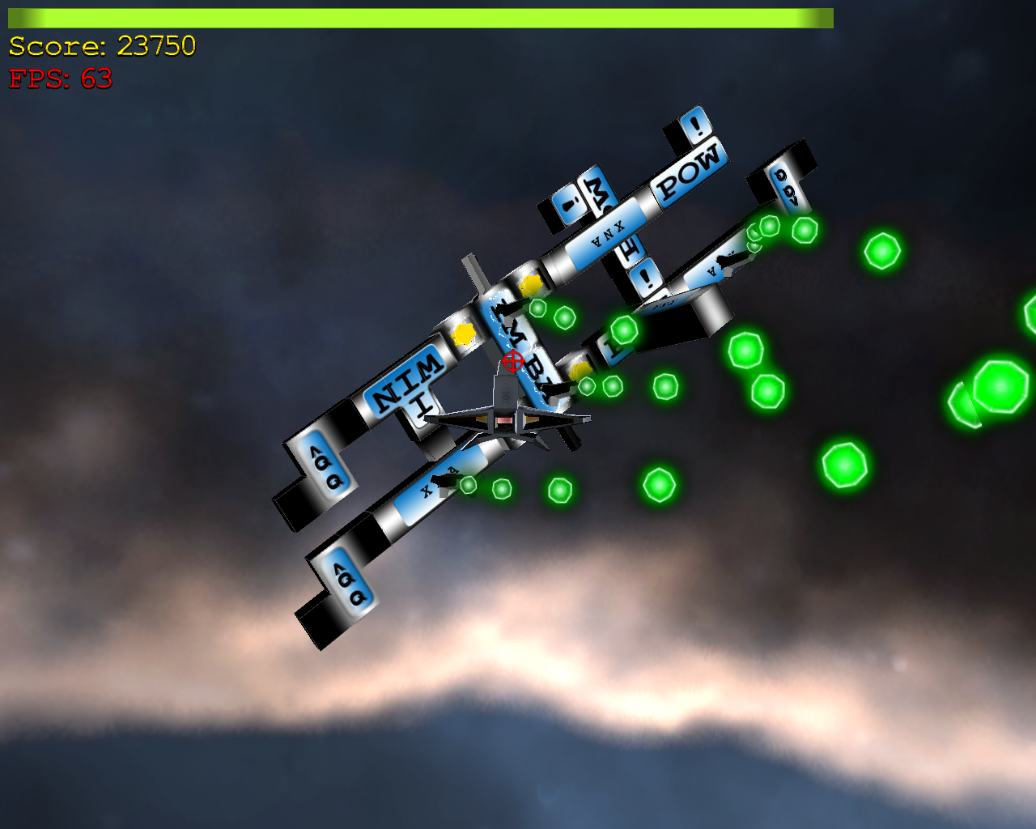

Title screen
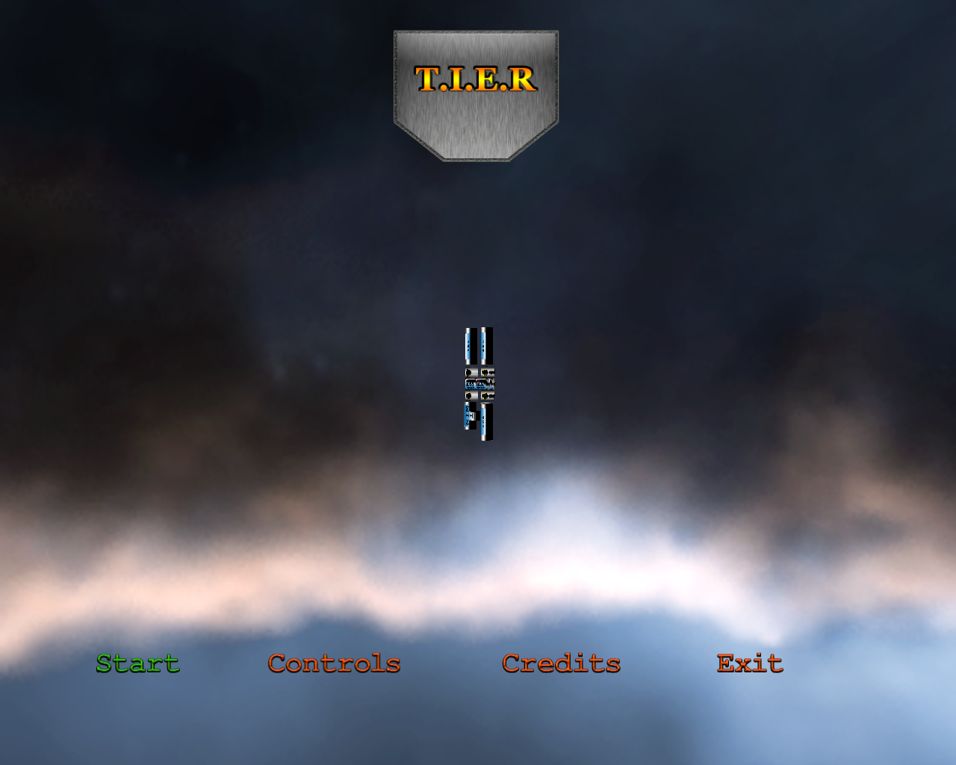 | 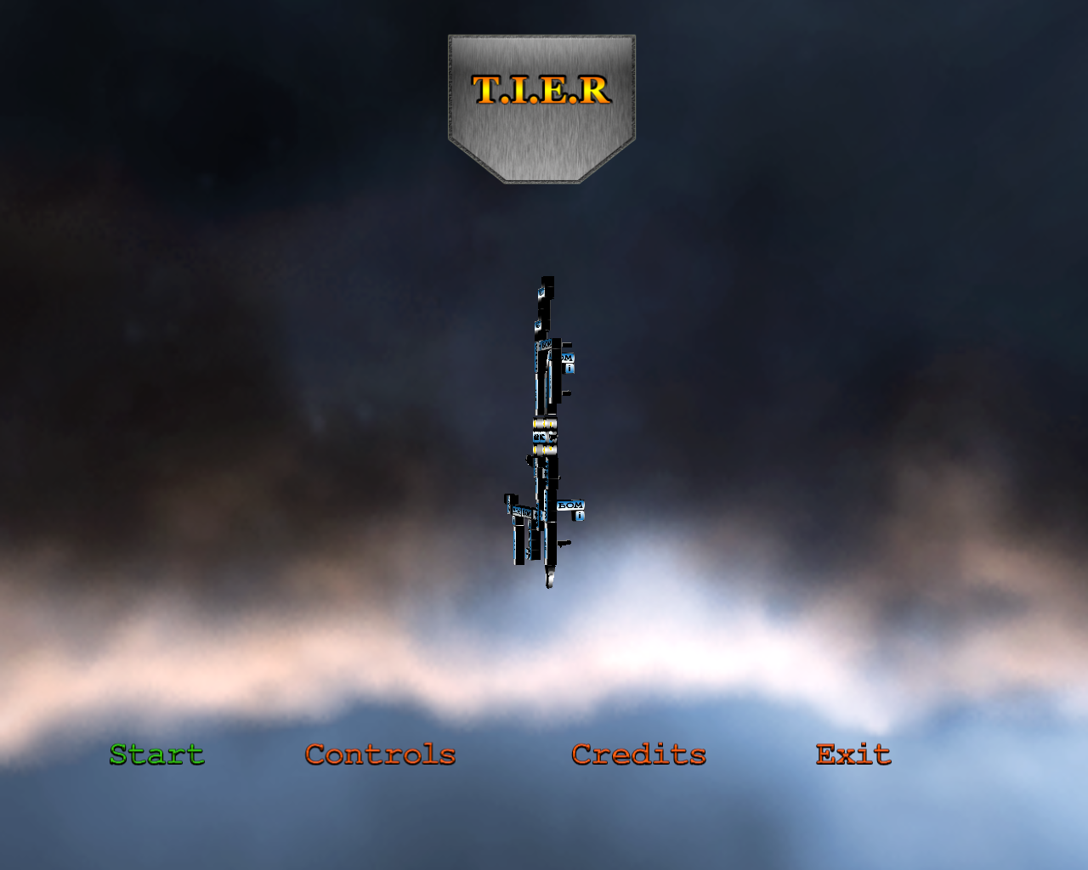 | 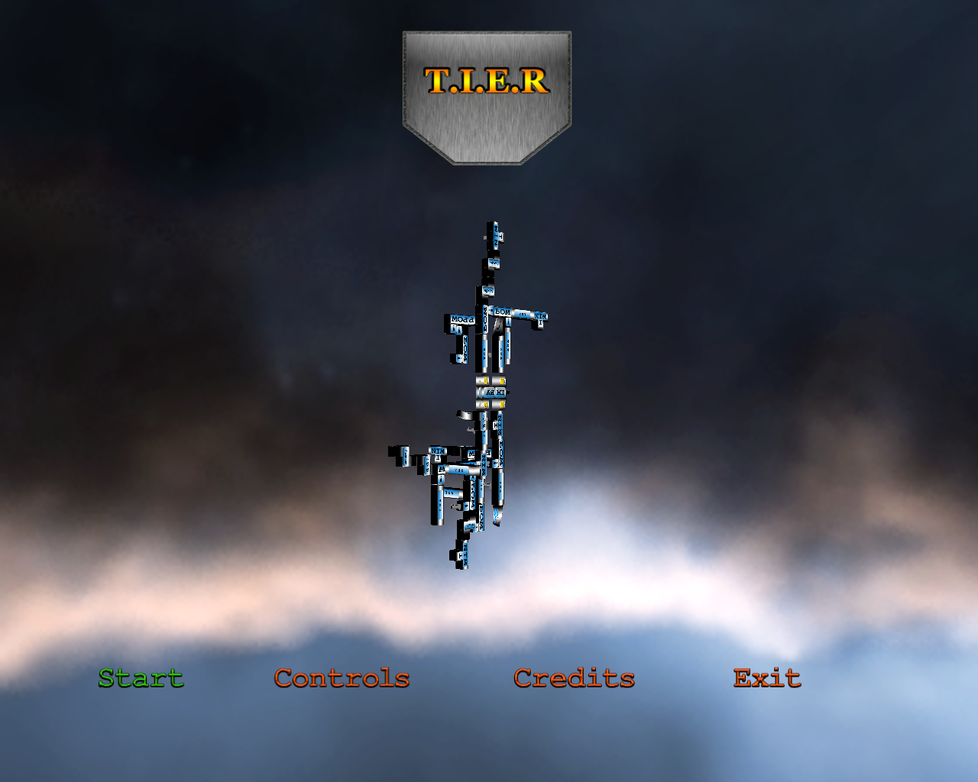
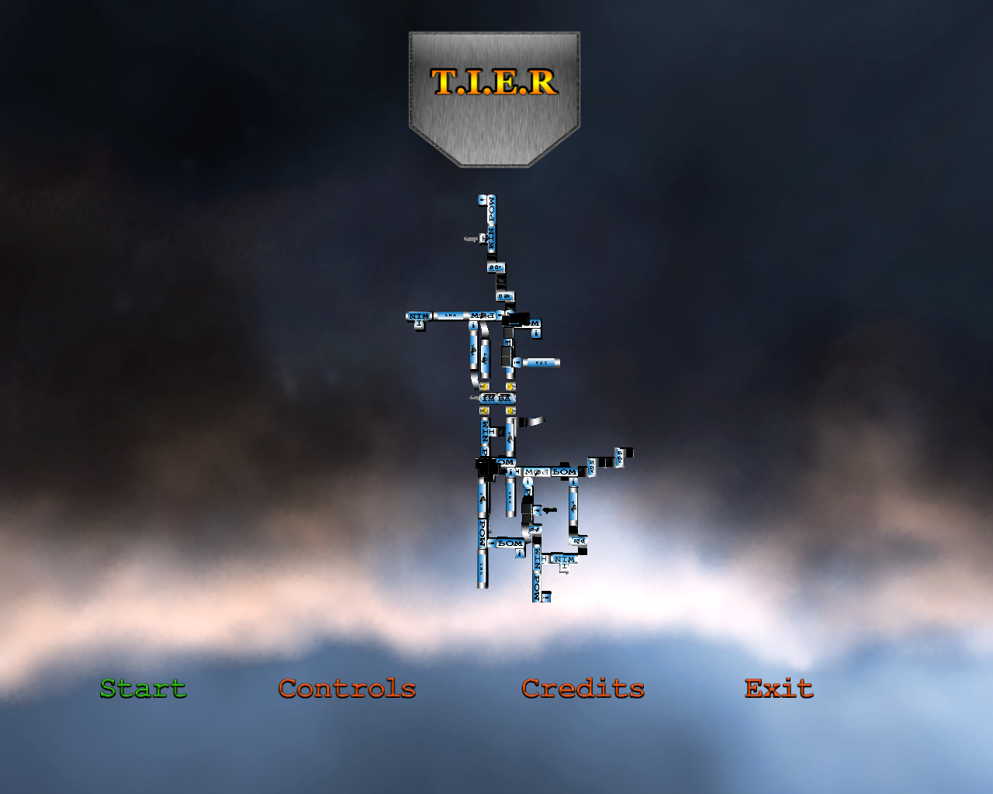 | 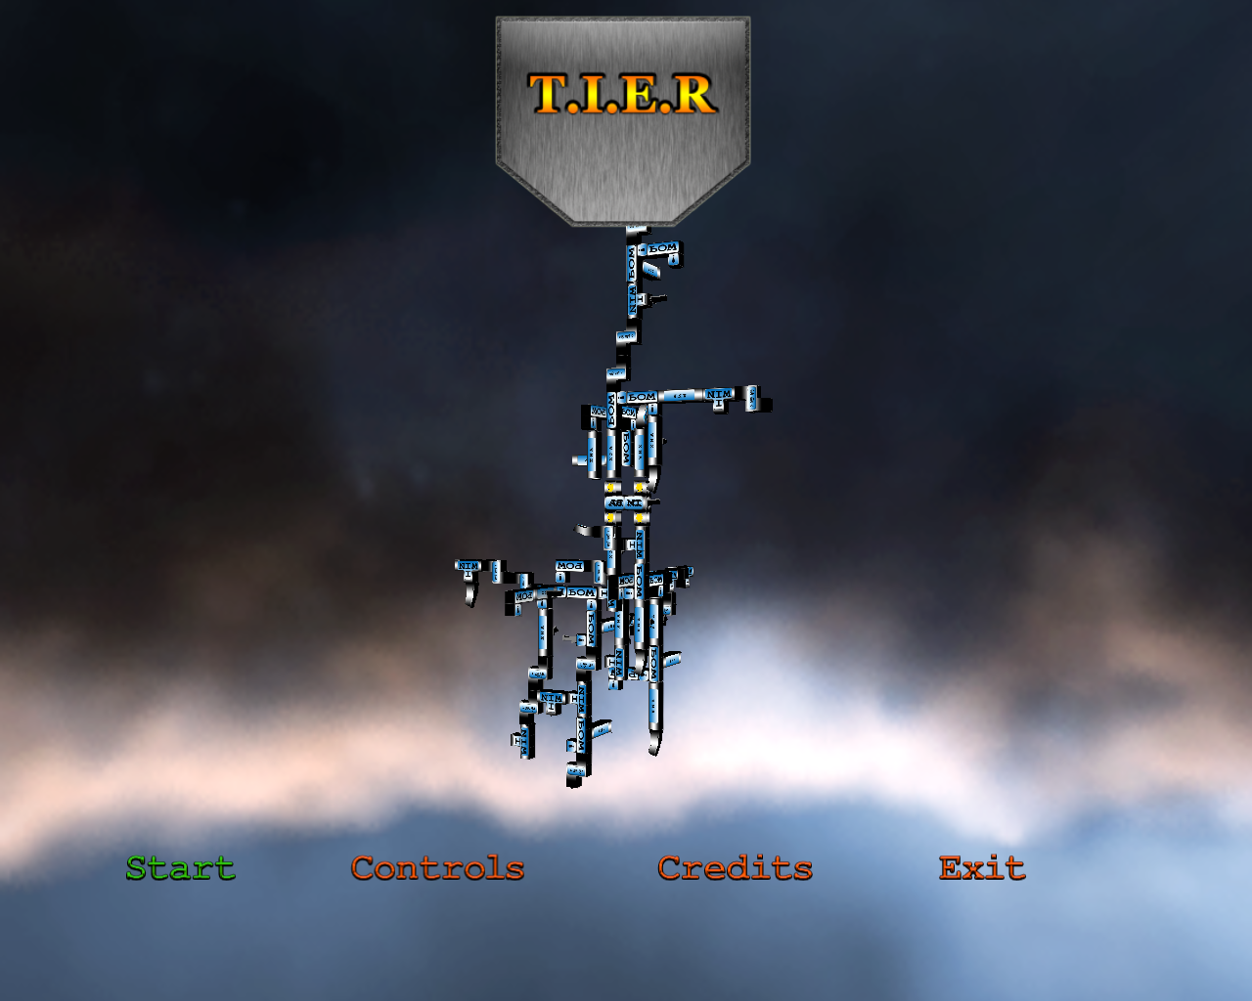

Logo, boss and menu options appear. The boss is centered in the screen and will constantly rotate. Every few seconds the boss will grow a little larger until it is reset again. The screenshots above demonstrate this proces. As a little added extra the logo will scale up and down with the rhythm of the music.
Four options are available, this document focuses on gameplay so we will choose “Start”.

MainGame
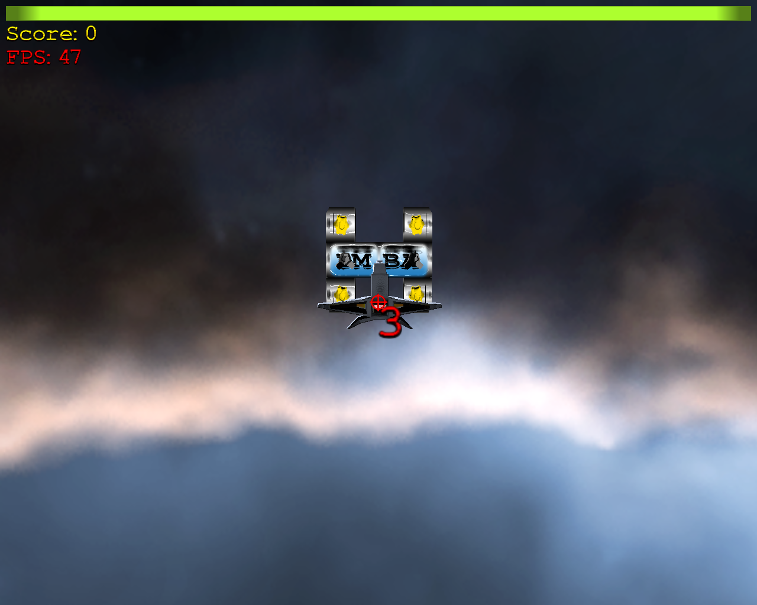 | 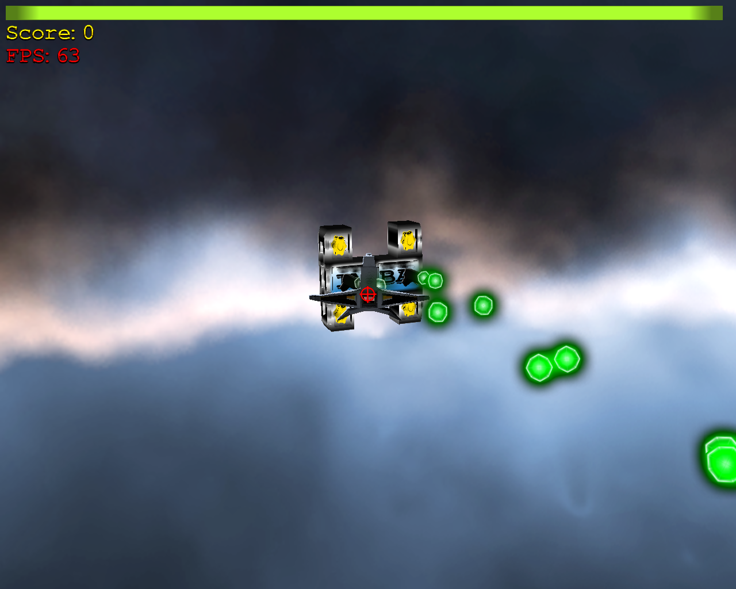

Boss and player will appear. Player can move around now using the left thumbstick. A counter will run from 3 to 1 which will start the actual game. Boss will move around and shoot now.

At the top of the screen the healthbar of the player is visible, this bar will gradually deplete. In addition to that, whenever the player is hit by the boss he/she will also lose health. Completing a level will replenish all health.

The player will have to dodge the incoming projectiles and fire at the boss using the right thumbstick and right shoulderbutton. Whenever the boss, or a piece small piece of it, is destroyed the player is awarded points. These points will spawn at the position of the destroyed piece and will traverse to the topleft position of the screen (where the total score amount is located). The next (grown) boss is now shown.

Boss Introduction

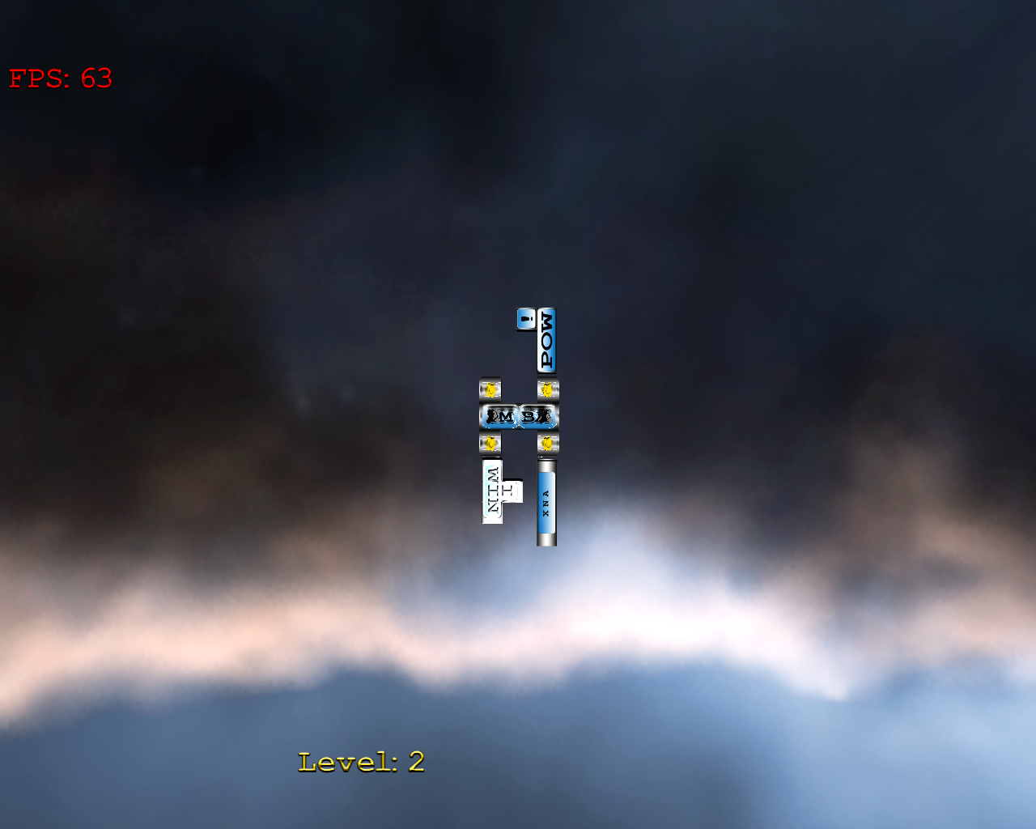
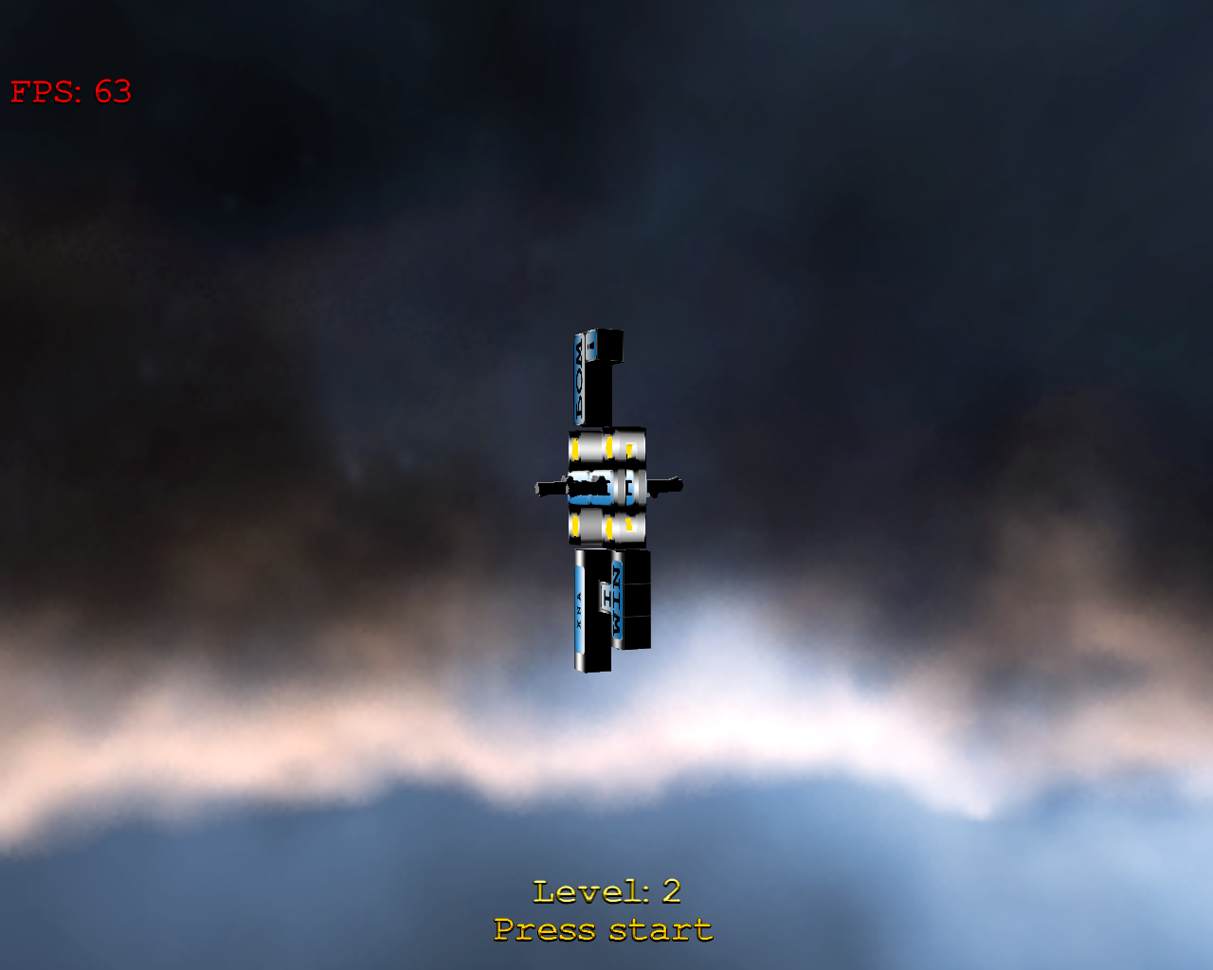

Next boss will fly in directly at the camera. When it halts it will rotate in a similar fashion like in the title screen. This screen will give the player the opportunity to inspect what is waiting for him/her in the next level!

Player will have to press start to continue playing.

More on maingame
The player has started the second level, boss has grown a little bigger and stronger. We will now target a specific part of the boss and kill this first. This part will grow even stronger the next level in addition to the normal boss growth. We will target the Iwin block!
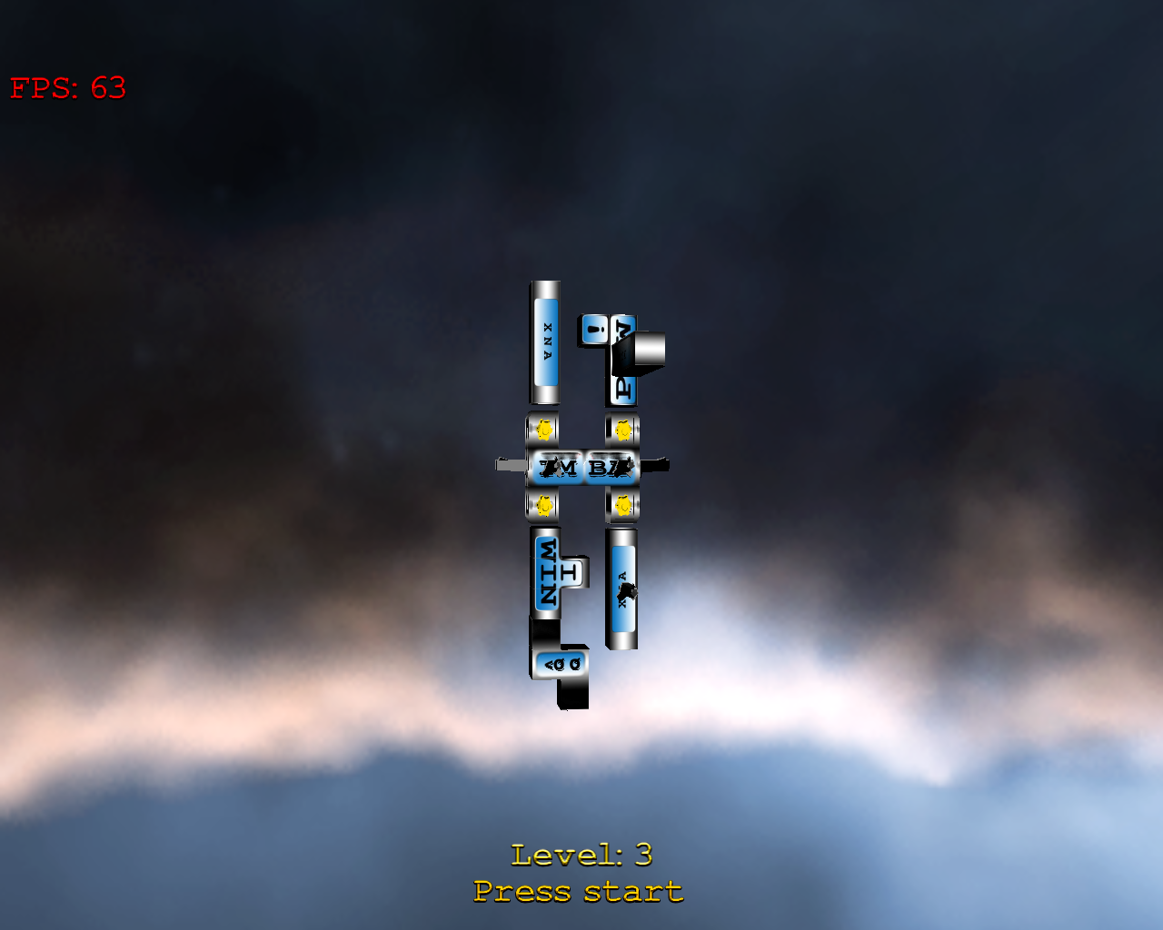

As you can see the Iwin button has a new block attached to it in the next level. In Addition to that, the other blocks have some upgrades of themselves!

Boss abilities
During the (epic) battle, the boss will unleash some powerful abilities for the player to counter. These abilities include:

Charge
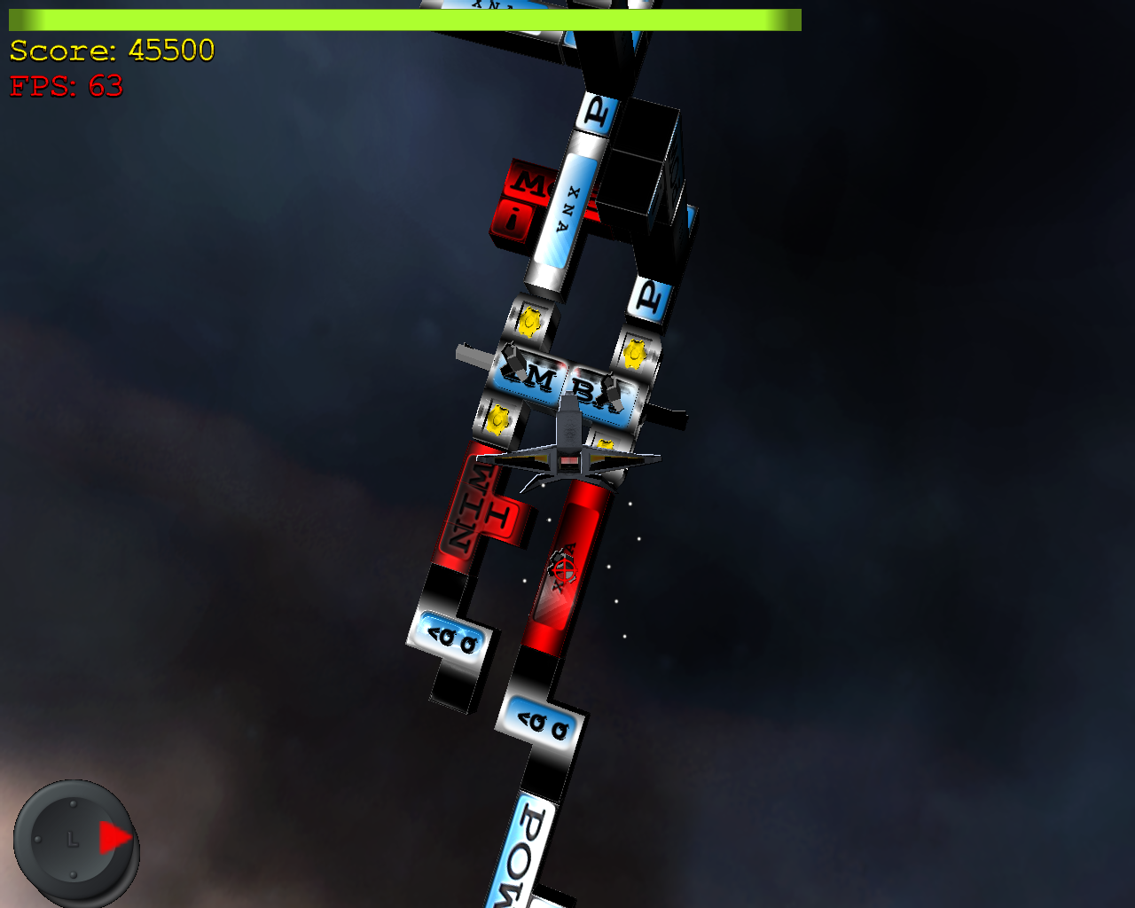
Boss will charge at player at high speed. Player will have to dodge this fast attack. The dodging is done by manuvering the left thumbstick in the direction which is shown in the bottomleft part of the screen.
Whenever the player dodges this attack he/she is awarded points. If the player dodges this attack at the very latest moment in time he/she is awarded extra points and time slows down in a matrixesque way.
When the player is moving in the wrong direction, the charge will hit and the player will lose health.
This ability will grow stronger with every ten levels the boss gains.

Rocket Combo
Boss will retreat to a safe spot and fire a barage of missiles at the player. Like the charge ability this has to be countered using the buttons on the Xbox360 controller. This time around a number of buttons will have to pressed to counter the missiles.
As shown in the screenshot, the buttons which will have to be pressed (in order) are displayed in the bottomleft portion of the screen. Whenever the player misses a buttonpress, the button will be marked missed(red). In the screenshot the player missed the first two buttonpresses.
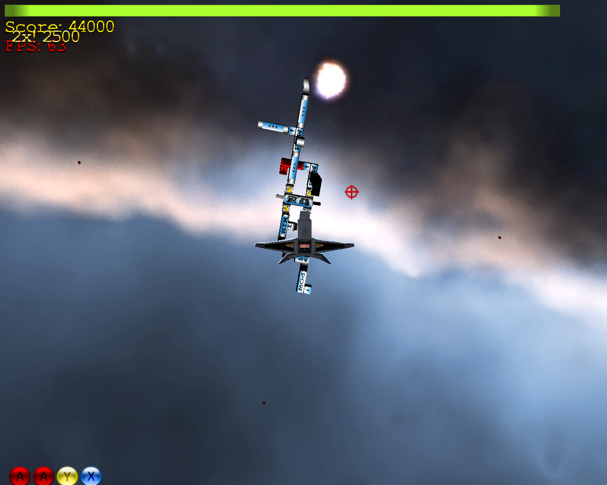
The player is awarded points or loses health in a similar fashion as in the Charge ability. For each missed button press the player loses health.
But for every correct buttonpress he/she will score points.
The number of buttonpresses will increase every 5 boss levels.

Conclusion
This concludes the 60 seconds of gameplay summary on The Incredible Evolving Robot (T.I.E.R.). I hope this was an informative and enjoyable read. To check out the further devolpment of this title check in with my portfolio at: http://www.pjstyle.net !

