1. Create dimension table definitions in SQL Server

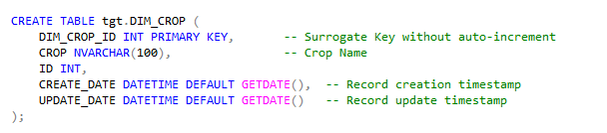

1. Import the CROP_PRODUCTION table into the source analyser.

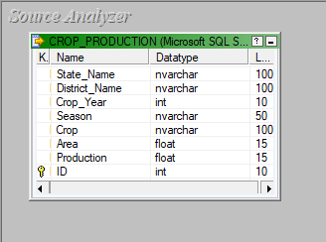

1. Import the DIM_CROP table created into the target analyser.

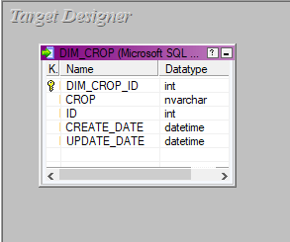

1. Create a mapping called m_dimension_season to create the required dimension table

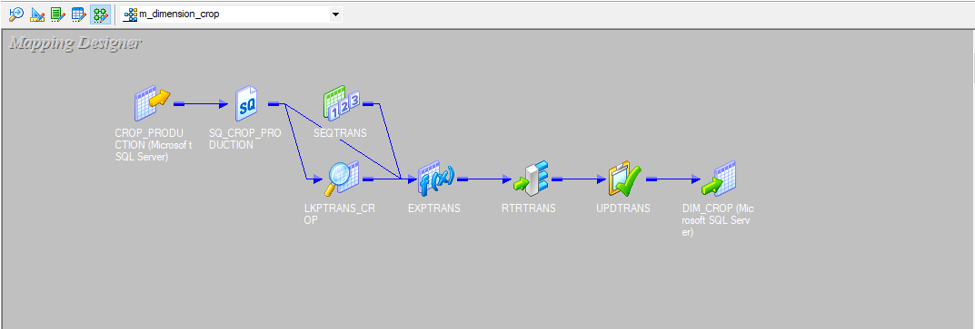

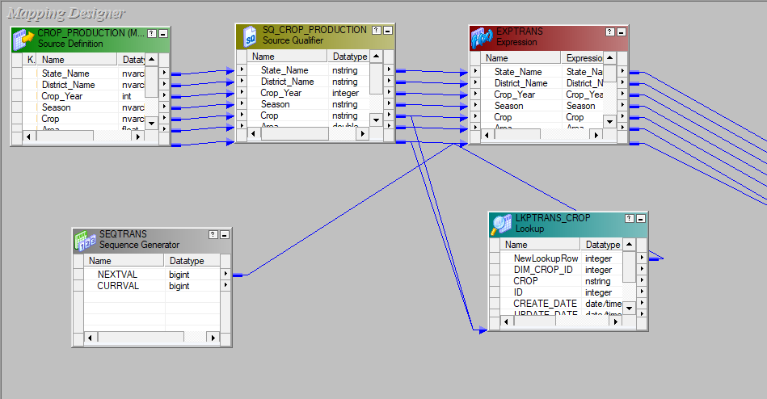

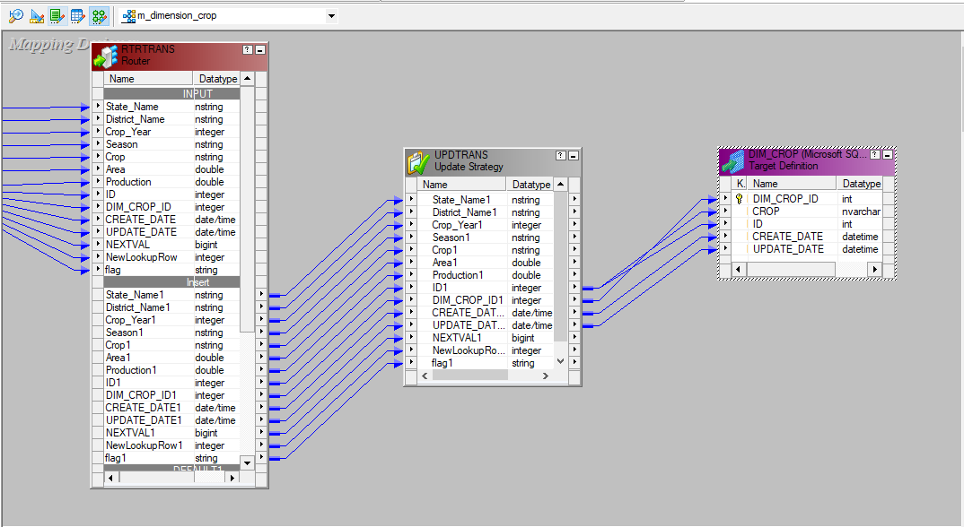

1. Workflow called wf_m_dimension_crop is created to execute the task along with an event_wait.

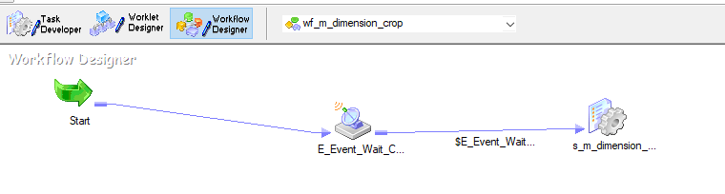

1. Final target table in the database which is populated with the required data.

