**PROBLEM STATEMENTS CHOSEN:**

1. **Financial Portfolio and Sentiment Analysis Dashboard**
2. **Educational Performance Analysis Tool**

**OUTPUT SCREENS:**

The code files in the archive file have the detailed .ipynb files of model training.

The Home Screen is accessible via port 5000, where users can register or log in by providing their credentials. Upon successful login, users can select their role—Admin, Editor, or Viewer. The screen displays a list of database entries, which users can interact with based on their role. Admins can manage entries, while Editors can only edit, and Viewers can only view. Once logged in with valid credentials, users gain access to the application running on port 5001. Access to this backend is restricted and requires authentication to ensure security and proper user roles.

This is the home page.

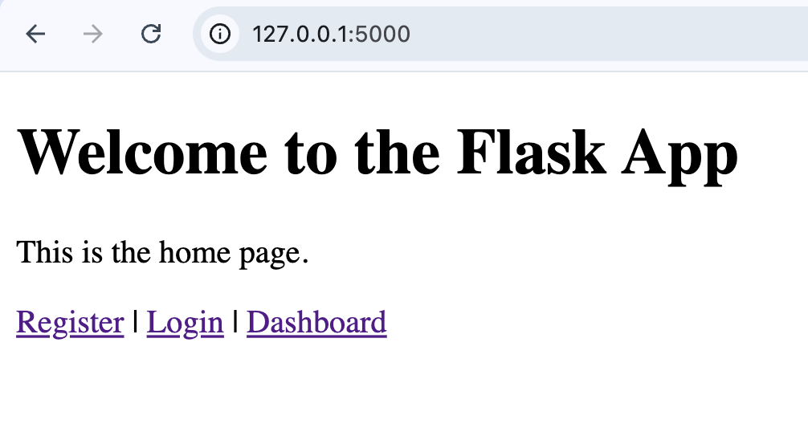

This is the register screen, the past data is also available here. You can choose your roles from Admin, Viewer and Editor.

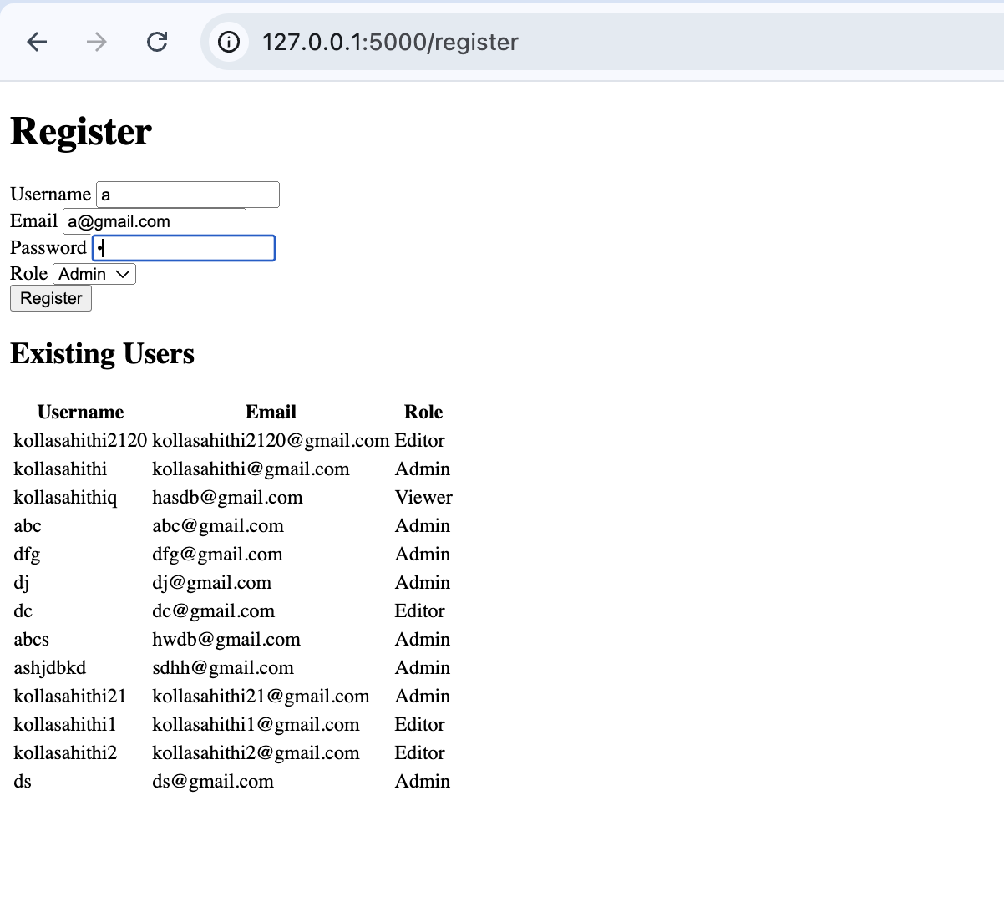

Once a user has registered as admin and logged in, they will be able to access the Financial dashboard, here you can enter the ticker of a stock and see its trends. The FINANCE folder code is running on port 5001 now.

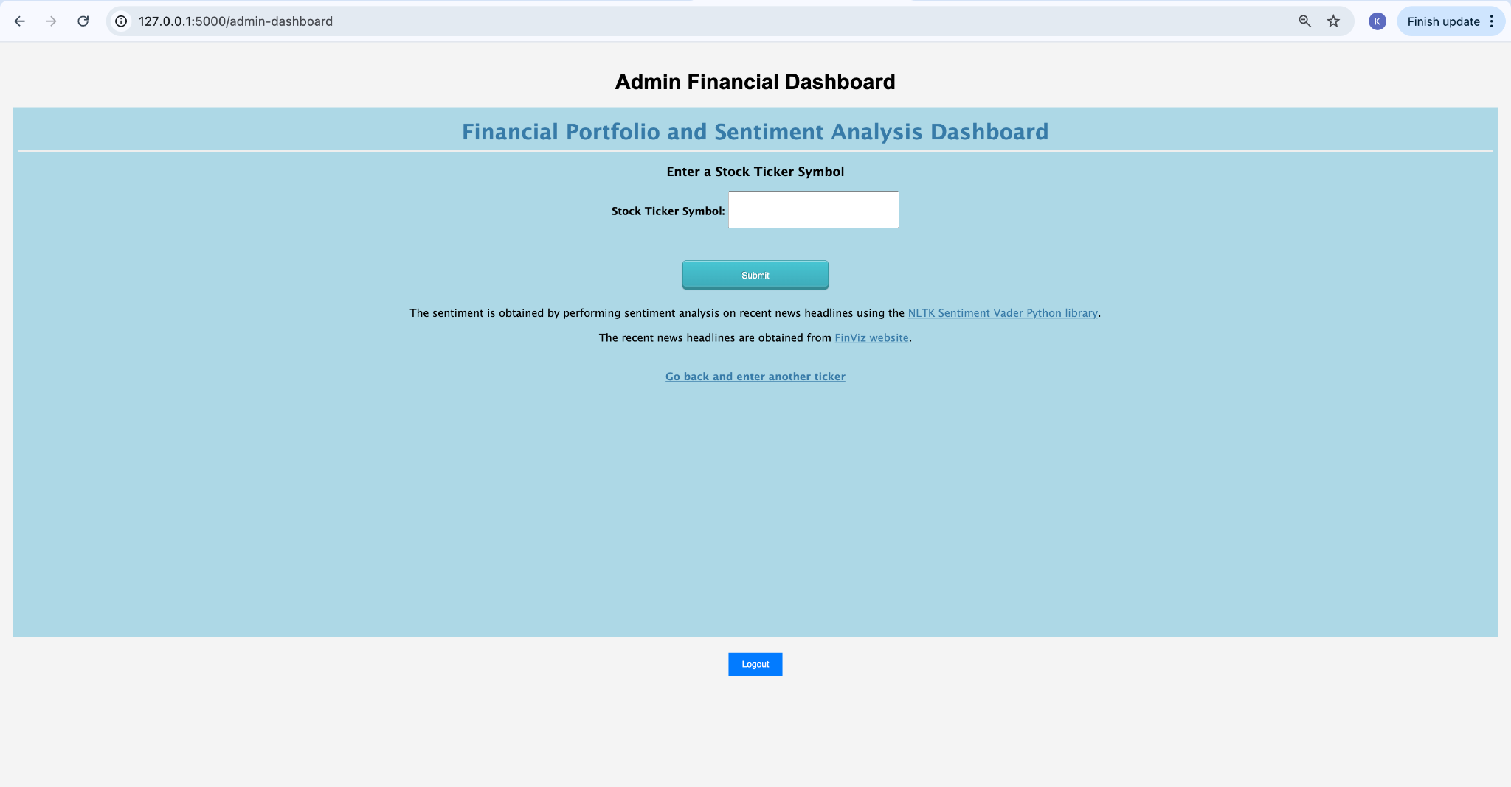

The trends for ‘aapl’ are searched.

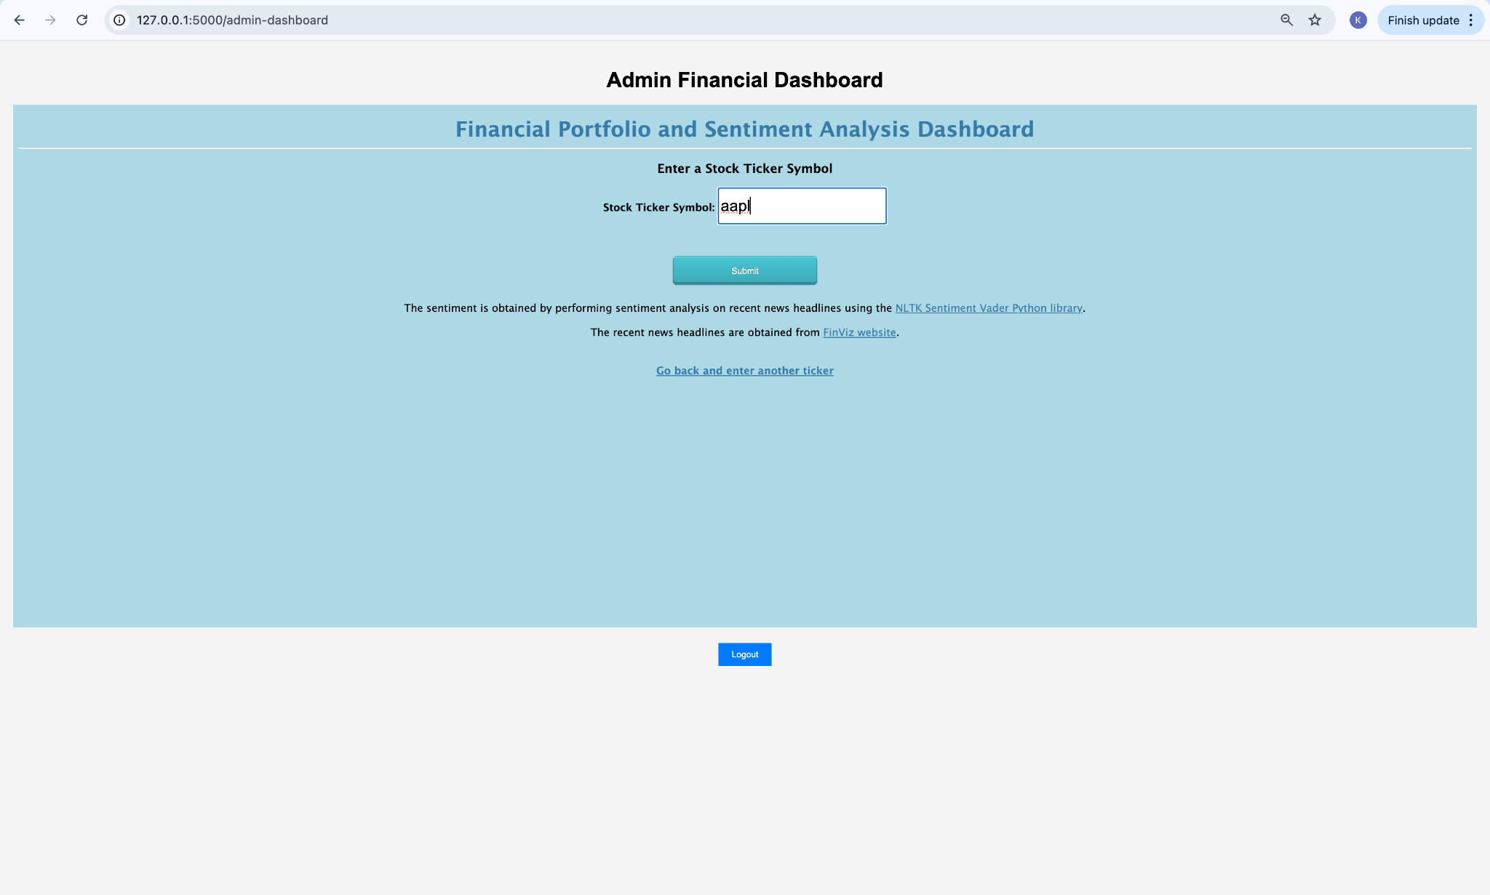

The hourly and daily sentiment of AAPL stock along with a wordcloud are displayed.

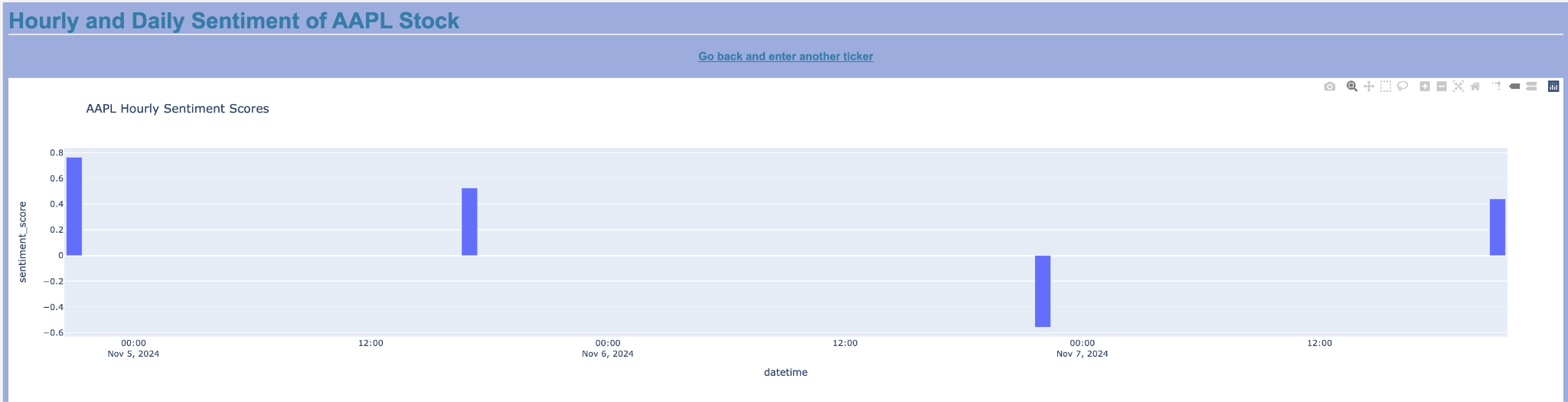

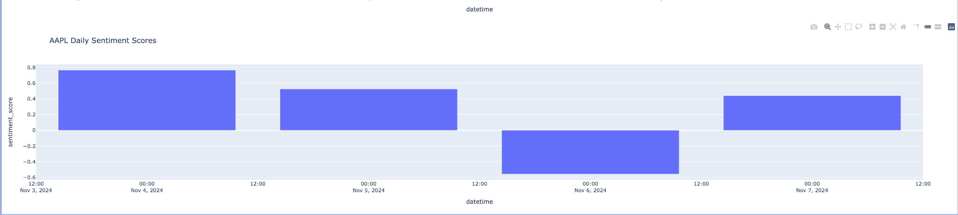

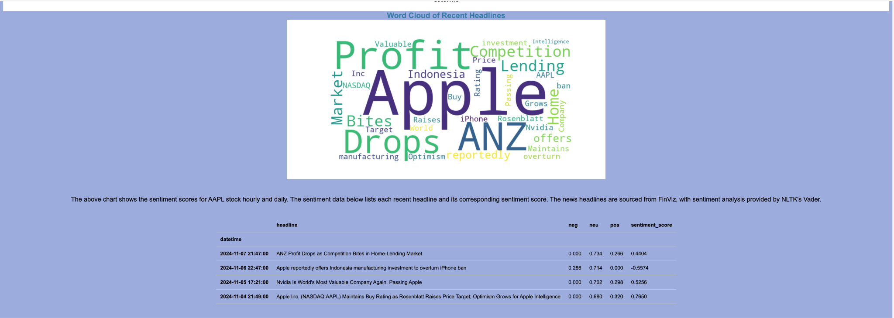

This is the registration for an editor role.

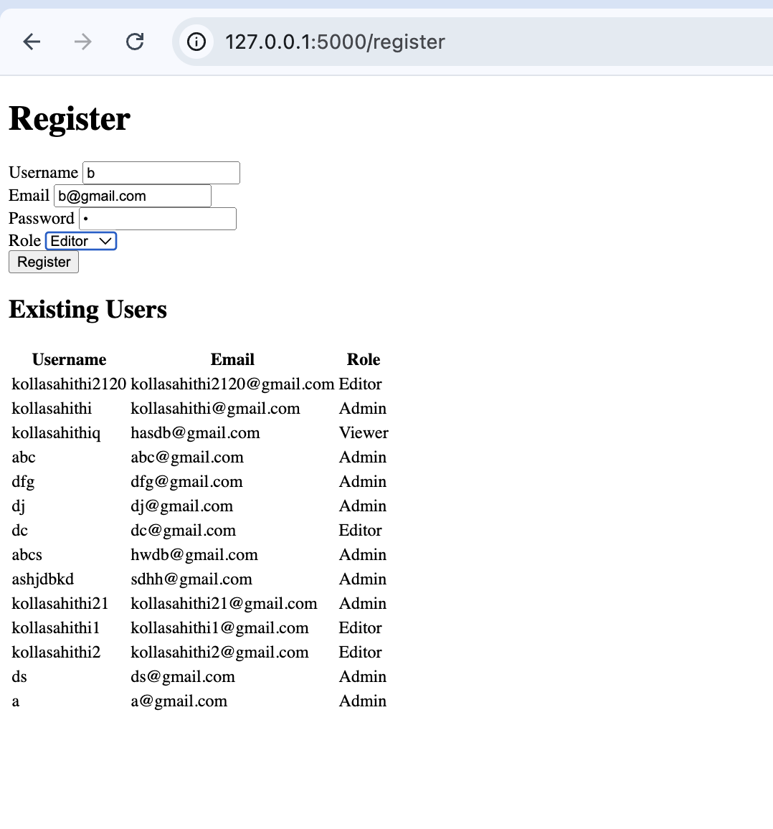

The editor cannot access the finance dashboard, they will be redirected to their own dashboard with different access which will be developed soon.

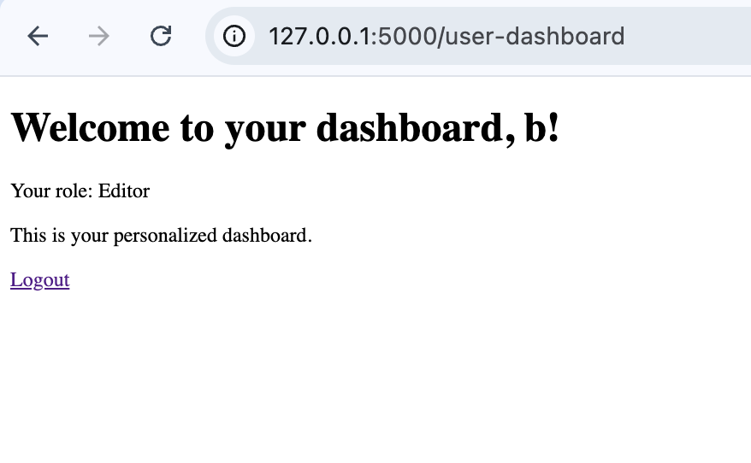

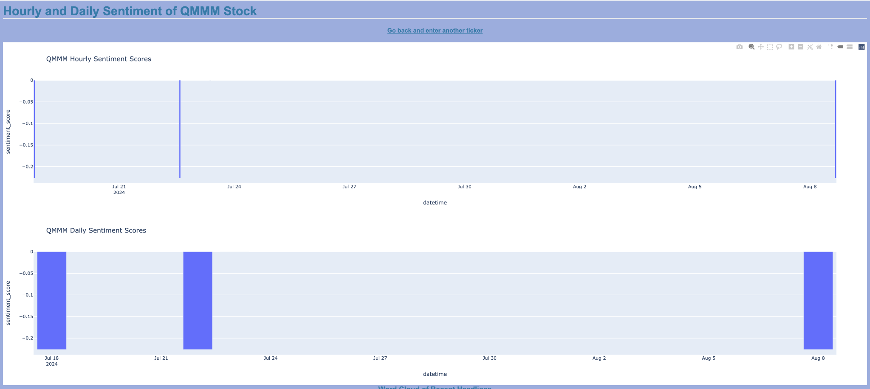

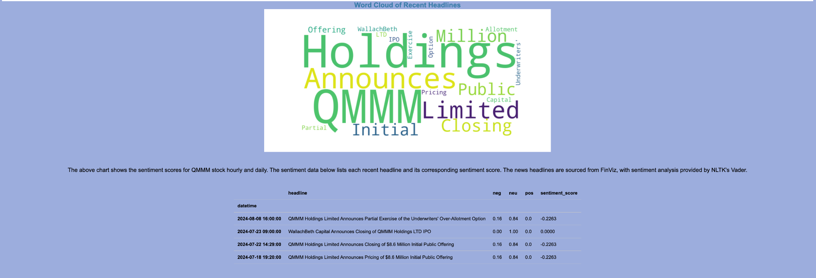

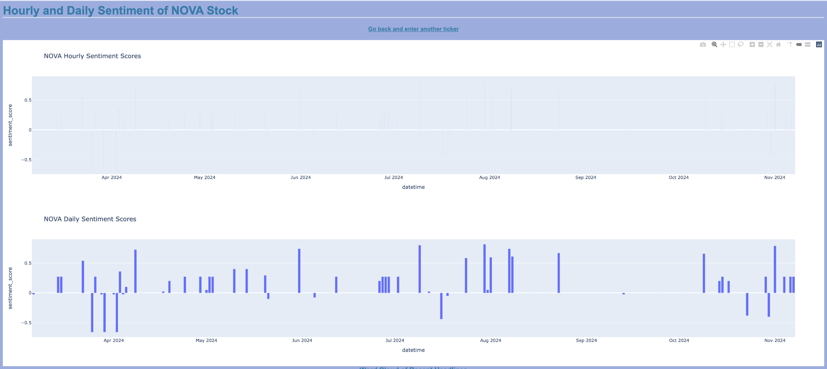

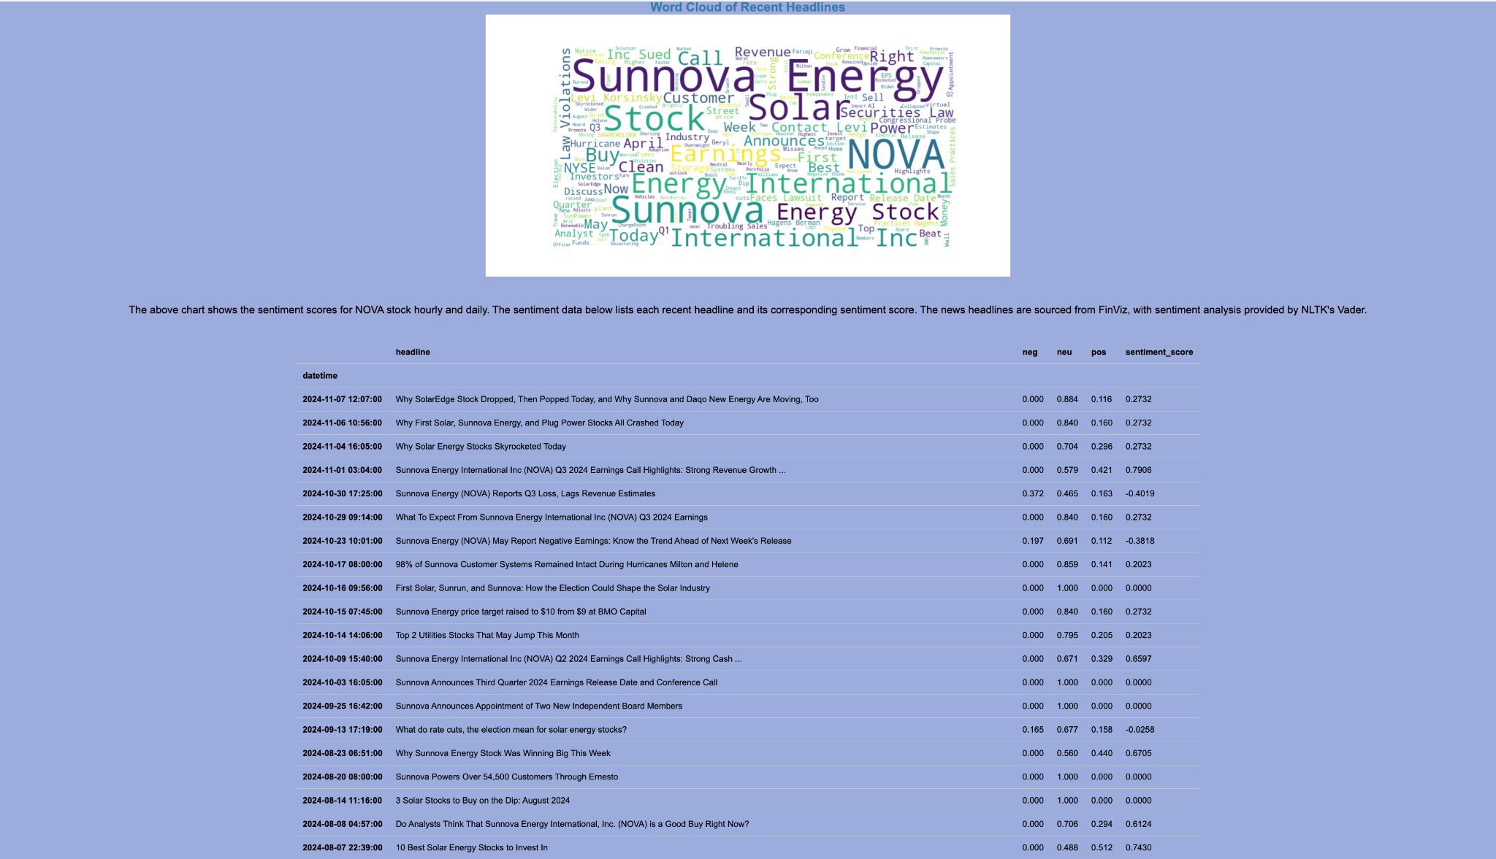

The STUDENT folder code is running on port 5001 now. When you login as admin you can access this page.

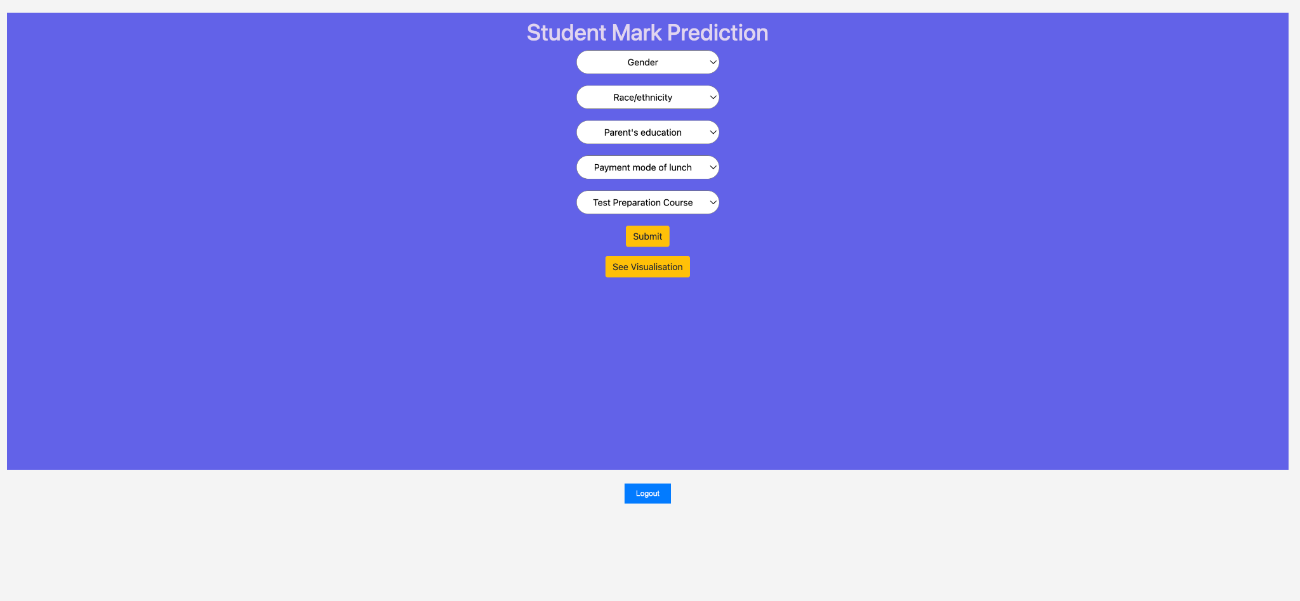

The required data must be chosen from the dropdowns.

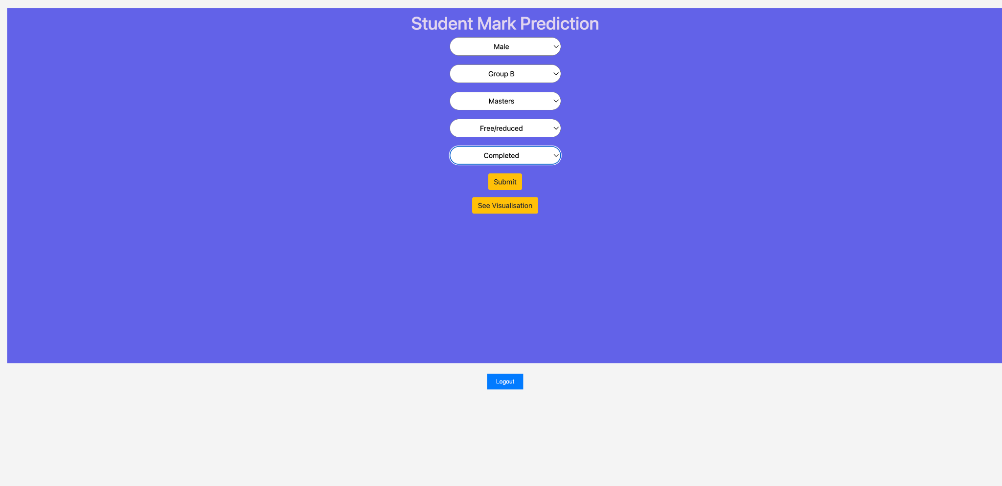

The results are predicted as shown below.



When You click on show visualisations in the home screen, you can see these. When you hover over a graph it will be maximised in the side window.

