**Weekly Assignment: Informatica Retail Store Data Processing**

1. **Retail_store file load into another file**

○ Load the provided Retail_store dataset file into a new output file.

○ This task is focused on practising file-to-file ETL transformations in Informatica.

The given csv file, loaded into the local machine.

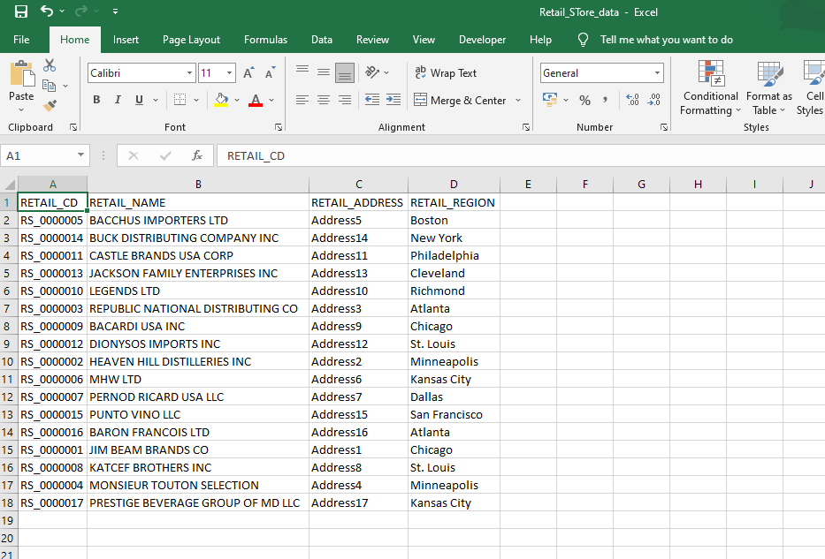

CSV flat file loaded into the source analyser.

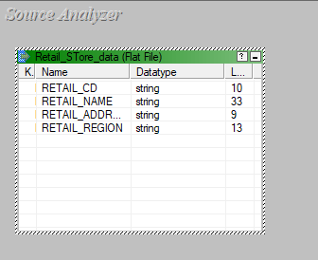

A target flat file called copy.csv loaded into the target designer.

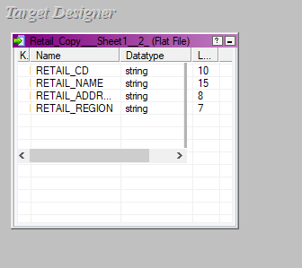

The source and target files are being mapped using a source qualifier, the mapping is named retail_mapping.

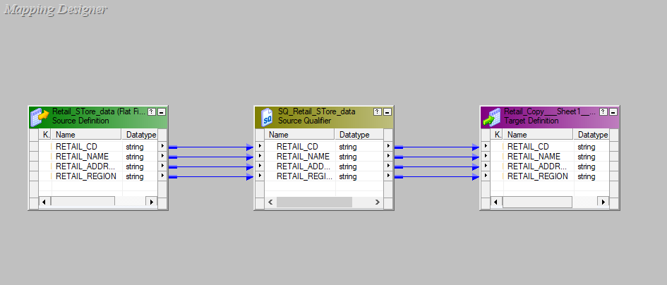

A workflow is designed under the name of wf_retail_mapping and executed.

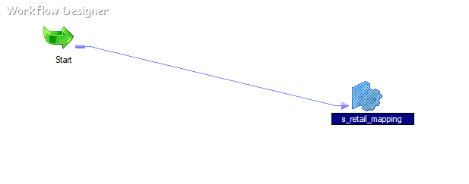

The final copy.csv file with the data from retail_store.csv.

