**Weekly Assignment: Informatica Retail Store Data Processing**

2. **Retail_store file load into table stg_retail**

○ Load the Retail_store data into the staging table stg_retail in the database.

○ Ensure accurate data mapping and loading with no errors. This step represents loading raw data into a staging environment.

Creating the Retail (Source) table in Oracle SQL Developer.

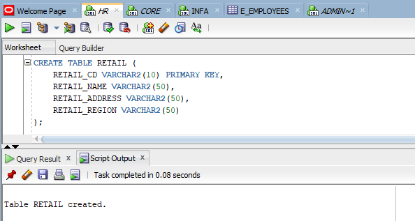

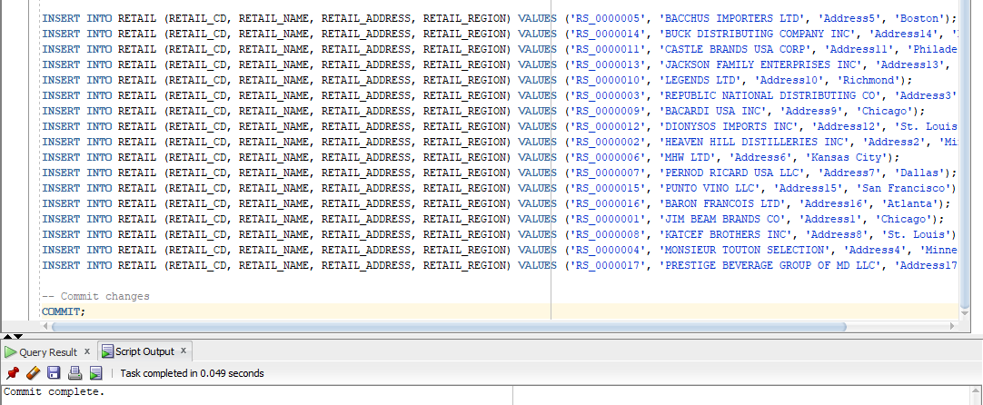

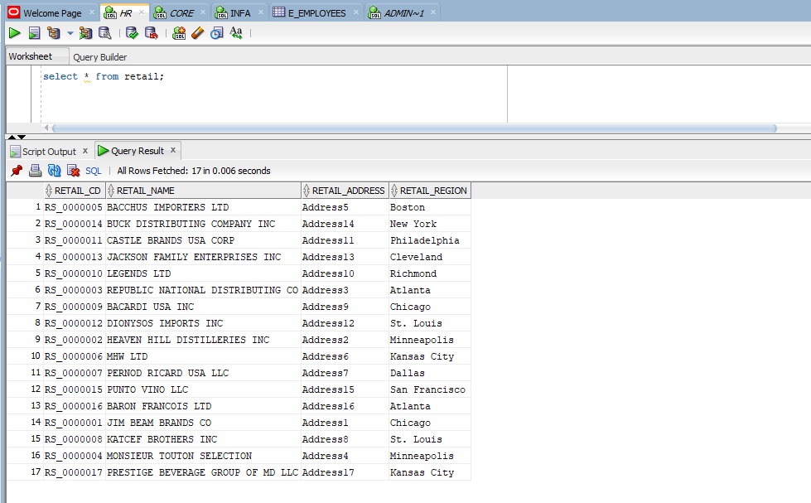

Creating stg_retail (target) in Oracle SQL Developer

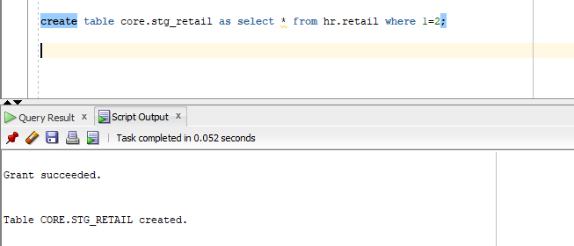

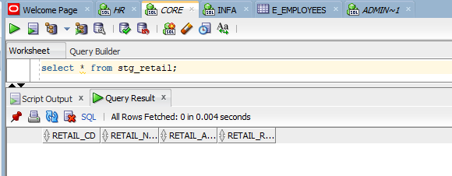

Retail file loaded into the source analyser.

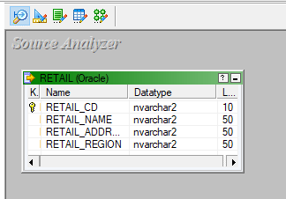

A target file called stg_retail loaded into the target designer.

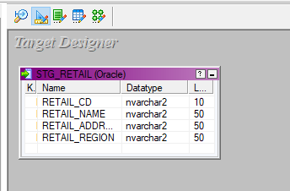

The source and target files are being mapped using a source qualifier, the mapping is named stg_mapping.

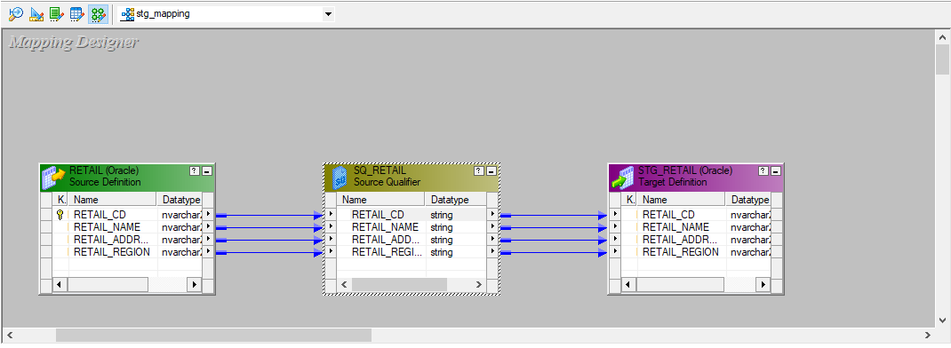

A workflow is designed under the name of wf_stg_mapping and executed.

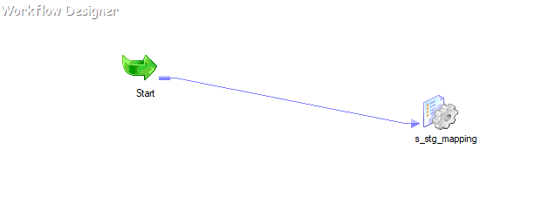

The final stg_retail which contains all the records from retail table.

