**Weekly Assignment: Informatica Retail Store Data Processing**

3. **Create a file of countrynames using country table**

○ Extract data from the country table to create a file containing only country names.

○ This exercise will help you practice extracting specific columns from a table.

Countries table in the Oracle SQL Developer.

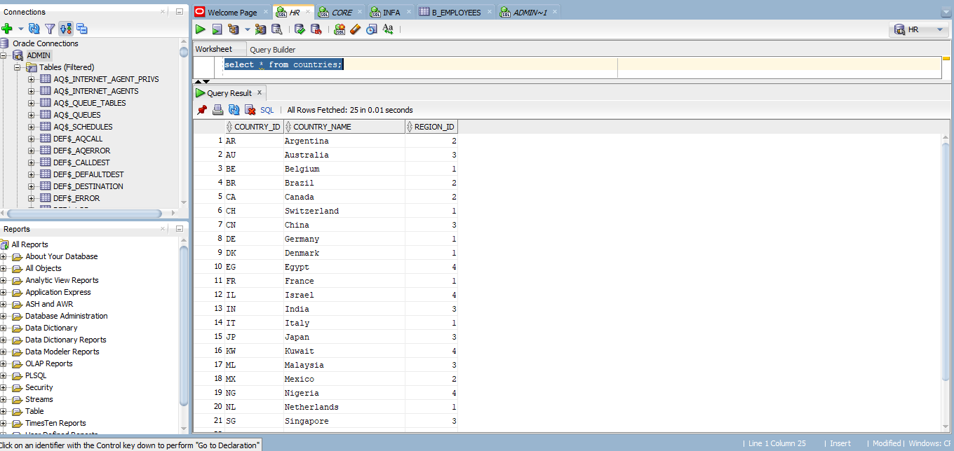

Countries file loaded into the source analyser.

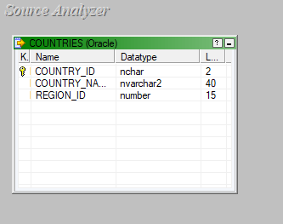

A target file called c_name loaded into the target designer.

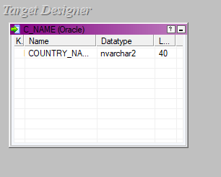

The source and target files are being mapped using a source qualifier, the mapping is named extract_cname.

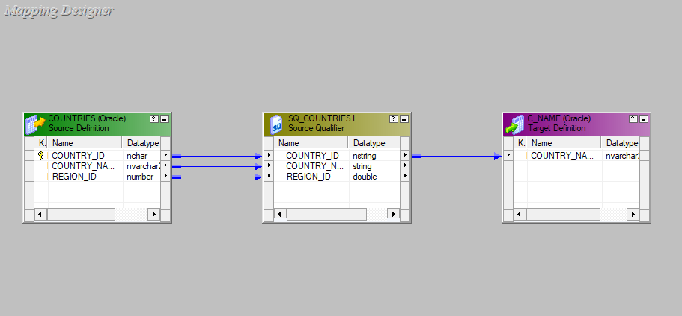

A workflow is designed under the name of wf_extract_cname and executed.

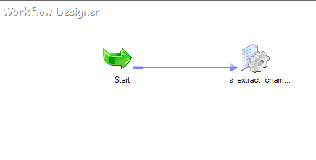

The final c_name with only the country names.

