**Weekly Assignment: Informatica Retail Store Data Processing**

4. **Create a file for manager_id = 100 using employee table**

○ Use the employee table to generate a file with records where manager_id equals 100.

○ This task focuses on conditional data extraction.

Employees table in the Oracle SQL Developer.

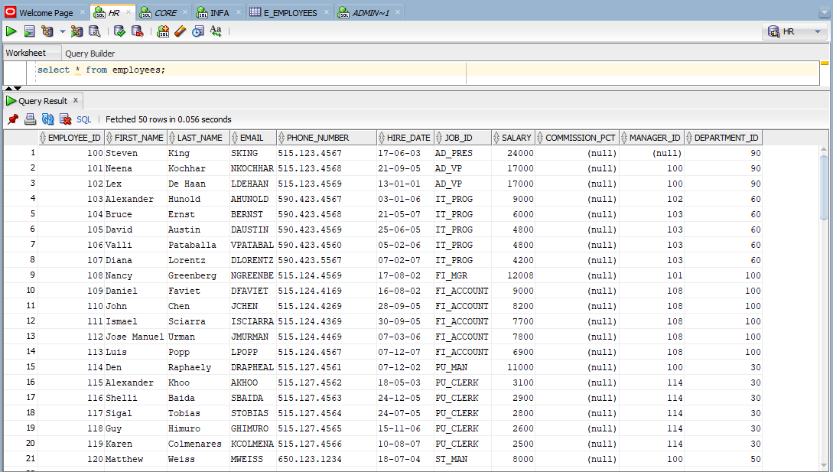

Employees file loaded into the source analyser.

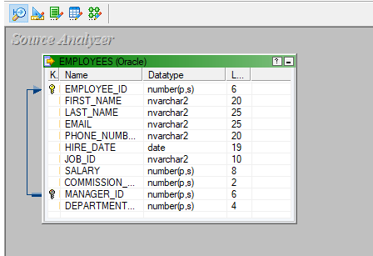

A target file called e_employees loaded into the target designer.

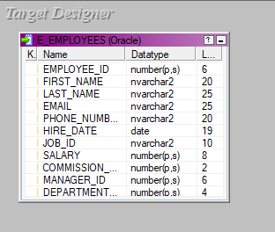

The source and target files are being mapped using a source qualifier, the mapping is named extract_manager_100.

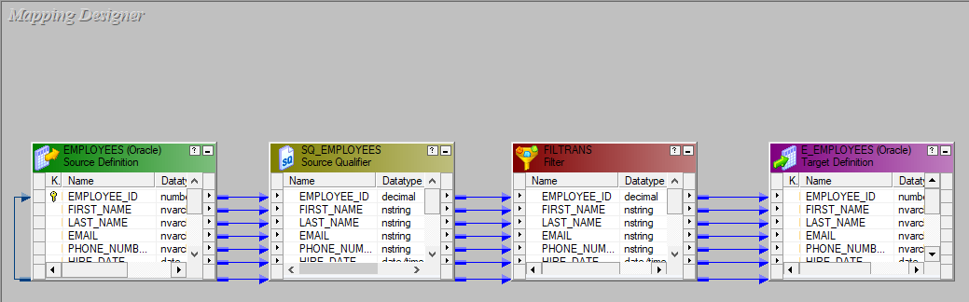

A workflow is designed under the name of wf_extract_manager_100 and executed.

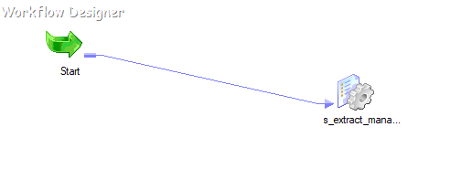

The final e_employees which only contains the records where manager _id=101

