**Weekly Assignment: Informatica Retail Store Data Processing**

5. **Create 3 files for manager_id = 101, 102, 103 using employee table**

○ Create separate files from the employee table for each manager_id (101, 102, and 103).

○ This step reinforces skills in conditional extraction for specific IDs.

Employees table in the Oracle SQL Developer.

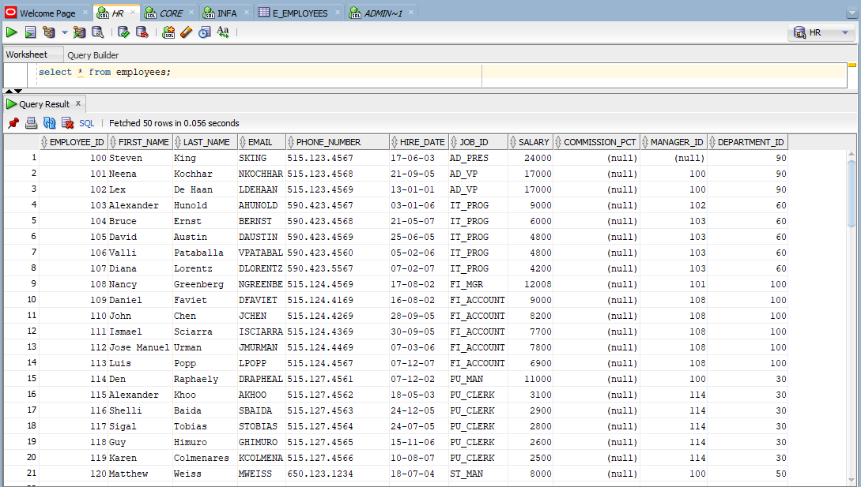

Employees file loaded into the source analyser.

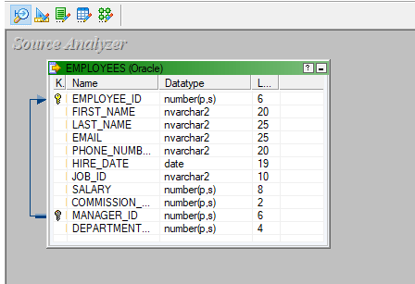

A target file called e_employees loaded into the target designer.

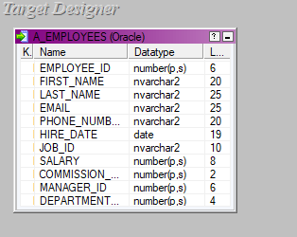

The source and target files are being mapped using a source qualifier, the mapping is named extract_manager_101.

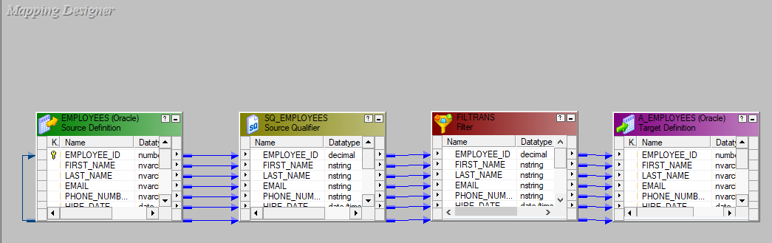

The transformation applied.

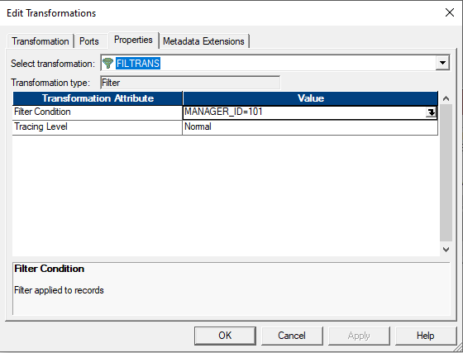

A workflow is designed under the name of wf_extract_manager_101 and executed.

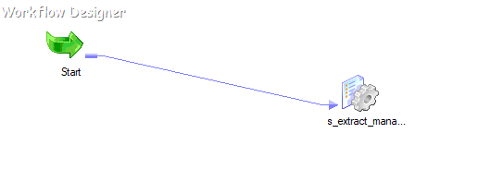

The final e_employees which only contains the records where manager _id=101

