**Weekly Assignment: Informatica Retail Store Data Processing**

6. **Union the files created in Assignment 5 and create a single output file**

○ Combine the three files created for manager_id 101, 102, and 103 into a single output file.

○ This task will test your ability to use union transformations effectively in Informatica.

Displaying the Employees(Source) table in Oracle SQL Developer.

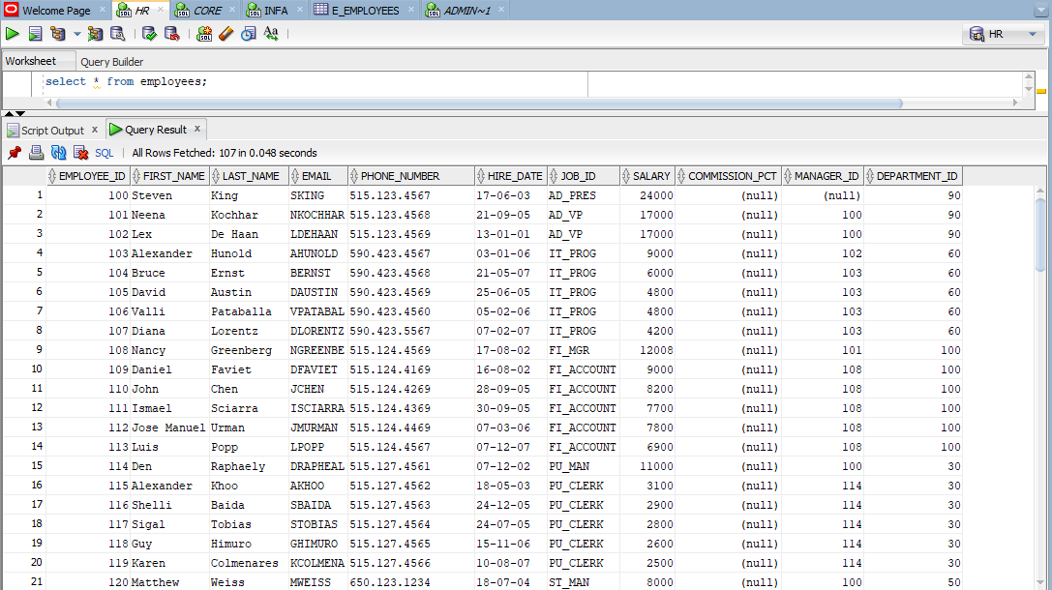

Three subsets of the employee table with manager_id=101, 102 and 103 are loaded into the source analyser.

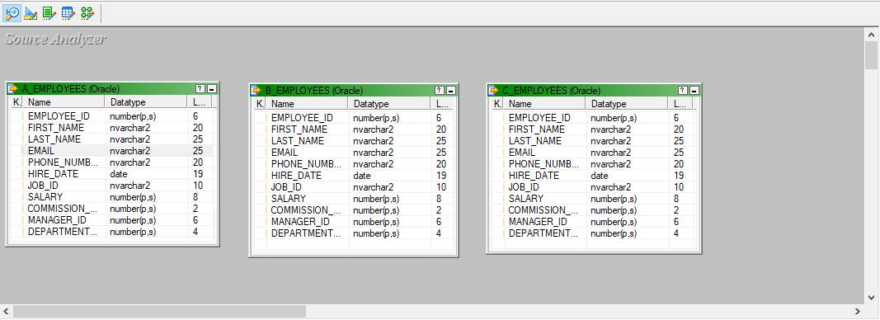

A target flat file called emp loaded into the target designer.

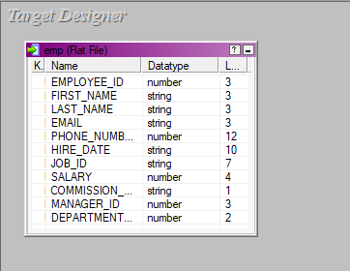

The source and target files are being mapped using a source qualifier and a union transformation, the mapping is named example_mapping.

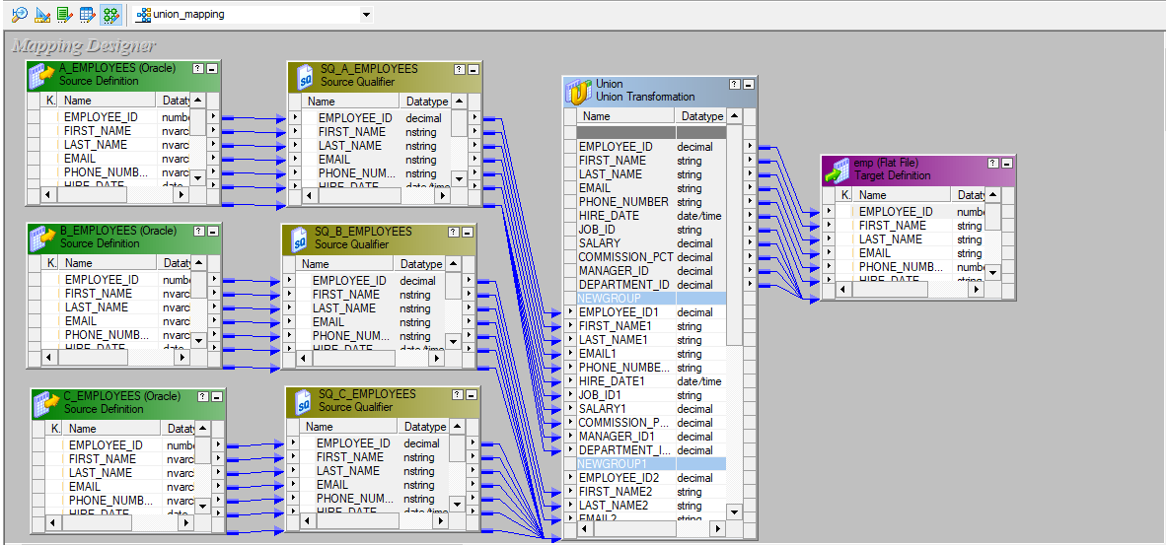

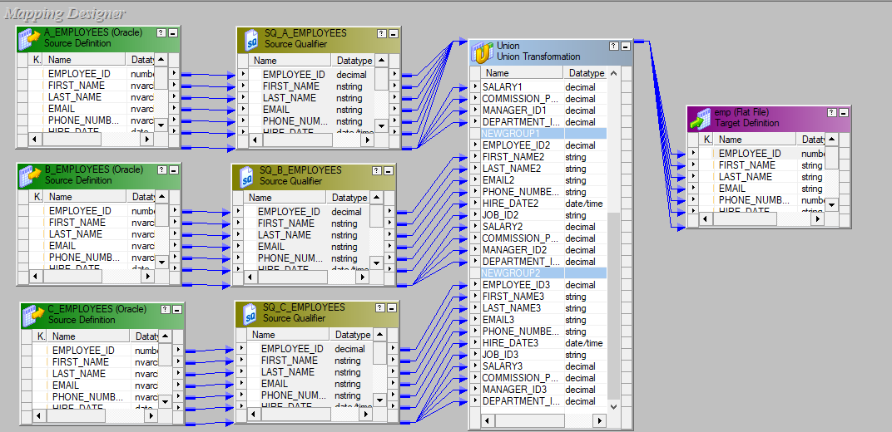

A workflow is designed under the name of wf_example_mapping and executed.

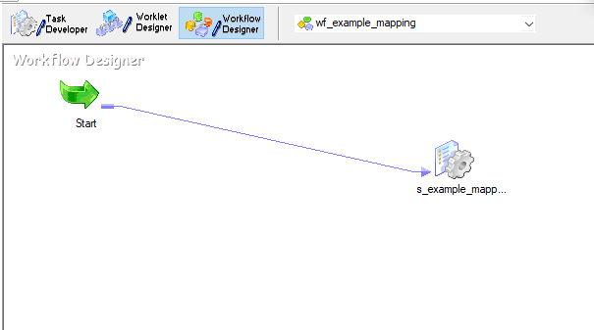

The final emp.csv which is the union of three tables whose manager_id’s are 101, 102 and 103.

