**Weekly Assignment 16-Nov-24 : Informatica Tasks**

1. **For Each Department, Sort the Data on Manager ID and Emp_ID Desc**

* Sort the data by Manager_id and then by Emp_id in descending order for each department.
* Use a **Source Qualifier Transformation** with a **SQL Override** or appropriate transformation to implement sorting.

**Displaying the unsorted Employees(Source) table in Oracle SQL Developer.**

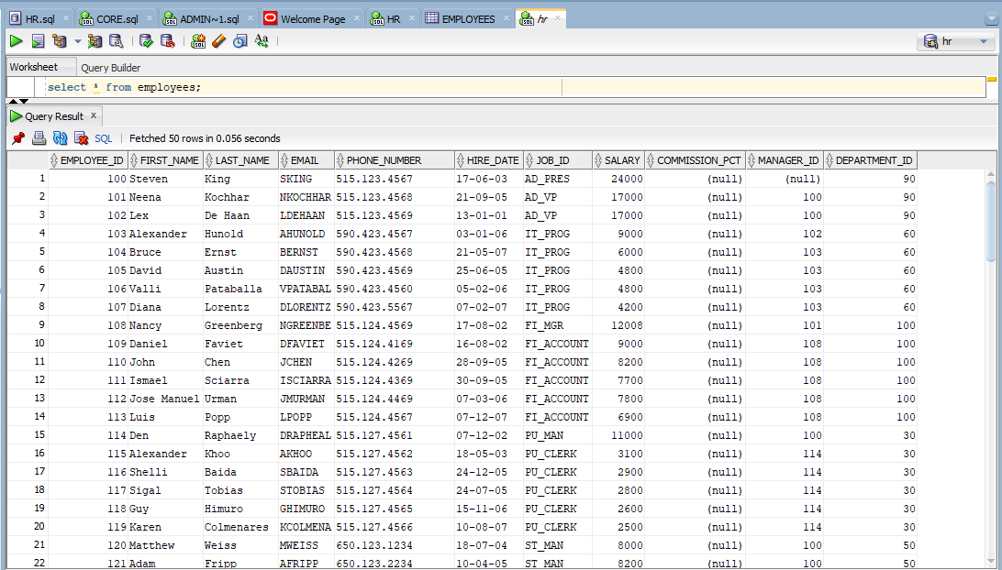

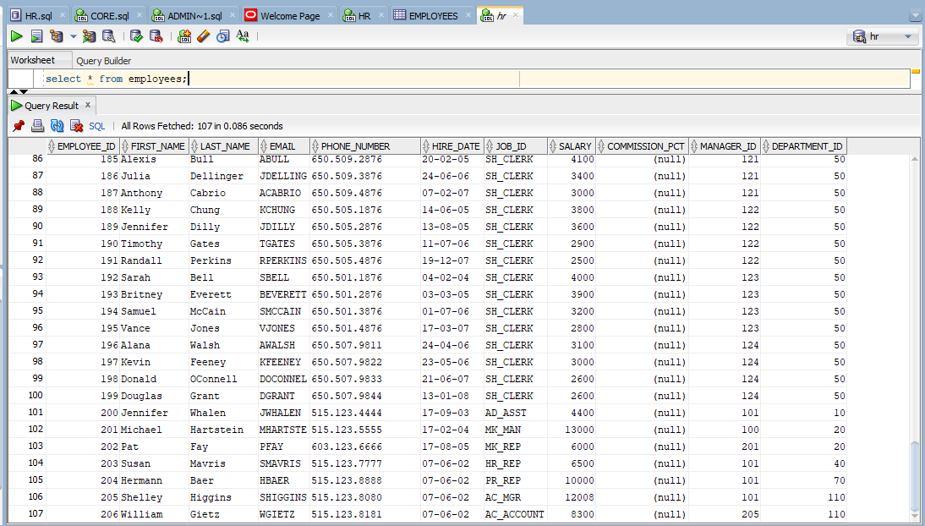

**Displaying the emp_sorted(Target) table in Oracle SQL Developer.**

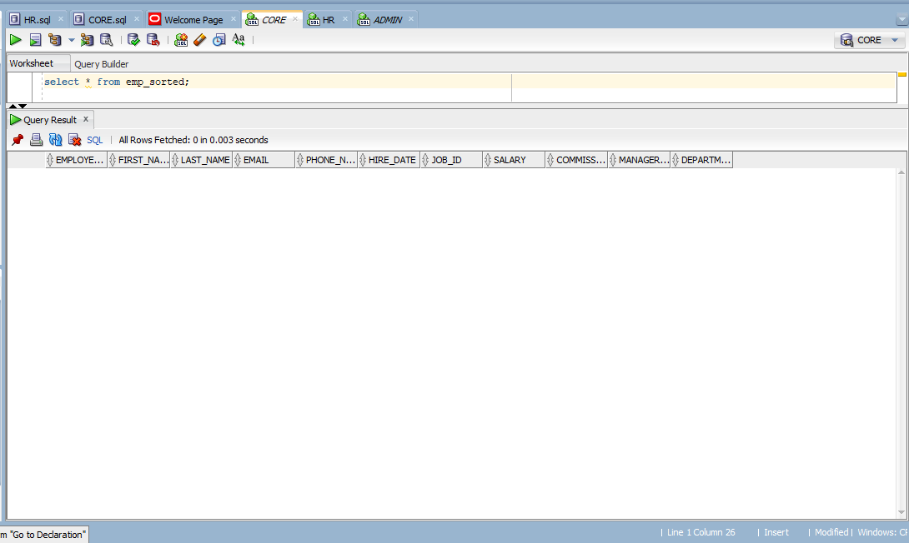

**The employee table is loaded into the source analyser.**

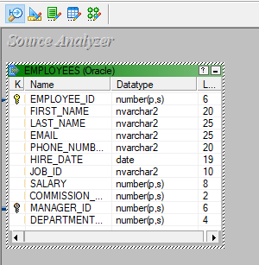

**A table called emp_sorted is loaded into the target designer.**

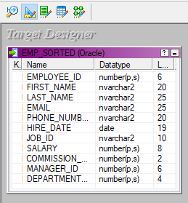

**The source and target files are being mapped using a source qualifier and a sorter transformation, the mapping is named m_sorter.**

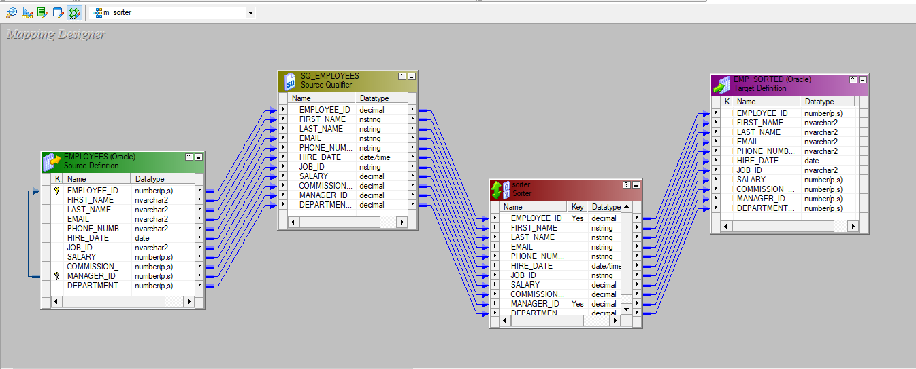

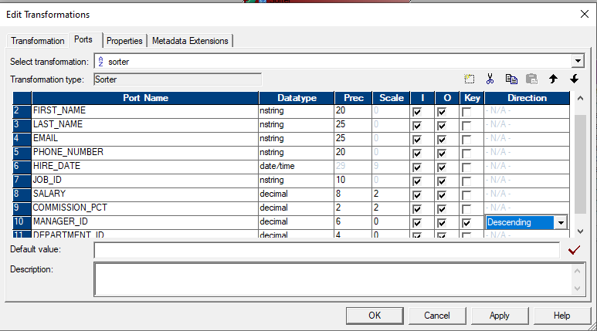

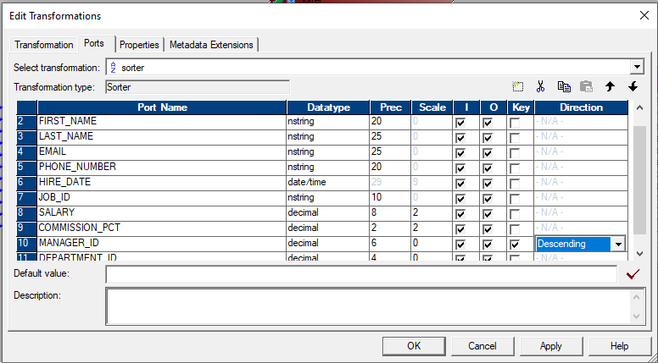

**A workflow is designed under the name of wf_m_sorter and executed.**

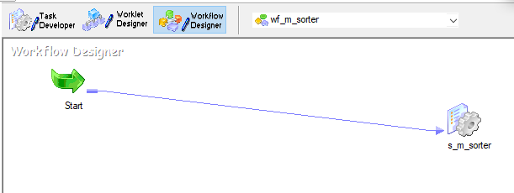

**The final emp_sorted which has the emoloyee_id and manager_id sorted in descending order is shown.**

