**Weekly Assignment 16-Nov-24 : Informatica Tasks**

2. **Location and Region Data Extract Using Source Qualifier SQL Override and Load into Target File**

* Extract Location and Region data using a **Source Qualifier SQL Override**.
* Load the data into a flat file target, ensuring the file format is accurate.

**Displaying the unsorted Locations(Source) table in Oracle SQL Developer.**

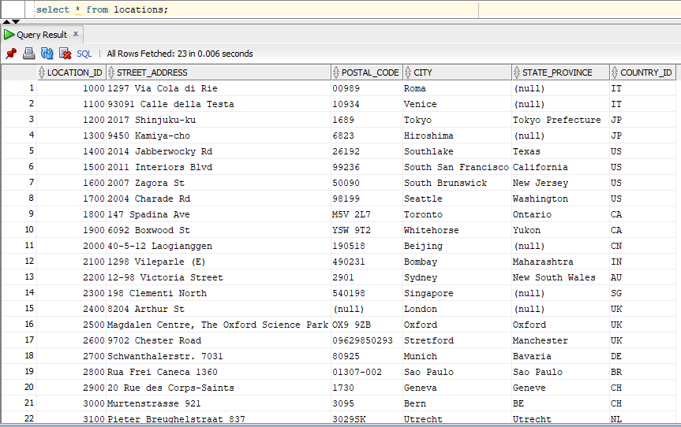

**Displaying the unsorted Regions(Source) table in Oracle SQL Developer.**

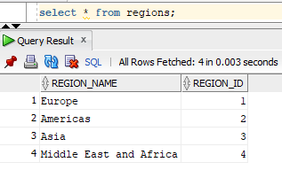

**Creating the loc.csv flat file in the local system.**

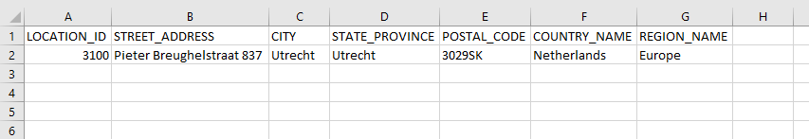

**The required tables are loaded into the source analyser.**

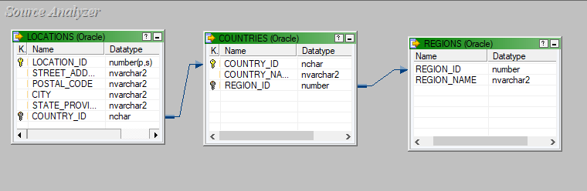

**A flat file called loc.csv is loaded into the target designer.**

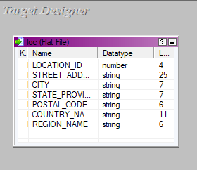

**The source and target files are being mapped using a source qualifier and sql override, the mapping is named m_loc.**

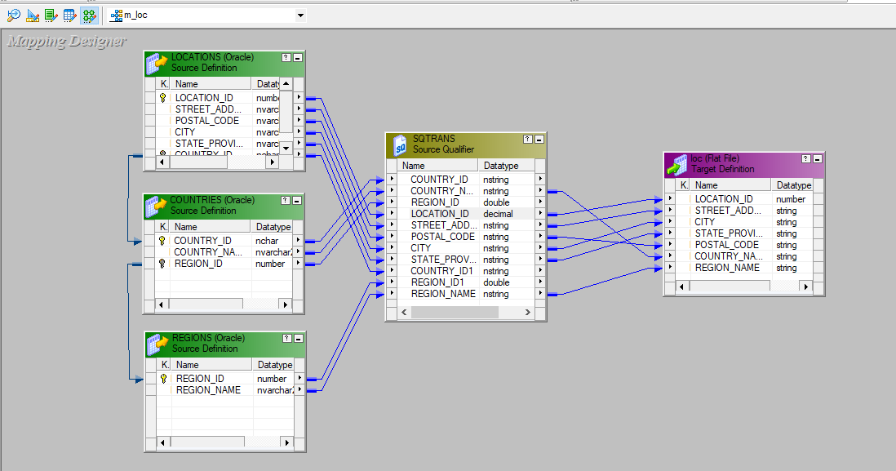

**SQL override is applied on the Source Qualifier to obtain the desired flat file.**

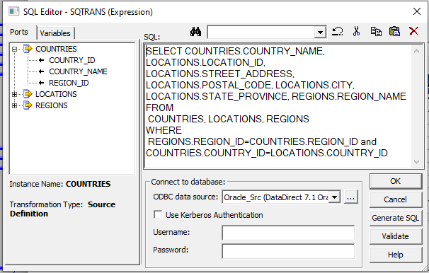

**A workflow is designed under the name of wf_m_loc and executed.**

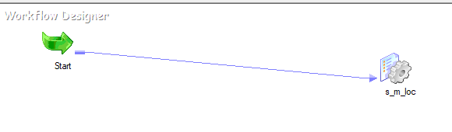



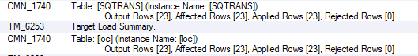

**The final loc.csv which has data from both Locations and Regions tables.**

