**Weekly Assignment 16-Nov-24 : Informatica Tasks**

3. **Get the Manager Name, Manager Email ID Domain, Max/Min/Avg Salary of Employees Under That Manager, and Load Date**

* Use transformations to calculate salary metrics (max, min, avg) and derive the email domain.
* Add the current Load Date field using an expression and load the results into a target.

**Displaying the Employees(Source) table in Oracle SQL Developer.**

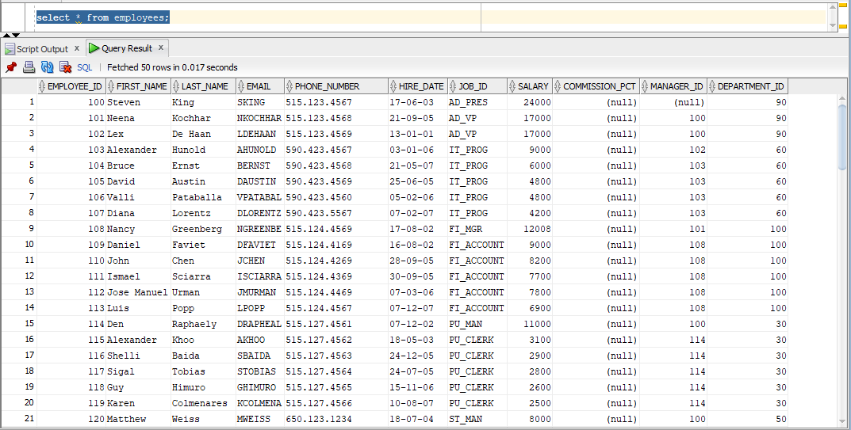

**Creating the manager_stats(Target) table in Oracle SQL Developer.**

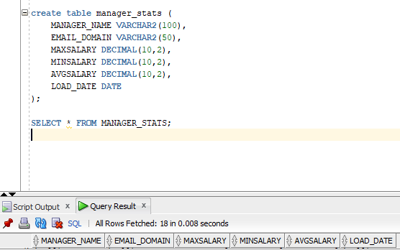

**The required tables are loaded into the source analyser.**

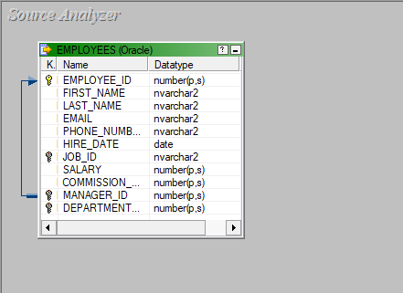

**A table called emp_dependent_count is loaded into the target designer.**

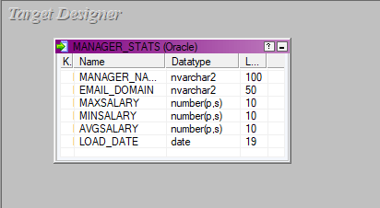

**The source and target files are being mapped using a Joiner, Expression and aggregator transformation, the mapping is named m_manager.**

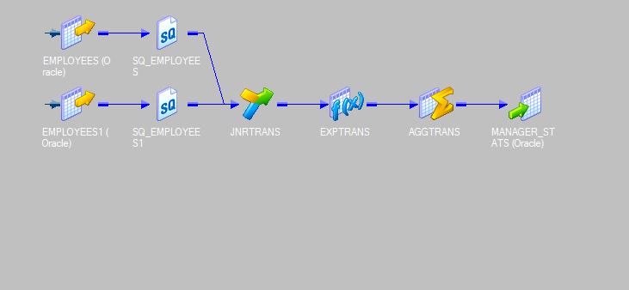

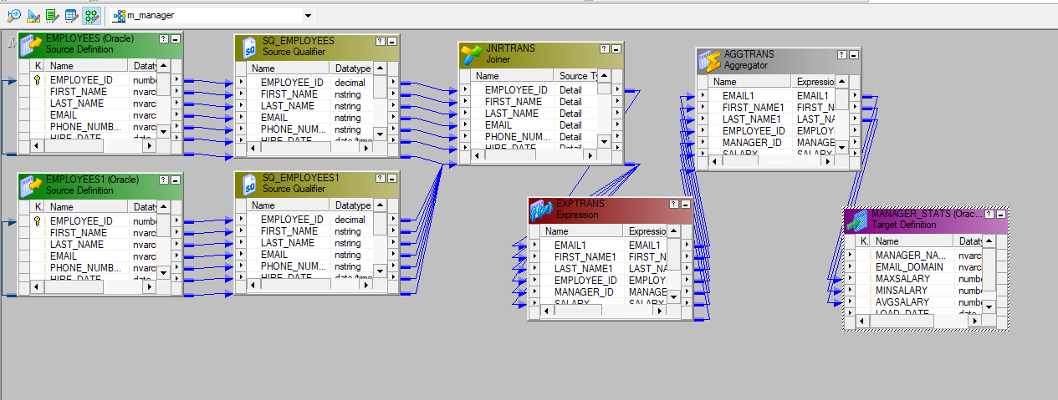

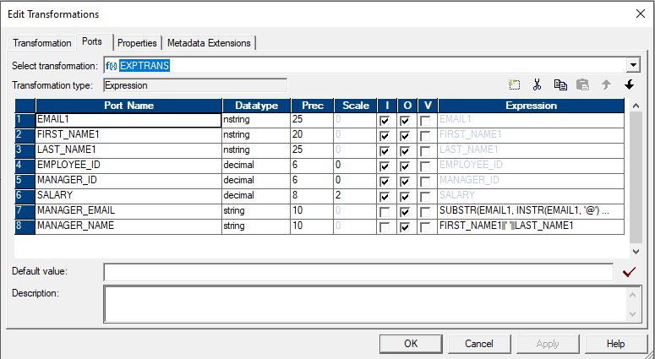

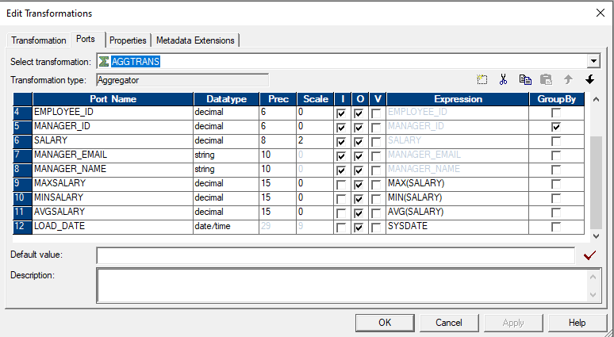

**A workflow is designed under the name of wf_m_manager and executed.**

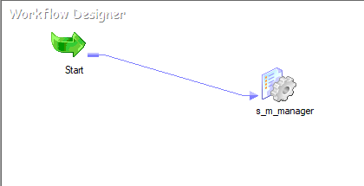



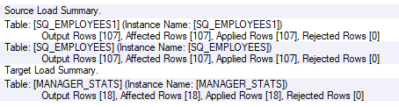

**The final manager_stats table.**

