**Weekly Assignment 16-Nov-24 : Informatica Tasks**

4. **Get Top Salary Employee Under Each Manager**

* Identify and extract the employee with the highest salary under each manager.
* Use a **Rank Transformation** or equivalent logic to achieve this.

**Displaying the unsorted Employees(Source) table in Oracle SQL Developer.**

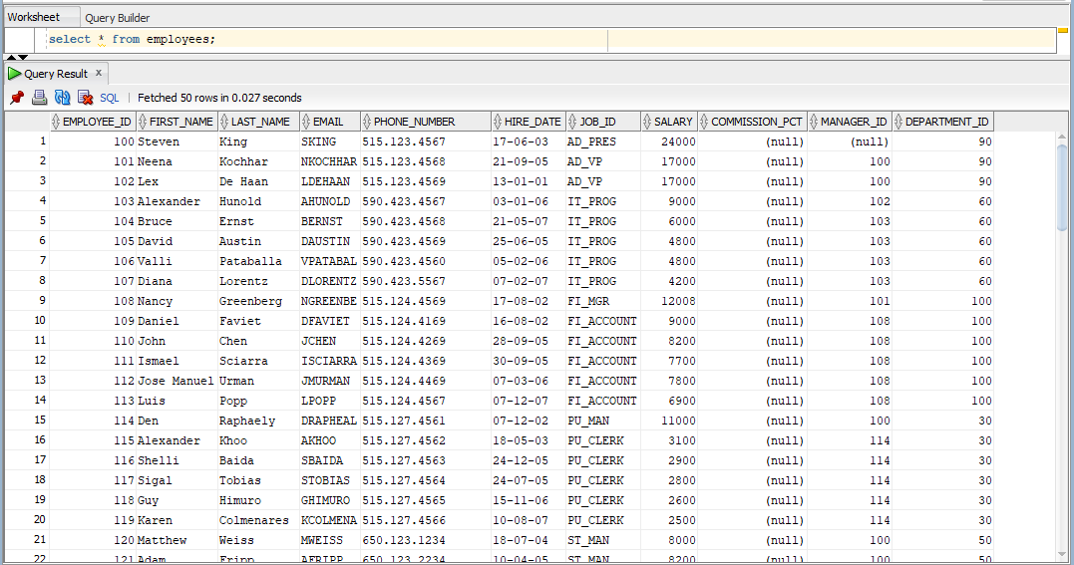

**Displaying the top_salary(Target) table in Oracle SQL Developer.**

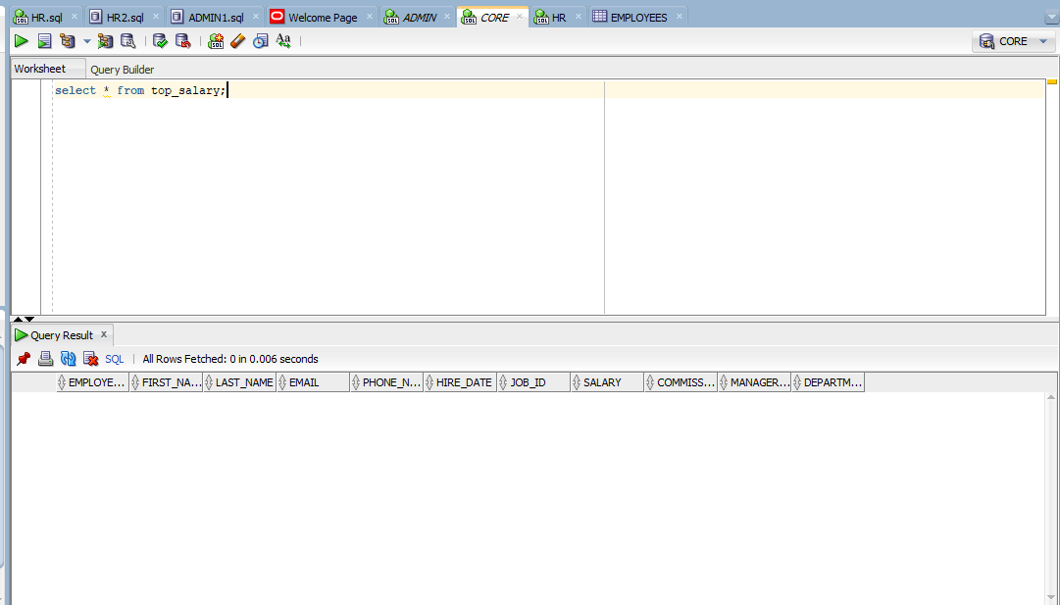

**The employee table is loaded into the source analyser.**

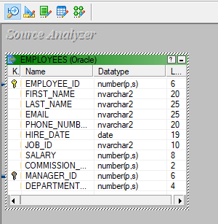

**A table called emp_sorted is loaded into the target designer.**

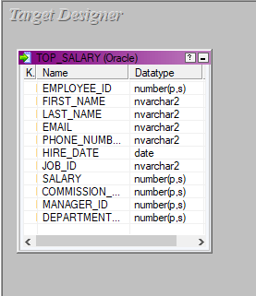

**The source and target files are being mapped using a source qualifier and a sorter transformation, the mapping is named m_topsal.**

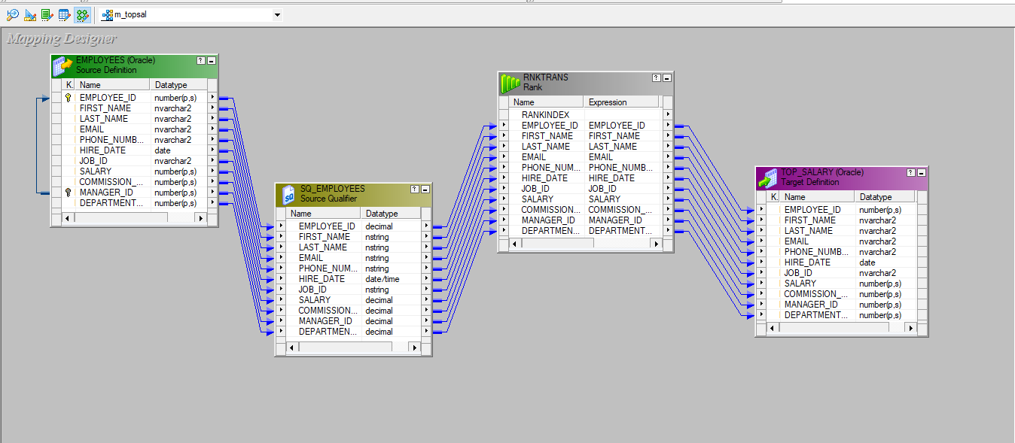

**Rank Transformation and the conditions in it which are applied to get the desired result.**

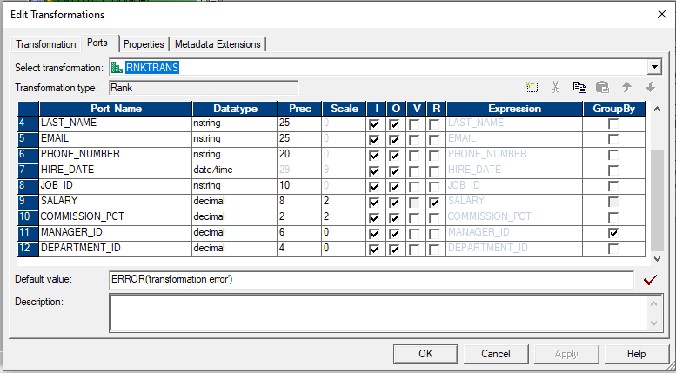

**A workflow is designed under the name of wf_m_topsal and executed.**



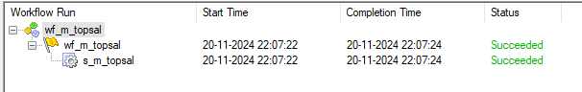

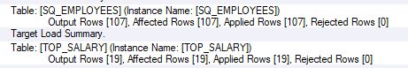

**The final top_salary which has the emoloyee_id and manager_id sorted in descending order is shown.**

