**Weekly Assignment 16-Nov-24 : Informatica Tasks**

5. **Get Employee ID, Full Name, Department Name, Location Details, Country Details, Region Details, Job Details Using Joiner**

* Use a **Joiner Transformation** to consolidate data from multiple sources and fetch the specified fields.
* Ensure proper join conditions and types are applied to avoid data mismatch.

**Displaying the unsorted Employees(Source) table in Oracle SQL Developer.**

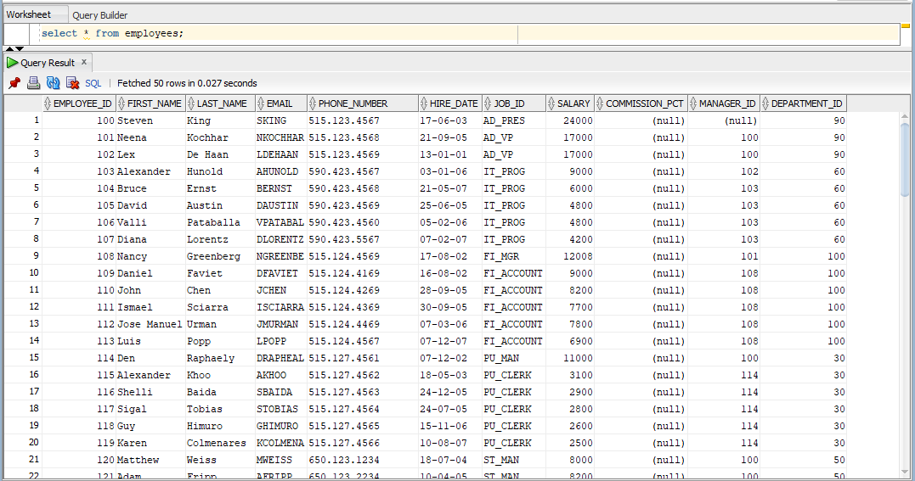

**Displaying the unsorted Countries(Source) table in Oracle SQL Developer.**

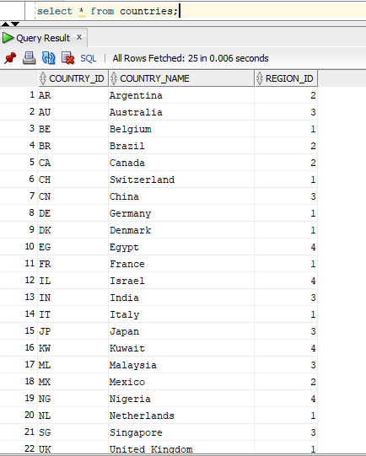

**Displaying the unsorted Departments(Source) table in Oracle SQL Developer.**

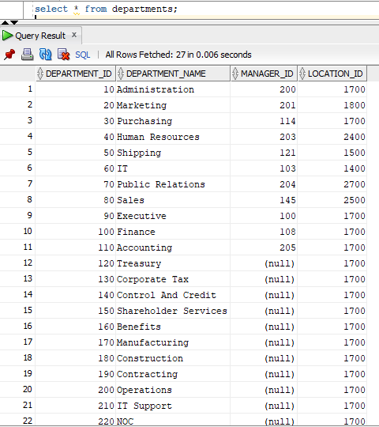

**Displaying the unsorted Jobs(Source) table in Oracle SQL Developer.**

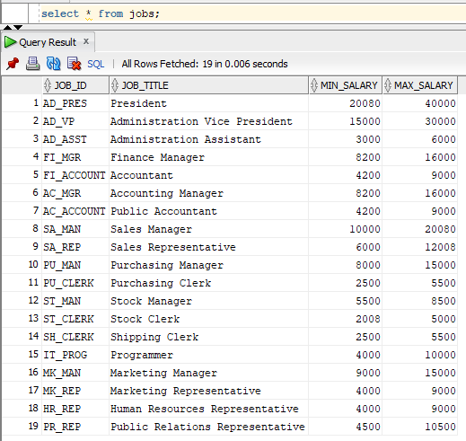

**Displaying the unsorted Locations(Source) table in Oracle SQL Developer.**

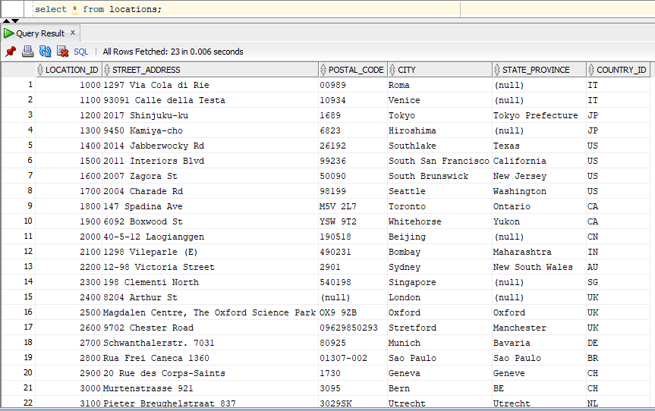

**Displaying the unsorted Regions(Source) table in Oracle SQL Developer.**

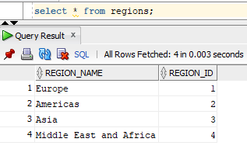

**Creating the top_salary(Target) table in Oracle SQL Developer.**

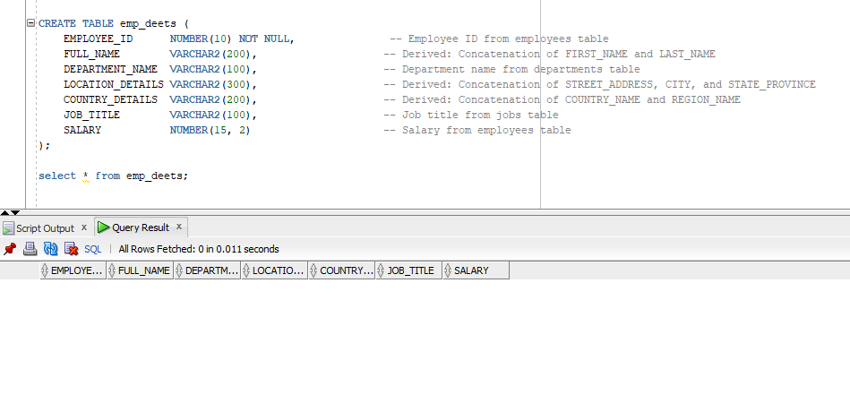

**The required tables are loaded into the source analyser.**

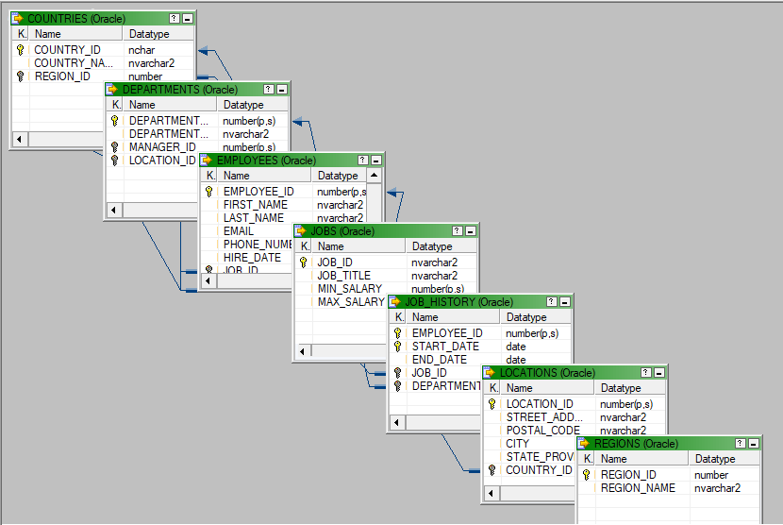

**A table called emp_deets is loaded into the target designer.**

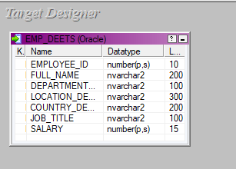

**The source and target files are being mapped using a source qualifier and a sorter transformation, the mapping is named m_emp_deets.**

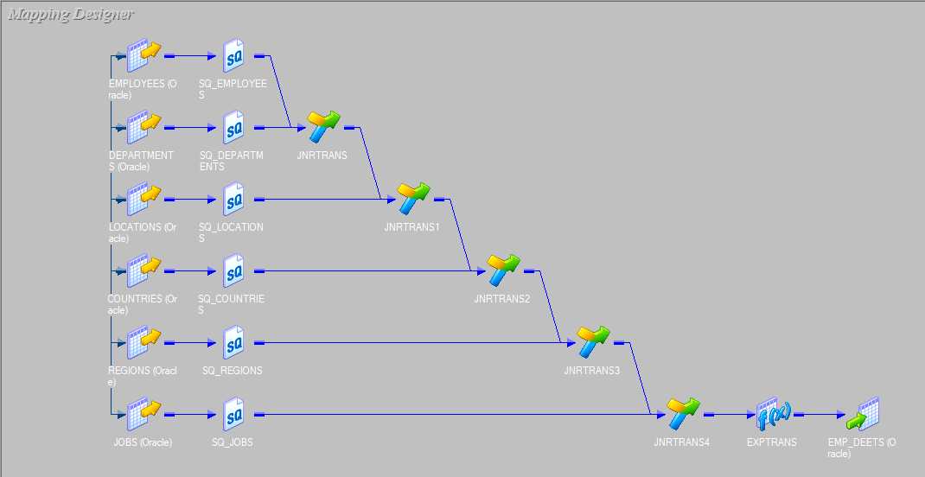

**Joiner Transformation and Expression transformation are applied to obtain the desired employee details table.**

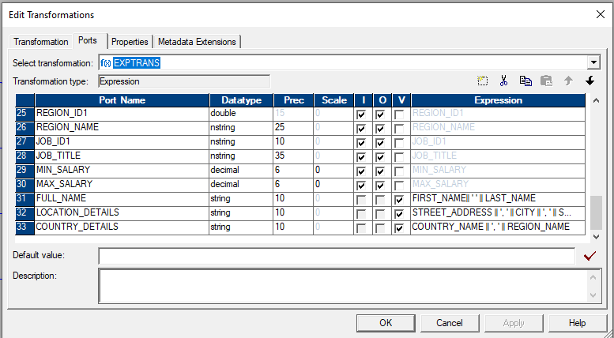

**Joiner condition for Employees + Departments table.**

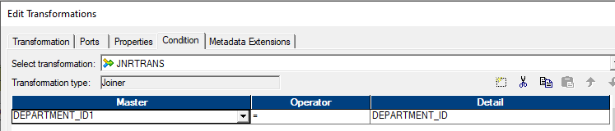

**Joiner condition for (Employees + Departments) + Locations table.**

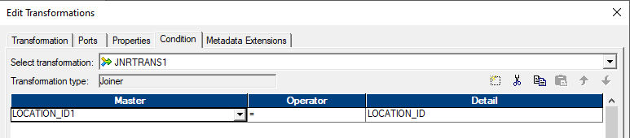

**Joiner condition for (Employees + Departments + Locations) + Countries table.**

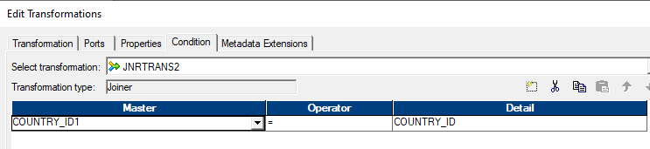

**Joiner condition for (Employees + Departments + Locations + Countries) + Regions table.**

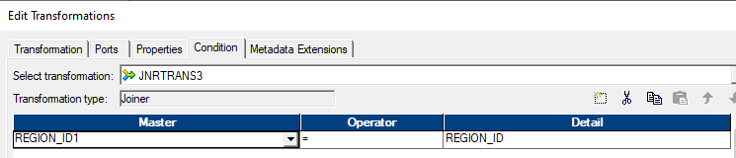

**Joiner condition for (Employees + Departments + Locations + Countries + Regions) + Jobs table.**

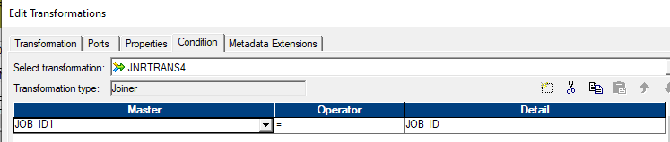

**A workflow is designed under the name of wf_m_emp_deets and executed.**

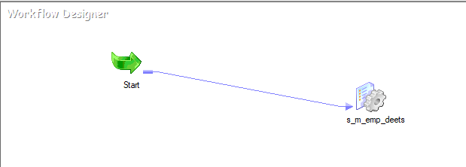

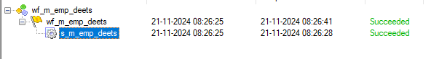

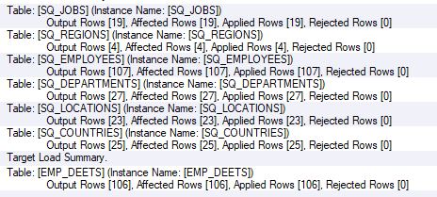

**The final emp_deets which has the consolidated employee details is shown.**

