**Weekly Assignment 16-Nov-24 : Informatica Tasks**

6. **Get Employee Name and Dependent Count Using Aggregator and Lookup**

* Use a **Lookup Transformation** to retrieve dependent details for each employee.
* Use an **Aggregator Transformation** to count the dependents per employee.

**Displaying the Employees(Source) table in Oracle SQL Developer.**

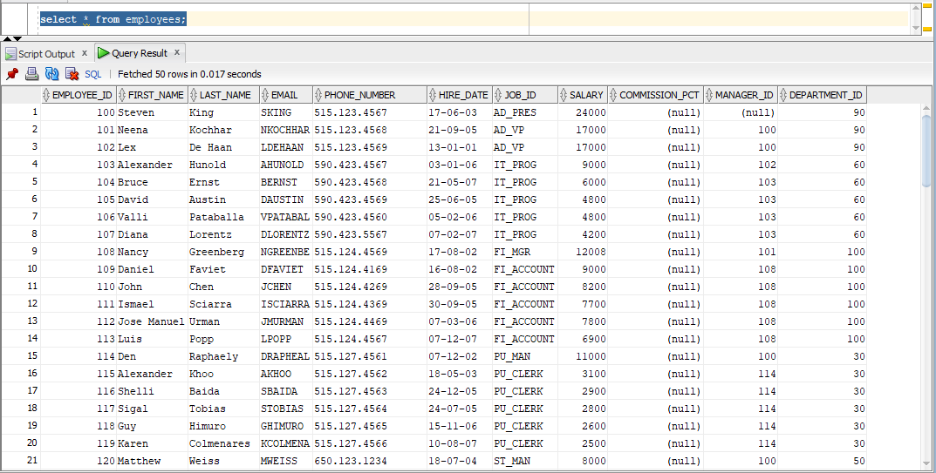

**Displaying the Dependents(Source) table in Oracle SQL Developer.**

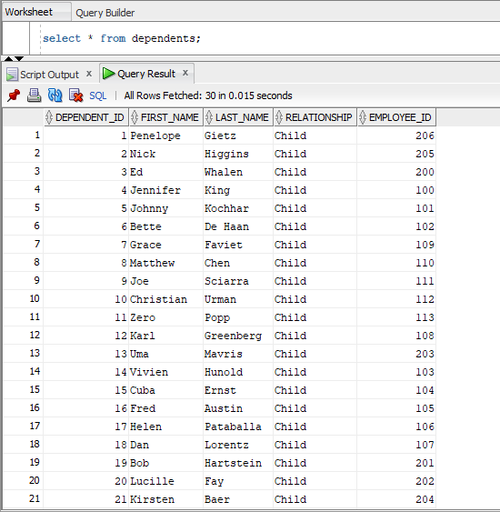

**Creating the emp_dependent_count(Target) table in Oracle SQL Developer.**

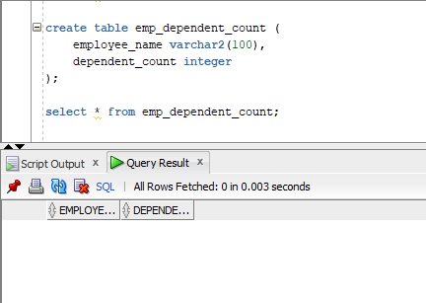

**The required tables are loaded into the source analyser.**

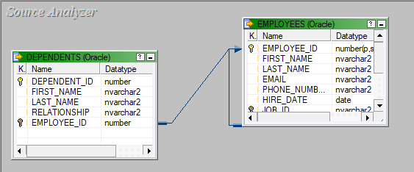

**A table called emp_dependent_count is loaded into the target designer.**

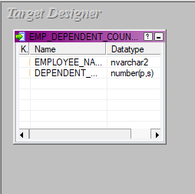

**The source and target files are being mapped using a lookup table and aggregator transformation, the mapping is named m_loookup.**

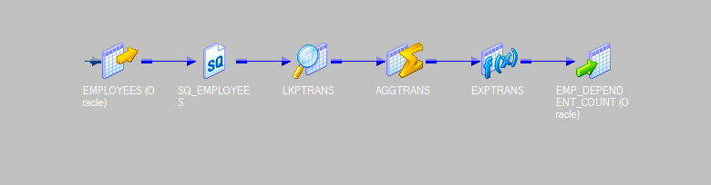

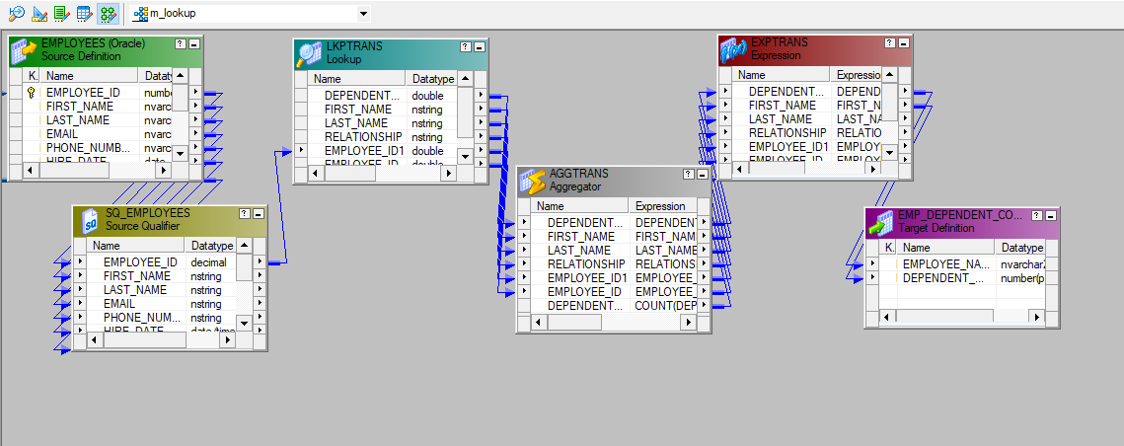

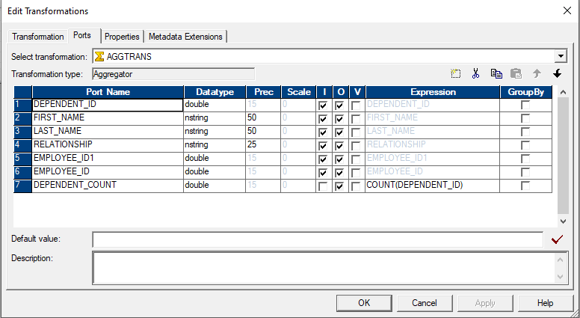

**A workflow is designed under the name of wf_m_loookup and executed.**

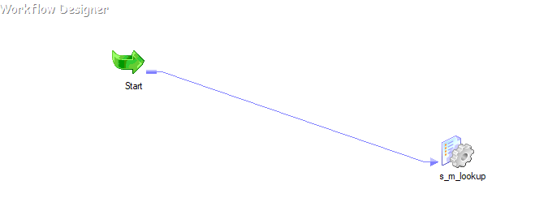

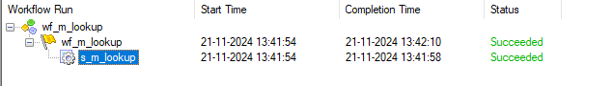

**The final emp_dependent_count table.**

