pip install pandas

Requirement already satisfied: pandas in c:\users\my pc\anaconda3\lib\site-packages (1.3.4)  
Requirement already satisfied: numpy>=1.17.3 in c:\users\my pc\anaconda3\lib\site-packages (from pandas) (1.20.3)  
Requirement already satisfied: python-dateutil>=2.7.3 in c:\users\my pc\anaconda3\lib\site-packages (from pandas) (2.8.2)  
Requirement already satisfied: pytz>=2017.3 in c:\users\my pc\anaconda3\lib\site-packages (from pandas) (2021.3)  
Requirement already satisfied: six>=1.5 in c:\users\my pc\anaconda3\lib\site-packages (from python-dateutil>=2.7.3->pandas) (1.16.0)  
Note: you may need to restart the kernel to use updated packages.

import pandas as pd

df = pd.read_csv("C:\\Users\\My PC\\Desktop\\Insomnia\\Hay_DA.csv")  
df.head()

Date [2023] Initial Ms_P1 (lbs) Measured Ms_P1(lbs) Initial Ms_P2(lbs) \  
0 Sep.6 6.20 6.30 6.50   
1 Sep.8 6.20 6.31 6.51   
2 Sep.9 6.30 6.32 6.53   
3 Sep.13 6.30 6.32 6.54   
4 Sep.15 6.32 6.34 6.55   
  
 Measured Ms_P2(lbs) Initial Ms_P3(lbs) Measured Ms_P3(lbs)   
0 7.01 7.60 7.80   
1 7.02 7.60 7.80   
2 7.04 7.60 7.82   
3 7.03 7.61 7.83   
4 7.06 7.61 7.83

df.info()

<class 'pandas.core.frame.DataFrame'>  
RangeIndex: 39 entries, 0 to 38  
Data columns (total 7 columns):  
 # Column Non-Null Count Dtype   
--- ------ -------------- -----   
 0 Date [2023] 39 non-null object   
 1 Initial Ms_P1 (lbs) 39 non-null float64  
 2 Measured Ms_P1(lbs) 39 non-null float64  
 3 Initial Ms_P2(lbs) 39 non-null float64  
 4 Measured Ms_P2(lbs) 39 non-null float64  
 5 Initial Ms_P3(lbs) 39 non-null float64  
 6 Measured Ms_P3(lbs) 39 non-null float64  
dtypes: float64(6), object(1)  
memory usage: 2.3+ KB

df.describe()

Initial Ms_P1 (lbs) Measured Ms_P1(lbs) Initial Ms_P2(lbs) \  
count 39.000000 39.000000 39.000000   
mean 6.437436 6.526923 6.733077   
std 0.119312 0.167193 0.158996   
min 6.200000 6.300000 6.500000   
25% 6.360000 6.390000 6.600000   
50% 6.420000 6.490000 6.710000   
75% 6.530000 6.665000 6.860000   
max 6.650000 6.850000 7.040000   
  
 Measured Ms_P2(lbs) Initial Ms_P3(lbs) Measured Ms_P3(lbs)   
count 39.000000 39.000000 39.000000   
mean 7.893846 7.738205 8.607949   
std 0.455583 0.120697 0.799270   
min 7.010000 7.600000 7.800000   
25% 7.915000 7.655000 7.895000   
50% 8.020000 7.720000 8.200000   
75% 8.210000 7.775000 9.350000   
max 8.380000 8.020000 9.890000

# Create a new column for the differences  
df['Difference_Ms_P1'] = df['Measured Ms_P1(lbs)'] - df['Initial Ms_P1 (lbs)']  
df['Difference_Ms_P2'] = df['Measured Ms_P2(lbs)'] - df['Initial Ms_P2(lbs)']  
df['Difference_Ms_P3'] = df['Measured Ms_P3(lbs)'] - df['Initial Ms_P3(lbs)']  
  
# Display the DataFrame with the new column  
print(df)

Date [2023] Initial Ms_P1 (lbs) Measured Ms_P1(lbs) Initial Ms_P2(lbs) \  
0 Sep.6 6.20 6.30 6.50   
1 Sep.8 6.20 6.31 6.51   
2 Sep.9 6.30 6.32 6.53   
3 Sep.13 6.30 6.32 6.54   
4 Sep.15 6.32 6.34 6.55   
5 Sep.16 6.33 6.34 6.56   
6 Sep.20 6.34 6.36 6.57   
7 Sep.22 6.33 6.36 6.57   
8 Sep.23 6.34 6.37 6.58   
9 Sep.27 6.36 6.38 6.60   
10 Sep.29 6.37 6.40 6.60   
11 Sep.30 6.37 6.41 6.61   
12 Oct.4 6.36 6.40 6.62   
13 Oct.6 6.37 6.41 6.63   
14 Oct.7 6.38 6.43 6.65   
15 Oct.11 6.38 6.43 6.65   
16 Oct.13 6.39 6.45 6.67   
17 Oct.14 6.40 6.46 6.69   
18 Oct.18 6.42 6.47 6.70   
19 Oct.20 6.42 6.49 6.71   
20 Oct.21 6.43 6.50 6.73   
21 Oct.25 6.42 6.51 6.74   
22 Oct.27 6.44 6.56 6.74   
23 Oct.28 6.46 6.58 6.76   
24 Nov.1 6.45 6.59 6.78   
25 Nov.3 6.46 6.59 6.80   
26 Nov.4 6.48 6.60 6.81   
27 Nov.8 6.49 6.62 6.83   
28 Nov.10 6.52 6.65 6.85   
29 Nov.11 6.54 6.68 6.87   
30 Nov.15 6.56 6.70 6.88   
31 Nov.17 6.58 6.72 6.90   
32 Nov.18 6.60 6.73 6.92   
33 Nov.22 6.60 6.75 6.94   
34 Nov.24 6.61 6.76 6.96   
35 Nov.25 6.62 6.78 6.98   
36 Nov.29 6.63 6.80 7.00   
37 Dec.1 6.64 6.83 7.02   
38 Dec.2 6.65 6.85 7.04   
  
 Measured Ms_P2(lbs) Initial Ms_P3(lbs) Measured Ms_P3(lbs) \  
0 7.01 7.60 7.80   
1 7.02 7.60 7.80   
2 7.04 7.60 7.82   
3 7.03 7.61 7.83   
4 7.06 7.61 7.83   
5 7.08 7.62 7.84   
6 7.09 7.62 7.85   
7 7.08 7.63 7.86   
8 7.91 7.64 7.87   
9 7.90 7.65 7.89   
10 7.92 7.66 7.90   
11 7.93 7.66 7.91   
12 7.92 7.66 7.92   
13 7.94 7.68 7.94   
14 7.99 7.69 7.96   
15 8.00 7.70 7.98   
16 8.00 7.71 7.99   
17 8.02 7.71 8.00   
18 8.00 7.71 8.10   
19 8.01 7.72 8.20   
20 8.03 7.73 8.40   
21 8.02 7.73 8.60   
22 8.04 7.74 8.80   
23 8.06 7.74 8.90   
24 8.09 7.75 8.90   
25 8.10 7.76 8.90   
26 8.14 7.76 9.00   
27 8.16 7.77 9.20   
28 8.19 7.77 9.30   
29 8.23 7.78 9.40   
30 8.25 7.78 9.50   
31 8.26 7.78 9.60   
32 8.28 7.79 9.80   
33 8.30 7.79 9.82   
34 8.32 8.00 9.83   
35 8.34 8.00 9.84   
36 8.35 8.01 9.86   
37 8.37 8.01 9.88   
38 8.38 8.02 9.89   
  
 Percentage_Increase Difference_Ms_P1 Difference_Ms_P2 Difference_Ms_P3   
0 7.846154 0.10 0.51 0.20   
1 7.834101 0.11 0.51 0.20   
2 7.810107 0.02 0.51 0.22   
3 7.492355 0.02 0.49 0.22   
4 7.786260 0.02 0.51 0.22   
5 7.926829 0.01 0.52 0.22   
6 7.914764 0.02 0.52 0.23   
7 7.762557 0.03 0.51 0.23   
8 20.212766 0.03 1.33 0.23   
9 19.696970 0.02 1.30 0.24   
10 20.000000 0.03 1.32 0.24   
11 19.969743 0.04 1.32 0.25   
12 19.637462 0.04 1.30 0.26   
13 19.758673 0.04 1.31 0.26   
14 20.150376 0.05 1.34 0.27   
15 20.300752 0.05 1.35 0.28   
16 19.940030 0.06 1.33 0.28   
17 19.880419 0.06 1.33 0.29   
18 19.402985 0.05 1.30 0.39   
19 19.374069 0.07 1.30 0.48   
20 19.316493 0.07 1.30 0.67   
21 18.991098 0.09 1.28 0.87   
22 19.287834 0.12 1.30 1.06   
23 19.230769 0.12 1.30 1.16   
24 19.321534 0.14 1.31 1.15   
25 19.117647 0.13 1.30 1.14   
26 19.530103 0.12 1.33 1.24   
27 19.472914 0.13 1.33 1.43   
28 19.562044 0.13 1.34 1.53   
29 19.796215 0.14 1.36 1.62   
30 19.912791 0.14 1.37 1.72   
31 19.710145 0.14 1.36 1.82   
32 19.653179 0.13 1.36 2.01   
33 19.596542 0.15 1.36 2.03   
34 19.540230 0.15 1.36 1.83   
35 19.484241 0.16 1.36 1.84   
36 19.285714 0.17 1.35 1.85   
37 19.230769 0.19 1.35 1.87   
38 19.034091 0.20 1.34 1.87

df.head()

Date [2023] Initial Ms_P1 (lbs) Measured Ms_P1(lbs) Initial Ms_P2(lbs) \  
0 Sep.6 6.20 6.30 6.50   
1 Sep.8 6.20 6.31 6.51   
2 Sep.9 6.30 6.32 6.53   
3 Sep.13 6.30 6.32 6.54   
4 Sep.15 6.32 6.34 6.55   
  
 Measured Ms_P2(lbs) Initial Ms_P3(lbs) Measured Ms_P3(lbs) \  
0 7.01 7.60 7.80   
1 7.02 7.60 7.80   
2 7.04 7.60 7.82   
3 7.03 7.61 7.83   
4 7.06 7.61 7.83   
  
 Percentage_Increase Difference_Ms_P1 Difference_Ms_P2 Difference_Ms_P3   
0 7.846154 0.10 0.51 0.20   
1 7.834101 0.11 0.51 0.20   
2 7.810107 0.02 0.51 0.22   
3 7.492355 0.02 0.49 0.22   
4 7.786260 0.02 0.51 0.22

df.describe()

Initial Ms_P1 (lbs) Measured Ms_P1(lbs) Initial Ms_P2(lbs) \  
count 39.000000 39.000000 39.000000   
mean 6.437436 6.526923 6.733077   
std 0.119312 0.167193 0.158996   
min 6.200000 6.300000 6.500000   
25% 6.360000 6.390000 6.600000   
50% 6.420000 6.490000 6.710000   
75% 6.530000 6.665000 6.860000   
max 6.650000 6.850000 7.040000   
  
 Measured Ms_P2(lbs) Initial Ms_P3(lbs) Measured Ms_P3(lbs) \  
count 39.000000 39.000000 39.000000   
mean 7.893846 7.738205 8.607949   
std 0.455583 0.120697 0.799270   
min 7.010000 7.600000 7.800000   
25% 7.915000 7.655000 7.895000   
50% 8.020000 7.720000 8.200000   
75% 8.210000 7.775000 9.350000   
max 8.380000 8.020000 9.890000   
  
 Percentage_Increase Difference_Ms_P1 Difference_Ms_P2 \  
count 39.000000 39.000000 39.000000   
mean 17.173634 0.089487 1.160769   
std 4.835743 0.055438 0.335688   
min 7.492355 0.010000 0.490000   
25% 19.075869 0.040000 1.300000   
50% 19.472914 0.090000 1.320000   
75% 19.734409 0.135000 1.345000   
max 20.300752 0.200000 1.370000   
  
 Difference_Ms_P3   
count 39.000000   
mean 0.869744   
std 0.695234   
min 0.200000   
25% 0.240000   
50% 0.480000   
75% 1.575000   
max 2.030000

# Calculate the total percentage increase for 'Initial_A' over time  
total_percentage_increase = ((df['Initial Ms_P1 (lbs)'].iloc[-1] - df['Initial Ms_P1 (lbs)'].iloc[0]) / df['Initial Ms_P1 (lbs)'].iloc[0]) * 100  
  
# Display the DataFrame with the calculated total percentage increase  
#print(df)  
print(f'Total Percentage Increase for Initial_A: {total_percentage_increase:.2f}%')

Total Percentage Increase for Initial_A: 7.26%

# Calculate the percentage increase for 'Initial_A' over time  
df['Percentage_Increase'] = ((df['Initial Ms_P1 (lbs)'].shift(-1) - df['Initial Ms_P1 (lbs)']) / df['Initial Ms_P1 (lbs)']) * 100  
  
# Calculate the average percentage increase  
average_percentage_increase = df['Percentage_Increase'].mean()  
  
# Display the DataFrame with the calculated percentage increases  
#print(df)  
print(f'Average Percentage Increase for Initial Ms_P1 (lbs) over time: {average_percentage_increase:.2f}%')

Average Percentage Increase for Initial Ms_P1 (lbs) over time: 0.18%

# Calculate the total percentage increase for 'Measured Ms_P1' over time  
total_percentage_increase = ((df['Measured Ms_P1(lbs)'].iloc[-1] - df['Measured Ms_P1(lbs)'].iloc[0]) / df['Measured Ms_P1(lbs)'].iloc[0]) * 100  
  
# Display the DataFrame with the calculated total percentage increase  
#print(df)  
print(f'Total Percentage Increase for Measured Ms_P1: {total_percentage_increase:.2f}%')

Total Percentage Increase for Measured Ms_P1: 8.73%

# Calculate the percentage increase for 'Initial_A' over time  
df['Percentage_Increase'] = ((df['Measured Ms_P1(lbs)'].shift(-1) - df['Measured Ms_P1(lbs)']) / df['Measured Ms_P1(lbs)']) * 100  
  
# Calculate the average percentage increase  
average_percentage_increase = df['Percentage_Increase'].mean()  
  
# Display the DataFrame with the calculated percentage increases  
#print(df)  
print(f'Average Percentage Increase for Measured Ms_P1(lbs) over time: {average_percentage_increase:.2f}%')

Average Percentage Increase for Measured Ms_P1(lbs) over time: 0.22%

import matplotlib.pyplot as plt  
  
# Calculate the percentage increase for 'Initial Ms_P1 (lbs)' over time  
df['Percentage_Increase'] = ((df['Measured Ms_P2(lbs)'] - df['Initial Ms_P2(lbs)']) / df['Initial Ms_P2(lbs)']) * 100  
  
# Calculate the average percentage increase  
average_percentage_increase = df['Percentage_Increase'].mean()  
  
# Plotting the comparison over time  
plt.figure(figsize=(12, 8))  
plt.plot(df['Date [2023]'], df['Initial Ms_P2(lbs)'], label='Initial Ms_P2(lbs)', marker='o')  
plt.plot(df['Date [2023]'], df['Measured Ms_P2(lbs)'], label='Measured Ms_P2(lbs)', marker='o')  
  
# Display the average percentage increase as text on the plot  
plt.text(df['Date [2023]'].iloc[-1], df['Measured Ms_P2(lbs)'].iloc[-1], f'Avg Increase: {average_percentage_increase:.2f}%', ha='right', va='bottom')  
  
# Rotate x-axis labels for better readability  
plt.xticks(rotation=45)  
  
# Add a gradient legend  
legend = plt.legend(loc='upper left', frameon=True)  
frame = legend.get_frame()  
frame.set_facecolor('white') # Adjust the face color as needed  
frame.set_edgecolor('black') # Adjust the edge color as needed  
  
# Remove y-axis tick labels  
plt.yticks([])  
  
plt.title('Comparison of Initial Ms_P2 and Measured Ms_P2 Over Time')  
plt.xlabel('Date [2023]')  
plt.ylabel('Ibs')  
plt.grid(False)  
plt.show()

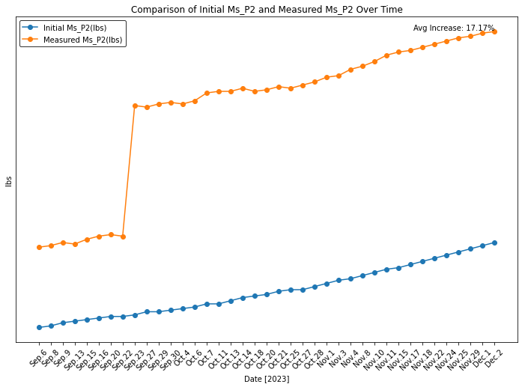

# Calculate the total percentage increase for 'Initial_A' over time  
total_percentage_increase = ((df['Initial Ms_P2(lbs)'].iloc[-1] - df['Initial Ms_P2(lbs)'].iloc[0]) / df['Initial Ms_P2(lbs)'].iloc[0]) * 100  
  
# Display the DataFrame with the calculated total percentage increase  
#print(df)  
print(f'Total Percentage Increase for Initial Ms_P2(lbs): {total_percentage_increase:.2f}%')

Total Percentage Increase for Initial Ms_P2(lbs): 8.31%

# Calculate the percentage increase for 'Initial_A' over time  
df['Percentage_Increase'] = ((df['Initial Ms_P2(lbs)'].shift(-1) - df['Initial Ms_P2(lbs)']) / df['Initial Ms_P2(lbs)']) * 100  
  
# Calculate the average percentage increase  
average_percentage_increase = df['Percentage_Increase'].mean()  
  
# Display the DataFrame with the calculated percentage increases  
#print(df)  
print(f'Average Percentage Increase for Initial Ms_P2(lbs) (lbs) over time: {average_percentage_increase:.2f}%')

Average Percentage Increase for Initial Ms_P2(lbs) (lbs) over time: 0.21%

# Calculate the total percentage increase for 'Measured Ms_P1' over time  
total_percentage_increase = ((df['Measured Ms_P2(lbs)'].iloc[-1] - df['Measured Ms_P2(lbs)'].iloc[0]) / df['Measured Ms_P2(lbs)'].iloc[0]) * 100  
  
# Display the DataFrame with the calculated total percentage increase  
#print(df)  
print(f'Total Percentage Increase for Measured Ms_P2: {total_percentage_increase:.2f}%')

Total Percentage Increase for Measured Ms_P2: 19.54%

# Calculate the percentage increase for 'Initial_A' over time  
df['Percentage_Increase'] = ((df['Measured Ms_P2(lbs)'].shift(-1) - df['Measured Ms_P2(lbs)']) / df['Measured Ms_P2(lbs)']) * 100  
  
# Calculate the average percentage increase  
average_percentage_increase = df['Percentage_Increase'].mean()  
  
# Display the DataFrame with the calculated percentage increases  
#print(df)  
print(f'Average Percentage Increase for Measured Ms_P2(lbs) over time: {average_percentage_increase:.2f}%')

Average Percentage Increase for Measured Ms_P2(lbs) over time: 0.49%

import matplotlib.pyplot as plt  
  
# Calculate the percentage increase for 'Initial Ms_P1 (lbs)' over time  
df['Percentage_Increase'] = ((df['Measured Ms_P3(lbs)'] - df['Initial Ms_P3(lbs)']) / df['Initial Ms_P3(lbs)']) * 100  
  
# Calculate the average percentage increase  
average_percentage_increase = df['Percentage_Increase'].mean()  
  
# Plotting the comparison over time  
plt.figure(figsize=(12, 8))  
plt.plot(df['Date [2023]'], df['Initial Ms_P3(lbs)'], label='Initial Ms_P3(lbs)', marker='o')  
plt.plot(df['Date [2023]'], df['Measured Ms_P3(lbs)'], label='Measured Ms_P3(lbs)', marker='o')  
  
# Display the average percentage increase as text on the plot  
plt.text(df['Date [2023]'].iloc[-1], df['Measured Ms_P3(lbs)'].iloc[-1], f'Avg Increase: {average_percentage_increase:.2f}%', ha='right', va='bottom')  
  
# Rotate x-axis labels for better readability  
plt.xticks(rotation=45)  
  
# Add a gradient legend  
legend = plt.legend(loc='upper left', frameon=True)  
frame = legend.get_frame()  
frame.set_facecolor('white') # Adjust the face color as needed  
frame.set_edgecolor('black') # Adjust the edge color as needed  
  
# Remove y-axis tick labels  
plt.yticks([])  
  
plt.title('Comparison of Initial Ms_P3 and Measured Ms_P3 Over Time')  
plt.xlabel('Date [2023]')  
plt.ylabel('Ibs')  
plt.grid(False)  
plt.show()

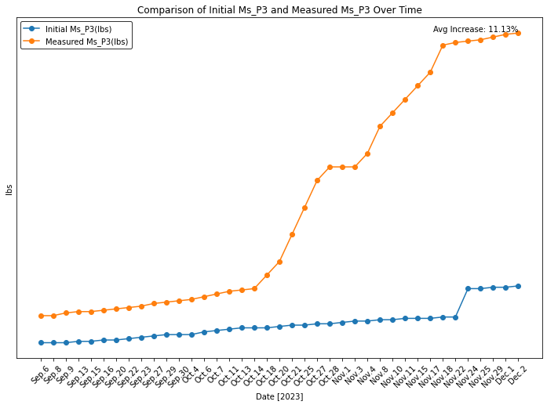

# Calculate the total percentage increase for 'Initial_A' over time  
total_percentage_increase = ((df['Initial Ms_P3(lbs)'].iloc[-1] - df['Initial Ms_P3(lbs)'].iloc[0]) / df['Initial Ms_P3(lbs)'].iloc[0]) * 100  
  
# Display the DataFrame with the calculated total percentage increase  
#print(df)  
print(f'Total Percentage Increase for Initial Ms_P3(lbs): {total_percentage_increase:.2f}%')

Total Percentage Increase for Initial Ms_P3(lbs): 5.53%

# Calculate the percentage increase for 'Initial_A' over time  
df['Percentage_Increase'] = ((df['Initial Ms_P3(lbs)'].shift(-1) - df['Initial Ms_P3(lbs)']) / df['Initial Ms_P3(lbs)']) * 100  
  
# Calculate the average percentage increase  
average_percentage_increase = df['Percentage_Increase'].mean()  
  
# Display the DataFrame with the calculated percentage increases  
#print(df)  
print(f'Average Percentage Increase for Initial Ms_P3(lbs) (lbs) over time: {average_percentage_increase:.2f}%')

Average Percentage Increase for Initial Ms_P3(lbs) (lbs) over time: 0.14%

# Calculate the total percentage increase for 'Measured Ms_P1' over time  
total_percentage_increase = ((df['Measured Ms_P3(lbs)'].iloc[-1] - df['Measured Ms_P3(lbs)'].iloc[0]) / df['Measured Ms_P3(lbs)'].iloc[0]) * 100  
  
# Display the DataFrame with the calculated total percentage increase  
#print(df)  
print(f'Total Percentage Increase for Measured Ms_P3: {total_percentage_increase:.2f}%')

Total Percentage Increase for Measured Ms_P3: 26.79%

# Calculate the AVG_percentage increase for 'Measured_A' over time  
df['Percentage_Increase'] = ((df['Measured Ms_P3(lbs)'].shift(-1) - df['Measured Ms_P3(lbs)']) / df['Measured Ms_P3(lbs)']) * 100  
  
# Calculate the average percentage increase  
average_percentage_increase = df['Percentage_Increase'].mean()  
  
# Display the DataFrame with the calculated percentage increases  
#print(df)  
print(f'Average Percentage Increase for Measured Ms_P3(lbs) over time: {average_percentage_increase:.2f}%')

Average Percentage Increase for Measured Ms_P3(lbs) over time: 0.63%

import matplotlib.pyplot as plt  
  
# Plotting the comparison over time  
plt.figure(figsize=(12, 8))  
plt.plot(df['Date [2023]'], df['Measured Ms_P1(lbs)'], label='Measured Ms_P1(lbs)', marker='o')  
plt.plot(df['Date [2023]'], df['Measured Ms_P2(lbs)'], label='Measured Ms_P2(lbs)', marker='o')  
plt.plot(df['Date [2023]'], df['Measured Ms_P3(lbs)'], label='Measured Ms_P3(lbs)', marker='o')  
  
# Rotate x-axis labels for better readability  
plt.xticks(rotation=45)  
  
# Add a gradient legend  
legend = plt.legend(loc='upper left', frameon=True)  
frame = legend.get_frame()  
frame.set_facecolor('white') # Adjust the face color as needed  
frame.set_edgecolor('black') # Adjust the edge color as needed  
  
# Remove y-axis tick labels  
plt.yticks([])  
  
plt.title('Comparison of Measured Ms_P1, Measured Ms_P2, and Measured Ms_P3 Over Time')  
plt.xlabel('Date [2023]')  
plt.ylabel('Ibs')  
plt.grid(False)  
plt.show()

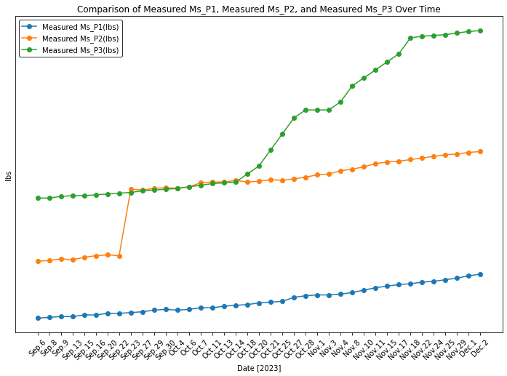

import matplotlib.pyplot as plt  
  
# Plotting the comparison over time  
plt.figure(figsize=(12, 8))  
plt.plot(df['Date [2023]'], df['Initial Ms_P3(lbs)'], label='Initial Ms_P3(lbs)', marker='o')  
plt.plot(df['Date [2023]'], df['Initial Ms_P2(lbs)'], label='Initial Ms_P2(lbs)', marker='o')  
plt.plot(df['Date [2023]'], df['Initial Ms_P1 (lbs)'], label='Initial Ms_P1 (lbs)', marker='o')  
  
# Rotate x-axis labels for better readability  
plt.xticks(rotation=45)  
  
# Add a gradient legend  
legend = plt.legend(loc='upper left', frameon=True)  
frame = legend.get_frame()  
frame.set_facecolor('white') # Adjust the face color as needed  
frame.set_edgecolor('black') # Adjust the edge color as needed  
  
# Remove y-axis tick labels  
plt.yticks([])  
  
plt.title('Comparison of Initial Ms_P1, Initial Ms_P2, and Initial Ms_P3 Over Time')  
plt.xlabel('Date [2023]')  
plt.ylabel('Ibs')  
plt.grid(False)  
plt.show()

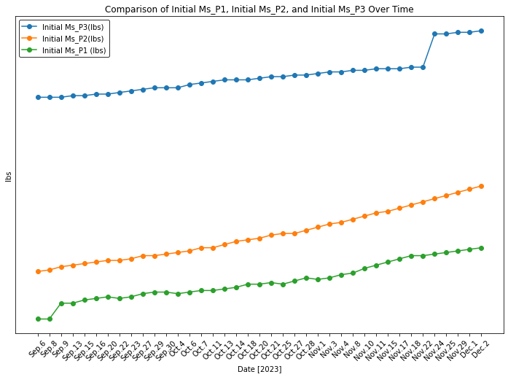

# Calculate the percentage increase for 'Initial Ms_P1 (lbs)' over time  
df['Percentage_Increase'] = ((df['Measured Ms_P1(lbs)'] - df['Initial Ms_P1 (lbs)']) / df['Initial Ms_P1 (lbs)']) * 100  
  
# Calculate the average percentage increase  
average_percentage_increase = df['Percentage_Increase'].mean()  
  
# Plotting the comparison over time  
plt.figure(figsize=(12, 8))  
plt.plot(df['Date [2023]'], df['Initial Ms_P1 (lbs)'], label='Initial Ms_P1 (lbs)', marker='o')  
plt.plot(df['Date [2023]'], df['Measured Ms_P1(lbs)'], label='Measured Ms_P1(lbs)', marker='o')  
  
# Display the average percentage increase as text on the plot  
plt.text(df['Date [2023]'].iloc[-1], df['Measured Ms_P1(lbs)'].iloc[-1], f'Avg Increase: {average_percentage_increase:.2f}%', ha='right', va='bottom')  
  
# Rotate x-axis labels for better readability  
plt.xticks(rotation=45)  
  
# Add a gradient legend  
legend = plt.legend(loc='upper left', frameon=True)  
frame = legend.get_frame()  
frame.set_facecolor('white') # Adjust the face color as needed  
frame.set_edgecolor('black') # Adjust the edge color as needed  
  
# Remove y-axis tick labels  
plt.yticks([])  
  
plt.title('Comparison of Initial Ms_P1 and Measured Ms_P1 Over Time')  
plt.xlabel('Date [2023]')  
plt.ylabel('Ibs')  
plt.grid(False)  
plt.show()

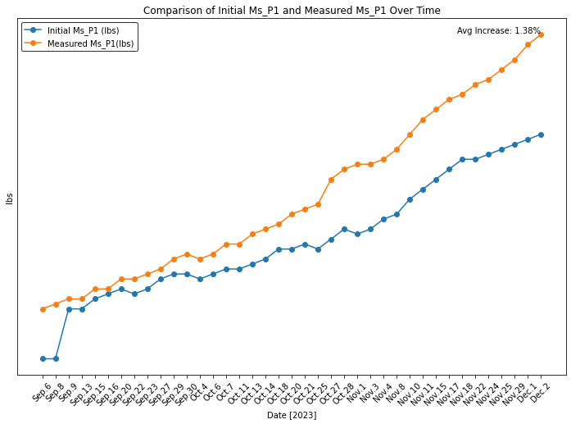

from scipy.stats import ttest_ind  
  
# Extract the two series to compare  
data1 = df['Measured Ms_P1(lbs)']  
data2 = df['Measured Ms_P3(lbs)']  
  
# Perform an independent two-sample t-test  
t_statistic, p_value = ttest_ind(data1, data2)  
  
print(t_statistic, p_value)  
  
# Check if the p-value is below the significance level (e.g., 0.05)  
significance_level = 0.05  
if p_value < significance_level:  
 print(f"There is a significant difference between 'Measured Ms_P1(lbs)' and 'Measured Ms_P3(lbs)' (p-value: {p_value:.4f})")  
else:  
 print(f"No significant difference between 'Measured Ms_P1(lbs)' and 'Measured Ms_P3(lbs)' (p-value: {p_value:.4f})")

-15.915361585478253 6.575399025889357e-26  
There is a significant difference between 'Measured Ms_P1(lbs)' and 'Measured Ms_P3(lbs)' (p-value: 0.0000)

from scipy.stats import ttest_ind  
  
# Extract the two series to compare  
data1 = df['Difference_Ms_P1']  
data2 = df['Difference_Ms_P3']  
  
# Perform an independent two-sample t-test  
t_statistic, p_value = ttest_ind(data1, data2)  
  
print(t_statistic, p_value)  
  
# Check if the p-value is below the significance level (e.g., 0.05)  
significance_level = 0.05  
if p_value < significance_level:  
 print(f"There is a significant difference between 'Measured Ms_P1(lbs)' and 'Measured Ms_P3(lbs)' (p-value: {p_value:.4f})")  
else:  
 print(f"No significant difference between 'Measured Ms_P1(lbs)' and 'Measured Ms_P3(lbs)' (p-value: {p_value:.4f})")

-6.9865447167369465 9.308654292119671e-10  
There is a significant difference between 'Measured Ms_P1(lbs)' and 'Measured Ms_P3(lbs)' (p-value: 0.0000)

import matplotlib.pyplot as plt  
  
# Plotting the comparison over time  
plt.figure(figsize=(12, 8))  
plt.plot(df['Date [2023]'], df['Difference_Ms_P1'], label='Difference_Ms_P1', marker='o')  
plt.plot(df['Date [2023]'], df['Difference_Ms_P2'], label='Difference_Ms_P2', marker='o')  
plt.plot(df['Date [2023]'], df['Difference_Ms_P3'], label='Difference_Ms_P3', marker='o')  
  
# Rotate x-axis labels for better readability  
plt.xticks(rotation=45)  
  
# Add a gradient legend  
legend = plt.legend(loc='upper left', frameon=True)  
frame = legend.get_frame()  
frame.set_facecolor('white') # Adjust the face color as needed  
frame.set_edgecolor('black') # Adjust the edge color as needed  
  
# Remove y-axis tick labels  
plt.yticks([])  
  
plt.title('Comparison of Difference_Ms_P1, Difference_Ms_P2 and Difference_Ms_P3 Over Time')  
plt.xlabel('Date [2023]')  
plt.ylabel('Ibs')  
plt.grid(False)  
plt.show()

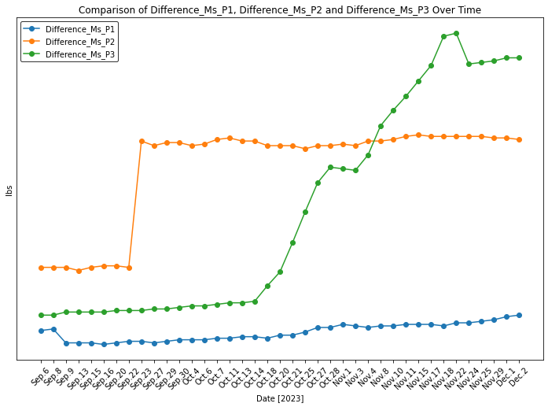

# Calculate the AVG_percentage increase for 'Measured_A' over time  
df['Percentage_Increase'] = ((df['Difference_Ms_P3'].shift(-1) - df['Difference_Ms_P3']) / df['Difference_Ms_P3']) * 100  
  
# Calculate the average percentage increase  
average_percentage_increase = df['Percentage_Increase'].mean()  
  
# Display the DataFrame with the calculated percentage increases  
#print(df)  
print(f'Average Percentage Increase for Difference_Ms_P3 over time: {average_percentage_increase:.2f}%')

Average Percentage Increase for Difference_Ms_P3 over time: 6.51%

# Calculate the AVG_percentage increase for 'Measured_A' over time  
df['Percentage_Increase'] = ((df['Difference_Ms_P2'].shift(-1) - df['Difference_Ms_P2']) / df['Difference_Ms_P2']) * 100  
  
# Calculate the average percentage increase  
average_percentage_increase = df['Percentage_Increase'].mean()  
  
# Display the DataFrame with the calculated percentage increases  
#print(df)  
print(f'Average Percentage Increase for Difference_Ms_P2 over time: {average_percentage_increase:.2f}%')

Average Percentage Increase for Difference_Ms_P2 over time: 4.26%

# Create a new column for the differences  
df['Difference_Ms_P1'] = df['Measured Ms_P1(lbs)'] - df['Initial Ms_P1 (lbs)']  
  
# Calculate the total increase and the average rate of increase  
total_increase = df['Difference_Ms_P1'].iloc[-1] - df['Difference_Ms_P1'].iloc[0]  
  
rate_of_increase = (total_increase / df['Difference_Ms_P1'].iloc[0])  
  
average_rate_of_increase_1 = (total_increase / df['Difference_Ms_P1'].iloc[0]) * 100 / (len(df) - 1)  
  
# Calculate the percentage increase for ' Ms_P1 (lbs)' over time  
df['Percentage_Increase'] = ((df['Measured Ms_P1(lbs)'] - df['Initial Ms_P1 (lbs)']) / df['Initial Ms_P1 (lbs)']) * 100  
  
# Calculate the average percentage increase overtime  
average_percentage_increase_2 = df['Percentage_Increase'].mean()  
  
#Display the total increase of Ms_P1  
print(f'Total Increase in Difference_Ms_P1: {total_increase:.2f}')  
  
# Display the total rate of increase  
print(f'Total Rate of Increase in Difference_Ms_P1: {rate_of_increase:.2f}')  
  
# Display the average rate of increase per unit period  
print(f'Average Rate of Increase in Difference_Ms_P1 per unit period: {average_rate_of_increase_1:.2f}%')  
  
# Display the average rate of increase over time  
print(f'Average Rate of Increase in Difference_Ms_P1 per over time: {average_percentage_increase_2:.2f}%')

Total Increase in Difference_Ms_P1: 0.10  
Total Rate of Increase in Difference_Ms_P1: 1.00  
Average Rate of Increase in Difference_Ms_P1 per unit period: 2.63%  
Average Rate of Increase in Difference_Ms_P1 per over time: 1.38%

# Create a new column for the differences  
df['Difference_Ms_P2'] = df['Measured Ms_P2(lbs)'] - df['Initial Ms_P2(lbs)']  
  
# Calculate the total increase and the average rate of increase  
total_increase = df['Difference_Ms_P2'].iloc[-1] - df['Difference_Ms_P2'].iloc[0]  
  
rate_of_increase = (total_increase / df['Difference_Ms_P2'].iloc[0])  
  
average_rate_of_increase_1 = (total_increase / df['Difference_Ms_P2'].iloc[0]) * 100 / (len(df) - 1)  
  
# Calculate the percentage increase for 'Initial Ms_P2 (lbs)' over time  
df['Percentage_Increase'] = ((df['Measured Ms_P2(lbs)'] - df['Initial Ms_P2(lbs)']) / df['Initial Ms_P2(lbs)']) * 100  
  
# Calculate the average percentage increase overtime  
average_percentage_increase_2 = df['Percentage_Increase'].mean()  
  
#Display the total increase of Ms_P2  
print(f'Total Increase in Difference_Ms_P2: {total_increase:.2f}')  
  
# Display the total rate of increase  
print(f'Total Rate of Increase in Difference_Ms_P2: {rate_of_increase:.2f}')  
  
# Display the average rate of increase per unit period  
print(f'Average Rate of Increase in Difference_Ms_P2 per unit period: {average_rate_of_increase_1:.2f}%')  
  
# Display the average rate of increase over time  
print(f'Average Rate of Increase in Difference_Ms_P2 per over time: {average_percentage_increase_2:.2f}%')

Total Increase in Difference_Ms_P2: 0.83  
Total Rate of Increase in Difference_Ms_P2: 1.63  
Average Rate of Increase in Difference_Ms_P2 per unit period: 4.28%  
Average Rate of Increase in Difference_Ms_P2 per over time: 17.17%

# Create a new column for the differences  
df['Difference_Ms_P3'] = df['Measured Ms_P3(lbs)'] - df['Initial Ms_P3(lbs)']  
  
# Calculate the total increase and the average rate of increase  
total_increase = df['Difference_Ms_P3'].iloc[-1] - df['Difference_Ms_P3'].iloc[0]  
  
rate_of_increase = (total_increase / df['Difference_Ms_P3'].iloc[0])  
  
average_rate_of_increase_1 = (total_increase / df['Difference_Ms_P3'].iloc[0]) * 100 / (len(df) - 1)  
  
# Calculate the percentage increase for 'Initial Ms_P1 (lbs)' over time  
df['Percentage_Increase'] = ((df['Measured Ms_P3(lbs)'] - df['Initial Ms_P3(lbs)']) / df['Initial Ms_P3(lbs)']) * 100  
  
# Calculate the average percentage increase overtime  
average_percentage_increase_2 = df['Percentage_Increase'].mean()  
  
#Display the total increase of Ms_P3  
print(f'Total Increase in Difference_Ms_P3: {total_increase:.2f}')  
  
# Display the total rate of increase  
print(f'Total Rate of Increase in Difference_Ms_P3: {rate_of_increase:.2f}')  
  
# Display the average rate of increase per unit period  
print(f'Average Rate of Increase in Difference_Ms_P3 per unit period: {average_rate_of_increase_1:.2f}%')  
  
# Display the average rate of increase over time  
print(f'Average Rate of Increase in Difference_Ms_P3 per over time: {average_percentage_increase_2:.2f}%')

Total Increase in Difference_Ms_P3: 1.67  
Total Rate of Increase in Difference_Ms_P3: 8.35  
Average Rate of Increase in Difference_Ms_P3 per unit period: 21.97%  
Average Rate of Increase in Difference_Ms_P3 per over time: 11.13%

from scipy.stats import pearsonr  
import seaborn as sns  
  
  
# Calculate Pearson correlation coefficient  
correlation_coefficient, p_value = pearsonr(df['Difference_Ms_P1'], df['Difference_Ms_P2'])  
  
# Display the correlation coefficient and p-value  
print(f"Pearson Correlation Coefficient: {correlation_coefficient}")  
print(f"P-Value: {p_value}")  
  
# Plot a scatter plot to visualize the relationship  
plt.figure(figsize=(8, 6))  
  
# Scatter plot with different colors for each variable  
sns.scatterplot(x='Difference_Ms_P1', y='Difference_Ms_P2', data=df, hue=df['Difference_Ms_P1'], palette='viridis')  
  
# Annotate the plot with correlation coefficient and p-value  
plt.text(plt.xlim()[0], plt.ylim()[1], f'Correlation: {correlation_coefficient:.2f}\nP-Value: {p_value:.4f}',  
 horizontalalignment='left', verticalalignment='top', fontsize=12, color='red')  
  
sns.scatterplot(x='Difference_Ms_P1', y='Difference_Ms_P2', data=df)  
plt.title('Scatter Plot between Difference_Ms_P1 and Difference_Ms_P2')  
plt.show()  
  
# Check significance based on the p-value  
alpha = 0.05 # significance level  
if p_value < alpha:  
 print("There is a significant relationship between Difference_Ms_P1 and Difference_Ms_P2.")  
else:  
 print("There is no significant relationship between Difference_Ms_P1 and Difference_Ms_P2.")

Pearson Correlation Coefficient: 0.47543154870965776  
P-Value: 0.00222261344584487

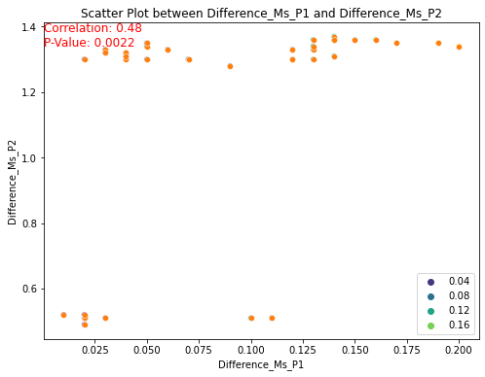

There is a significant relationship between Difference_Ms_P1 and Difference_Ms_P2.

from scipy.stats import pearsonr  
import seaborn as sns  
  
  
# Calculate Pearson correlation coefficient  
correlation_coefficient, p_value = pearsonr(df['Difference_Ms_P3'], df['Difference_Ms_P2'])  
  
# Display the correlation coefficient and p-value  
print(f"Pearson Correlation Coefficient: {correlation_coefficient}")  
print(f"P-Value: {p_value}")  
  
# Plot a scatter plot to visualize the relationship  
plt.figure(figsize=(8, 6))  
  
# Scatter plot with different colors for each variable  
sns.scatterplot(x='Difference_Ms_P3', y='Difference_Ms_P2', data=df, hue=df['Difference_Ms_P3'], palette='viridis')  
  
# Annotate the plot with correlation coefficient and p-value  
plt.text(plt.xlim()[0], plt.ylim()[1], f'Correlation: {correlation_coefficient:.2f}\nP-Value: {p_value:.4f}',  
 horizontalalignment='left', verticalalignment='top', fontsize=12, color='red')  
  
sns.scatterplot(x='Difference_Ms_P3', y='Difference_Ms_P2', data=df)  
plt.title('Scatter Plot between Difference_Ms_P1 and Difference_Ms_P2')  
plt.show()  
  
# Check significance based on the p-value  
alpha = 0.05 # significance level  
if p_value < alpha:  
 print("There is a significant relationship between Difference_Ms_P3 and Difference_Ms_P2.")  
else:  
 print("There is no significant relationship between Difference_Ms_P3 and Difference_Ms_P2.")

Pearson Correlation Coefficient: 0.5181271868993695  
P-Value: 0.0007285554368866722

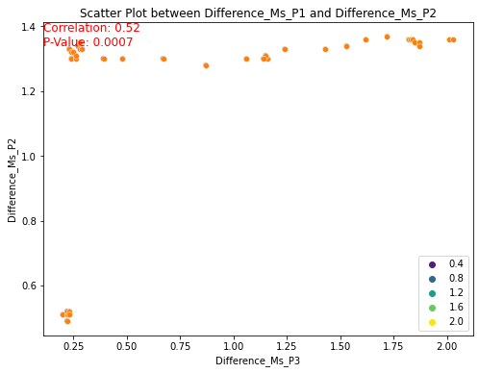

There is a significant relationship between Difference_Ms_P3 and Difference_Ms_P2.

pip install sweetviz

Note: you may need to restart the kernel to use updated packages.

WARNING: Retrying (Retry(total=4, connect=None, read=None, redirect=None, status=None)) after connection broken by 'NewConnectionError('<pip._vendor.urllib3.connection.HTTPSConnection object at 0x00000234FCA561F0>: Failed to establish a new connection: [WinError 10051] A socket operation was attempted to an unreachable network')': /simple/sweetviz/  
WARNING: Retrying (Retry(total=3, connect=None, read=None, redirect=None, status=None)) after connection broken by 'NewConnectionError('<pip._vendor.urllib3.connection.HTTPSConnection object at 0x00000234FCA56730>: Failed to establish a new connection: [Errno 11001] getaddrinfo failed')': /simple/sweetviz/  
WARNING: Retrying (Retry(total=2, connect=None, read=None, redirect=None, status=None)) after connection broken by 'NewConnectionError('<pip._vendor.urllib3.connection.HTTPSConnection object at 0x00000234FCA56940>: Failed to establish a new connection: [Errno 11001] getaddrinfo failed')': /simple/sweetviz/  
WARNING: Retrying (Retry(total=1, connect=None, read=None, redirect=None, status=None)) after connection broken by 'NewConnectionError('<pip._vendor.urllib3.connection.HTTPSConnection object at 0x00000234FCA56AF0>: Failed to establish a new connection: [Errno 11001] getaddrinfo failed')': /simple/sweetviz/  
WARNING: Retrying (Retry(total=0, connect=None, read=None, redirect=None, status=None)) after connection broken by 'NewConnectionError('<pip._vendor.urllib3.connection.HTTPSConnection object at 0x00000234FCA56CA0>: Failed to establish a new connection: [Errno 11001] getaddrinfo failed')': /simple/sweetviz/  
ERROR: Could not find a version that satisfies the requirement sweetviz (from versions: none)  
ERROR: No matching distribution found for sweetviz