import pandas as pd  
import numpy as np

df_1 = pd.read_csv("C.csv")  
df_1.head()

Country 2002 2003 2004 2005 2006 2007 2008 2009 2010 ... \  
0 Algeria 5.6 7.2 4.3 5.9 1.7 3.4 2.4 1.6 3.6 ...   
1 Angola 13.7 3.0 11.0 15.0 11.5 14.0 11.2 0.9 4.9 ...   
2 Botswana 7.4 5.4 1.4 5.0 6.0 5.8 3.3 -14.1 10.1 ...   
3 Burkina Faso 4.4 7.8 4.5 8.7 6.3 4.1 5.8 3.0 8.4 ...   
4 Ghana 4.6 5.1 5.4 6.2 5.8 4.1 9.0 5.7 7.8 ...   
  
 2014 2015 2016 2017 2018 2019 2020 2021 2022 Continent   
0 3.8 3.7 3.2 1.4 1.2 1.0 -5.1 3.4 2.9 Africa   
1 4.8 0.9 -2.6 -0.2 -1.3 -0.7 -5.6 1.1 2.8 Africa   
2 5.7 -4.9 7.2 4.1 4.2 3.0 -8.7 11.8 6.4 Africa   
3 4.3 3.9 6.0 6.2 6.6 5.7 1.9 6.9 2.5 Africa   
4 2.9 2.1 3.4 8.1 6.2 6.5 0.5 5.4 3.2 Africa   
  
[5 rows x 23 columns]

The dataset was gotten from Kaggle, World GDP Growth (1980-2028). To put scope put the analysis and study,the dataset was profiled.

First, Data Cleaning, all row with an empty cell, or the word "No data" were deleted. Then, a period of 20 years (2022-2022) observation was selected, that is, every other "year" below 2002 and above 2022 were deleted.

The Dataset set was further manipulated by manually adding a "Continent" column, Six Continents were observed which are "Asia, Africa, Australia, Europe, North America, South America". This column was used to select 10 countries from each continent.

In conclusion, the dataset contains 60 countries (10 countries from 6 continents) with an outlook period of 20years, 2002 -2022.

df_1.describe()

2002 2003 2004 2005 2006 2007 \  
count 60.000000 60.000000 60.000000 60.000000 60.000000 60.000000   
mean 2.715000 5.090000 5.733333 4.721667 5.088333 5.166667   
std 4.822223 10.664827 7.347839 3.368905 4.280468 3.630972   
min -10.900000 -7.800000 -1.900000 -3.700000 -4.000000 -2.500000   
25% 0.650000 1.900000 3.100000 2.625000 2.600000 2.750000   
50% 3.150000 3.950000 4.600000 4.400000 4.750000 4.500000   
75% 5.100000 5.850000 6.725000 6.225000 6.625000 6.900000   
max 14.600000 81.800000 53.400000 15.000000 28.100000 18.200000   
  
 2008 2009 2010 2011 ... 2013 2014 \  
count 60.00000 60.000000 60.000000 60.000000 ... 60.000000 60.000000   
mean 3.93000 -0.028333 4.448333 4.558333 ... 3.285000 3.356667   
std 4.06007 4.725125 4.078156 3.155103 ... 2.741015 2.436541   
min -5.30000 -14.100000 -5.700000 -1.700000 ... -1.600000 -3.900000   
25% 0.90000 -3.250000 1.775000 2.500000 ... 1.175000 1.700000   
50% 4.00000 -0.350000 4.100000 4.250000 ... 2.950000 3.350000   
75% 6.25000 3.000000 7.350000 6.450000 ... 5.125000 5.025000   
max 17.50000 13.100000 17.700000 13.900000 ... 11.100000 8.600000   
  
 2015 2016 2017 2018 2019 2020 \  
count 60.000000 60.000000 60.000000 60.000000 60.000000 60.000000   
mean 3.516667 2.996667 2.618333 2.656667 2.038333 -5.845000   
std 4.161656 4.002794 3.716865 3.771677 4.836587 6.033366   
min -6.200000 -17.000000 -15.700000 -19.700000 -27.700000 -30.000000   
25% 1.775000 1.800000 1.400000 1.625000 0.700000 -8.400000   
50% 3.300000 3.000000 2.800000 2.750000 2.200000 -5.050000   
75% 4.825000 4.700000 4.800000 4.250000 4.400000 -2.075000   
max 24.400000 15.200000 9.000000 8.600000 13.800000 6.200000   
  
 2021 2022   
count 60.000000 60.000000   
mean 5.321667 4.041667   
std 5.049218 3.644513   
min -12.100000 -6.000000   
25% 3.325000 2.500000   
50% 5.300000 3.500000   
75% 7.825000 6.000000   
max 15.300000 14.500000   
  
[8 rows x 21 columns]

# Create a customized legend  
  
  
plt.figure(figsize=(14, 6))  
  
  
country_data = df_1[df_1['Country'] == all_countries]  
country_data = country_data.replace('no data', pd.NA).dropna(axis=1)  
years = country_data.columns[1:-1].astype(int)  
gdp_growth_mean_flattened = country_data.iloc[:, 1:-1].mean(axis=0).values.flatten().astype(float)  
   
plt.plot(years, gdp_growth_mean_flattened, linestyle='-', marker='o', markersize=4)  
  
# Additional settings for the plot  
plt.grid(True)  
plt.xlim(min(years), max(years))  
plt.ylim(min(gdp_growth_mean_flattened), max(gdp_growth_mean_flattened))  
plt.xlabel('Year')  
plt.ylabel('GDP Growth (Annual percent change)')  
plt.title(f'Global GDP Growth (Annual percent change) from 2002 - 2022')  
plt.legend(custom_labels, loc='upper right')  
plt.xticks(years, rotation=45)  
plt.show()

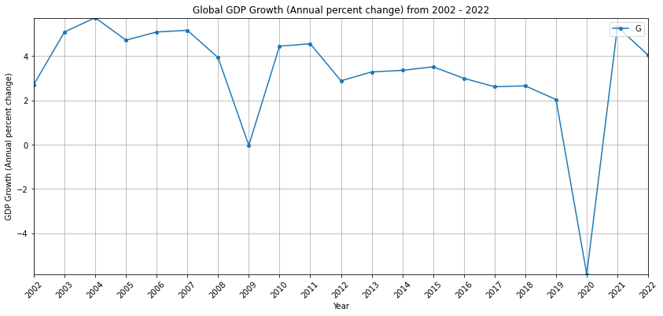

Continent_name = 'Africa'  
  
plt.figure(figsize=(14, 6))  
  
Continent_data = df_1[df_1['Continent'] == Continent_name]  
Continent_data = Continent_data.replace('no data', pd.NA).dropna(axis=1)  
years = Continent_data.columns[1:-1].astype(int)  
  
gdp_growth_mean_flattened = Continent_data.iloc[:, 1:-1].mean(axis=0).values.flatten().astype(float)  
plt.plot(years, gdp_growth_mean_flattened, linestyle='-', marker='o', markersize=4)  
# Additional settings for the plot  
plt.grid(True)  
plt.xlim(min(years), max(years))  
plt.ylim(min(gdp_growth_mean_flattened), max(gdp_growth_mean_flattened))  
plt.xlabel('Year')  
plt.ylabel('GDP Growth (Annual percent change)')  
plt.title(f'Africa GDP Growth (Annual percent change) from 2002 - 2022')  
plt.legend(Continent_name, loc='upper right')  
plt.xticks(years, rotation=45)  
plt.show()

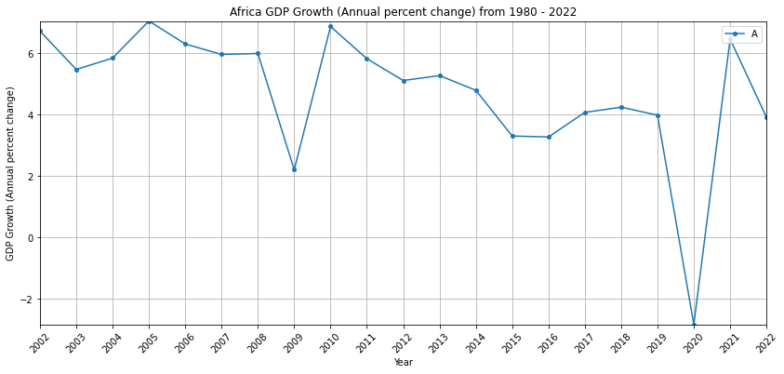

Continent_name = 'Asia'  
  
plt.figure(figsize=(14, 6))  
  
Continent_data = df_1[df_1['Continent'] == Continent_name]  
Continent_data = Continent_data.replace('no data', pd.NA).dropna(axis=1)  
years = Continent_data.columns[1:-1].astype(int)  
  
gdp_growth_mean_flattened = Continent_data.iloc[:, 1:-1].mean(axis=0).values.flatten().astype(float)  
plt.plot(years, gdp_growth_mean_flattened, linestyle='-', marker='o', markersize=4)  
# Additional settings for the plot  
plt.grid(True)  
plt.xlim(min(years), max(years))  
plt.ylim(min(gdp_growth_mean_flattened), max(gdp_growth_mean_flattened))  
plt.xlabel('Year')  
plt.ylabel('GDP Growth (Annual percent change)')  
plt.title(f'Asia GDP Growth (Annual percent change) from 2002 - 2022')  
plt.legend(Continent_name, loc='upper right')  
plt.xticks(years, rotation=45)  
plt.show()

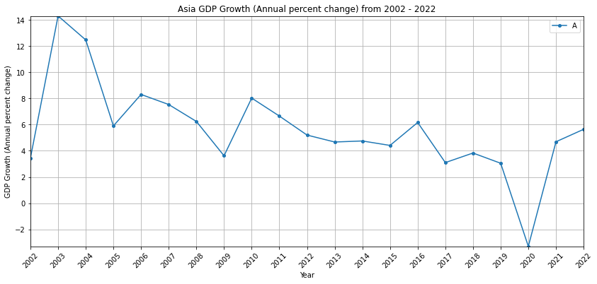

Continent_name = 'Europe'  
  
plt.figure(figsize=(14, 6))  
  
Continent_data = df_1[df_1['Continent'] == Continent_name]  
Continent_data = Continent_data.replace('no data', pd.NA).dropna(axis=1)  
years = Continent_data.columns[1:-1].astype(int)  
  
gdp_growth_mean_flattened = Continent_data.iloc[:, 1:-1].mean(axis=0).values.flatten().astype(float)  
plt.plot(years, gdp_growth_mean_flattened, linestyle='-', marker='o', markersize=4)  
# Additional settings for the plot  
plt.grid(True)  
plt.xlim(min(years), max(years))  
plt.ylim(min(gdp_growth_mean_flattened), max(gdp_growth_mean_flattened))  
plt.xlabel('Year')  
plt.ylabel('GDP Growth (Annual percent change)')  
plt.title(f'Europe GDP Growth (Annual percent change) from 2002 - 2022')  
plt.legend(Continent_name, loc='upper right')  
plt.xticks(years, rotation=45)  
plt.show()

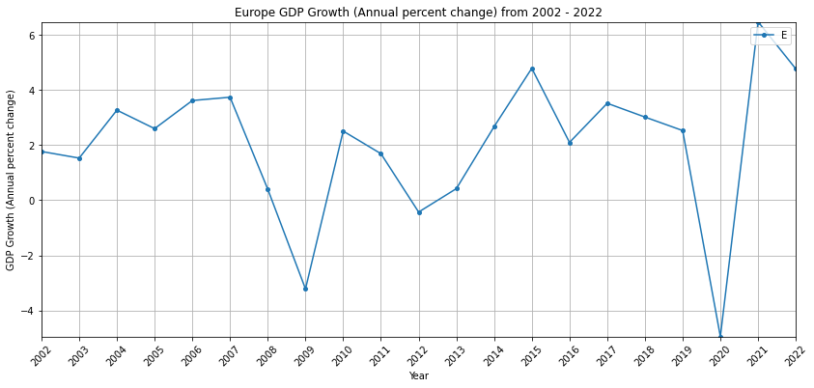

Continent_name = 'North America'  
  
plt.figure(figsize=(14, 6))  
  
Continent_data = df_1[df_1['Continent'] == Continent_name]  
Continent_data = Continent_data.replace('no data', pd.NA).dropna(axis=1)  
years = Continent_data.columns[1:-1].astype(int)  
  
gdp_growth_mean_flattened = Continent_data.iloc[:, 1:-1].mean(axis=0).values.flatten().astype(float)  
plt.plot(years, gdp_growth_mean_flattened, linestyle='-', marker='o', markersize=4)  
# Additional settings for the plot  
plt.grid(True)  
plt.xlim(min(years), max(years))  
plt.ylim(min(gdp_growth_mean_flattened), max(gdp_growth_mean_flattened))  
plt.xlabel('Year')  
plt.ylabel('GDP Growth (Annual percent change)')  
plt.title(f'North America GDP Growth (Annual percent change) from 2002 - 2022')  
plt.legend(Continent_name, loc='upper right')  
plt.xticks(years, rotation=45)  
plt.show()

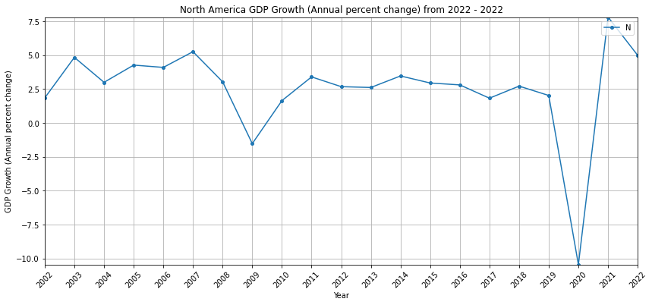

Continent_name = 'South America'  
  
plt.figure(figsize=(14, 6))  
  
Continent_data = df_1[df_1['Continent'] == Continent_name]  
Continent_data = Continent_data.replace('no data', pd.NA).dropna(axis=1)  
years = Continent_data.columns[1:-1].astype(int)  
  
gdp_growth_mean_flattened = Continent_data.iloc[:, 1:-1].mean(axis=0).values.flatten().astype(float)  
plt.plot(years, gdp_growth_mean_flattened, linestyle='-', marker='o', markersize=4)  
# Additional settings for the plot  
plt.grid(True)  
plt.xlim(min(years), max(years))  
plt.ylim(min(gdp_growth_mean_flattened), max(gdp_growth_mean_flattened))  
plt.xlabel('Year')  
plt.ylabel('GDP Growth (Annual percent change)')  
plt.title(f'South America GDP Growth (Annual percent change) from 2002 -2022')  
plt.legend(Continent_name, loc='upper right')  
plt.xticks(years, rotation=45)  
plt.show()

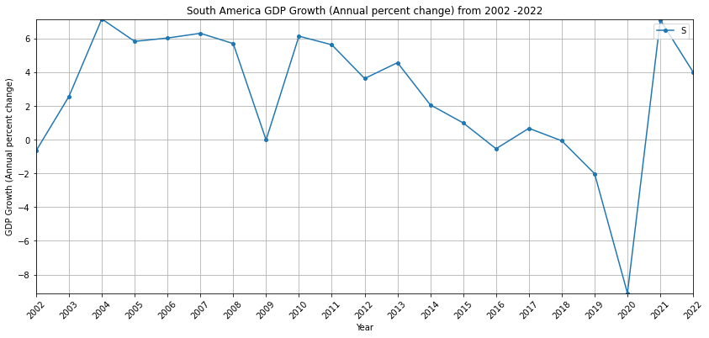

Continent_name = 'Australia'  
  
plt.figure(figsize=(14, 6))  
  
Continent_data = df_1[df_1['Continent'] == Continent_name]  
Continent_data = Continent_data.replace('no data', pd.NA).dropna(axis=1)  
years = Continent_data.columns[1:-1].astype(int)  
  
gdp_growth_mean_flattened = Continent_data.iloc[:, 1:-1].mean(axis=0).values.flatten().astype(float)  
plt.plot(years, gdp_growth_mean_flattened, linestyle='-', marker='o', markersize=4)  
# Additional settings for the plot  
plt.grid(True)  
plt.xlim(min(years), max(years))  
plt.ylim(min(gdp_growth_mean_flattened), max(gdp_growth_mean_flattened))  
plt.xlabel('Year')  
plt.ylabel('GDP Growth (Annual percent change)')  
plt.title(f'Australia GDP Growth (Annual percent change) from 2002 - 2022')  
plt.legend(Continent_name, loc='upper right', fontsize=16)  
plt.xticks(years, rotation=45)  
plt.show()

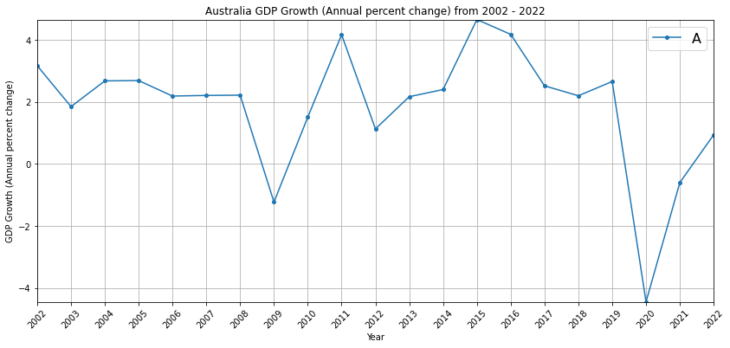

plt.figure(figsize=(22, 12))  
  
# Plot for Australia  
Continent_name = 'Australia'  
Continent_data = df_1[df_1['Continent'] == Continent_name]  
Continent_data = Continent_data.replace('no data', pd.NA).dropna(axis=1)  
years = Continent_data.columns[1:-1].astype(int)  
gdp_growth_mean_flattened = Continent_data.iloc[:, 1:-1].mean(axis=0).values.flatten().astype(float)  
plt.plot(years, gdp_growth_mean_flattened, linestyle='-', marker='o', markersize=4, label=Continent_name)  
  
# Plot for South America  
Continent_name = 'South America'  
Continent_data = df_1[df_1['Continent'] == Continent_name]  
Continent_data = Continent_data.replace(' no data', pd.NA).dropna(axis=1)  
gdp_growth_mean_flattened = Continent_data.iloc[:, 1:-1].mean(axis=0).values.flatten().astype(float)  
plt.plot(years, gdp_growth_mean_flattened, linestyle='-', marker='o', markersize=4, label=Continent_name)  
  
# Plot for Africa  
Continent_name = 'Africa'  
Continent_data = df_1[df_1['Continent'] == Continent_name]  
Continent_data = Continent_data.replace(' no data', pd.NA).dropna(axis=1)  
gdp_growth_mean_flattened = Continent_data.iloc[:, 1:-1].mean(axis=0).values.flatten().astype(float)  
plt.plot(years, gdp_growth_mean_flattened, linestyle='-', marker='o', markersize=4, label=Continent_name)  
  
# Plot for North America  
Continent_name = 'North America'  
Continent_data = df_1[df_1['Continent'] == Continent_name]  
Continent_data = Continent_data.replace(' no data', pd.NA).dropna(axis=1)  
gdp_growth_mean_flattened = Continent_data.iloc[:, 1:-1].mean(axis=0).values.flatten().astype(float)  
plt.plot(years, gdp_growth_mean_flattened, linestyle='-', marker='o', markersize=4, label=Continent_name)  
  
# Plot for Asia  
Continent_name = 'Asia'  
Continent_data = df_1[df_1['Continent'] == Continent_name]  
Continent_data = Continent_data.replace(' no data', pd.NA).dropna(axis=1)  
gdp_growth_mean_flattened = Continent_data.iloc[:, 1:-1].mean(axis=0).values.flatten().astype(float)  
plt.plot(years, gdp_growth_mean_flattened, linestyle='-', marker='o', markersize=4, label=Continent_name)  
  
# Plot for Europe  
Continent_name = 'Europe'  
Continent_data = df_1[df_1['Continent'] == Continent_name]  
Continent_data = Continent_data.replace(' no data', pd.NA).dropna(axis=1)  
gdp_growth_mean_flattened = Continent_data.iloc[:, 1:-1].mean(axis=0).values.flatten().astype(float)  
plt.plot(years, gdp_growth_mean_flattened, linestyle='-', marker='o', markersize=4, label=Continent_name)  
  
# Additional settings for the plot  
plt.grid(True)  
plt.xlim(min(years), max(years))  
plt.xlabel('Year', fontsize=20) # Adjust the fontsize as needed  
plt.ylabel('GDP Growth (Annual percent change)', fontsize=20)  
plt.title('Continental Comparison of GDP Growth (Annual percent change) from 2002-2022', fontsize=20)  
plt.legend(loc='upper right', fontsize=16)  
plt.xticks(years, rotation=45, fontsize=14) # Adjust the fontsize as needed

([<matplotlib.axis.XTick at 0x2b312380dc0>,  
 <matplotlib.axis.XTick at 0x2b3123805b0>,  
 <matplotlib.axis.XTick at 0x2b312d0b3d0>,  
 <matplotlib.axis.XTick at 0x2b312e1a280>,  
 <matplotlib.axis.XTick at 0x2b312c74b50>,  
 <matplotlib.axis.XTick at 0x2b312e1a460>,  
 <matplotlib.axis.XTick at 0x2b312c74cd0>,  
 <matplotlib.axis.XTick at 0x2b312ed8a00>,  
 <matplotlib.axis.XTick at 0x2b312ed8430>,  
 <matplotlib.axis.XTick at 0x2b312db7a60>,  
 <matplotlib.axis.XTick at 0x2b312db7f10>,  
 <matplotlib.axis.XTick at 0x2b312db7e80>,  
 <matplotlib.axis.XTick at 0x2b312db7b50>,  
 <matplotlib.axis.XTick at 0x2b312ed87c0>,  
 <matplotlib.axis.XTick at 0x2b3127cbee0>,  
 <matplotlib.axis.XTick at 0x2b3127cb970>,  
 <matplotlib.axis.XTick at 0x2b311c9ec70>,  
 <matplotlib.axis.XTick at 0x2b311c9e9d0>,  
 <matplotlib.axis.XTick at 0x2b311c9efa0>,  
 <matplotlib.axis.XTick at 0x2b3127cb610>,  
 <matplotlib.axis.XTick at 0x2b312db77f0>],  
 [Text(0, 0, ''),  
 Text(0, 0, ''),  
 Text(0, 0, ''),  
 Text(0, 0, ''),  
 Text(0, 0, ''),  
 Text(0, 0, ''),  
 Text(0, 0, ''),  
 Text(0, 0, ''),  
 Text(0, 0, ''),  
 Text(0, 0, ''),  
 Text(0, 0, ''),  
 Text(0, 0, ''),  
 Text(0, 0, ''),  
 Text(0, 0, ''),  
 Text(0, 0, ''),  
 Text(0, 0, ''),  
 Text(0, 0, ''),  
 Text(0, 0, ''),  
 Text(0, 0, ''),  
 Text(0, 0, ''),  
 Text(0, 0, '')])

