Student ID: 2400031869
Name: K. Sruthi
Skill Experiment Number: 01
Section Number: S02
Title: FSAD Skill Experiment – 3
SKILL EXPERIMENT-3
HQL.java:
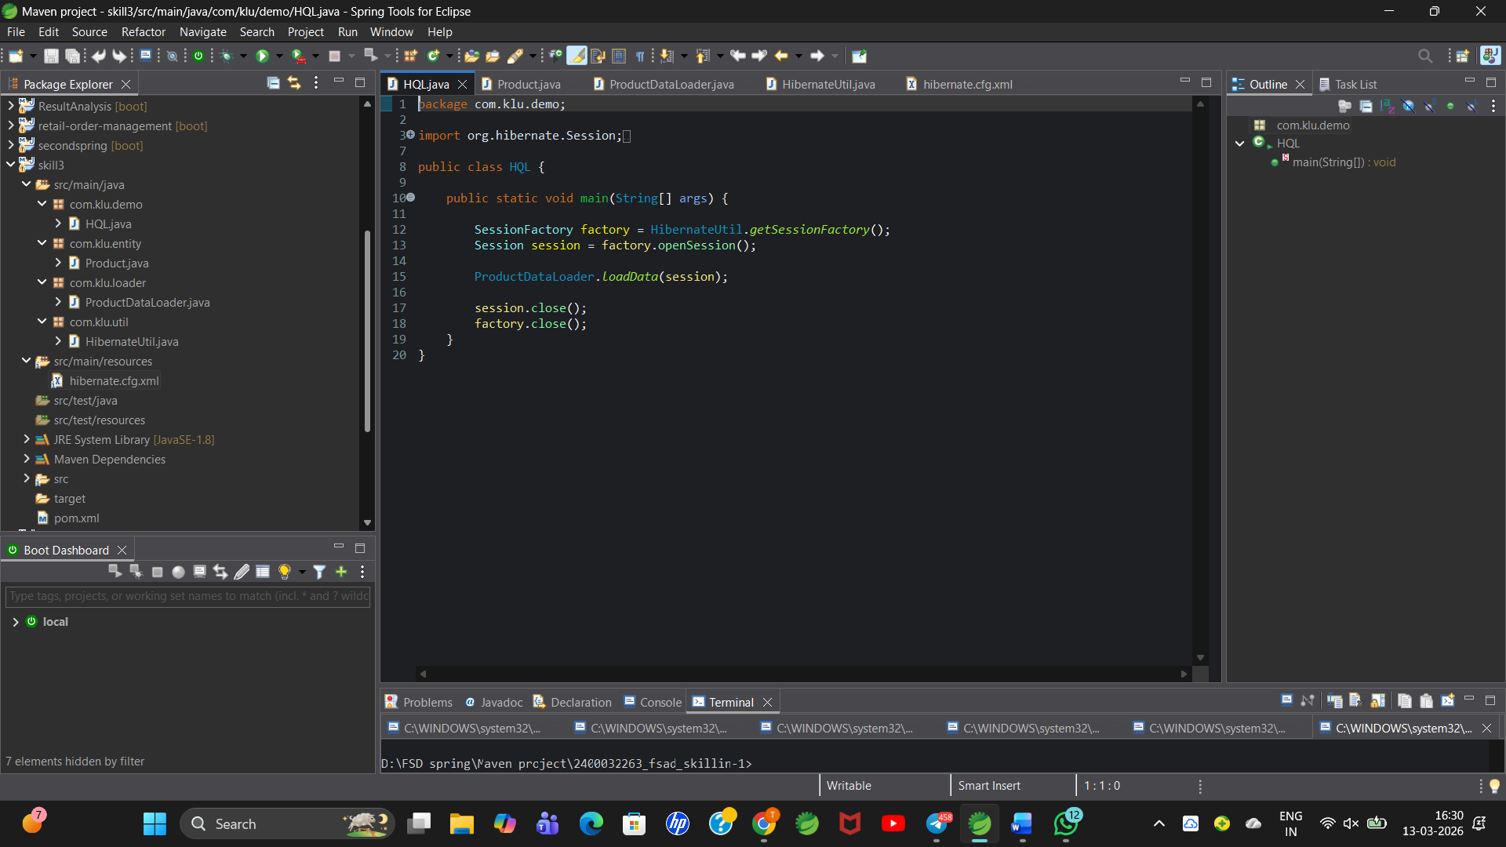

Product.java:
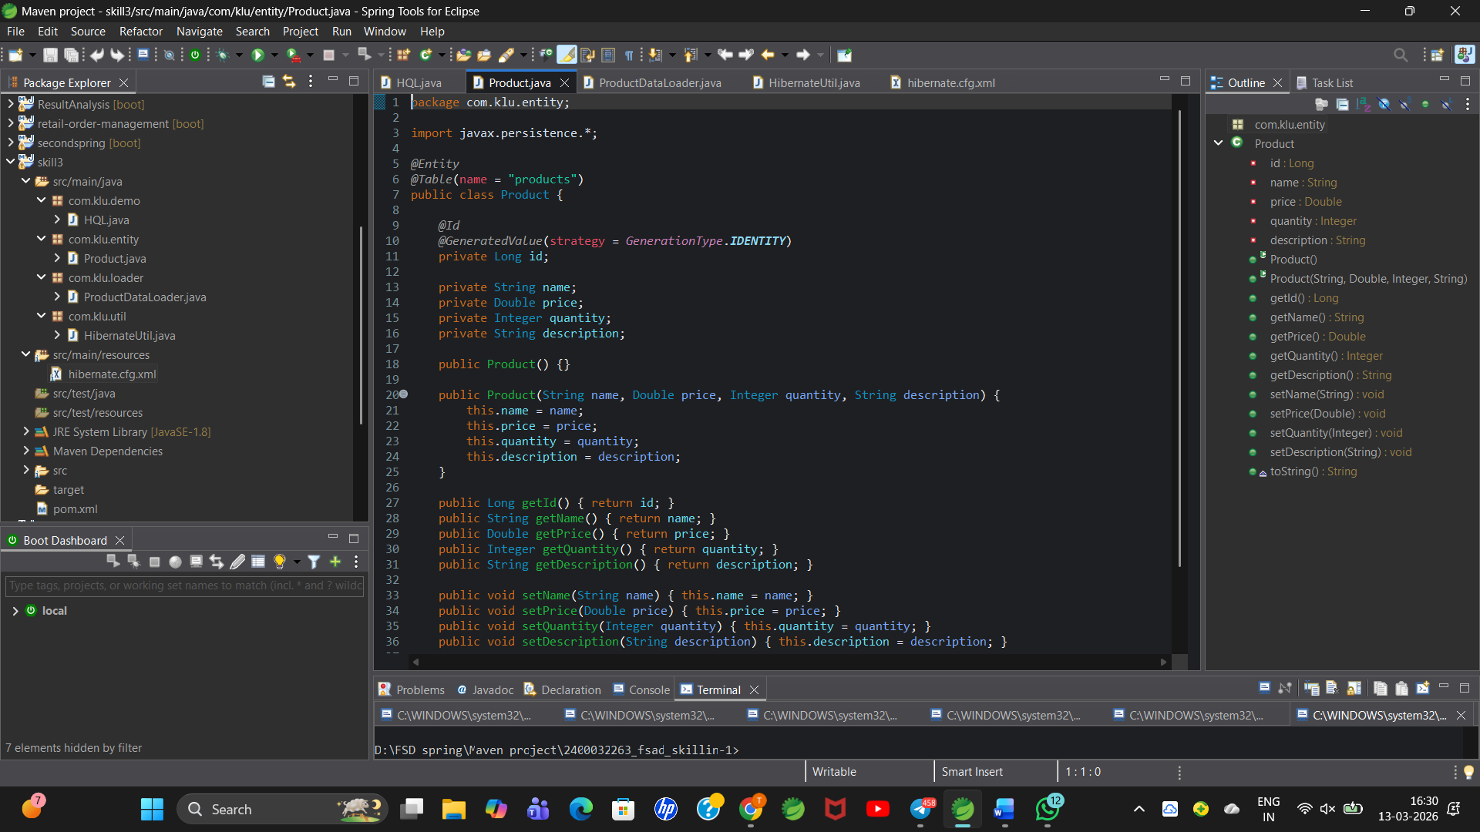
ProductDataLoader.java:
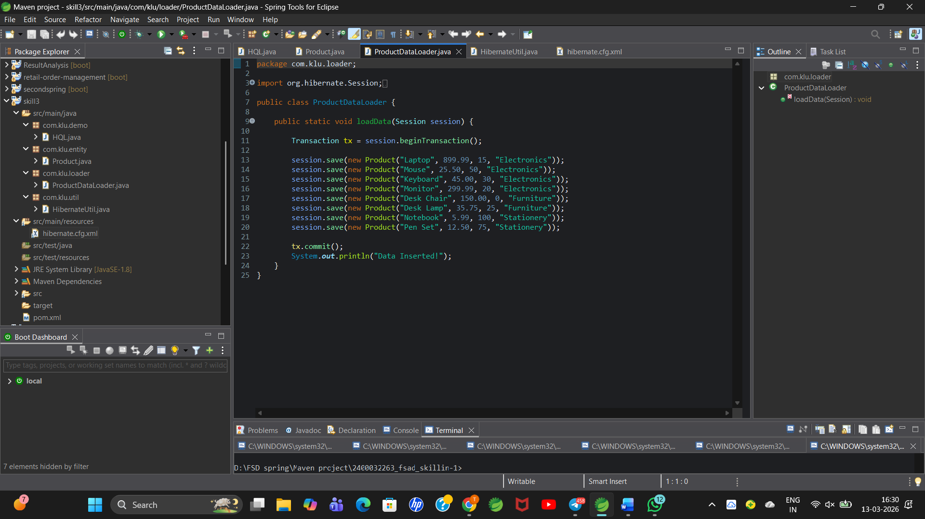

HibernateUtil.java:
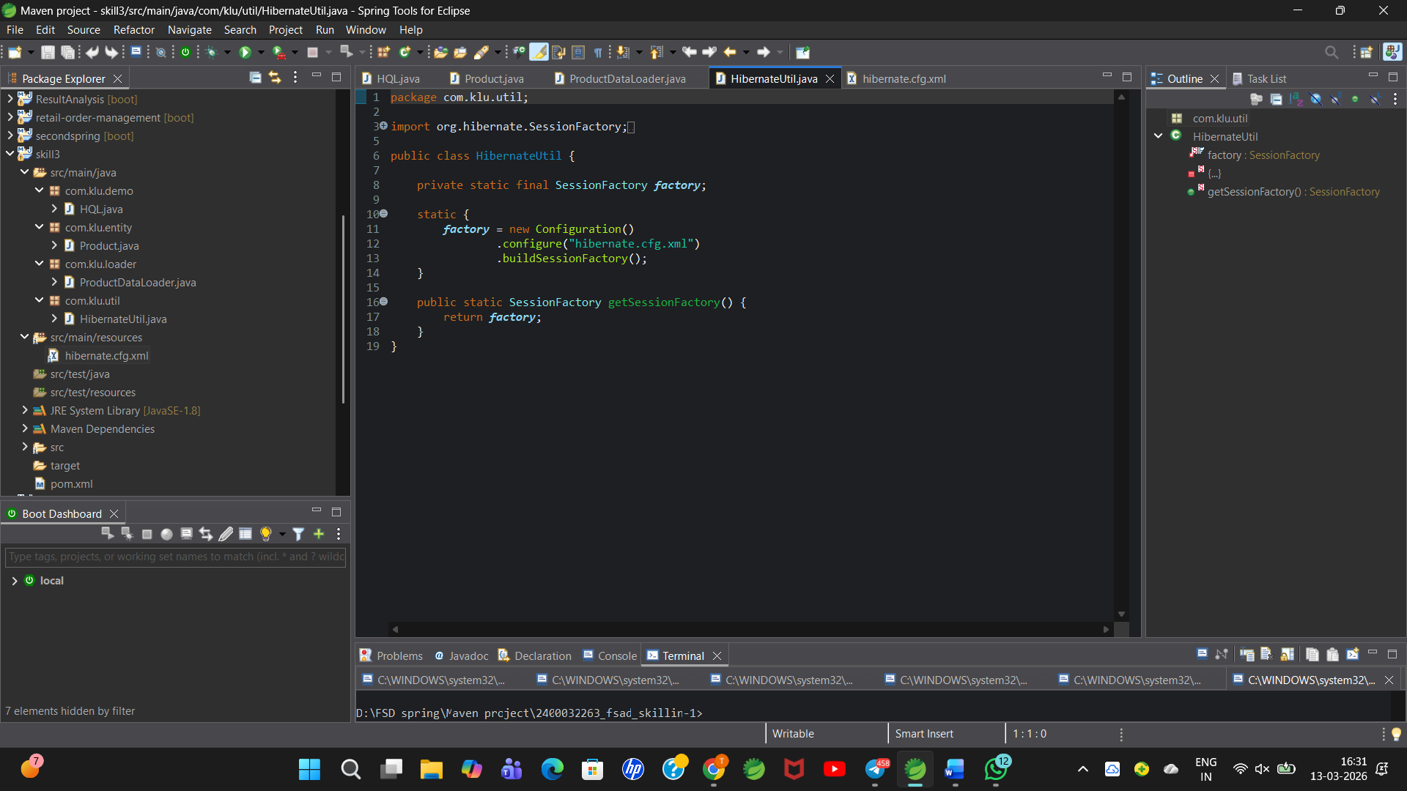
Pom.xml:
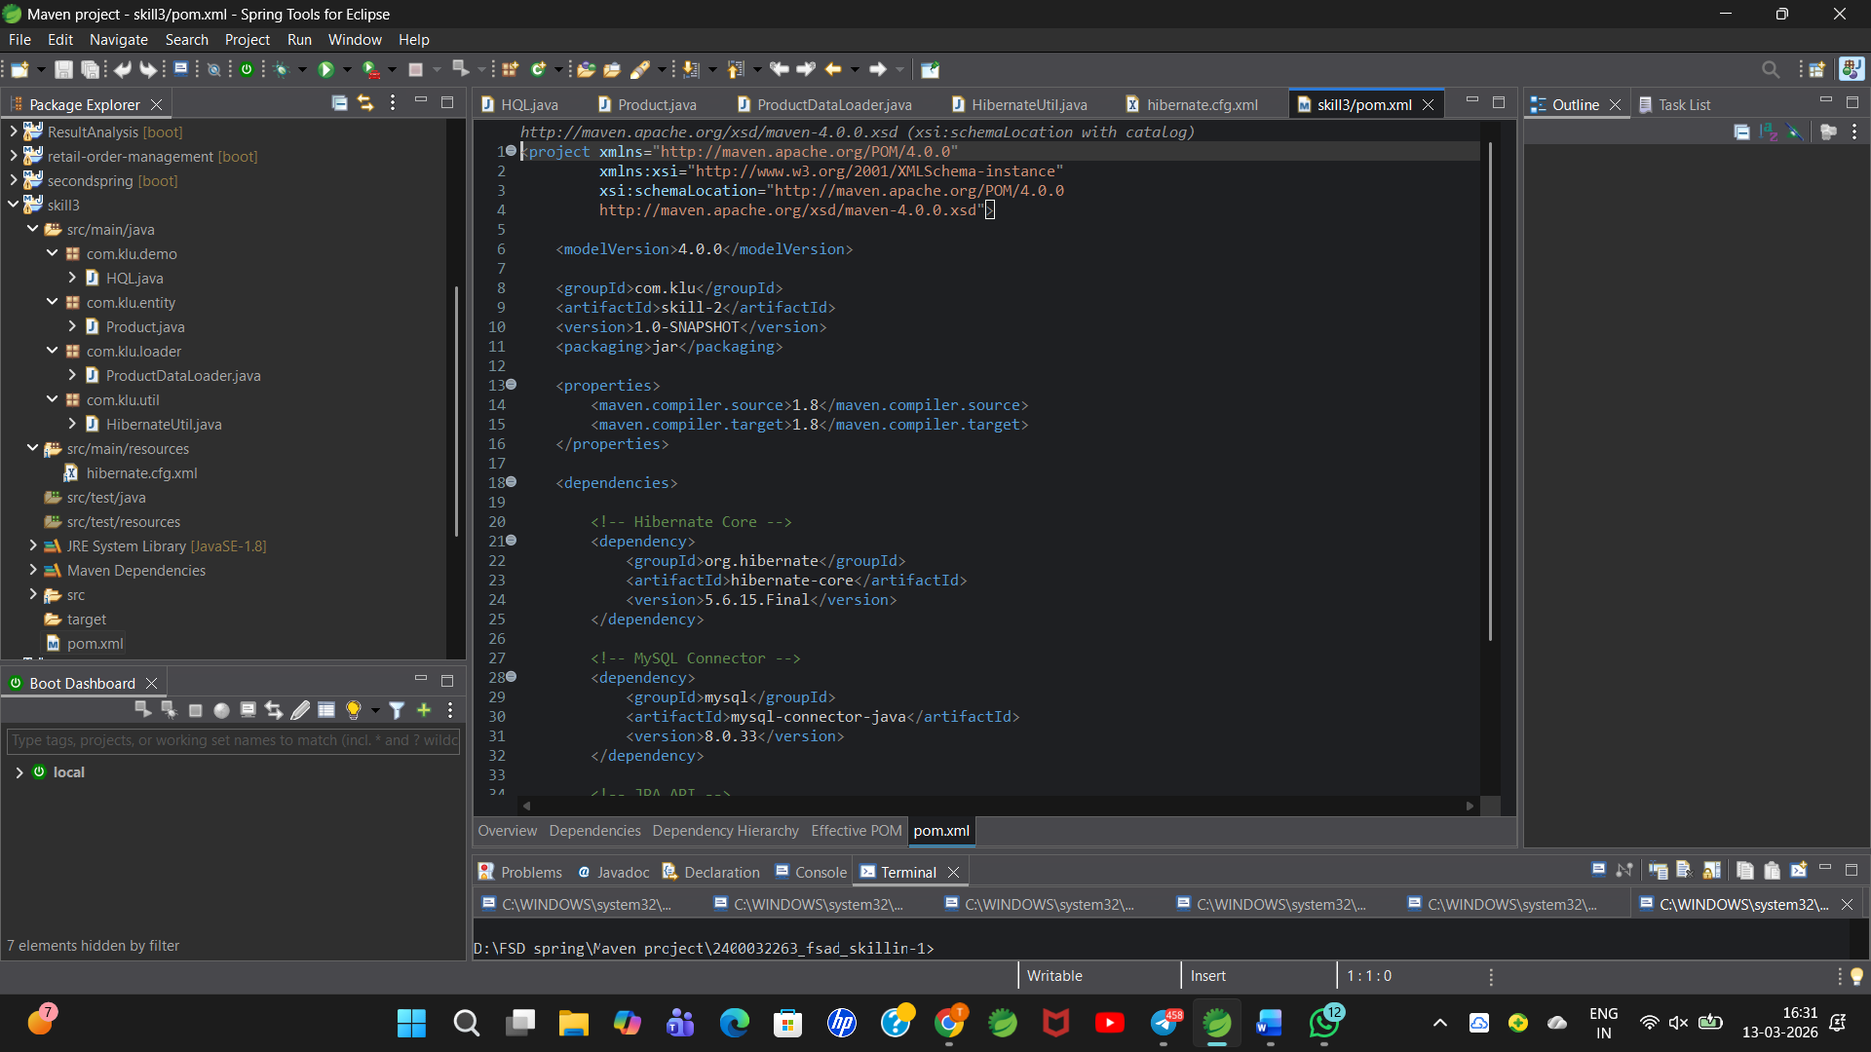

Hibernate.cfg.xml:
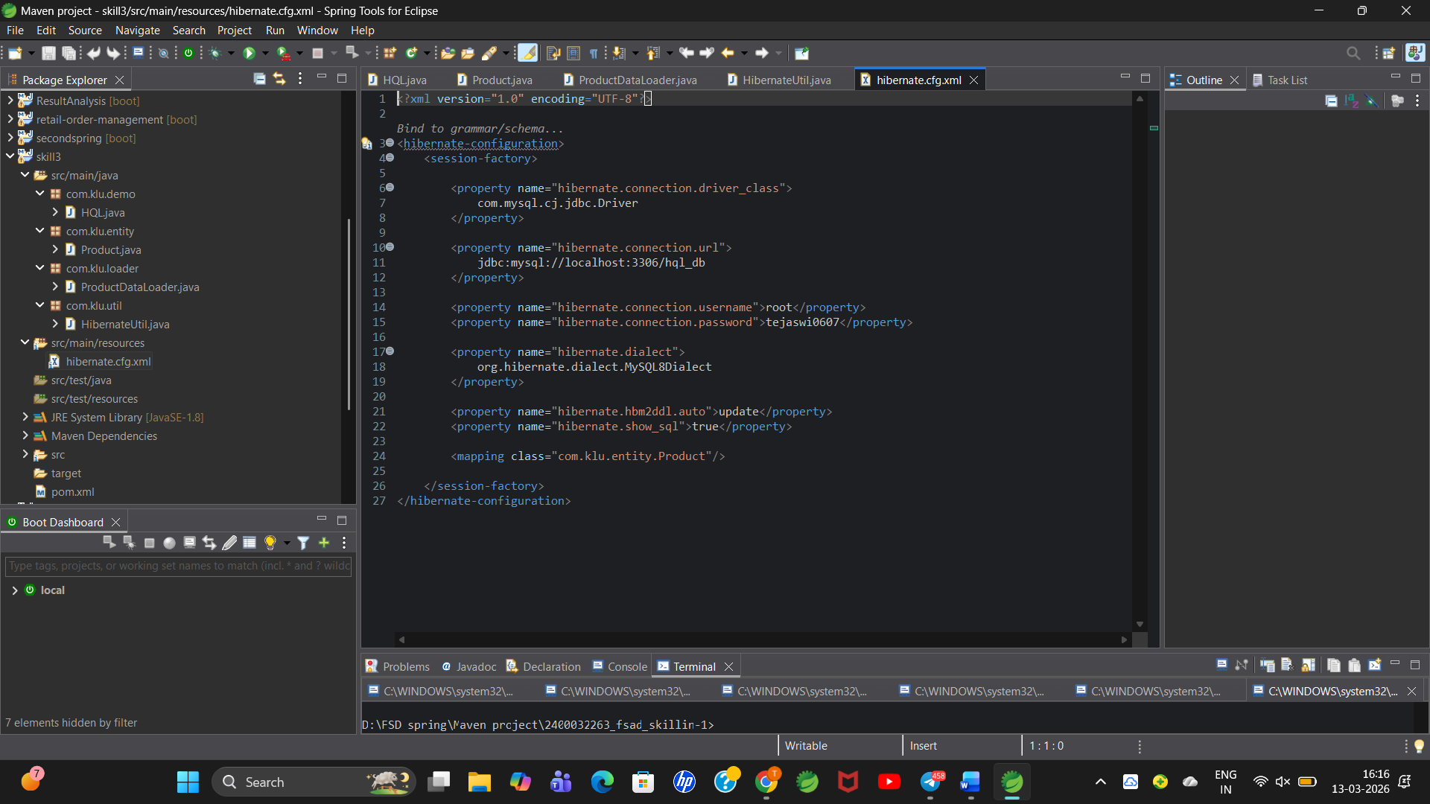
Output:
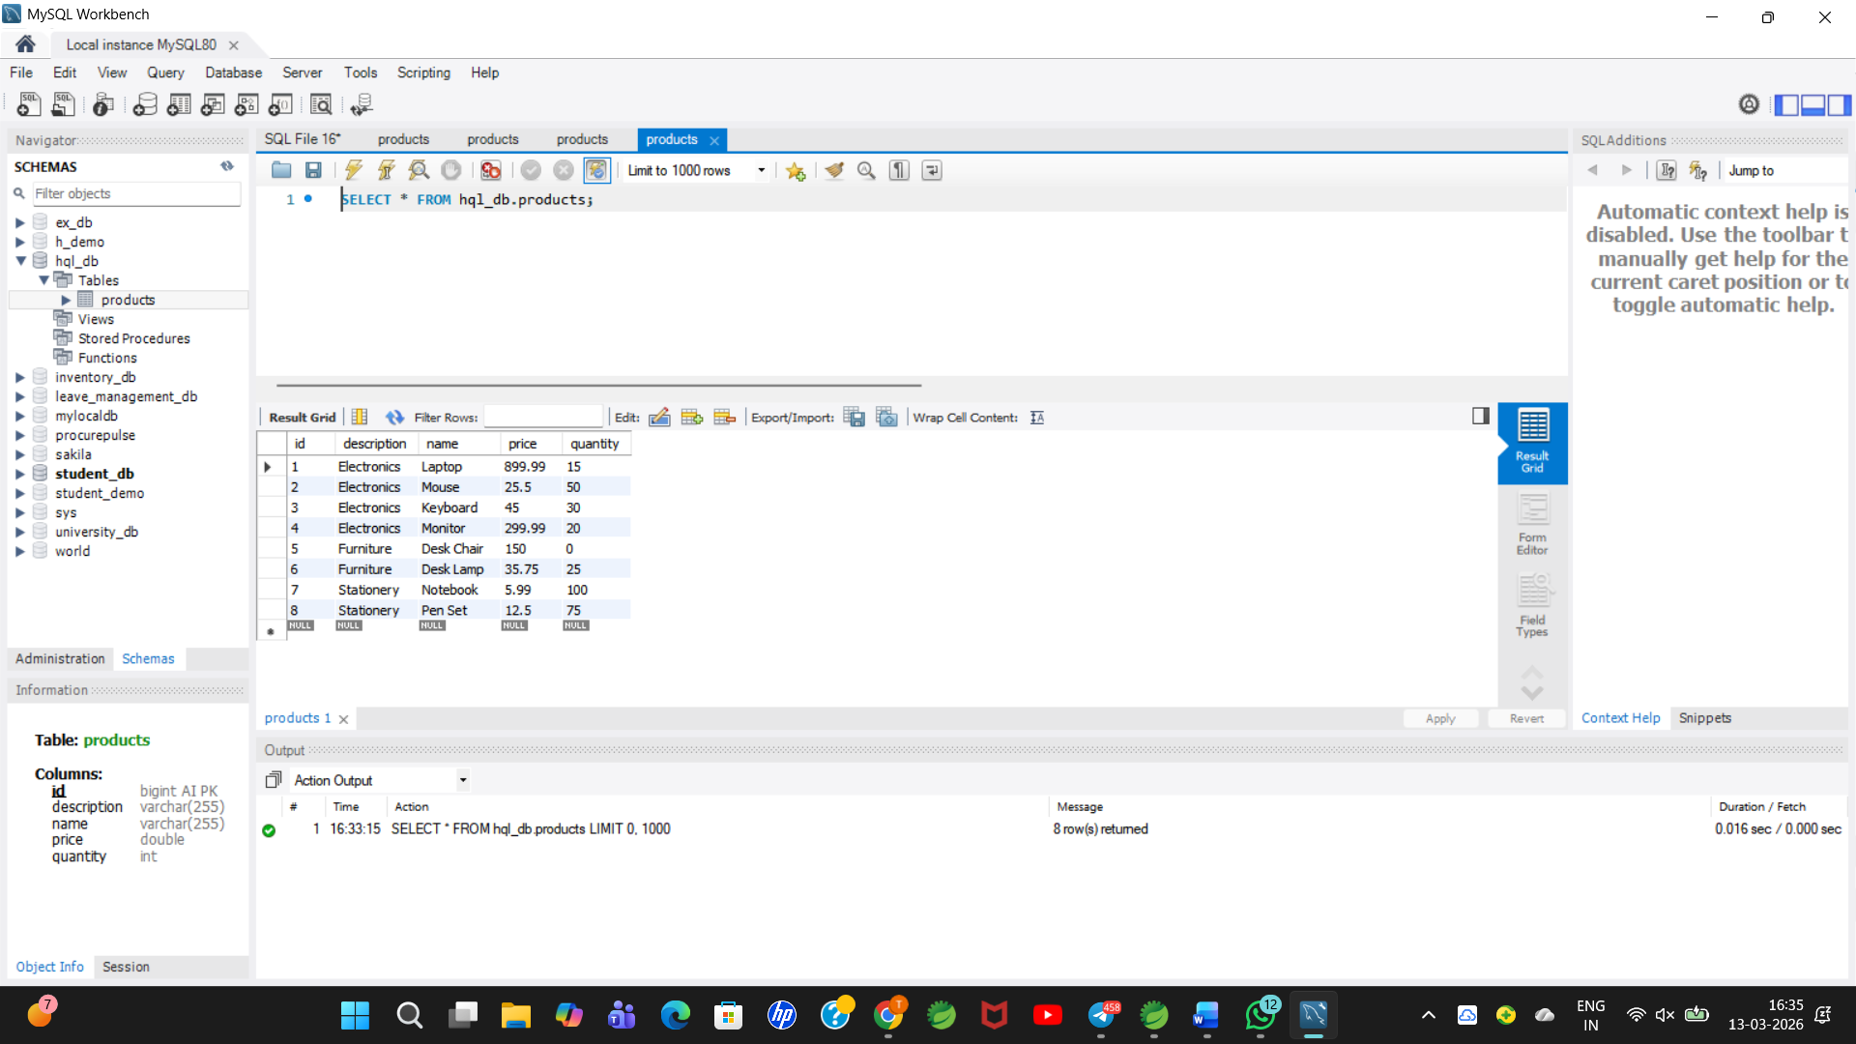
GitHub repo link: https://github.com/ChikkaTejaswi/skill-3

