1. Given an array **Arr** of size **N**, print second largest distinct element from an array.

2. Given an unsorted array **Arr** of size **N** of positive integers. **One number 'A'** from set {1, 2,....,N} is missing and one number 'B' occurs twice in array. Find these two numbers.

### 3.  How to find all possible substring of a given string?

* input: abcd , output : a ab abc abcd b bc bcd c cd d

4. Write a C# program to generate random numbers.

5. Write a Program to perform addition operations for the given numbers. Input might be two or three or four parameters.

# 6. Write a Program to print pattern

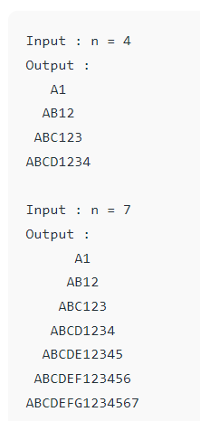

7. Find smallest element from integer array in C#

8. Create classes for **Student** and **Course**, showcasing encapsulation to manage student enrollment in courses.