Low Level Design

**HR Analytic Job Classification**

|  |  |
| --- | --- |
| **Written By** | Vamshi Chowdary |
| **Document Version** | 0.1 |
| **Last Revised Date** | 07-06-2023 |

# DOCUMENT CONTROL

**Change Record:**

|  |  |  |  |
| --- | --- | --- | --- |
| **VERSION** | **DATE** | **AUTHOR** | **COMMENTS** |
| 0.1 | 27-04-2023 | Vamshi Chowdary | Introduction and architecture defined |
| 0.2 | 28-04-2023 | Vamshi Chowdary | Architecture & Architecture description appended and updated. |
| 0.3 | 29-04-2023 | Vamshi Chowdary | Architecture |
| 0.4 | 29-04-2023 | Vamshi Chowdary | Architecture Description |
| 0.5 | 29-04-23 | Vamshi Chowdary | Deployment |
| 0.5 | 29-04-2023 | Vamshi Chowdary | Done |

**Reviews:**

|  |  |  |  |  |  |  |  |  |
| --- | --- | --- | --- | --- | --- | --- | --- | --- |
| **VERSION** | **DATE** |  | **REVIEWER** |  | **COMMENTS** | | |  |
|  |  |  |  |  |  | | |  |
| **Approval Status:** | |  |  |  |  | | |  |
| **VERSION** | **REVIEW DATE** |  | **REVIEWED BY** |  |  | **APPROVED BY** |  | **COMMENTS** |
|  |  |  | |  | |  |  | |

# Contents

## 1. Introduction…………………………………………………………………………………………………04

**1.1 What is Low-Level Design Document? …………………………………………………….. 04**

**1.2 Scope ……………………………………………………………………………………………………... 04**

## 2. Architecture ……………………………………………………………………………………………….. 05

## 3. Architecture Description …………………………………………………………………………… 07

**3.1 Data Description ……………………………………………………………………………………… 07**

**3.2 Web Scrapping ………………………………………………………………………………………… 08**

**3.3 Data Transformation ……………………………………………………………………………… 08**

**3.4 Data insertion into database …………………………………………………………………... 08**

**3.5 Export Data from database ……………………………………………………………………… 09**

**3.6 Deployment …………………………………………………………………………………………… 08**

**4. Unit test cases ……………………………………………………………………………………………10**

# 1. Introduction

**1.1 What is Low-Level design document?**

The goal of the LDD or Low-level design document (LLDD) is to give the internal logic design of the actual program code for the House Price Prediction dashboard. LDD describes the class diagrams with the methods and relations between classes and programs specs. It describes the modules so that the programmer can directly code the program from the document.

## 1.2 Scope

Low-level design (LLD) is a component-level design process that follows a step-by-step refinement process. The process can be used for designing data structures, required software architecture, source code and ultimately, performance algorithms. Overall, the data organization may be defined during requirement analysis and then refined during data design work.

# 2. Architecture

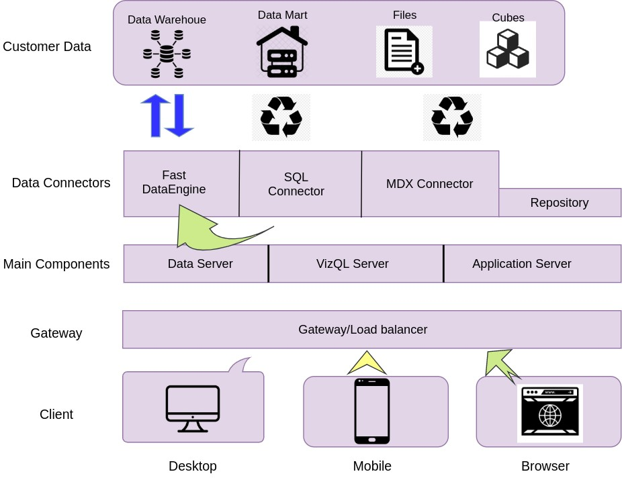

# Tableau Server Architecture

|  |  |
| --- | --- |
| Tableau has a highly scalable, n-tier client-server architecture that serves mobile clients, web clients and desktop-installed software. Tableau Server architecture supports fast and flexible deployments. | |
| The following diagram shows Tableau Server’s architecture: |  |

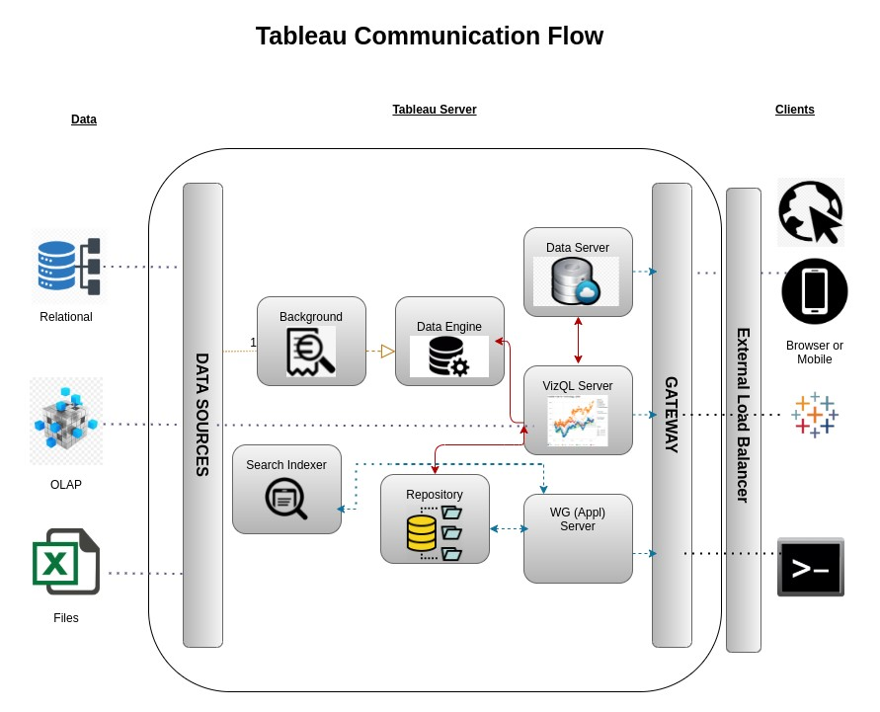

Tableau Server is internally managed by the multiple server processes.

## 1. Gateway/Load Balancer

It acts as an Entry gate to the Tableau Server and also balances the load to the Server if multiple Processes are configured.

## 2) Application Server: -

Application Server processes (wgserver.exe) handle browsing and permissions for the Tableau Server web and mobile interfaces. When a user opens a view in a client device, that user starts a session on Tableau Server. This means that an Application Server thread starts and checks the permissions for that user and that view.

## 3) Repository: -

Tableau Server Repository is a PostgreSQL database that stores server data. This data includes information about Tableau Server users, groups and group assignments, permissions, projects, data sources, and extract metadata and refresh information.

## 4) VIZQL Server: -

Once a view is opened, the client sends a request to the VizQL process (vizqlserver.exe). The VizQL process then sends queries directly to the data source, returning a result set that is rendered as images and presented to the user. Each VizQL Server has its own cache that can be shared across multiple users

**5) Data Engine: -**

It Stores data extracts and answers queries.

## 6) Backgrounder: -

The backgrounder Executes server tasks which includes refreshes scheduled extracts, tasks initiated from tabcmd and manages other background tasks.

## 7) Data Server: -

Data Server Manages connections to Tableau Server data sources

It also maintains metadata from Tableau Desktop, such as calculations, definitions, and groups.

# 3. Architecture Description

## 3.1. Data Description

The Dataset contains house price of cities that fall under the categories A,B and C based on the availability of parking, rainfall, its built-up area etc

1. Dist_Taxi: Distance to nearest taxi stand from the property (in metres).
2. Dist_Market: Distance to nearest grocery market from the property (in metres).
3. Dist_Hospital: Distance to nearest hospital from the property (in metres).
4. Carpet: Carpet area of the property in square feet (in square ft.)
5. Built-up: Built-up area of the property in square feet (in square ft.)
6. Parking: Type of car parking available with the property
7. City Category: Categorization of the city based on the size
8. Rainfall: Annual rainfall in the area where property is located (in cm)
9. 9. House Price: Price at which the property was sold (in Dollars)

## 3.2. Web Scrapping

Web scraping is a technique to automatically extract content and data from websites using bots. It is also known as web data extraction or web harvesting. Web scrapping is made simple now days, many tools are used for web scrapping. Some of python libraries used for web scrapping are Beautiful Soup, Scrapy, Selenium, etc.

## 3.3. Data Transformation

In the Transformation Process, we will convert our original datasets with other necessary attributes format. And will merge it with the Scrapped dataset.

## 3.4. Data Insertion into Database

1. Database Creation and connection - Create a database with name passed. If the database is already created, open the connection to the database.
2. Table creation in the database.
3. Insertion of files in the table .

## 3.5. Export Data from Database

Data Export from Database - The data in a stored database is exported as a CSV file to be used for Data Pre-processing.

**3.6 Deployment.**

Once you’ve completed your dashboard, follow these steps: **- Server, Tableau Public, Save to Tableau Public As**

You may be prompted to log into your Tableau Public profile first if this is your first time publishing.

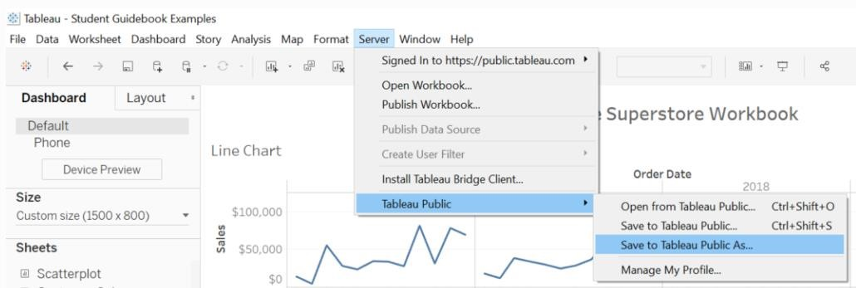

Next, fill out the title you want your viz to have and click “save”.

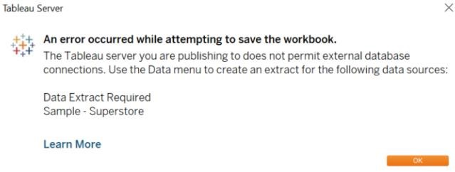

This message means that your connection to the Sample-Superstore data set is a live connection. Tableau Public cannot host live connections, so you’ll need to convert your connection to an extract (like a frozen screenshot of your data).

Here in the below screenshot, we can see that out workbook has been published to tableau public.

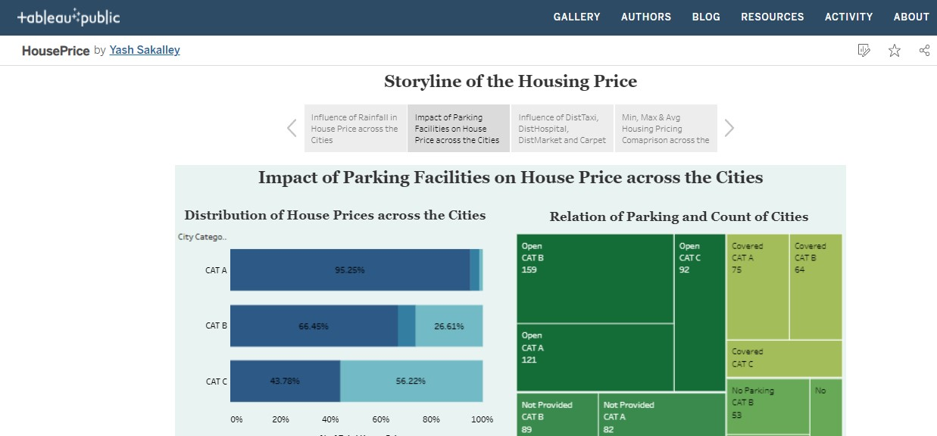

# 4. Unit Test Cases

|  |  |
| --- | --- |
| **TEST CASE DESCRIPTION** | **EXPECTED RESULTS** |
| **Some Tiles for Quick Analysis**: | Tiles show that total job class, total family and his education type. |
| **column and bar chart visualisation** | We easily analyse pay and contact level and we easily analyse job family and job description through column chart. |
| **Chart Visuals** | We find it chart help that PG and dependent job family and we see that PG and job class. |
| **Education and Grade Based Analysis Visuals** | This tiles analyse top 10 grade and family description. |