High Level Design (HLD)

NBA Data Analysis

Revision Number: 1.0

Last date of revision: 02/07/2023

Vamshi Chowdary

Document Version Control

Date Issued Version Description Author

02 July 2023

1.0 First Version of Complete HLD vamshi chowdary

Contents

Document Version Control ......................................................................................................... 2

Abstract ...................................................................................................................................... 3

1. Introduction ............................................................................................................................. 4

1.1 Why this High-Level Design Document? ....................................................................... 4

1.2 Scope ............................................................................................................................. 5

2. General Description .............................................................................................................. 5

1.3 Product Perspective & Problem Statement .................................................................... 5

NBA is like a god to many people and is played and loved by many. In this project, we will see various insights into NBA and we will see various aspects of NBA players............................... 5

2.2 Tools used ........................................................................................................................ 5

3. Design Details .........................................................................................................................7

3.1 Functional Architecture .................................................................................................... 7

4. KPIs ........................................................................................................................................7

4.2 KPIs (Key Performance Indicators) .................................................................................. 8

5. Final

Section........................................................................................................................................8

Abstract

The National Basketball Association, NBA, is a professional basketball league comprised of 30 teams across North America featuring the best basketball players in the world.

Today, the NBA is the most innovative league in sports, helping drive the game's growth around the globe. We’re pioneers in using technology to deliver content to fans over all forms of media, and a leader in social responsibility and community development.

3. High Level Design (HLD)

1. Introduction

**1.1 Why this High-Level Design Document?**

The purpose of this High-Level Design (HLD) Document is to add the necessary detail to the current project description to represent a suitable model for coding. This document is also intended to help detect contradictions before coding and can be used as a reference manual for how the modules interact at a high level.

The HLD will:

• Present all of the design aspects and define them in detail

• Describe the user interface is implemented

• Describe the hardware and software interfaces

• Describe the performance requirements

• Include design features and the architecture of the project

• List and describe the non-functional attributes like:

o Security

o Reliability

o Maintainability

o Reusability

o Application compatibility o Resource utilization

o Serviceability

**4** .High Level Design (HLD)

**1.2 Scope**

The HLD documentation presents the structure of the system, such as the database architecture, application architecture (layers), application flow (Navigation), and technology architecture. The HLD

uses non-technical to mildly-technical terms which should be understandable to the administrators of the system.

**2 General Description**

**2.1 Product Perspective & Problem Statement**

The National Basketball Association was founded at the Commodore Hotel in New York. Maurice Podoloff was the league’s first president, a title later changed to the commissioner. Eleven teams were part of that league, originally called the Basketball Association of America. Podoloff’s name is now emblazoned on the

NBA MVP trophy.

The National Basketball Association, NBA, is a professional basketball league comprised of 30 teams across North America featuring the world’s best basketball players.

In this project, we will see various aspects and qualities of NBA players (i.e. Body Fat, Weight, Height, etc, and we will see what trends and relationships their qualities are following.

We will visualize their qualities using visualization tools like Plotly and matplotlib and tableau.



**6**. High Level Design (HLD)

**3 Design Details**

**3.1 Functional Architecture**

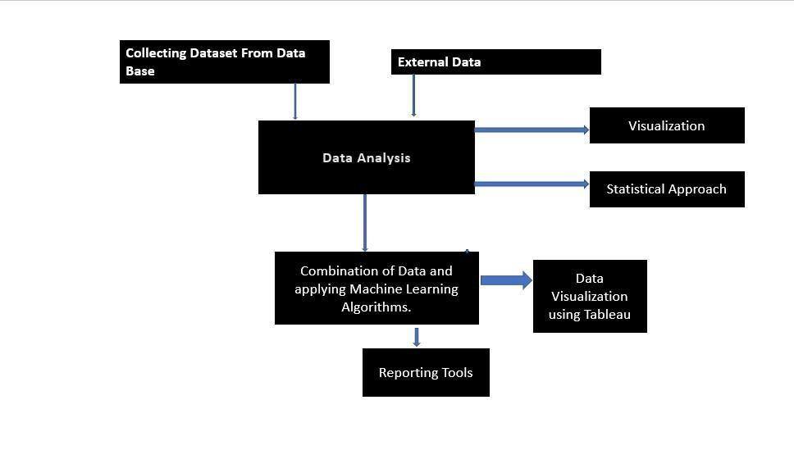

**4 KPIs**

Figure 1: Functional Architecture of Business Intelligence

Dashboards will be implemented to display and indicate certain KPIs and relevant indicators for the project result.



**7**. High Level Design (HLD)



historical/periodic data for a user, the dashboards will be

included to display charts over time with progress on various indicators or factors.

**4.1 KPIs (Key Performance Indicators)**

Key indicators displaying a summary of the NBA Dataset and its relationship with different metrics

1. Impact of Height on Wingspan across the player.

2. Impact of weight on height across the player

3. Impact of Hand (Length) on Wingspan

4. Impact of Weight on Body Fat

5. Impact of Body Fat on Sprint

6. Influence of height parameter on sprint.

7. Influence of height parameter on vertical (max reach)

8. Influence of height (No shoes) parameter on wingspan

9. Influence of Body fat parameter on agility

10. Influence of Height (No Shoes) Parameter on Sprint.

**5 Final Section**



**8**. High Level Design (HLD)

Prioritizing data and analytics couldn’t come at a better time. No matter what size,

your company is already collecting data and most likely analyzing just a portion of it to solve business problems, gain competitive advantages, and drive enterprise transformation. With the explosive growth of enterprise data, database technologies, and the high demand for analytical skills, today’s most effective IT organizations have shifted their focus to enabling self-services by using and operating Plotly at scale, as well as organizing, orchestrating, and unifying disparate sources of data for business users and experts alike to author and consume content.

Tableau helps people see and understand data. Our visual analytics platform is transforming the way people use data to solve problems. See why organizations of all sizes trust Tableau to help them be more data-driven.