*NBA Draft Combine Measurements*

***Wireframe Documentation***

**Vamshi Chowdary**

Homepage

As per the problem statement, we have divided the analysis into various sections:-

1. **Impact of Weight and Sprint vs Year**

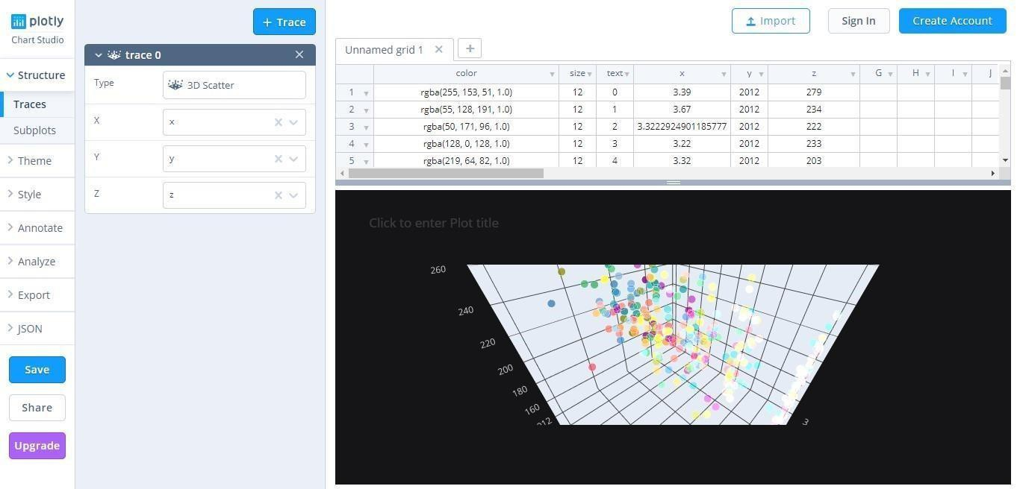

**2. Impact of Weight on player**

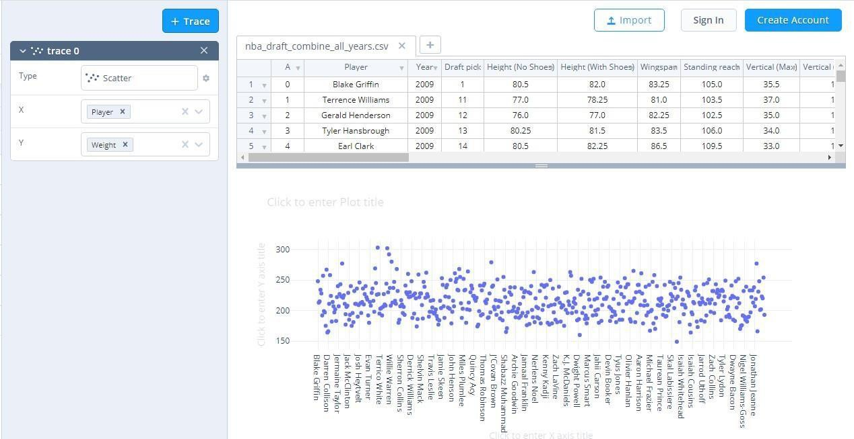

3. **Impact of Weight on Sprint**

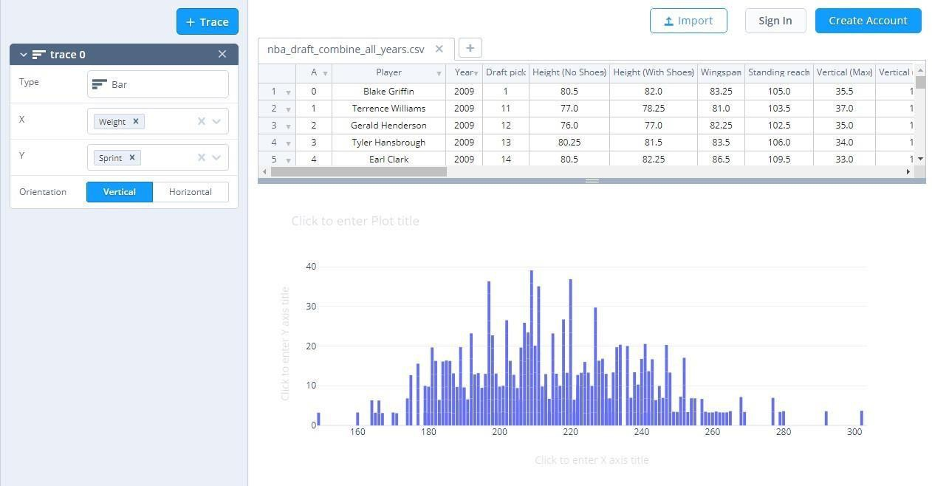

4. Impact of Weight on Vertical(Max )

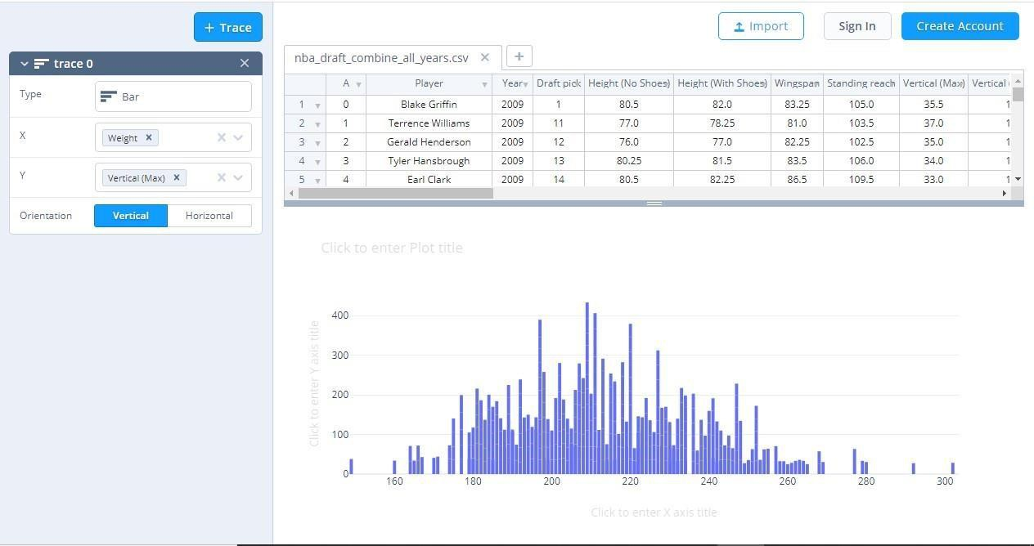

5. **Impact on Weight on Standing Reach vs Player**

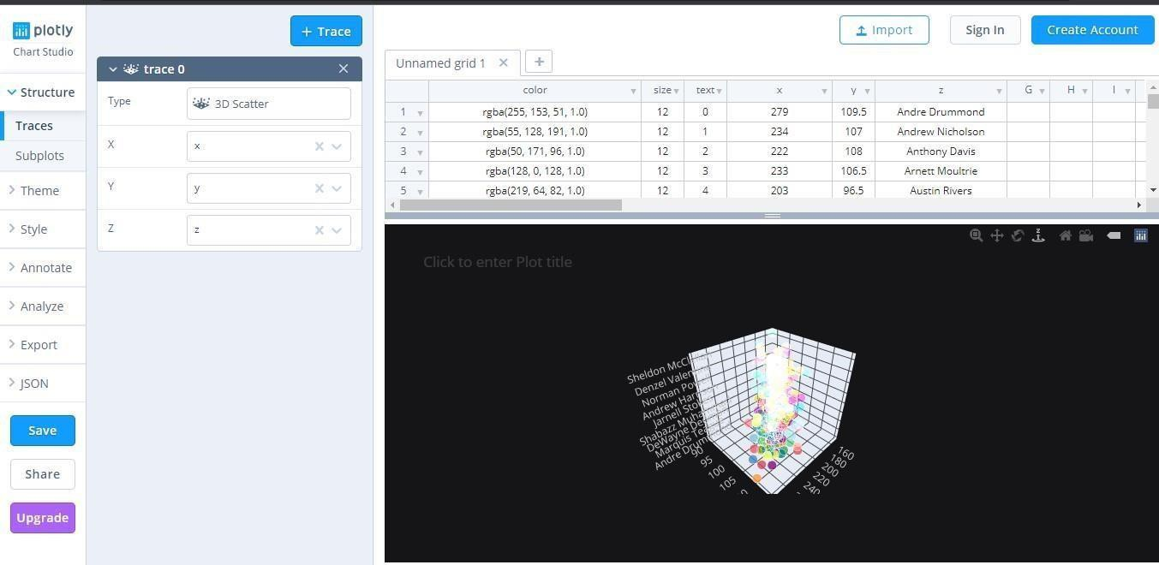

6. **Relationships between Hand (Length) and Hand (Width)**

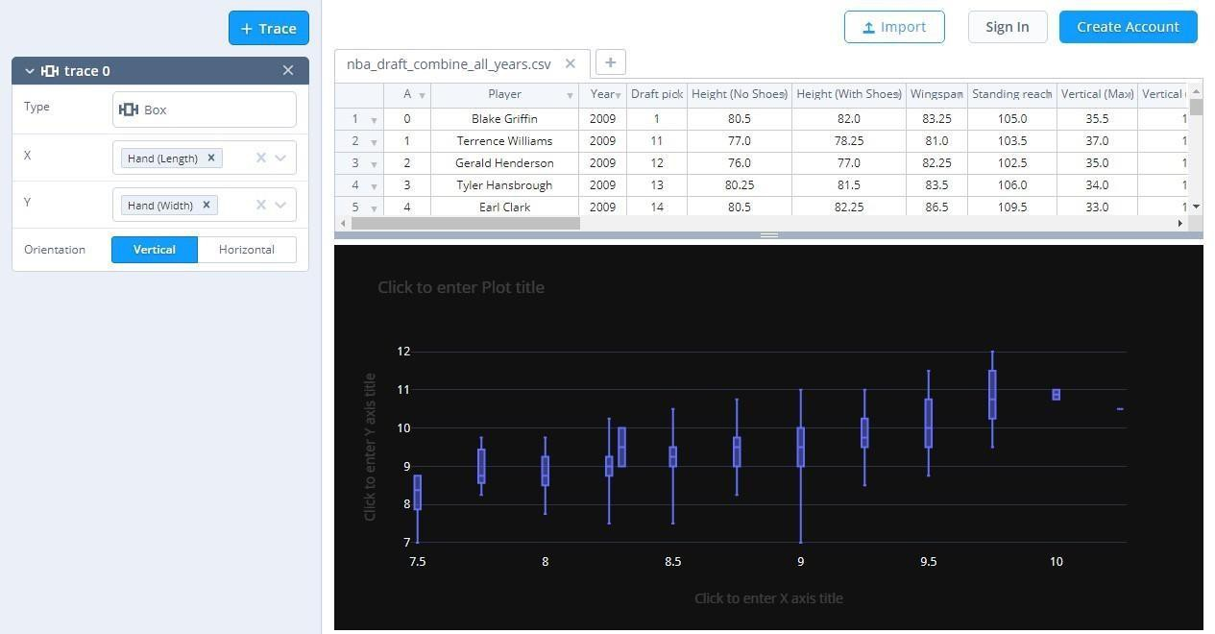

**7. Impact of Wingspan on player**

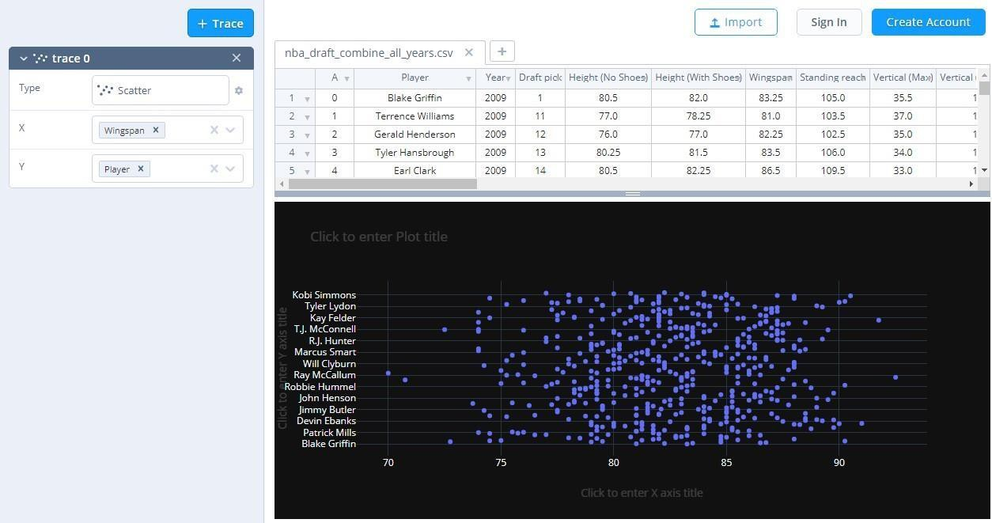

**8. Impact of Sprint on height (No Shoes)**

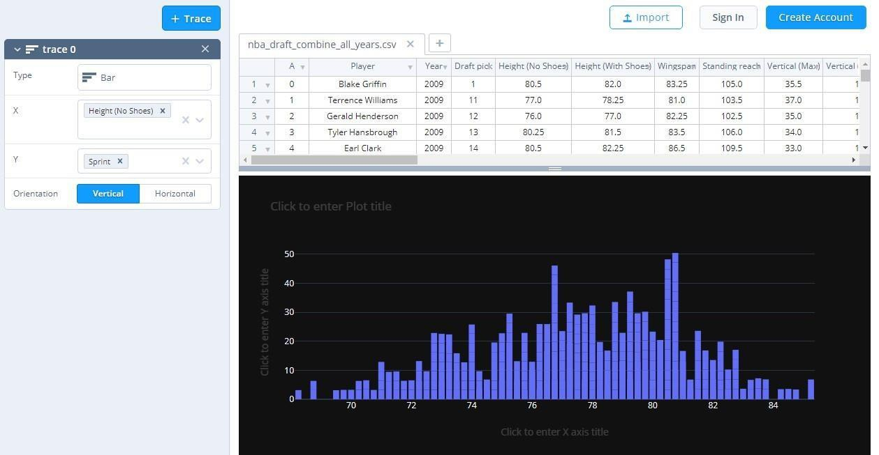

**9. Impact of Draft Pick on Vertical (Max Reach)**

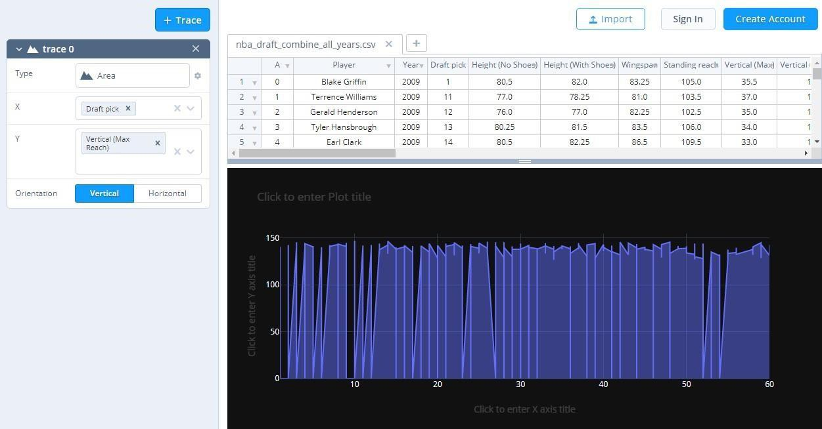

**10. Impact of Vertical (No Step Reach) on Player**

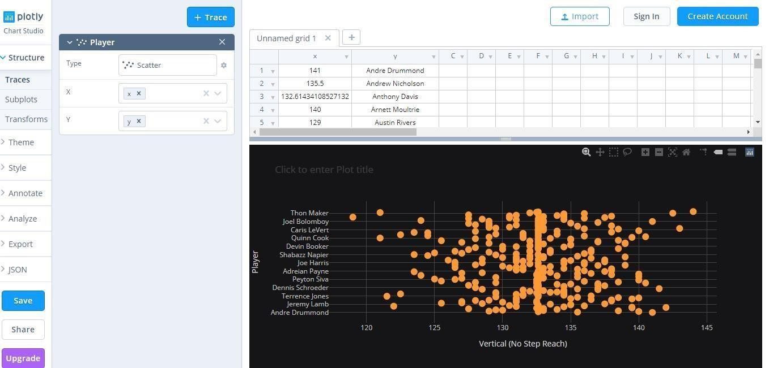

**11. Parallel Coordinate pl**

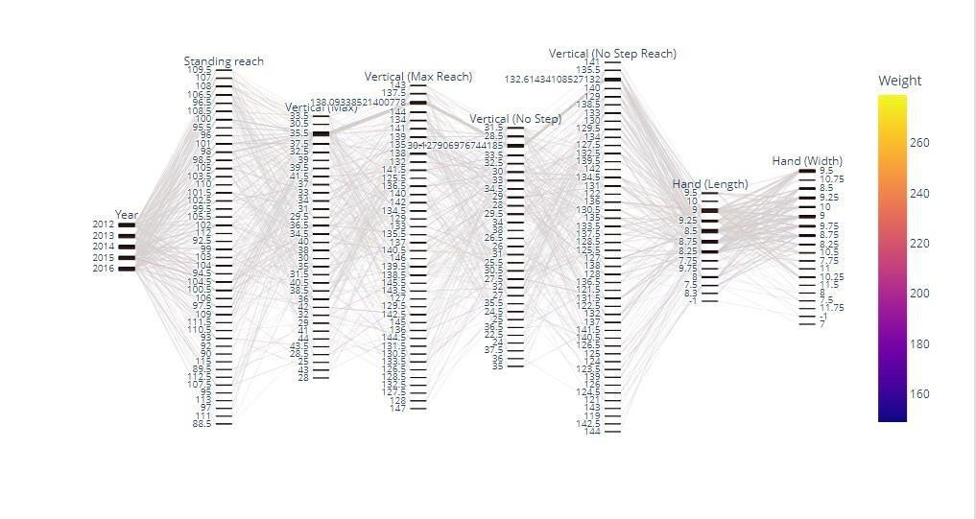

**12. Impact of a sprint on standing reach with player**

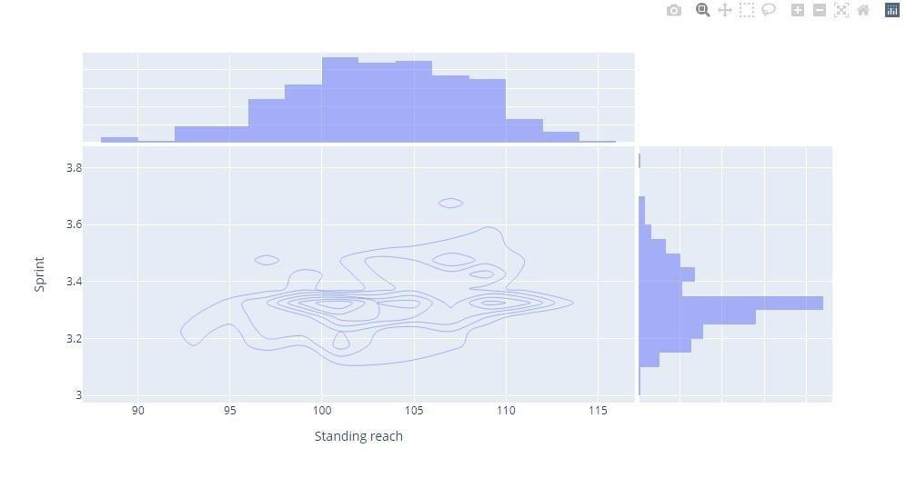

**13. Impact of wingspan on standing reach**

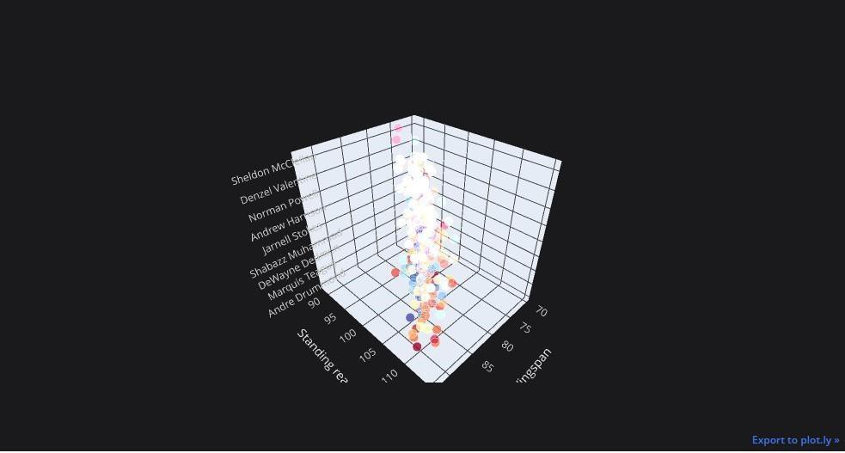

**14. Pair-plot**

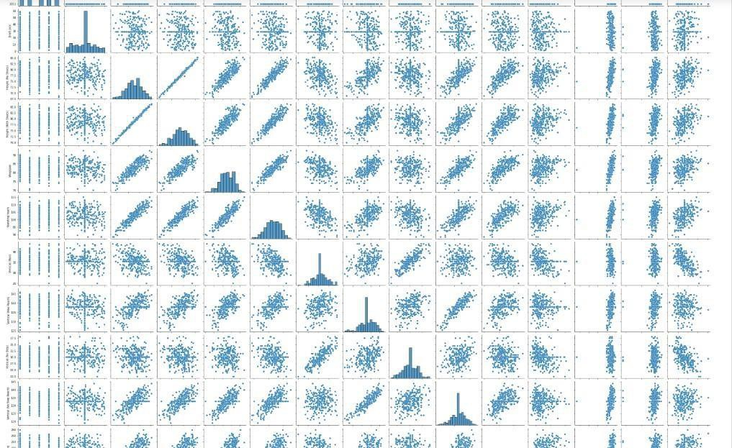

**15.Empirical Cumulative plot or Probability plot**

