Secret
A Secret in Kubernetes is an object used to store and manage sensitive information securely.
The sensitive information is commonly referred to as a secret key, such as:
- Database passwords
- API keys
- OAuth tokens
- SSH private keys
- TLS certificates
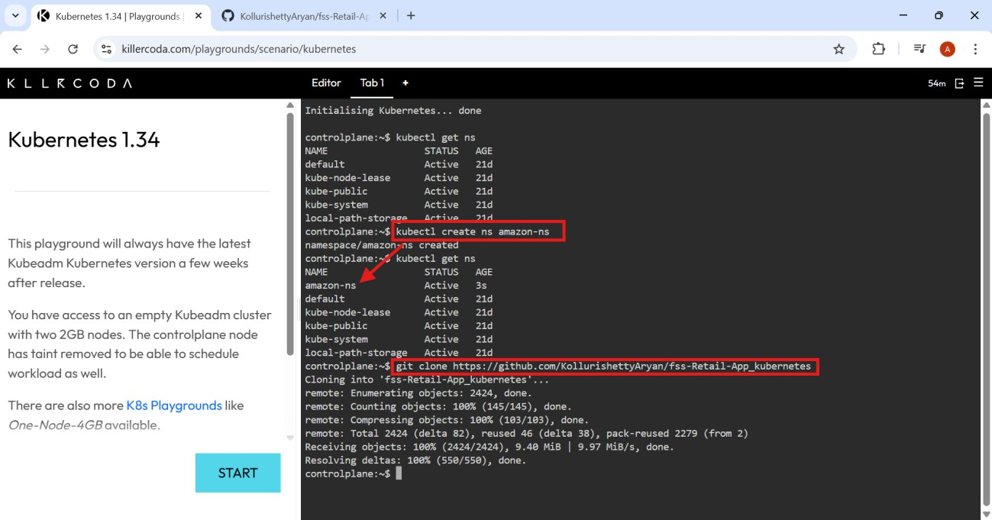
Following is the way to use secrets in Kubernetes: Step 1: Create namespace and clone the git repo.

Step 2: Generate required .yaml files, after cloning the git repo.

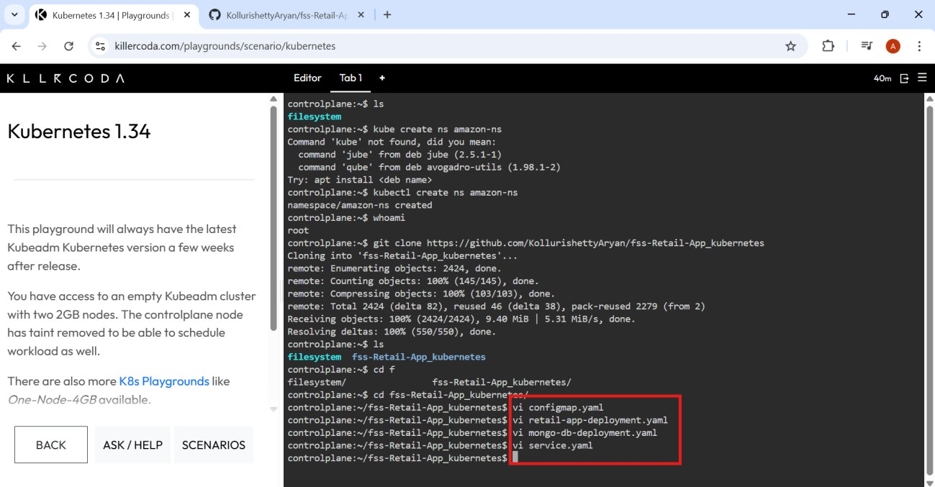

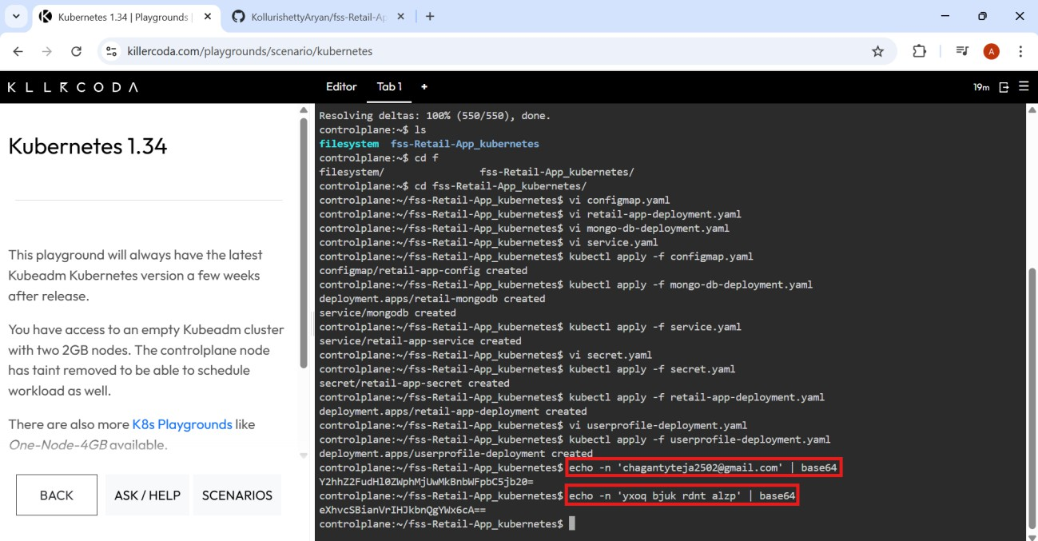
Step 3: Now run the below commands

Step 4: Apply the yaml files to execute them.

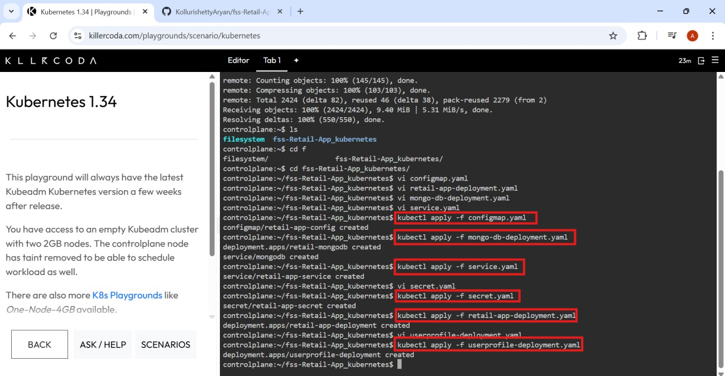

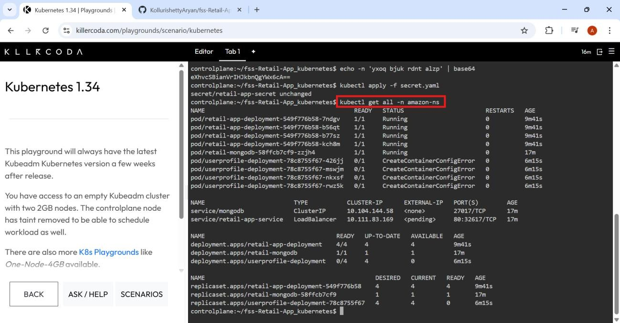
Step 5: Check required terms under name space (amazon-ns)

Step 6: Now get the nodes.

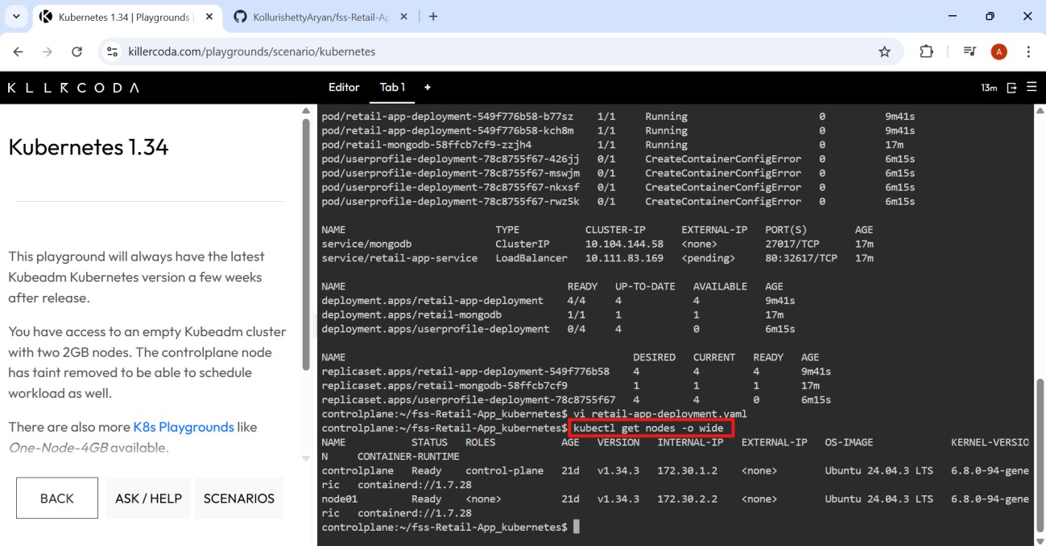

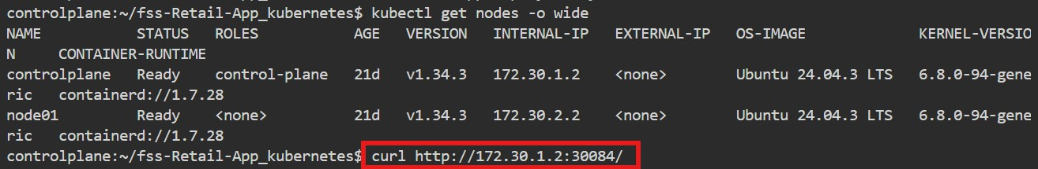
Step: Check the running process using internal IP

