Kubernetes
Kubernetes: It is an open source platform where it is used to design and automate the deployment, scaling and management of container applications.
Initially developed by Google and currently maintained by CNCF. It acts as the brain of a system which performs several critical tasks.

Why Kubernetes?
Docker helps us package and run applications inside containers to solve problems like dependency conflicts, easy deployment etc.
But docker has few limitations, such as following:
- No auto scaling
- No self-healing
- No built in load balancing
- It is hard to manage many containers across multiple servers
When applications grow in high traffic, managing containers manually becomes difficult. So that is the reason why we prefer to use Kubernetes.
Kubernetes is used to manage docker containers to scale properly and give efficient results.

What is Kubernetes?

Kubernetes is used to deploy the containers applications, to manage the containers across multiple machines and to automate the scale, heal and balance applications.

Difference between docker and Kubernetes:

Docker | Kubernetes
> It creates containers and  images. | > It will manage the containers
> This runs on single machine  easily | > This runs across multiple  machines
> It has manual scaling | > It has auto scaling
> It is good for small  applications | > It can handle big applications
> It has no self healing process | > This consists of self healing.

Advantages of Kubernetes:
- Kubernetes is highly available even if pods get failed.
- It will handle a huge number of users and requests passed from the source smoothly.
- It has automation which includes deployment, scaling, recovery and load balancing.
- Kubernetes is used to reduce infrastructure cost.
- It is perfect for modern microservices architecture.

Disadvantages of Kubernetes:
- This will take time to build a complex setup.

- This might be huge for small apps.
- It consumes more CPU and memory than docker.
- The debugging complexity issue is harder due to multiple layers.

Architecture:
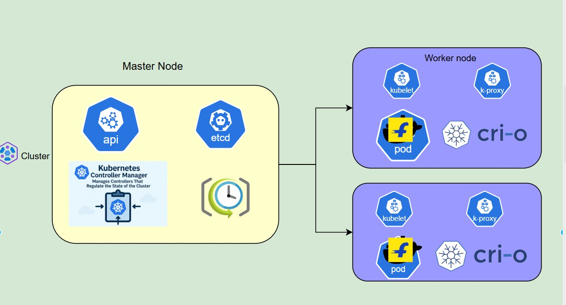

Master Node: The Master node is responsible for managing and control the cluster like API server, etcd, controller manager and scheduler.
Woker Nodes: Worker nodes are where the application actually runs, such as kubelet, kube-proxy, running containers and pods.
Workflow of architecture:

First, the user sends a request to API server, then scheduler selects a worker node, kubelet creates pods using Cri-o. Kube-proxy manages networks, controllers will keep everything stable.

