IBM NAAN MUDHALVAN

ELECTRICITY PRICES

PREDICTION

|  |  |
| --- | --- |
| DOMAIN | APPLIED DATA SCIENCE |
| PROJECT TOPIC | ELECTRICITY PRICES PREDICTION |
| TEAM MEMBERS&  REGISTER NUMBER | ARAVINDHATCHAN S[ 420421104007]  ANBUMANI P[ 420421104006 ]  VIGNESHWAR T [ 420421104086]  KOLLURU LAKSHMI MANI [ 420421104037 ] |

PHASE_4: SUBMISSION DOCUMENT

Introduction:

* **Predicting electricity prices is a common task in energy economics, finance, and energy management. Accurate predictions can help energy companies, consumers, and policymakers make informed decisions. Here's a high-level overview of the steps involved in predicting electricity prices**

Import Libraries:

* Numpy
* Pandas
* Matplotlib
* Seaborn

Data Set Link:

[**https://www.kaggle.com/datasets/chakradharmattapalli/electricity-price-prediction**](https://www.kaggle.com/datasets/chakradharmattapalli/electricity-price-prediction) 

**READING FILE:**

|  |
| --- |
| df=pd.read_csv("Electricity.csv", low_memory=False)  df.head() |

**OUTPUT:**

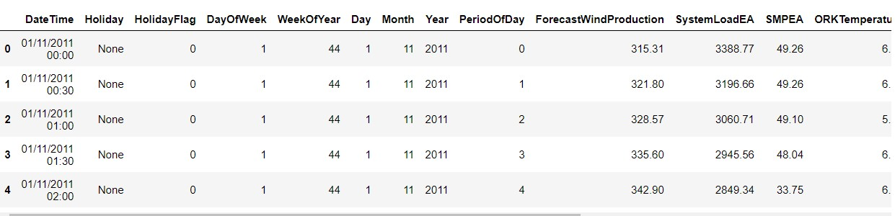

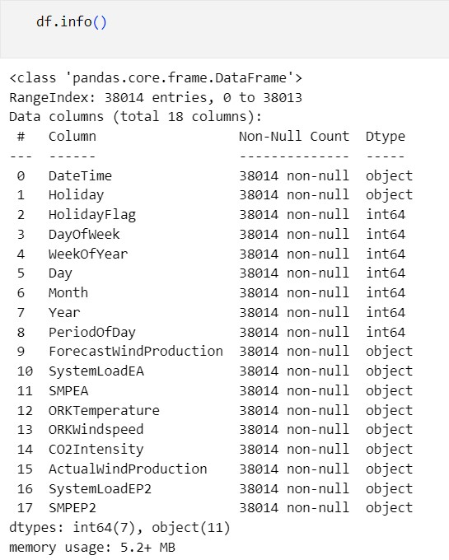

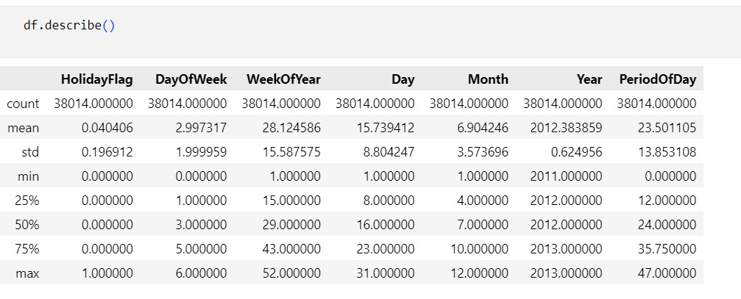

MODEL BUILDING:

Building a model for a dataset involves a series of steps and considerations. Here's a general outline of the process:

* **Understand the Problem**
* **Data Collection**
* **Data Preprocessing**
* **Feature Engineering**
* **Model selection**
* **Model Training**
* **Model Evaluation**
* **Model Testing**
* **Model Interpretation**
* **Model Deployement**

**PROGRAM:**

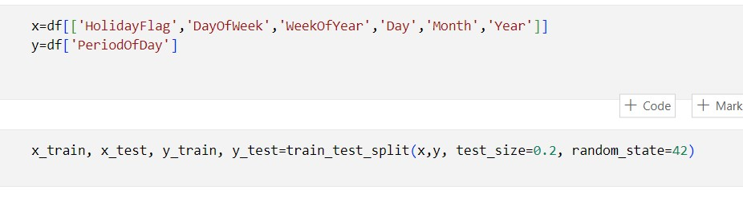

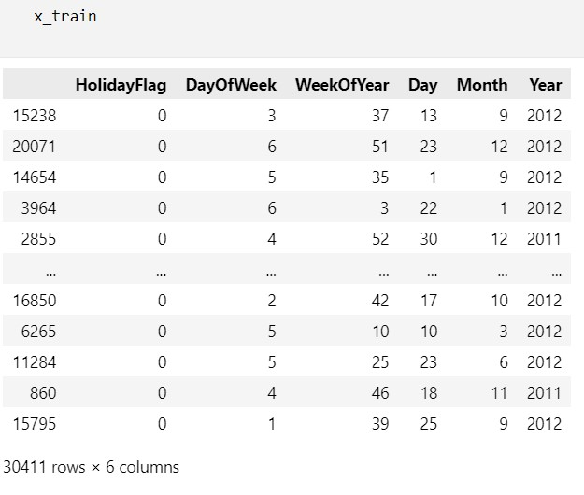

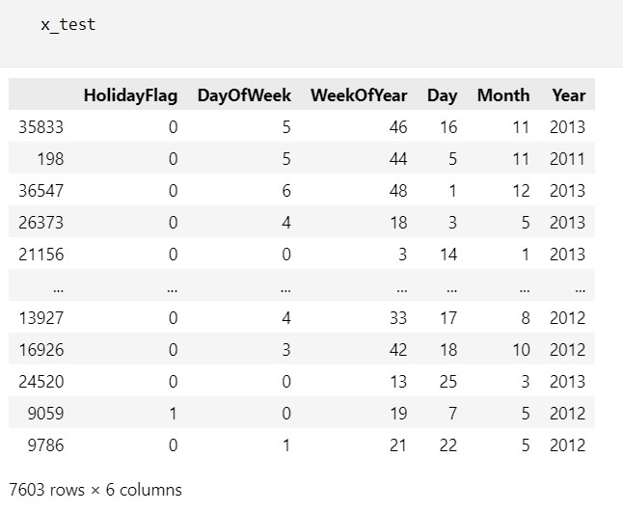

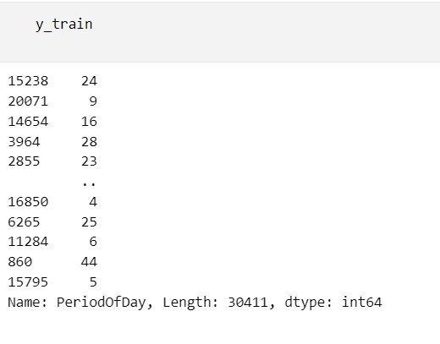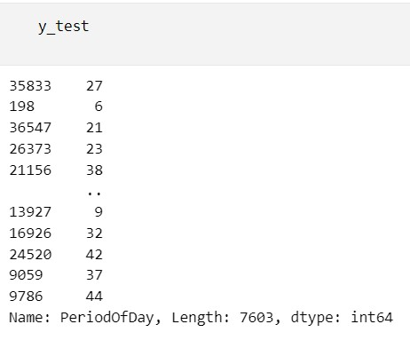

MODEL EVALUATION:

* Model evaluation is a critical step in the machine learning and data analysis process. It involves assessing how well a trained model performs on a given dataset. The goal of model evaluation is to determine the model's effectiveness, generalization capability, and suitability for a specific task. Here are some common techniques and metrics used for model evaluation.
* **Splitting the Data**
* **Training the Model**
* **Model Evaluation Metrics**
* **Classification Problems**
* Accuracy
* Precision, Recall, F1-Score
* ROC AUC
* Confusion Matrix
* **Regression Problems**
* Mean Absolute Error (MAE)
* Mean Squared Error (MSE)
* Root Mean Squared Error (RMSE)
* R-squared (R2)
* **Error Analysis**
* **Deployment and Monitoring**

**PROGRAM:**

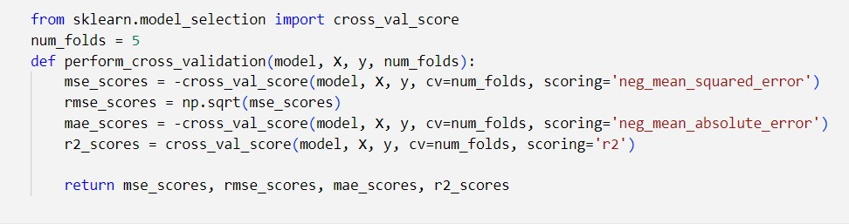

##LINE REGRESSION##

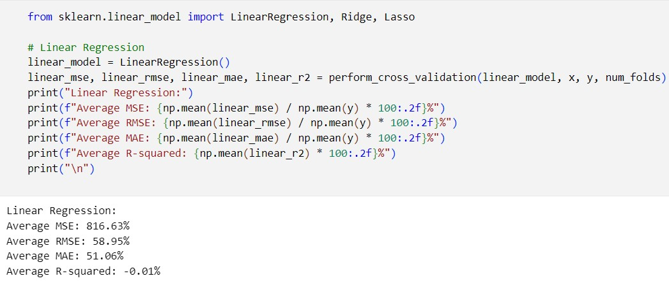

##RIDGE REGRESSION##

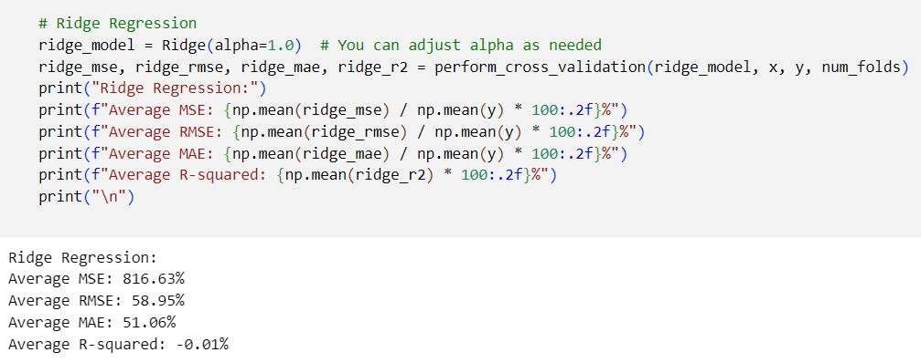

##LASSO REGRESSION##

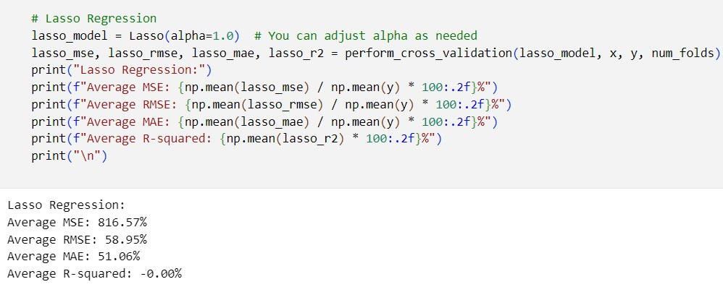

##DECISION TREE##

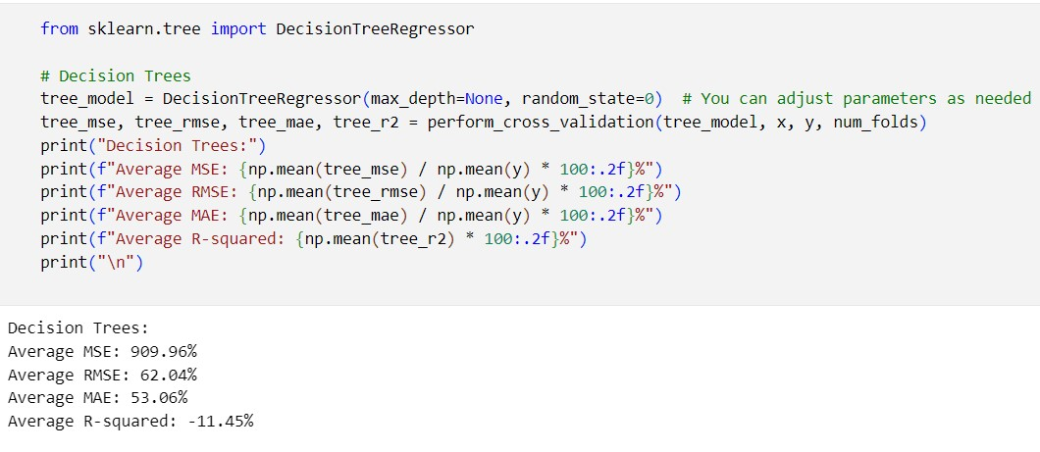

##RANDOM FOREST##

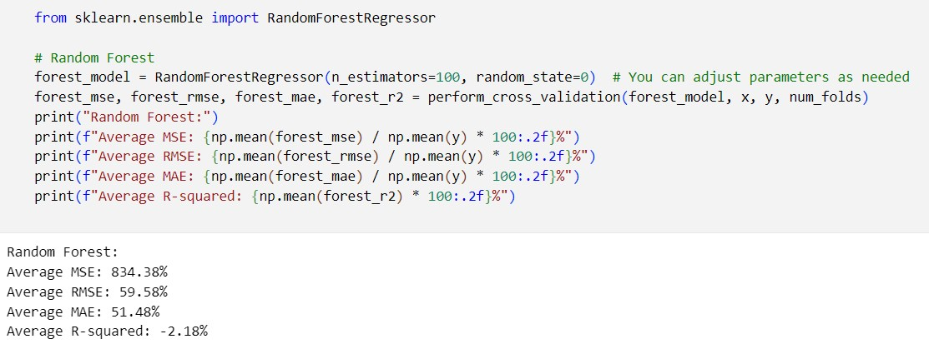

VISUALIZATION:

* Data visualization is a powerful way to represent and communicate information from data through visual elements like charts, graphs, and maps. Effective data visualization can make complex data more understandable and can help identify patterns, trends, and insights that might be hidden in raw data. Here are some key concepts and best practices for data visualization.

**PROGRAM:**

##LINE PLOT##

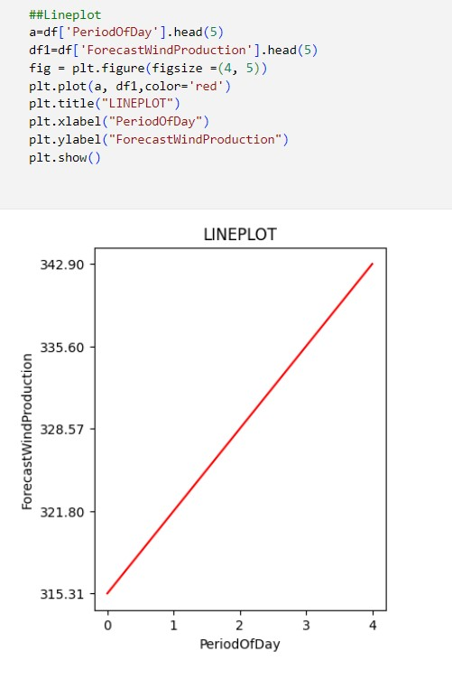

##SCATTER PLOT##

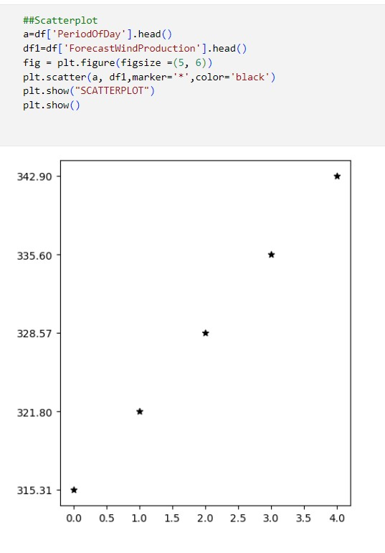

##PIE CHART##

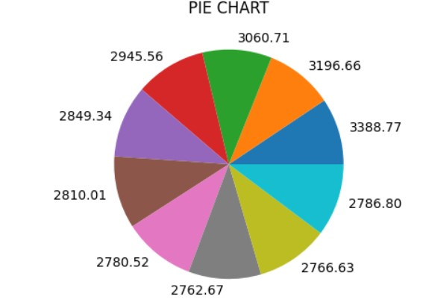

##BAR CHART##

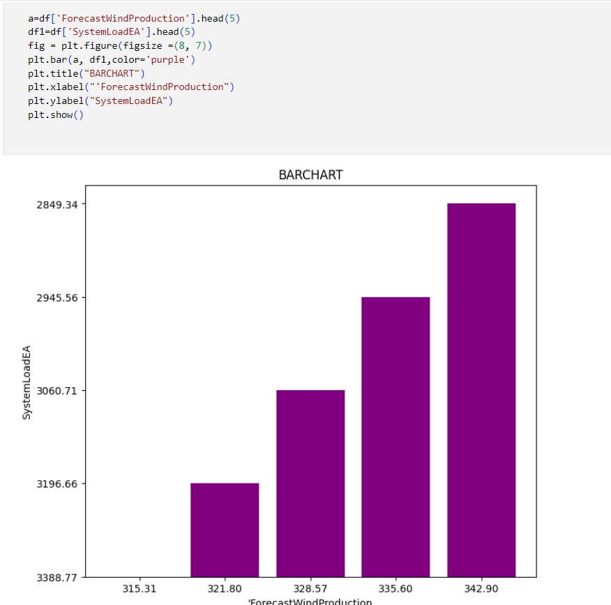

Conclusion:

In this phase,The Model Building ,Model Evaluation and visualize the Dataset has been successfully verified and executed successfully.