**Тема**: Дослідження роботи dhcp server`а. Налаштування топології в Cisco Packet Tracer

**Виконав**: 05 09

Топологія завдання

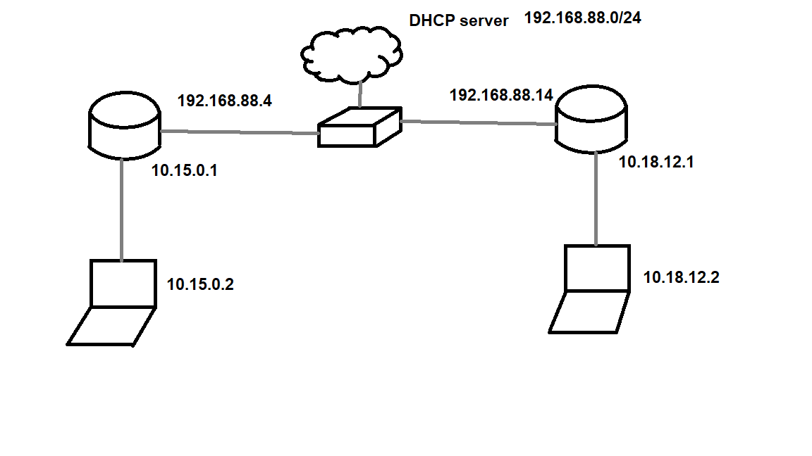

Схема в Cisco Packet Tracer:

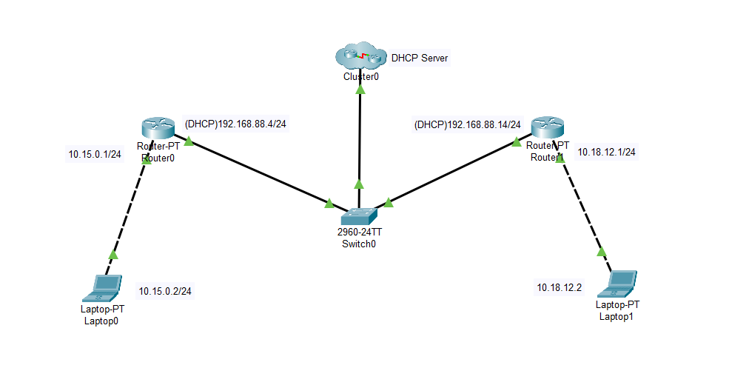

Конфігурація пристроїв:

* DHCP server:

dhcp server: en

dhcp server: conf t

dhcp server: int f0/0

dhcp server:ip address 192.168.88.1 255.255.255.0

dhcp server: no sh

dhcp server: exit

dhcp server: ip dhcp pool my_pool

dhcp server: network 192.168.88.0 255.255.255.0

dhcp server: default-router 192.168.88.1

dhcp server: exit

dhcp server: ip route 10.15.0.0. 255.255.255.0 192.168.88.4

dhcp server: ip route 10.18.12.0. 255.255.255.0 192.168.88.14

dhcp server: end

dhcp server: write

* Router 1:

router 1: en

router 1: conf t

router 1: int f1/0

router 1: no sh

router 1: ip add dhcp

router 1:int f0/0

router 1: ip add 10.15.0.1 255.255.255.0

router 1: no sh

router 1: end

router 1: write

* Router 2:
* router 1: en
* router 1: conf t
* router 1: int f1/0
* router 1: no sh
* router 1: ip add dhcp
* router 1:int f0/0
* router 1: ip add 10.18.12.1 255.255.255.0
* router 1: no sh
* router 1: end
* router 1: write
* PC-1:

Ip address: 10.15.0.2

Subnet Mask: 255.255.255.0

Default Gateway: 10.15.0.1

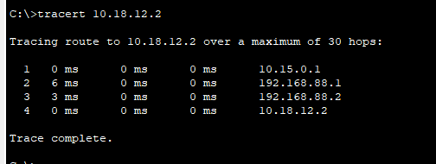

* PC-2:

Ip address: 10.18.12.2

Subnet Mask: 255.255.255.0

Default Gateway: 10.18.12.1

